## Apache Spark Streaming ( UD )

Data processing started with the idea of capturing and storing data first and then processing it later. When Bigdata processing started to emerge, it followed the same pattern. Capture the data first, save it, and then processes it later. Data Lake is the result of the same idea. Data Lake is a place where data goes to sit, and after that, you process it in smaller batches. These batches are scheduled to run at regular intervals, such as once every day. However, in many cases, the business refused to wait for a day and started demanding smaller and quicker batches. And that is where all the problems started.

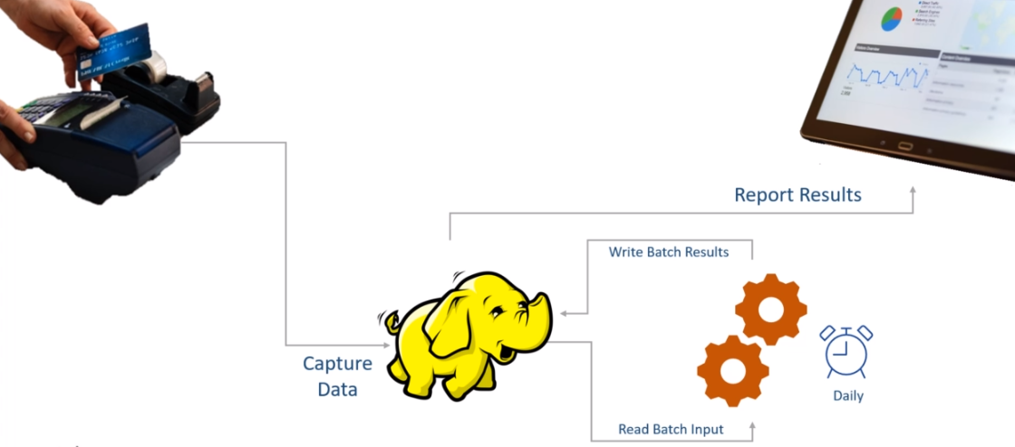

At first, it looks like a super simple problem to solve. We created a batch job to collect data for 24 hours and process it once. Now, the business wants to process data every five minutes. No big deal. Right? Schedule the same batch to collect data for five minutes and run it once. If the five-minute window is too big, we can even schedule the job to run every second. What's a big deal?

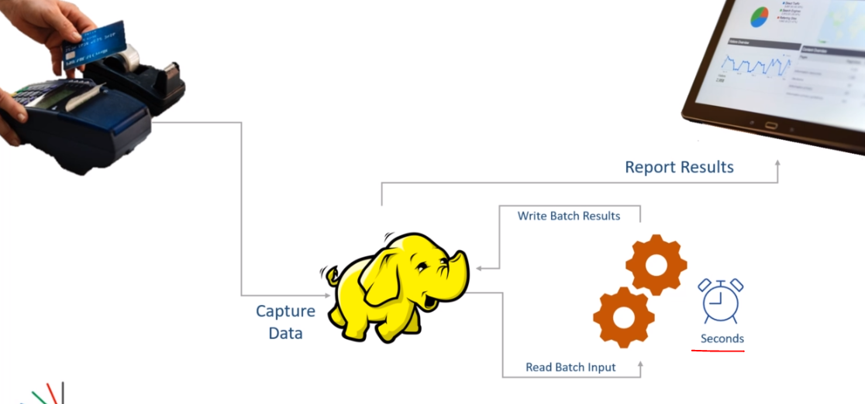

However, extracting information from your data every second on an ever-growing data which is continuously flowing to your system is not a job scheduling problem. You cannot solve it by merely scheduling your batch jobs to run more frequently. The business does not want to run your jobs every second. All they asked is to deliver the information every second. And computing results which are accurate and updated till the previous second is a real-time stream processing problem.

The stream processing starts from the one fundamental change in perspective. When you process a data stream, you do not look at the data as a table in a database or a file in the data lake. The data lake is stationary, but the stream is the data in motion. A stream is a continuous, unbounded, and an endless flow of data that keeps bringing more data to your system every second. How do you deal with that? How do you process that stream and compute the most recent and accurate information? The moment you start thinking about real-time stream processing, many new problems start popping in your mind. And that's what this course is all about. Solving those problems and answering those questions using Spark Structured Streaming. In this course, I am going to teach you two things. Stream processing problems and challenges. And How to solve those problems using Spark's most recent Structured Streaming APIs.

This is a Spark Stream processing course, and I am going to cover Spark Structured Streaming APIs and Stream Processing concepts in great detail. However, you will also need to know the following things. These three things are not in the scope of this course.

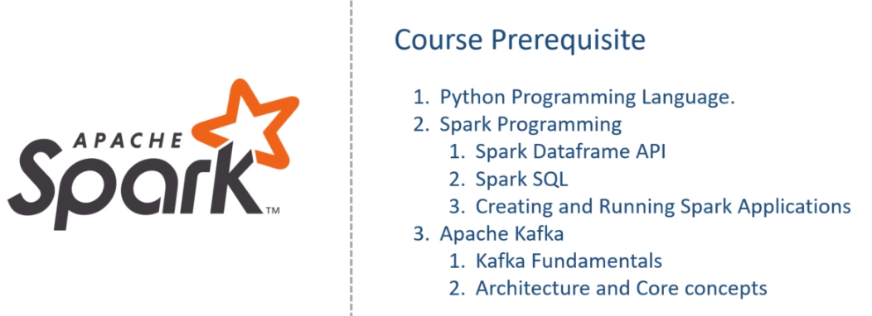

This course is assuming that you are already familiar with these prerequisites of the course. If not, I also teach those subjects. I recommend that you take my other courses to fill the gap and then return to the current course. I will help you set up your Python IDE, Install Apache Spark, and Apache Kafka on your local machines. This course will give you steps to set up and configure your learning environment. However, I am not going to discuss Spark Dataframe APIs, Apache Kafka, or the programming language topics. If you lack any of the three skills listed here, this course is not for you. However, if you are familiar with these three subjects and want to deep dive into Stream Processing using Apache Spark Structured Streaming API, you are at the right place.

### Source Code & Resources

All the source code, examples, data, and other resources are available in a public GitHub repository. You can refer to it anytime using the Course GitHub Repository.

<https://github.com/LearningJournal/Spark-Streaming-In-Python>

You can also download it using the below link. Compressed Source Code Download Link

<https://github.com/LearningJournal/Spark-Streaming-In-Python/archive/refs/heads/master.zip>

### Dev Environment

The first step in learning Apache Spark is to get access to the Spark System. You can get Spark in many ways, but a Spark developer always wants to work using a development IDE. The main objective here is to help you set up your IDE and run a simple Spark application to test your setup. Setting up your Spark development environment is a three-step process.

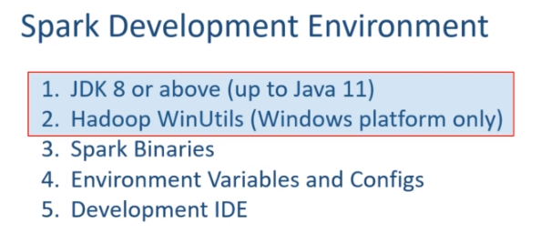

The first step is to install JDK and Hadoop WinUtils. If you are on Linux or Mac platform, Hadoop WinUtils is not required. However, if you are on the Windows machine, then you must install the Hadoop WinUtils. The second step is to install Spark binaries and configure some necessary environment variables. This second step is mandatory if you are planning to use Python language for Spark programming. However, if you are using Java or Scala language, this second step is optional. The third and final step is to set up your development IDE. I will be using PyCharm IDE in this course. You can download the community version of the IDE and use it for free. If you are not familiar with the IDE, nothing to worry, I will be helping you with the IDE throughout the course. We also have a bunch of other ways to get access to the Spark. Some of them are listed here. However, I will not talk about these and assuming that you learned these things in your Spark fundamentals.

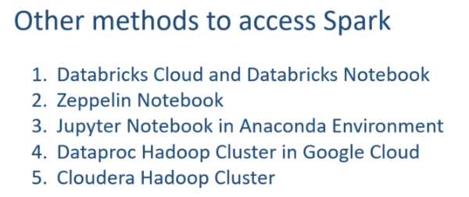

**Setup**

Apache Spark runs on a JVM, and developing Spark application requires Java Development Kit. Spark 3.0.0 runs on Java 8 and Java 11. If you are using Java 8, then it must be JDK 1.8u92 or above. If you already have JAVA installed on your machine, you can skip the Java installation. And you can check the JAVA on your machine using the java -version command. Start the command window and run the following java -version command. If you see a similar outcome, you do not have JAVA. However, if you get something like this, then you have JAVA.

|  |  |
| --- | --- |
|  | Make sure you have Java 1.8 update 92 or above. You can also have Java 9, 10, or 11. But Java 12 and above are not yet supported. Let me show you steps to download and install Java 11 on my machine. I am going to set up Java 11. And you can get Open Java from the following URL. Download the file for your platform. I have a windows machine, so I downloaded the 64-bit windows version. Extract your downloaded files somewhere, and it should give you the following folder. Copy this folder and place it at a safe location. I prefer to keep it in Program Files Java folder on my windows machine. Wherever you are placing your JDK-11 folder, that becomes your JAVA_HOME. |

However, this is not going to work until we set the following environment variables. The first environment variable is to set the JAVA_HOME. And your JAVA_HOME is the absolute path of your JDK-11 directory. The second environment variable is the PATH environment variable. You must add the JDK-11\bin folder to your PATH. Let me do it. You can use the command line, but I always feel safer to use the UI for doing this on windows. So, My JAVA_HOME is the absolute path to the JDK-11 directory. Similarly, I will add the absolute path of the JDK-11\bin folder to the path. That's all. JDK installation is complete. However, I want to check if things are working. Start a command window and run the java -version. You should get an output, which is something like this. Make Sense? That's all for the JDK setup.

Hadoop WinUtils

The next thing is to set up the Hadoop WinUtils. However, if you are using Linux or Mac machine, you do not need the Hadoop WinUtils. I am using a windows machine, so I also need Hadoop WinUtils. Let's do it. You can download the winutils from the following URL. Once downloaded, extract it. You will see a bunch of versions. However, I am going to use Hadoop 2.7.7. So, I will copy the bin folder of the Hadoop 2.7.7 and place it at another safe location. Here is my safe location. So, this hadoop27 directory becomes my HADOOP_HOME. Let me set the HADOOP_HOME environment variable also. You should also add the Hadoop's bin directory to the PATH environment variable. That's all. We are done with the winutils. Let me check it once. Start the command window and run the echo command. And you should see the value. Make Sense? Great! So we are done with step 1.

**Apache Spark Installation**

We talked about the three steps of setting up your Spark development environment and also finished implementing the first step. In this video, we are going to complete the second step. The second step is needed if you are using Python language for Spark programming.

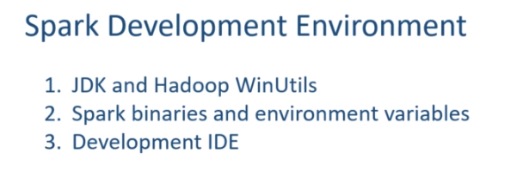

However, if you are using Java or Scala, this step is not mandatory. But it is always good to have this done. So, let's start. The first thing is to get the Spark Binaries. You can download the Spark binaries from spark.apache.org. Click the download link, and it will take you to the download page. Here we are. You can download the Spark selecting two things. Spark Version and Package Type I am interested in the Spark 3.0, so I am going to download the Spark 3 binaries. And you can see the package type here. This Hadoop version should match with your Hadoop WinUtils. I am going to download it for Hadoop 2.7, and that is why I took the Hadoop 2.7 for my winutils. Make Sense?

Let's download the binaries. Here it is. Now, I am going to Un-compress the downloaded file, and you should get a tar file. Now you need to extract the tar file, and you should get a Spark 3.0 directory. Let me rename it as Spark3. This renaming is not necessary, but I feel convenient with small directory names. The download folder is not the right place to keep the Spark binaries. So, I am going to copy this and place it to a safer location. Here it is. Good. Now let's look into the content of the directory. The bin folder is the place where all your Spark command-line tools are included. You will see two versions of every command. The first one is a shell script,ย and the other one is a CMD file. I will be using windows laptop, so I am going to use the cmd files. However, you can use shell scripts on Linux and Mac machines in the same manner. There are other directories as well. But let's not worry about them at this stage. Great! The first part of installing Spark binaries are over.

Before you start using Apache Spark, you must set some environment variables and modify some configuration files. Here is the list. Let's do it one by one.

|  |  |
| --- | --- |
|  | The first thing is to set the **SPARK_HOME**. What is my Spark Home? The absolute path of the spark3 folder. Right? Let me set the SPARK_HOME. Done. I also want to add the bin folder of the spark home to my PATH. Let me do it. Great. I am done with the first item. Let's do the next one. If you are using Python, then you must provide your python installation details to Spark. Spark binaries do not include Python. So, you should have already installed Python on your machine and configure the PYSPARK_PYTHON environment variable to establish the relation. |

I installed the Anaconda platform on my system. You can also get Anaconda from the following URL and install it. I recommend using Anaconda. However, you can have any other Python distribution, but make sure you have Python 3.7 or above. Some older versions of Python are also supported, but the recommendation is to use Python 3.7 or above. Once you have Python installation, you need to find the python.exe on your machine. I am using Anaconda. So, let me try finding my python.exe. Search for Anaconda and open the file location. Here is the shortcut. But this is not what I am looking for. Let me go to my user directory. . Here is my Anaconda3 home I will get inside and here it is. So this directory location \ python becomes my PYSPARK_PYTHON. Let me copy it and set the environment variable. Done. We are done with the second environment variable as well. Let's move on to the third one.

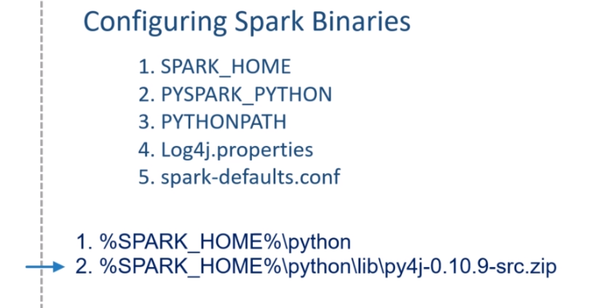

The PYTHONPATH is an environment variable which you can set to add additional directories where Python will look for modules and packages. So, this variable should point to the following things. The first one is the Python directory in your Spark home. Let me show you. Here it is. The second one is the py4j source bundle. And this is found in your Spark-home-python-lib. Let me show this as well. Here it is. Both of these should be added to your PYTHONPATH environment variable.

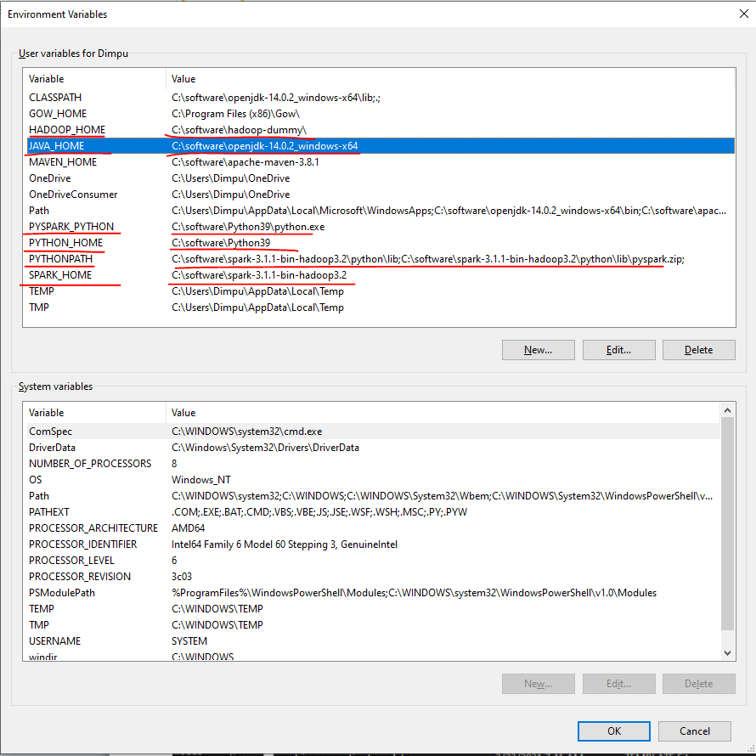

Path setting is as below

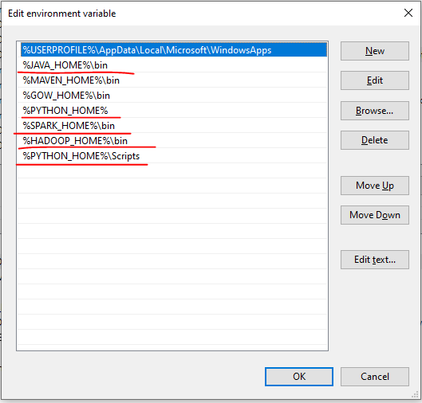

Let me do it. Great! We fulfilled the third requirement. The next one is the log4j properties. Spark gives you a template for the log4j. You will find it in the spark-home-conf directory. Here it is.

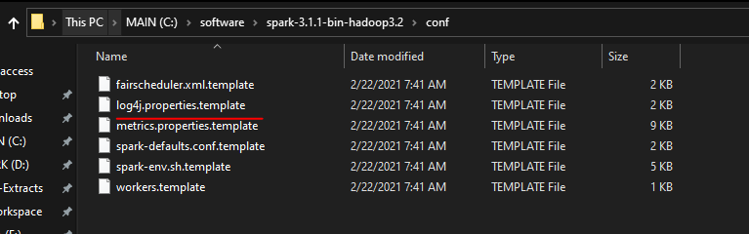

All we need to do is to rename it and remove the dot-template extension. The default file is good enough. However, I recommend making a small change. Open the file and change the root level to WARN.

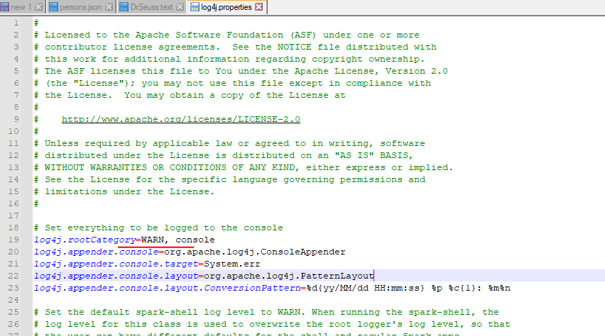

This small change will disable the INFO messages and show you only Warnings and Errors. Save the file, and you are done. The next one is spark-defaults.conf.

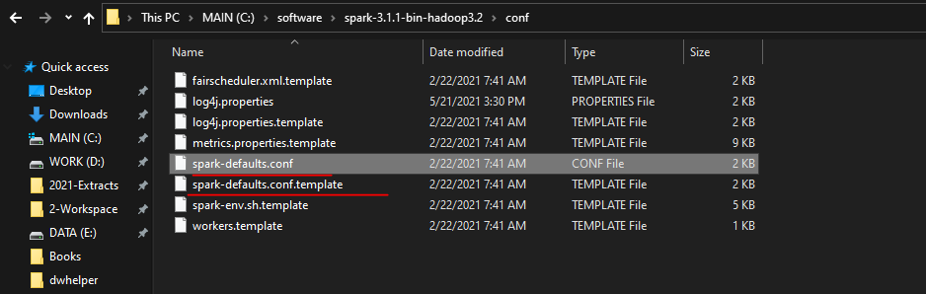

I am not going to make any changes to this file at this stage. However, we will be using it in the following lectures. However, at this stage, let's rename this file to remove the dot-template extension. That's all. We are done. Now its time to test the setup. Start the command window, and you can run the spark-shell command line. Spark-shell should start smoothly.

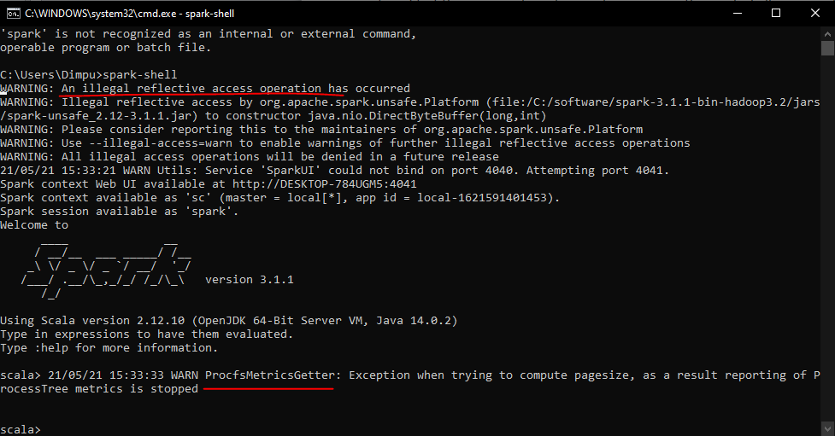

You might see some warnings about the illegal reflective access. This comes if you are using Java 9 or above. However, nothing to worry much, and you can ignore this warning. You might also see the ProcfsMetricsGetter throwing a warning. Just press the enter key, and you can ignore this one too. So we started spark-shell, and that one is your Scala REPL. Similarly, you can also start pyspark. Go to the command line and type the pyspark.

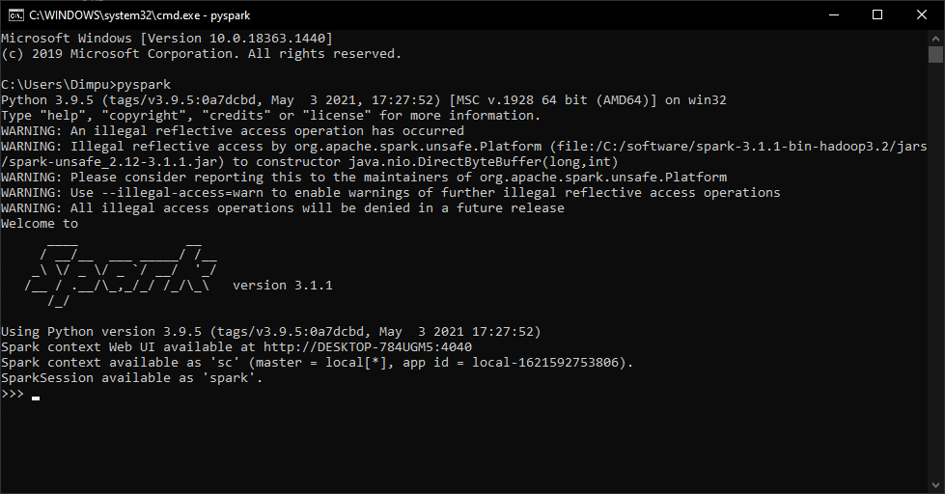

**PySpark Setup**

We talked about the three steps of setting up your Spark development environment and also finished implementing the first two-step. In this lecture, we are going to do the third step. I am going to help you configure and use PyCharm as your Spark development IDE. So, let's start. I will use the PyCharm Community edition and assume that you already have PyCharm Idea installed on your machine. However, if you do not have it, you can get it from the given URL. We will be using Python as our Spark programming language. And I already recommended Anaconda distribution, so I am assuming that you also have Anaconda pre-installed on your system. If you have Anaconda and PyCharm installed on your machine, you can use PyCharm for Spark development. No unique setup is required. You can straightaway start using it. Let me show you an example to make sure that we can run and test Spark Programs using PyCharm. We will learn to create new programs. But for now, let's use an example and test it. All examples and source code of this course is available in a public GitHub repository. You can access it using the following URL.

Github Repo: <https://github.com/LearningJournal/Spark-Streaming-In-Python>

<https://github.com/LearningJournal/Spark-Streaming-In-Python/archive/refs/heads/master.zip>

Let me download the example source code. This is going to give you a zip file. Uncompress it and keep it at a safe place. I am keeping it here. Great! Start your PyCharm IDE. Now, we will open the Hello Spark SQL project. Your IDE should automatically configure a virtual environment for your example project using the latest version of Python found on your machine. However, all the examples in this course are using Python 3.7, so you need to make sure that your IDE is also picking up Python 3.7. You can change it. Go to the File menu and click settings. Look for your project name and select a project interpreter. Your project interpreter should show Python 3.7.

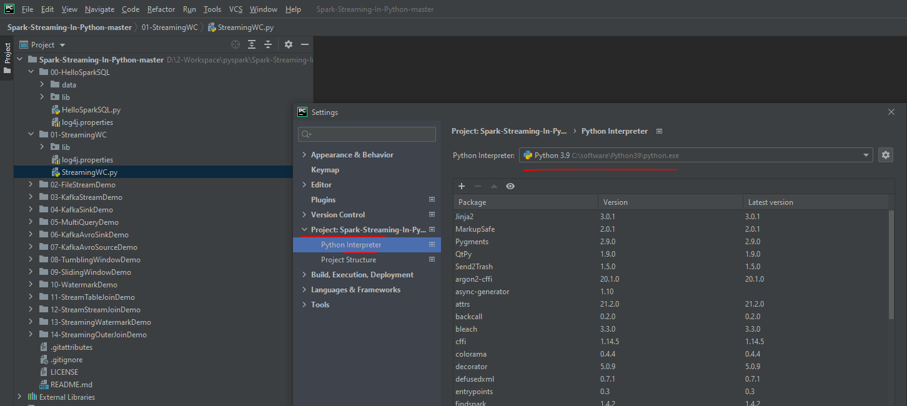

If not, click the settings button and select Add. I am using Conda virtual environment. Change the name of your environment. I am giving a name as PySpark3. However, you can use whatever name you want. Python version should be 3.7. And make it available to all projects. We will be using this same environment for all the projects. Click OK, and the PyCharm will create a Conda based virtual environment for you. You also need to add PySpark package to your Virtual Environment. So, let me add it. t. Search for PySpark and Install it That's all. Done. Great! The first Spark example is loaded in your IDE. Now we want to run it once. Let me run it. Here is the output. If you see these lines, you are done with the IDE setup. This example is not a Stream Processing Example. However, you are running Apache Spark Example from the IDE and you are all set to run the Spark Stream processing applications as well. We will learn to create and run Stream Processing examples in the following sections. One last thing. You can safely ignore these warnings. They will keep coming as long as you are using Java 9 or above. I expect the Spark community to fix this problem, but they seem to be ignoring it.

**Kafka Setup**

We learned to install and set up the Spark development environment on our local machines. However, Stream processing in Apache Spark often works with Apache Kafka. Apache Kafka is the most popular real-time data integration system, and Spark often reads data in real-time from a Kafka server. So, you may also need to set up Kafka Server on your machine. In this video, I will help you set up a single node Kafka cluster on your local machine. I will also take it further and run a command line producer and consumer tools to test your Kafka installation. So, let's start. The first thing is to download the Kafka binaries. So, go to the Apache Kafka website. Hit the download button.

We are looking for a binary download. You can get any of these versions, but let's take the which is build with Scala 2.12. Our Spark is also built for Scala 2.12, so keeping Spark and Kafka both to the save Scala version might be a good option. Hit the link, and your download should start. Here is my download. Let me uncompress it. I got a tar file. Let me extract this one also. Here is the Kafka directory. Let me rename it. Then I copy it to a safer location. Here it is. Now let's look inside the folder. You should see the following directory structure. We have a bunch of directories here, but you will be using two of these directories. The first one is the bin directory. Let me show you. The bin directory comes with a bunch of Kafka command-line tools. All of these are shell scripts. However, I am working on a windows machine, and these shell scripts are not going to run on my windows laptop.

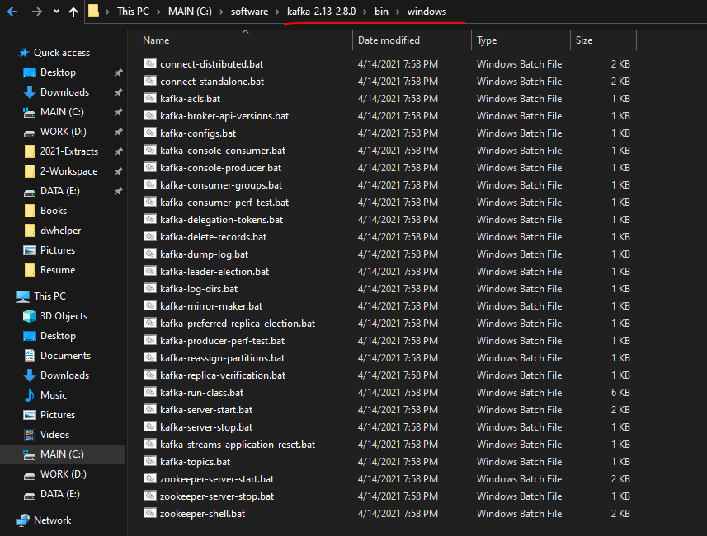

Kafka also gives you the same tools for windows. And you can find them in the windows directory. If you are on Windows machine like me, you will be using these batch files to run and use Kafka. However, if you are using a Linux or a Mac machine, then you should be using the shell script.

We will come back and run some of these tools in a minute. Let's go to the Kafka home directory. You also have a Config directory. The config directory also comes with a bunch of config files. However, we are going to use only two of these. zookeeper.properties and server.properties.

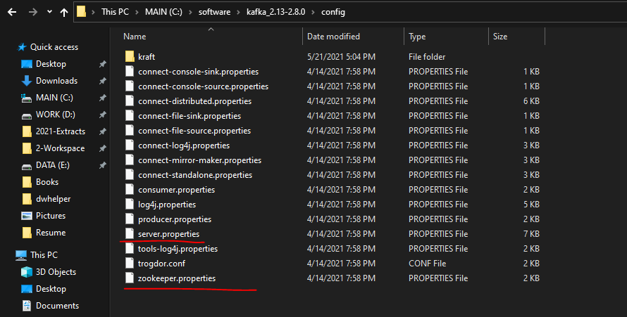

The zookeeper.properties file is used by the zookeeper server, and the server-properties file is used by the Kafka broker. These files come with a default configuration, and it should work out of the box. However, I want to make some changes to these files. Let's do it for the zookeeper.properties. Open the zookeeper configuration file. It is a small file. You will see a configuration for the data directory.

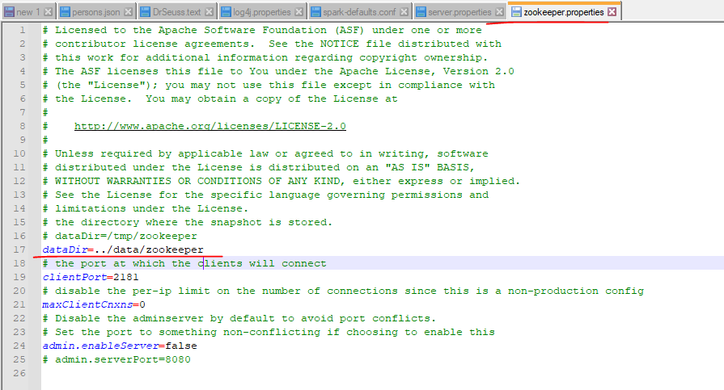

This configuration sets the zookeeper data file location. The current value looks fine, but I want to change it to something like this. Now, when I am starting the zookeeper server, it will create the Kafka-logs folder in my current directory and then a zookeeper folder inside it. All the zookeeper data will be saved in the Kafka-logs\zookeeper directory. That's all I wanted to change. Save it and done. Now we will modify the server.properties file. This one is a bigger file, and most of the default values are good enough to start a Kafka server on a local machine. However, I want to make some changes.



The first change is to uncomment the listener's port configuration. This is an optional change. You can even leave it commented, and the default port is always 9092. However, I wanted to uncomment it.

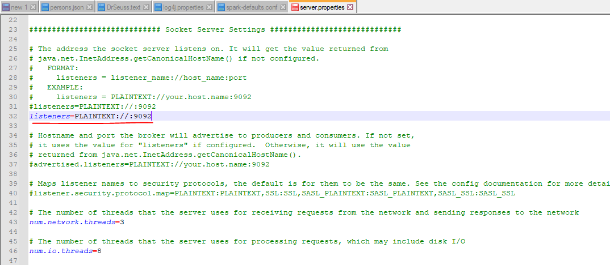

Rest all remains the same, and we scroll down to the log.dirs configuration. This configuration sets the Kafka data directory. Same as Zookeeper, I want to change this one also and make it something like this. So my Kafka data directory and the zookeeper data directory parent is the same, but they use a different subdirectory. Right? That's all. We do not want to change anything else. So basically, we wanted to change the data directories for Zookeeper and Kafka. Rest all remains as the default value.

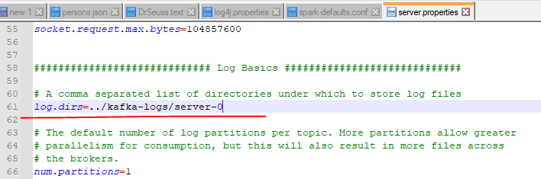

Now we are all set. We can start working with Kafka. However, it is always good to set the KAFKA_HOME environment variable and then add the bin folder to your PATH. So, let me do it. I am going to set my KAFKA_HOME. What is the home directory? The absolute path of my Kafka directory. Right? The next thing is to add the Kafka binary to my path. Let me do that as well. I am going to add the absolute path of my Kafka bin directory. Wait a minute. I am on windows. Right? So it should be bin\windows directory. If you are on Linux or Mac machine, you should add the bin directory to your path. But windows users will be using the batch files which are there in the windows directory. That's all. We are all set. Let me test it once. I am going to follow Kafka Quickstart from the Kafka documentation. Here it is. .

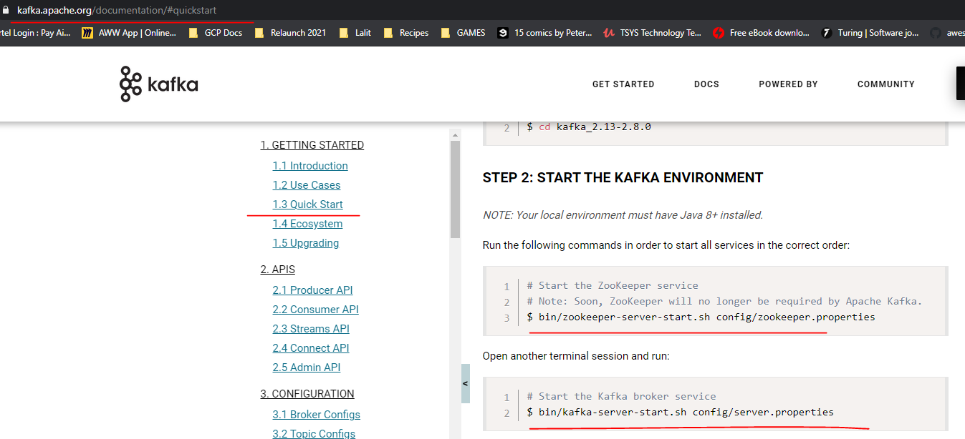

Starting Kafka is a two-step process Start the Zookeeper and Start the Kafka broker. Here is the command to start the Zookeeper. Let me copy it and paste it in the command window. I am not going to use the .sh files. So, let me replace it with the .bat. So, I am using the zookeeper-server-start.bat command to start the Zookeeper. This command takes Zookeeper.properties file. So, I must tell the Path for the Zookeeper.properties file. What is the Path? %KAFKA_HOME%/config Correct? You can use the environment variable, or you can give the absolute path. It should work both ways. Let me run it. Good. Do you see this message? Binding to port 2181. So your Zookeeper is now started. Minimize this window and leave the Zookeeper running. Let's move on to the next step. The next step is to start the Kafka server. Here is the command. I will modify this one also. So, I am replacing the .sh with the .bat. Then I am changing it to the absolute path. Now It should work. Right? Let's see. Great! Do you see this message? [KafkaServer id=0] started So your Kafka server is also started. Minimize this window also and let Kafka running. We are almost done. However, I want to start a producer and a consumer to test if things are working fine. Now let's start two more terminal windows. I am going to use the first terminal to create a Kafka topic and start a consumer.

**zookeeper started**

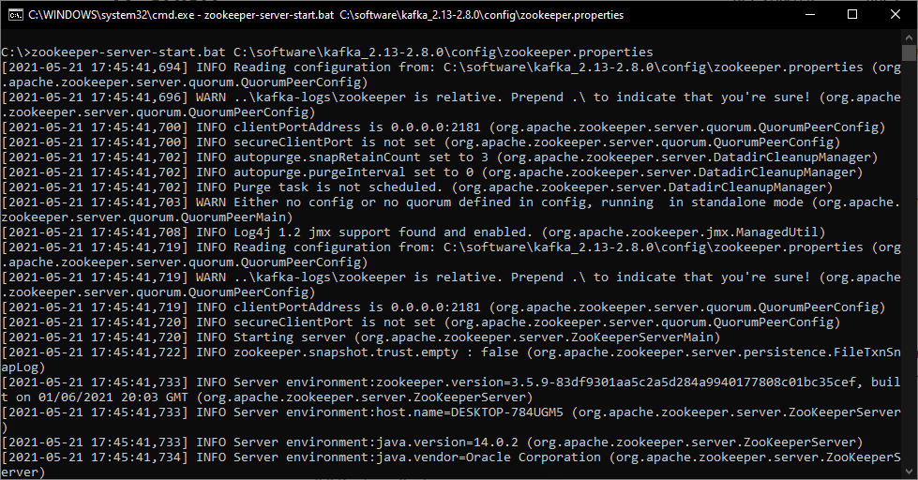

**Kafka server started**

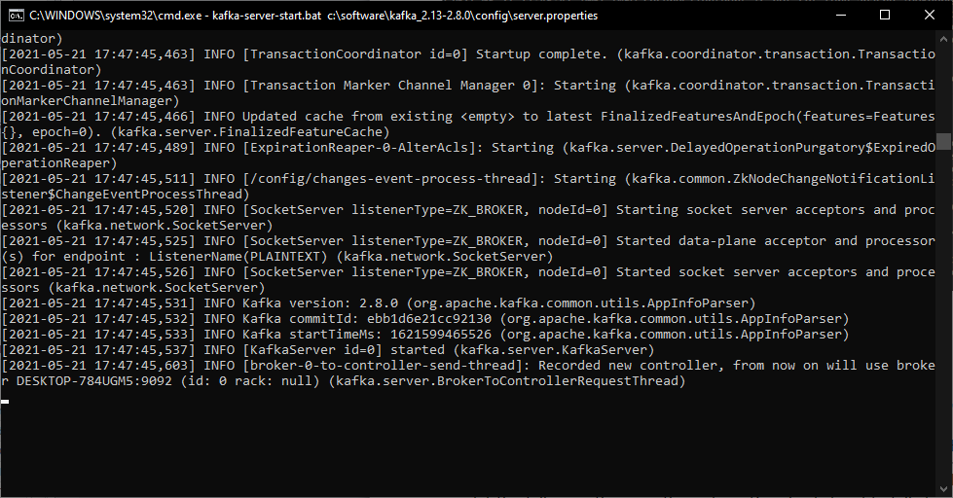

Here is the command to create a Kafka topic. Let me change this .sh to .bat and run it. Topic created.

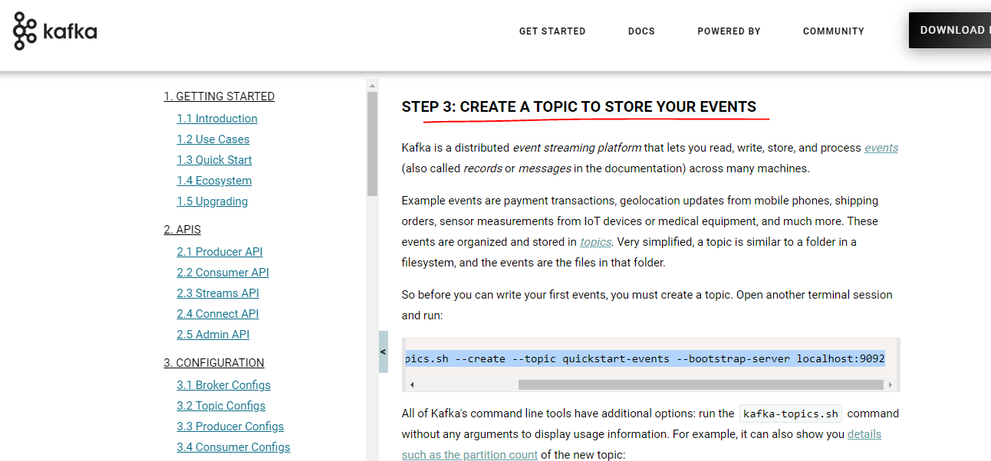

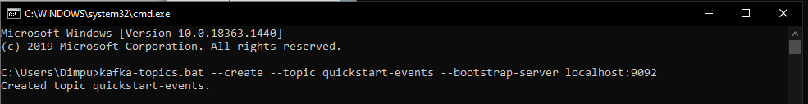

Now, let's start a consumer. Here is the command to start a consumer.

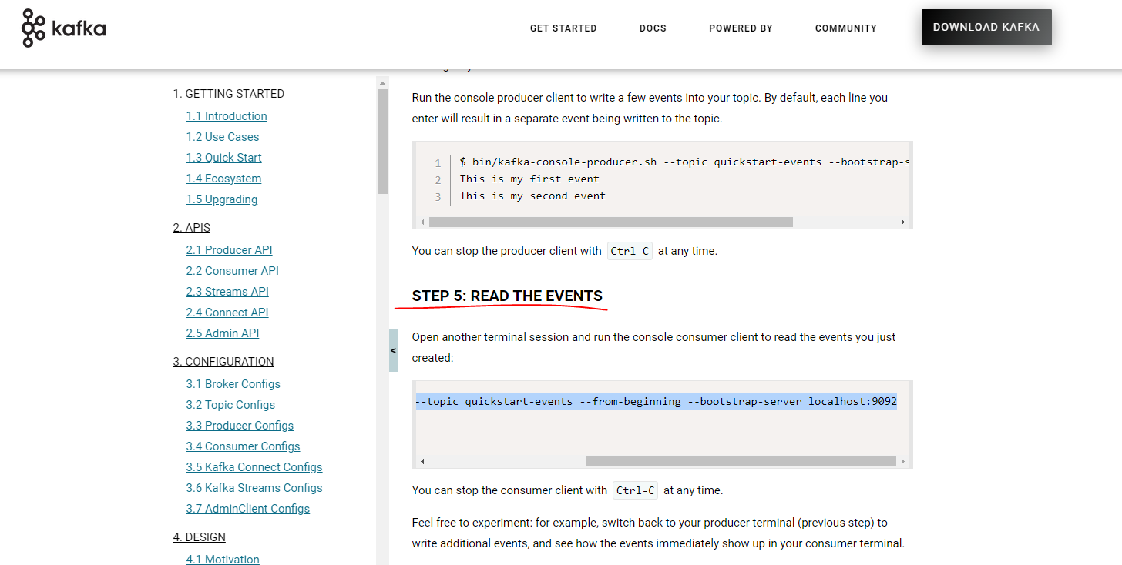

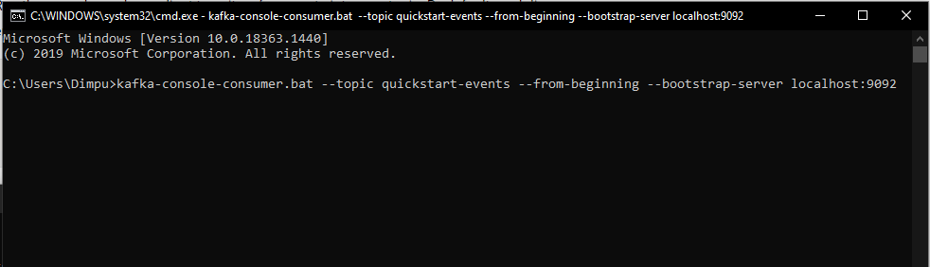

Change the .sh to .bat and run it. We do not see any outcome here. But the consumer is running and listening to the Kafka topic. Let's come to the next window. We will start a producer here. Let me copy the command for starting a producer. Same here also. Change it to .bat and run it. Now the producer is running. So, let me send some text messages from the producer. And it should come here. Looks good. Right? That's all.

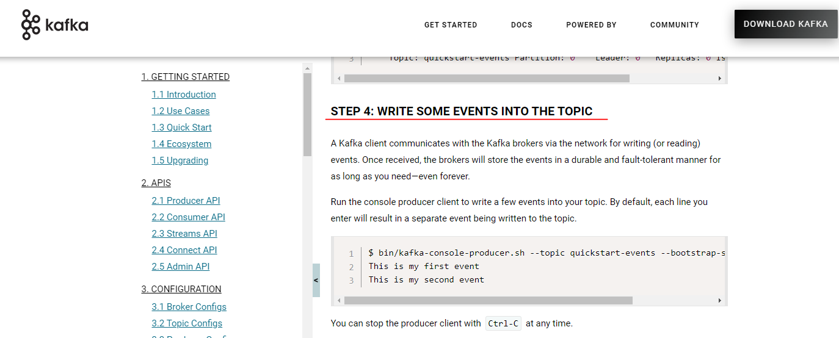

Start the Consumer

$ kafka-console-consumer.bat --topic quickstart-events --from-beginning

--bootstrap-server localhost:9092

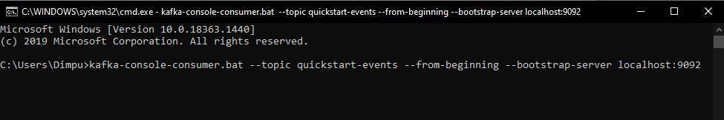

Start the Producer

$ kafka-console-producer.bat --topic quickstart-events --bootstrap-server localhost:9092

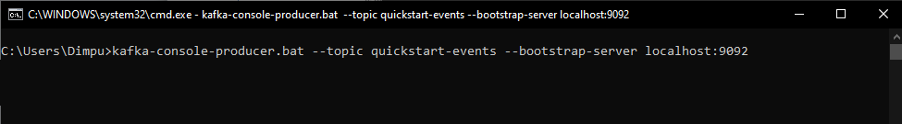

Publish messages now

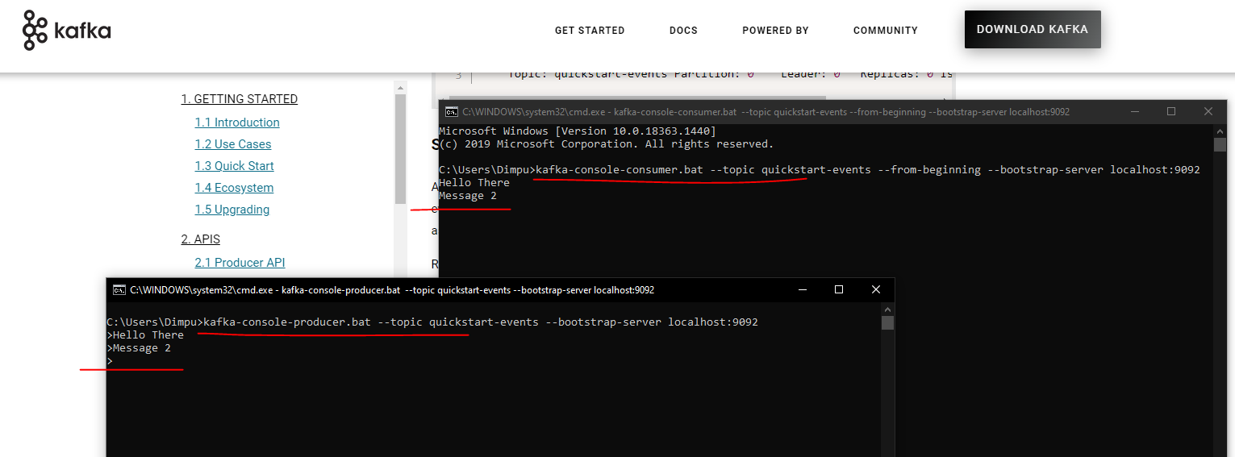

|  |  |
| --- | --- |
|  | So we did the following things in this video. Downloaded and Installed a single node Kafka Server. Setup the KAFKA_HOME environment variable and add the Kafka binary tools to the Path environment variable. Started Zookeeper and then started Kafka Server. We created a Kafka topic. We started a command-line Consumer and a Producer And Finally, we tested producer/consumer interaction. That's all. You are now all set to start learning Spark Stream processing. |

### Spark Structured Streaming

**Stream Processing**

Big data processing has a long history of collecting humongous volumes of data and process it in smaller and regular batches using distributed computing frameworks such as Apache Spark. However, the business started demanding more and more frequent batches. In many cases, these expectations started reaching to produce results in a few minutes and even a few seconds. However, producing some results every minute or second is not an easy goal.

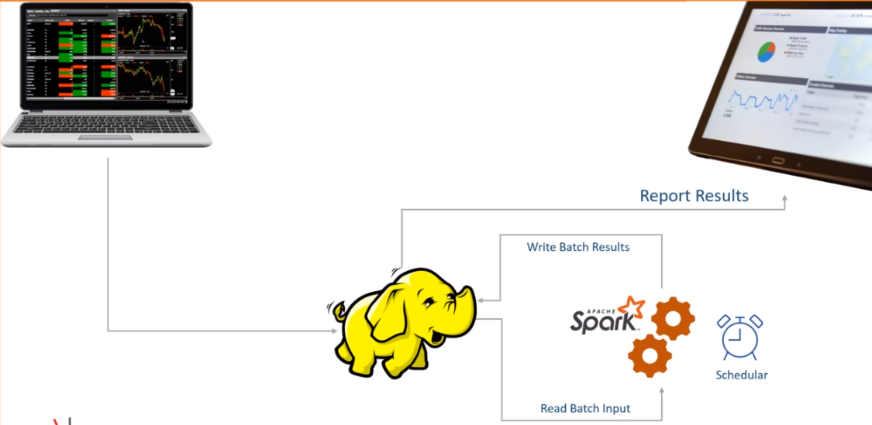

Let's assume you are a stockbroking house. You have trading terminals across the country. Your customers and your employees are buying and selling stocks from those terminals for the entire day. These trades are continuously producing transaction records with the following information. Your trade starts at 9.15 AM, and it ends at 3.30 PM. You are a big company, and your offices are generating millions of transactions in every 15 minutes. However, you have an excellent infrastructure design in place, and you manage to bring these millions of records to your Data Lake in less than 15 minutes. What does it mean? It means each transaction takes less than 15 minutes to travel from the terminal to your data lake. Now the business is asking you to produce the following report, which refreshes every 15 minutes. The X-axis is the time, and the Y-axis is the amount in thousands. The blue line is the cumulative BUY.

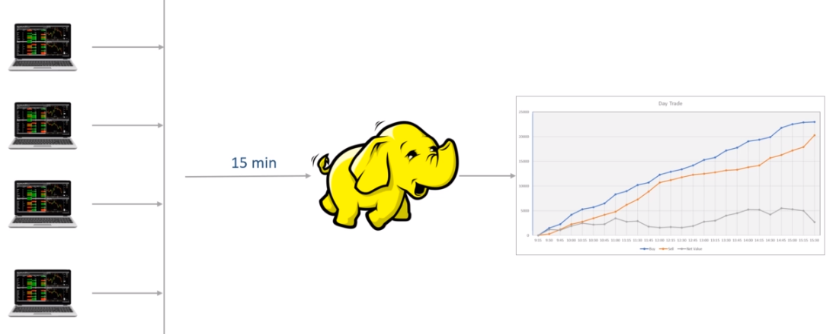

So it started with zero at 9:15, but the total BUY reached a little over 5 million by 10:15. Similarly, the orange line is for the SELL, and the gray line shows the net value that goes for settlement. By the end of the trading session, you have roughly more than 2.5 million in settlements. Now you are expected to create a Spark application that simply computes the total SELL and BUY every 15 minutes. How are you going to do it? Think about it. Let me give you some hint. You already have a data ingestion pipeline, which is expected to create a data file every 15 minutes in a distributed storage. So, let's assume you have the following directory. Your data ingestion job is supposed to create one data file at 9:30. This file should contain all the transactions performed between 9:15-9:30. You will get another file at 9:45. This file should contain all the records generated between 9:30-9:45. And this file creation must go on until 3:30 PM. You keep getting one new file every 15 minutes. And this is the ideal case expectation, which is almost impossible to achieve. I will come to the point of why creating a file every 15 minutes is not practically possible. But let's assume that we achieved it. You are getting a file every 15 minutes. Now you are supposed to compute these three points every 15 minutes. How will you do it? Think about it? First thing first, You will create a Spark application to do this and schedule it to start every 15 minutes. Right? And the application is going to compute these three numbers.

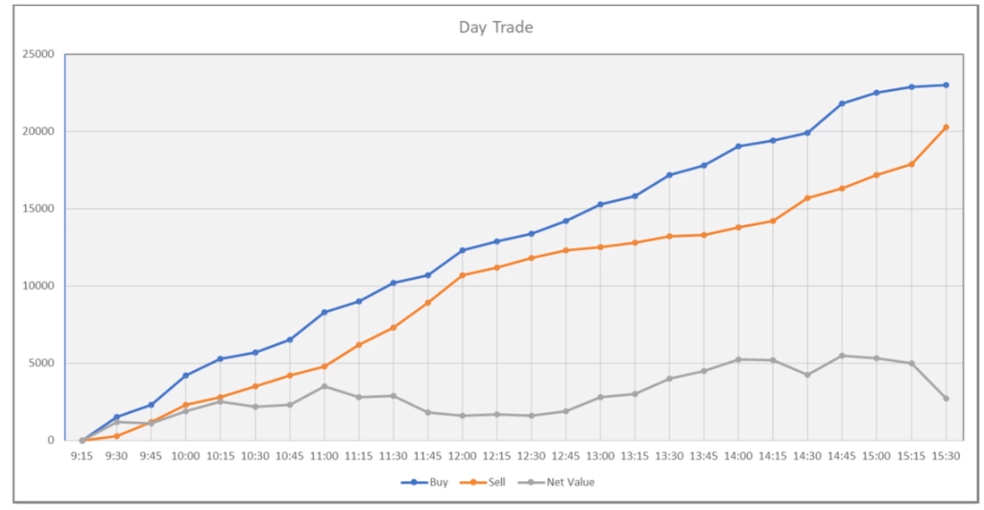

Computing these numbers can be done in two ways. Read and process all Read and process incrementally The first option is to read all the data in this directory. Compute these three sums. So, at 9:15, you will read only one file and correctly compute the sum. Right? When your job again starts at 9:30, you will have two files. So you will read both the files and compute the correct results for 9:30. And this goes on every 15 minutes. Make Sense?

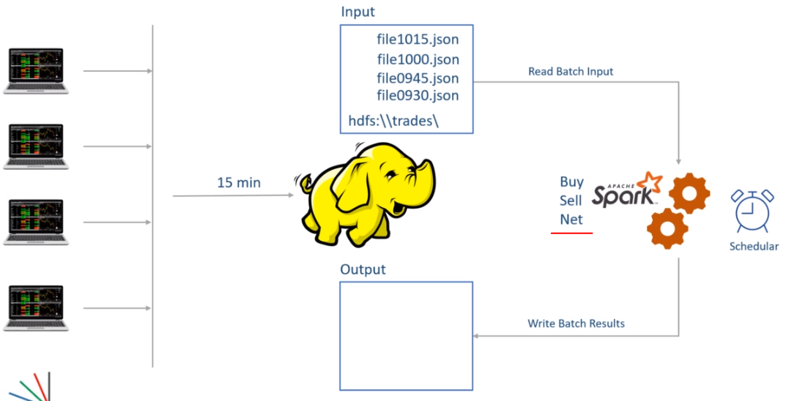

I know you already started identifying a bunch of gotchas in this approach. What about the performance? Every 15 minutes, I am processing more and more data. After three hours, I will be reading 12 files. Right? My jobs are not going to finish in 15 minutes. This approach might not work. Nothing to worry. We have a second approach. In this approach, I will be reading only one file. So, I will start at 9:30, read the first file, compute the sums, and keep it somewhere. I will again begin at 9:45, read the second file, calculate the sum, add it to the previous sum, and keep the new value. And this goes on every 15 minutes. Right? So, in this approach, I am only processing the sum for the most recent file. Then I am adding it to the sum for the earlier files to get the cumulative value. Right? This all looks perfect. However, you may have to do some housekeeping activities. I mean, let's assume you started at 9.30 and finished the first batch. You again started at 9:45. But now, you have some questions to answer. How many files do I have in the given directory? Which one I processed last time, and which one is new? What if the new file is not yet written? Should I wait or terminate for another 15 minutes? What if the current batch fails for some reason? How would I know where to start again? What if the previous batch is still running? Should I start or wait until the last batch finishes? These are some failure cases that you must handle in a production-grade application. Some of these problems are not unique for smaller batches. They already existed in longer batches as well.

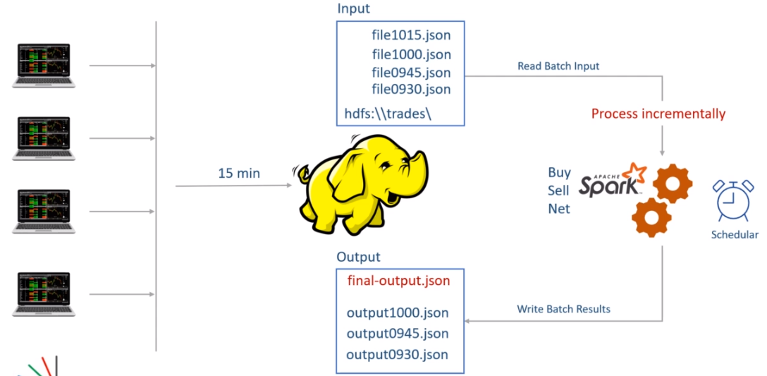

For example, even if you are running a batch job once a day, you still need to know which file you processed yesterday and which one you want to process in today's batch. But such problems were a little easier to handle for daily or hourly batches. However, you should also realize that all these failure cases are common problems that every application should handle. Don't we have these facilities in the Spark framework itself? Why Spark cannot give a solution to such problems. Well, Spark gives an answer to all these problems. And that's what this course will teach you.

However, I want to highlight another problem specific to the smaller batches, and we ignored it in the earlier discussion. I made an assumption earlier that your data collection job is going to create a file every fifteen minute. Right? So, the file0930.json file is created at 9:30. And this file is assumed to have all the transactions that are created between 9:15-9:30. Right? However, this is almost impossible? Why? Because the transaction is created at the trading terminal. We must transport the transaction from the terminal to the Data Lake. Right?

We made one assumption that we have excellent infrastructure, and each transaction reaches to the Data Lake in less than 15 minutes. So, a transaction created at 9:29 will can reach to data lake by 9:44. However, the data collection job is creating the first data file at 9.30. So, the record generated at 9:29 will not make a place in the first file. It can only get into the second file. What does it mean? Simple. The sums that we calculate using the first file are incorrect. They do not have all the records which are generated between 9.15-9.30. Some records are arriving late. If you start considering these late record scenario, you will realize that each file will have some records for the current interval and some other records from the previous interval. So, it is almost impossible to create the correct file for 15 minutes of duration. How do you handle these late-arriving records?

The point is straight. Stream processing is not a subset of the batch processing problem. It is a bigger problem than batch processing. You still have the batch processing problems which you must solve. And the stream processing poses a bunch of new difficulties for you to handle. In fact, a batch processing is a subset of the stream processing. And that's how Spark implements stream processing as a superset of batch processing. I mean, Spark extends the batch processing Dataframe APIs to solve the Stream processing problems. We will start learning those techniques from the next video. However, let me summarize the main takeaway of this video. Stream Processing is a superset of batch processing techniques.

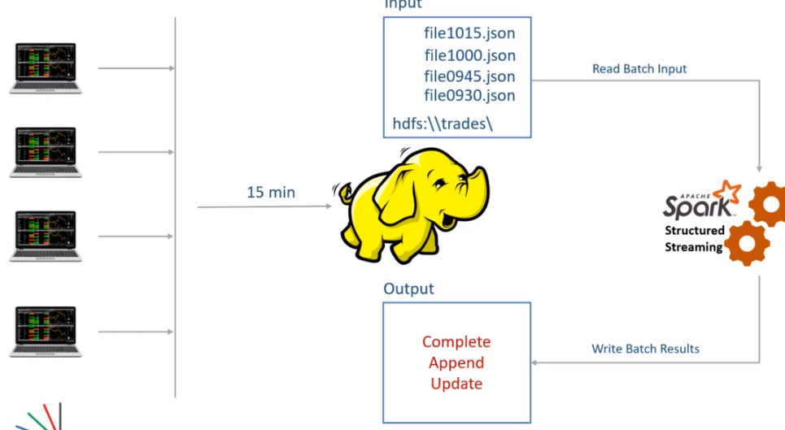

Many of the batch processing problems are also addressed by the stream processing solutions. For example Stream processing job can take care of the scheduling requirements of your batch job. It can handle job failures and restart again from the same point where it failed. Streaming jobs can maintain intermediate results and combine the results of previous batches to the current batch. They can also track if the previous batch is still running and wait for the completion before a new batch starts. Other than these, stream processing also offers you a bunch of facilities to solve unique streaming problems. I already talked about the late arrival of the records. We will learn some other problems and their solutions as we progress with the course. And finally, Spark Stream processing is an extension of Spark Dataframe APIs. So, the learning curve is a lot simpler for those who already learned Spark Dataframe.

**DStream vs Structured Streaming**

In the earlier lecture, I gave you an initial sense of stream processing. I hope you realized the fact that the notion of stream processing starts with the idea of reducing the duration between the batches. One natural approach to achieve stream processing is to reduce the batch size to a few seconds. However, that's not an easy goal. Why? Because smaller batches will exaggerate a bunch of existing problems. Other than those problems, a stream processing requirement will need some additional facilities as well. In fact, Spark also took the same approach to start offering stream processing.

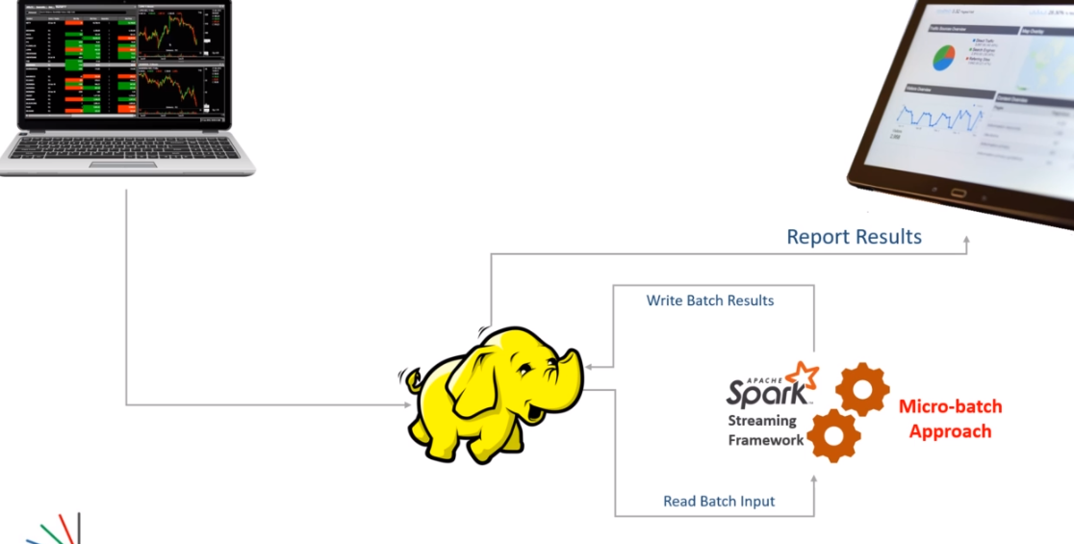

Spark introduced the idea of micro-batch stream processing. In this approach, we collect data for a short duration and then process it as a micro-batch. Then we loop again and process the next batch. So Spark also takes the same approach of reducing the batch duration. But to simplify our life and address other problems, Spark Streaming API takes care of the following. Automatic looping between the batches. Maintaining the batch start and end positions. Storing and managing intermediate state. Combining results to the previous batch results. Restarting from the same place in case of failure. In the beginning, Spark offered all this and many other features using Spark Streaming APIs that are also known as Spark DStream APIs.

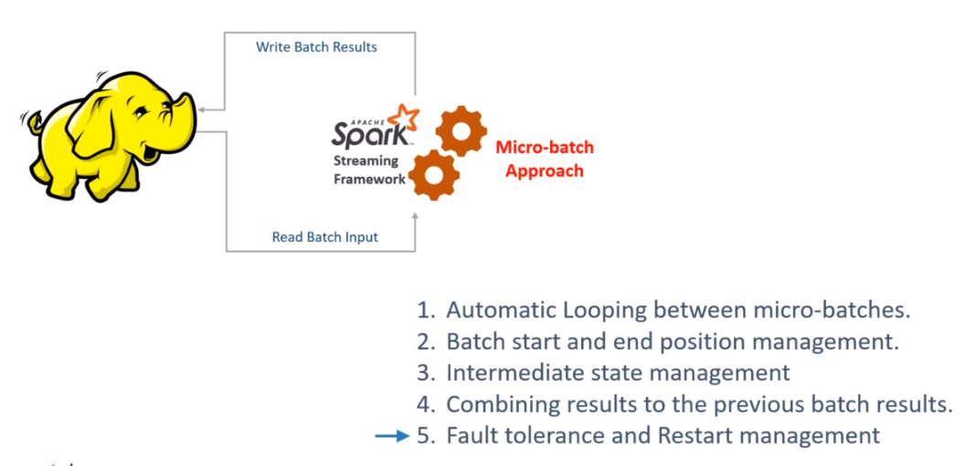

These DStream APIs were built on top of Spark RDD APIs. However, over a while, Spark evolved, and the DSTream APIs were left behind with the following limitations. Spark moved to Dataframe APIs, and RDD APIs are now not recommended for use. The DStream APIs were based on RDD APIs, and the Spark project wanted to migrate to the latest Dataframe APIs. DStream APIs were directly based on RDD APIs, so they could not take advantage of Spark SQL Engine and its optimations. DStream APIs only supported processing time schematics, and they did not have native support for the event time semantics. You might not understand this point for now, but nothing to worry about. I will talk more about the time schematics in the following lecture.

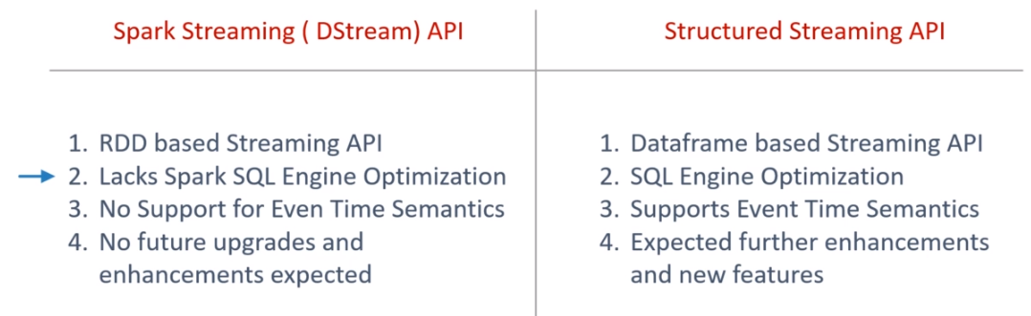

For these three main disadvantages, the Spark project decided to retire the DStream APIs and recreated a brand new Stream Processing API set built on top of the Spark Dataframe APIs. The new API is now known as Spark Structured Streaming API.

They are designed to offer the following advantages over the DStream. Structured streaming offers a unified model for batch and stream processing. That means you can use the same Dataframe transformations or even Spark SQL for solving your stream processing problems. Structured streaming runs over the Spark SQL engine, and hence, it can automatically take advantage of SQL optimizations. The new API also has native support for even time schematics. Spark RDD APIs, DStream APIs, and even the Spark ML/Lib based on RDD APIs are now being deprecated. Everything in Spark is upgraded to follow the unified structure offered by Dataframe APIs and the Spark SQL engine. In this course, we will focus on the modern Structured Streaming APIs, and we will not even talk about the outdated DStream APIs.

**First Spark Streaming Application**

Structured Streaming is a scalable and fault-tolerant stream processing engine built on the Spark SQL engine. You can express your streaming computation the same way you would express a batch computation on static data. The Spark SQL engine will take care of running it incrementally and continuously and updating the final result as streaming data continues to arrive. You can use the Dataset/DataFrame API in Scala, Java, Python or R to express streaming aggregations, event-time windows, stream-to-batch joins, etc. The computation is executed on the same optimized Spark SQL engine. Finally, the system ensures end-to-end exactly-once fault-tolerance guarantees through checkpointing and Write-Ahead Logs. In short, Structured Streaming provides fast, scalable, fault-tolerant, end-to-end exactly-once stream processing without the user having to reason about streaming.

Internally, by default, Structured Streaming queries are processed using a micro-batch processing engine, which processes data streams as a series of small batch jobs thereby achieving end-to-end latencies as low as 100 milliseconds and exactly-once fault-tolerance guarantees. However, since Spark 2.3, we have introduced a new low-latency processing mode called Continuous Processing, which can achieve end-to-end latencies as low as 1 millisecond with at-least-once guarantees. Without changing the Dataset/DataFrame operations in your queries, you will be able to choose the mode based on your application requirements.

In this guide, we are going to walk you through the programming model and the APIs. We are going to explain the concepts mostly using the default micro-batch processing model, and then later discuss Continuous Processing model. First, let’s start with a simple example of a Structured Streaming query - a streaming word count.

Let’s say you want to maintain a running word count of text data received from a data server listening on a TCP socket. Let’s see how you can express this using Structured Streaming. You can see the full code in Scala/Java/Python/R. And if you download Spark, you can directly run the example. In any case, let’s walk through the example step-by-step and understand how it works. First, we have to import the necessary classes and create a local SparkSession, the starting point of all functionalities related to Spark.

We are going to create our first Spark Streaming application. So, let's start. Let me define the problem, and then I will create the solution for the same. We want to create a streaming word count. In fact, I am going to create the same example that is given in the Spark documentation. You can get the details here. Great! Reading a text stream and counting words is an excellent example to start with. This example might not make a lot of practical use, but it can help you get the first sense of how stream processing works in Apache Spark. So here is the pictorial representation of what we are going to do. We will start a Netcat listener on port 9999. The Netcat will start a TCP/IP socket and listens to the port for incoming connections. Once the connection is established, we can send some text using the Netcat terminal. We will be using Netcat to generate a stream of text that will be sent to a TCP/IP port. On the other side, we will create a Spark-Structured-Streaming application. The application will connect to the TCP/IP port 9999 and start reading the incoming text. After reading the text, we will apply some spark transformations to count the words and print word count to the console. That's all. However, all of this will happen in real-time. As soon as you send the data to the TCP port, the spark application will read it, count words, and print the results to the console. Make sense? Let's do it.

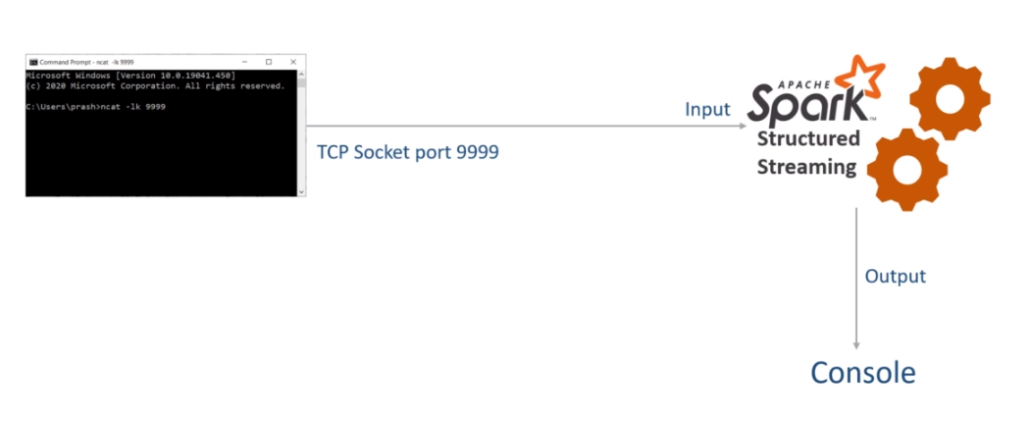

You will need the Netcat tool for creating a listener. If you are on the Linux machine, you can use the NC command. The NC command is included in most of the Linux distributions. However, I am on a windows machine, so I need to download and install something for using Netcat. I downloaded the NMap tool for this purpose. You can get it from the following URL. Download and install it. Once you have the Nmap tool, you can run the Netcat command from the Windows command prompt.

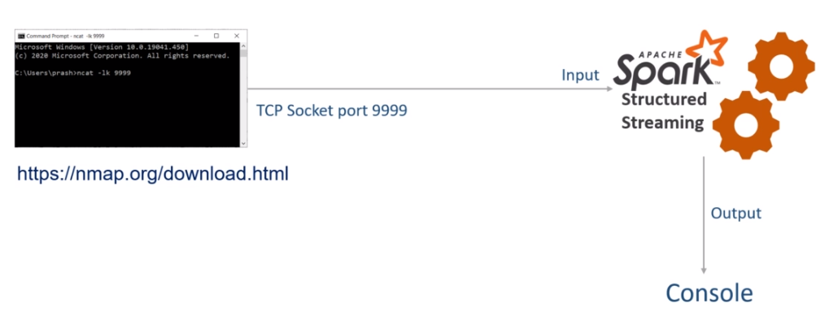

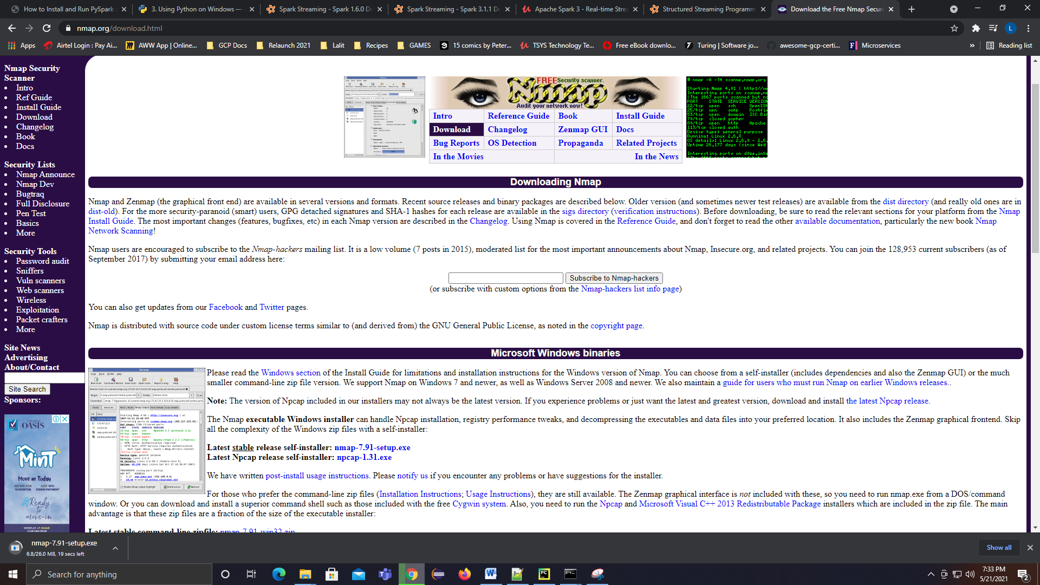

Let me show you. Start the command window or windows Powershell and type the following command. That's all. The listener started. Once you have the connection on the other side, you can type some text and press enter. The text goes to the 9999 port, which your application can read. Let me close it for now, and we will start it again after creating the Spark application.

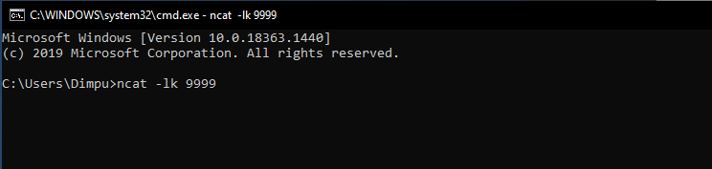

Great! So now, we are ready to create our first Spark Structured Streaming application. Start your IDE and create a new project. Give a name to your project. Expand this interpreter section and select the existing interpreter. Choose the PySpark3 interpreter, which we created in the earlier lecture. Click the create button, and that's all. The IDE will create an empty project for you. This project already comes with PySpark, and you do not need anything else for creating Spark Stream processing applications. However, you might want to configure Spark log4J. You can do it using two steps. The first step is to add the log4j—properties file to your project. I already have one which I am going to paste in this project.

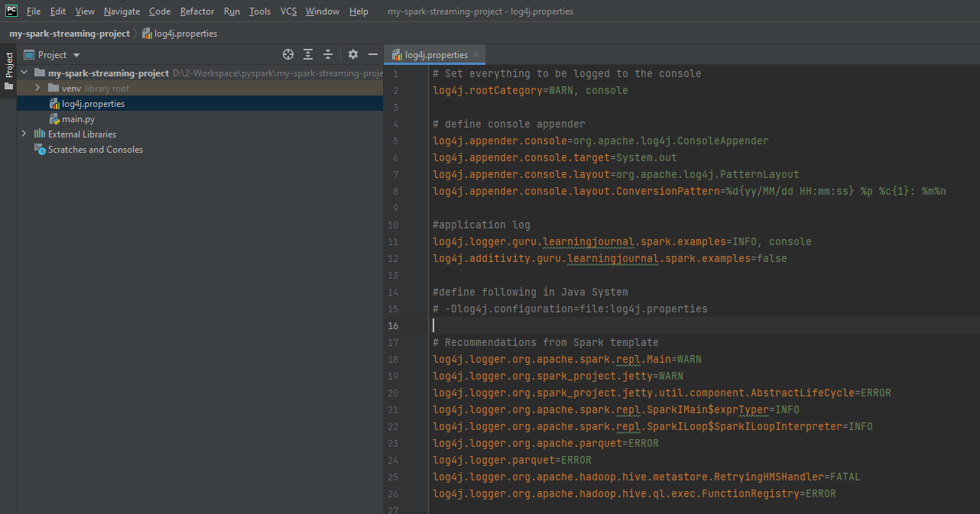

# Set everything to be logged to the console

log4j.rootCategory=WARN, console

# define console appender

log4j.appender.console=org.apache.log4j.ConsoleAppender

log4j.appender.console.target=System.out

log4j.appender.console.layout=org.apache.log4j.PatternLayout

log4j.appender.console.layout.ConversionPattern=%d{yy/MM/dd HH:mm:ss} %p %c{1}: %m%n

#application log

log4j.logger.guru.learningjournal.spark.examples=INFO, console

log4j.additivity.guru.learningjournal.spark.examples=false

#define following in Java System

# -Dlog4j.configuration=file:log4j.properties

# Recommendations from Spark template

log4j.logger.org.apache.spark.repl.Main=WARN

log4j.logger.org.spark_project.jetty=WARN

log4j.logger.org.spark_project.jetty.util.component.AbstractLifeCycle=ERROR

log4j.logger.org.apache.spark.repl.SparkIMain$exprTyper=INFO

log4j.logger.org.apache.spark.repl.SparkILoop$SparkILoopInterpreter=INFO

log4j.logger.org.apache.parquet=ERROR

log4j.logger.parquet=ERROR

log4j.logger.org.apache.hadoop.hive.metastore.RetryingHMSHandler=FATAL

log4j.logger.org.apache.hadoop.hive.ql.exec.FunctionRegistry=ERROR

This file will help you control the log levels for your application, and it is the same log4j configuration that comes as default with the apache spark downloads. However, I made a small change. I changed the root log level to WARN and also added this application logger at the INFO level. That's all. Rest all is the same as the default Spark log4j—properties template.

However, your IDE is not going to pick this log4J configuration, so you must add the given configuration to the spark-default configs. That's the second step to configure your log4J. So, I am going to my spark home. . Then we go to the conf directory and edit the spark-defaults.conf You need to add the following line to your spark-defaults.

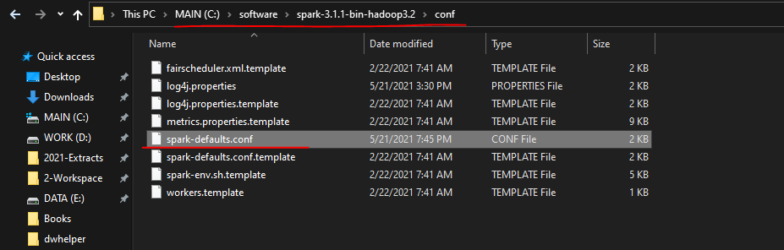

**spark-defaults.conf**

#

# Licensed to the Apache Software Foundation (ASF) under one or more

# contributor license agreements. See the NOTICE file distributed with

# this work for additional information regarding copyright ownership.

# The ASF licenses this file to You under the Apache License, Version 2.0

# (the "License"); you may not use this file except in compliance with

# the License. You may obtain a copy of the License at

#

# http://www.apache.org/licenses/LICENSE-2.0

#

# Unless required by applicable law or agreed to in writing, software

# distributed under the License is distributed on an "AS IS" BASIS,

# WITHOUT WARRANTIES OR CONDITIONS OF ANY KIND, either express or implied.

# See the License for the specific language governing permissions and

# limitations under the License.

#

# Default system properties included when running spark-submit.

# This is useful for setting default environmental settings.

# Example:

# spark.master spark://master:7077

# spark.eventLog.enabled true

# spark.eventLog.dir hdfs://namenode:8021/directory

# spark.serializer org.apache.spark.serializer.KryoSerializer

# spark.driver.memory 5g

# spark.executor.extraJavaOptions -XX:+PrintGCDetails -Dkey=value -Dnumbers="one two three"

spark.driver.extraJavaOptions -Dlog4j.configuration=file:log4j.properties

This line will set the JVM parameter, and your spark application will look for the log4j—properties file in the current directory. Save this file and you are done. We are back to the project. Great! We are now ready to start writing some code. So let me create a python file. A typical Spark application follows a fixed template for the main entry point. Here it is. So, I created the main entry point, and also created a spark session. Now we can use this spark session to read and process the data. Right? You already know all this. If you want to use the Log4j Logger, then you may have to create a Log4J class. I already have one, so let me paste it here. I created this Log4J class, which pulls the logger instance from the JVM. Once you have this class, you can create a logger and use it. Let me show you. You can create a logger like this, and then using this logger will be straightforward. I will show you in a minute. Great. We are all set.

Create a new project

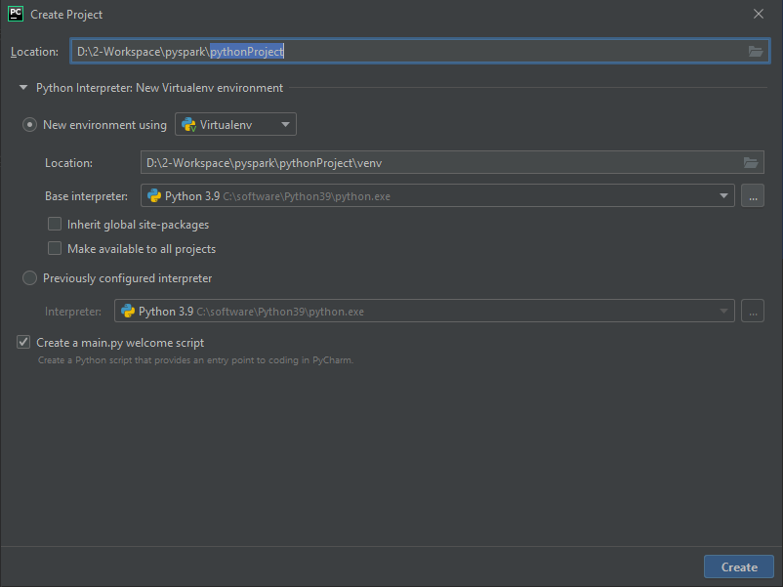

Create a new package under the project called as "lib"

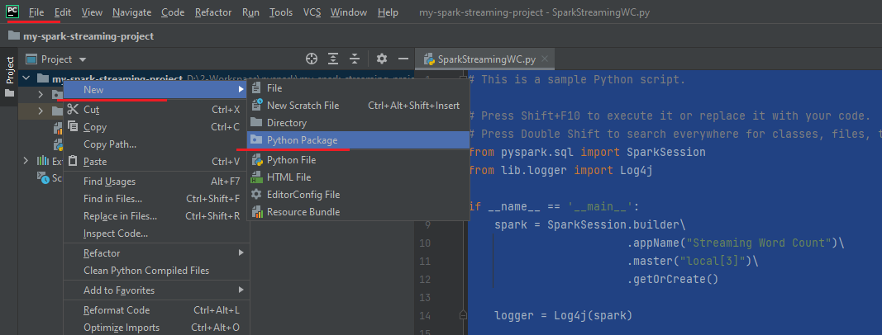

Add the logger.py file to this

**logger.py**

class Log4j:

def __init__(self, spark):

log4j = spark._jvm.org.apache.log4j

root_class = "guru.learningjournal.spark.examples"

conf = spark.sparkContext.getConf()

app_name = conf.get("spark.app.name")

self.logger = log4j.LogManager.getLogger(root_class + "." + app_name)

def warn(self, message):

self.logger.warn(message)

def info(self, message):

self.logger.info(message)

def error(self, message):

self.logger.error(message)

def debug(self, message):

self.logger.debug(message)

The project structure looks like this

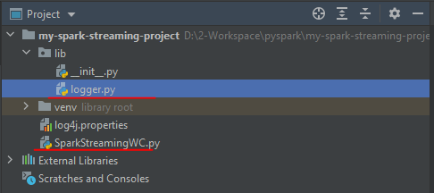

The main file SparkStreamingWC.py contains the following

**SparkStreamingWC.py**

# This is a sample Python script.

# Press Shift+F10 to execute it or replace it with your code.

# Double Shift to search everywhere for classes, files, tool windows, actions, & settings.

from pyspark.sql import SparkSession

from lib.logger import Log4j

if __name__ == '__main__':

spark = SparkSession.builder\

.appName("Streaming Word Count")\

.master("local[3]")\

.getOrCreate()

logger = Log4j(spark)

This is my first example, so I explained all the necessary steps to create the Spark project. Most of the examples in this course will follow the same steps to create a new example. And I am not going to repeat it again. All the examples will start from this point onwards, where you will see the main method with a Spark session. Make sense? Great!

Now we are ready to start writing the Spark Stream processing code. Spark Structured streaming application follows a three-step process. The first step is to read a stream of data from a source. In this step, you will create a streaming DataFrame. You can call that initial data frame as your input DataFrame. The second step is to apply some transformations to process your data and create a final DataFrame which you want to output. You can call this final DataFrame as your output DataFrame. Finally, the third step is to write your output DataFrame to a sink. That's all.

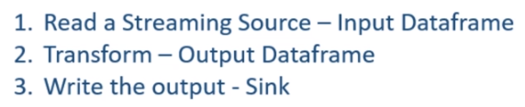

Let's code it, and you will start getting some sense of it. So we want to create our input DataFrame, Let me call it the linesDF. We will be reading a line of text from the TCP/IP socket. Right? That's what we discussed in the beginning. How do we read it? Simple. Start with the spark session and call the readStream method. The readStream method gives you a DataStreamReader. The DataStreamReader follows the same pattern as a DataFrameReader. So, just like a DataFrameReader, you can specify the input format, set the necessary options, and load it. Right? In our case, the format is the socket. The first option is the host, and the second option is the port. That's all we need. Finally, we load the DataFrame.

lines_df = spark.readStream\

.format("socket")\

.option("host", "localhost")\

.option("port", 9999)\

.load()

This code returns the same DataFrame, which you are already familiar with. I mean, you can apply almost all kinds of DataFrame transformations and work with this DataFrame as you work in the batch processing application. However, this is a Streaming DataFrame, and some standard DataFrame transformation is not allowed. For example, you cannot apply a count() action on this DataFrame. I will talk more about what is not allowed and why it is not allowed at a later stage. But you can safely assume that most of the transformations are allowed, and most of the actions are not allowed. Great! So we have our streaming DataFrame. And you can think of this DataFrame reading some lines of text from the TCP socket.

Now, what do we want to do with this DataFrame? We want to transform it to get the word count. Right? However, DataFrame transformation starts with knowing the schema of the DataFrame. Right? What is the schema of this streaming DataFrame? Let's print the schema and run it.

Since our project uses a virtual environment – and its complaining for py4j missing, lets install py4j

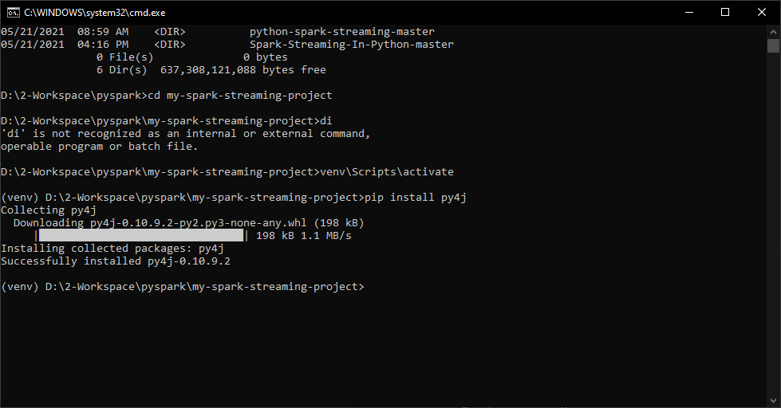

Run the main file now by right clicking and Run

from pyspark.sql import SparkSession

from lib.logger import Log4j

if __name__ == '__main__':

spark = SparkSession.builder\

.appName("Streaming Word Count")\

.master("local[3]")\

.getOrCreate()

logger = Log4j(spark)

lines_df = spark.readStream\

.format("socket")\

.option("host", "localhost")\

.option("port", 9999)\

.load()

lines_df.printSchema()

Output as below

D:\2-Workspace\pyspark\my-spark-streaming-project\venv\Scripts\python.exe D:/2-Workspace/pyspark/my-spark-streaming-project/SparkStreamingWC.py

WARNING: An illegal reflective access operation has occurred

WARNING: Illegal reflective access by org.apache.spark.unsafe.Platform (file:/C:/software/spark-3.1.1-bin-hadoop3.2/jars/spark-unsafe_2.12-3.1.1.jar) to constructor java.nio.DirectByteBuffer(long,int)

WARNING: Please consider reporting this to the maintainers of org.apache.spark.unsafe.Platform

WARNING: Use --illegal-access=warn to enable warnings of further illegal reflective access operations

WARNING: All illegal access operations will be denied in a future release

21/05/21 20:06:56 WARN TextSocketSourceProvider: The socket source should not be used for production applications! It does not support recovery.

root

|-- value: string (nullable = true)

Process finished with exit code 0

So, here is the DataFrame schema. I have a single string field, and the column name is the value. That's good to start my word count transformation.

Let's come back to the code. So, how do I go about it? I mean, how can we compute the word count? We can do it in two steps. The first step is to split the value column by whitespaces to separate the words. The second step is to group the words and apply the count aggregate. That's all. Right? Let me do it. I will create one DataFrame for separated words. So, we start with the lines DataFrame and use the select method. I will take the value and split it by space character. However, the split function gives me an array of words. I don't want an array. I want each word to form a row. So, I can use the explode method. The explode function will transform an array of words into rows. The explode method works like a flatMap(), which takes a single input and returns a bunch of rows. I hope you understand that.

from pyspark.sql.functions import expr

lines_df = spark.readStream\

.format("socket")\

.option("host", "localhost")\

.option("port", 9999)\

.load()

words_df = lines_df.select(**expr**("**explode**(**split**(value, ' '))"))

So now, my text is broken into words, and it is also exploded into rows. This whole thing is an expression, so I must enclose it within the expr() function. I should also give an alias to the new column. Make Sense? Now we have a DataFrame of words. The rest is simple. We will again start with the word DataFrame, group it by words, and count it. I said count action is not allowed on a streaming DataFrame. Right? However, this count is not an action. It is an aggregate transformation. So the count aggregate is allowed on a streaming DataFrame. Good. So now, we have an output DataFrame.

counts_df = words_df.groupby("word").count()

What is next? The third step is to write your DataFrame to a valid sink. Writing your output DataFrame is as simple as writing a DataFrame. So we start with the output DataFrame and call the writeStream method. The writeStream method gives you a DataStreamWriter. The DataStreamWriter is similar to the DataFrameWriter. That means we set the format, then we set some necessary options and start the write operation. We want to write to the console, so the format is the console. Then we set some necessary options. The first and most important option is the checkpoint location. The value of the checkpoint location is a directory location. I am giving a new directory name in the current directory. The DataStreamWriter will use this directory location to store the progress information. I will talk more about the checkpoint location in the next video.

from pyspark.sql import SparkSession

from pyspark.sql.functions import expr

from lib.logger import Log4j

if __name__ == '__main__':

spark = SparkSession.builder\

.appName("Streaming Word Count")\

.**configName**("spark.streaming.stopGracefullyOnShutdown", "true")

.**configName**("spark.sql.shuffle.partitions", 3)

.**master**("local[3]")\

.getOrCreate()

logger = Log4j(spark)

lines_df = spark.**readStream**\

.**format**("**socket**")\

.**option**("**host**", "localhost")\

.**option**("**port**", 9999)\

.**load**()

# lines_df.printSchema()

words_df = lines_df.select(**expr**("**explode**(**split**(value, ' ')) as word"))

counts_df = words_df.**groupby**("word").**count**()

word_count_query = counts_df.**writeStream**.**format**("**console**")\

.**option**("**checkpointLocation**", "chk-point-dir")\

.**outputMode**("**complete**")\

.**start()**

But for now, let's assume that a checkpoint location is a mandatory option, and DataFrameWriter will use this directory to store some progress information about the streaming job. The next mandatory configuration is the output mode. Spark streaming supports three output modes, and I will cover them in the next video. But for now, let me set the complete-mode. The complete-mode will show the complete output for each batch. That's all. The final step is to start the DataStreamWriter. The start method is like action, and it will start a background Spark job. This method also returns a StreamingQuery object. The start method is a non-blocking method that starts a background job and returns. So, we must wait for the background job to complete. You can use the StreamingQuery to await for the background job to complete. A typical stream processing application is expected to run forever. So this await termination is not going to end until the following happens. You want to stop your application for some kind of maintenance, so killed the Streaming application. Your streaming application faced some error or exception, and it terminated. In both cases, we want your application to shutdown gracefully.



And you can achieve it by setting a configuration for your Spark session. Let me do it. I am adding a new configuration ( see in brown above ) to the Spark session. The default value of this configuration is false, and I am setting it to true. That's all. We are good to run it. However, I am applying a groupBy() transformation in this example. And you know that the groupBy will internally cause a shuffle operation. You also know that the default shuffle partition configuration is 200. And that's a large value for this tiny and straightforward word count application. So your application might run slow because it will be unnecessary working with 200 partitions. So let me set the spark.sql.shuffle.partitions to a lower value.

from pyspark.sql import SparkSession

from pyspark.sql.functions import expr

from lib.logger import Log4j

if __name__ == '__main__':

spark = SparkSession.builder\

.appName("Streaming Word Count") \

.**config**("spark.streaming.stopGracefullyOnShutdown", "true")\

.**config**("spark.sql.shuffle.partitions", 3)\

.**master**("local[3]")\

.getOrCreate()

logger = Log4j(spark)

lines_df = spark.**readStream**\

.**format**("socket")\

.**option**("host", "localhost")\

.**option**("port", 9999)\

.**load()**

# lines_df.printSchema()

words_df = lines_df.**select**(**expr**("**explode**(**split**(value, ' ')) as word"))

counts_df = words_df.**groupby**("word").**count()**

word_count_query = counts_df.**writeStream**.**format**("console")\

.**option**("checkpointLocation", "chk-point-dir")\

.**outputMode**("complete")\

.**start()**

logger.info("Listening to 9999")

word_count_query.**awaitTermination**()

Great! We are done. Do you want to run it? Let me start a command window and trigger the Netcat. Good. So we now have a TCP Listener. Now let me run the application. Great! So we are now listening to the localhost:9999. The application runs as a micro-batch, and the first batch is triggered. We don't have any data yet, so you don't see any word count in the first batch. Let me send some text. Great! Do you see the word counts here? Let me send something more. Now the word count is changing. Isn't it. The results are coming almost immediately. Right? You can terminate your application.

Listening to 9999 – Micro Batching Mode of Spark Streaming

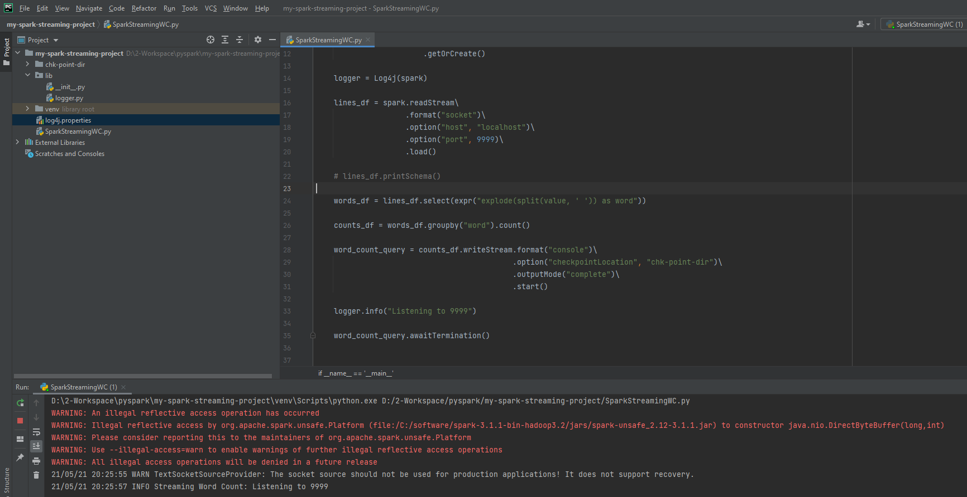

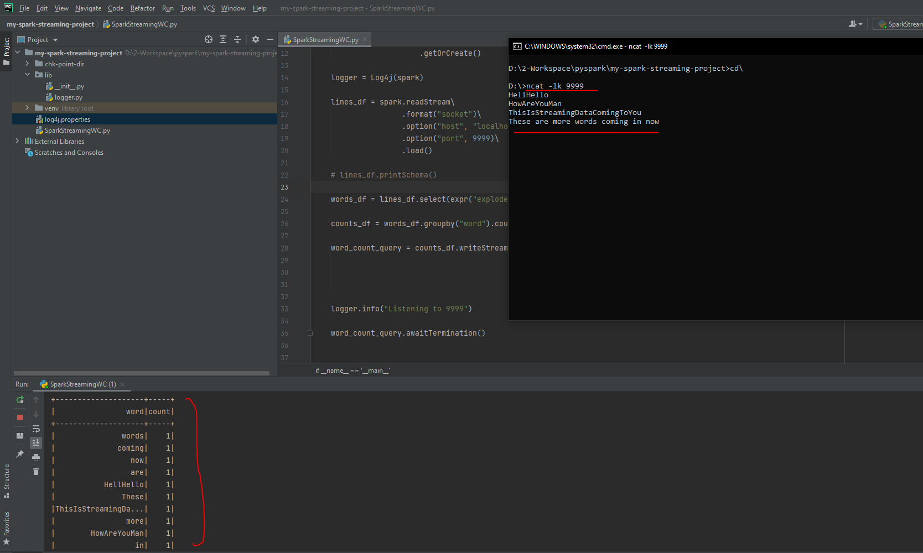

Do you see this checkpoint directory? This directory contains information about the progress of the current batch and some information about the previous batches. If you want to rerun this example, you should delete the checkpoint directory. I will explain the reason and more details about the checkpoint location in the following video. But for now, delete it if you want to restart your application.

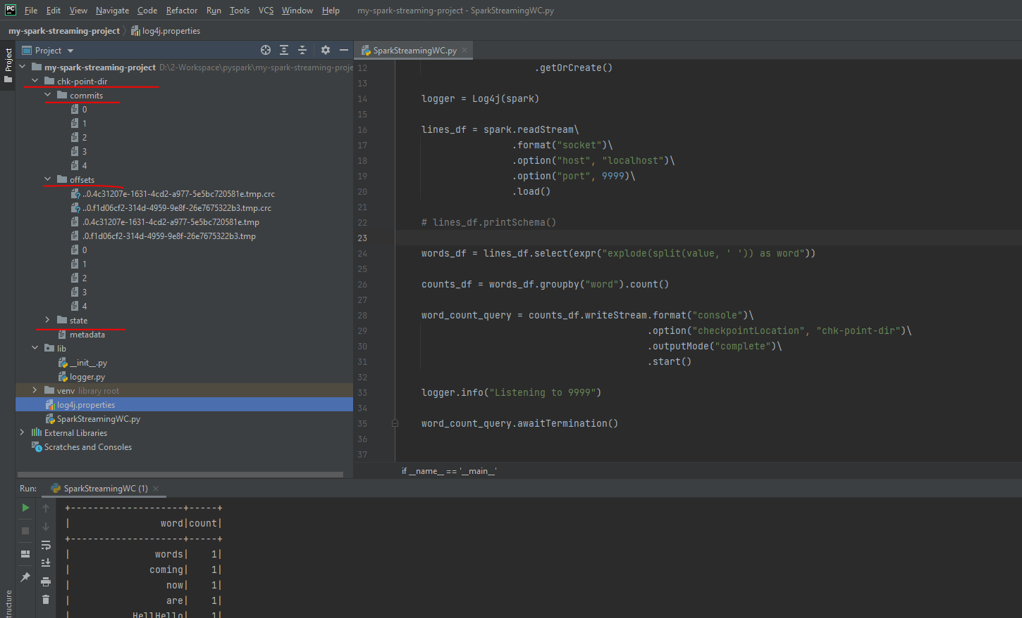

Great! We are done with the first Spark Structured Streaming application. Let me summarize the main takeaway here. We learned the following things.

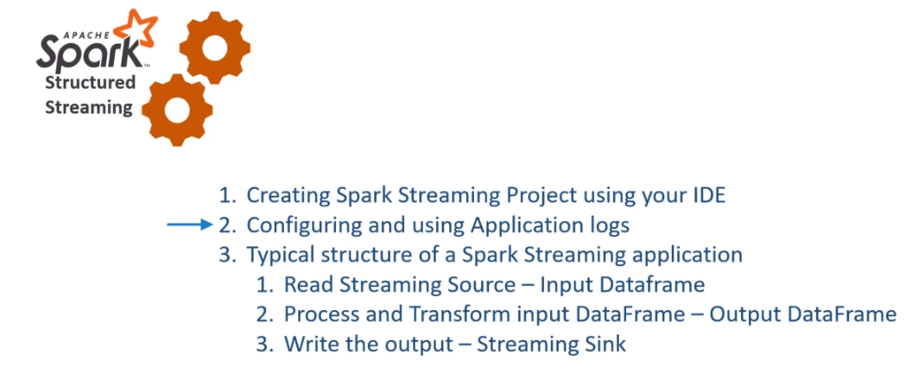

How to create a starter template Project for Spark Streaming applications. Configuring and using Application logs. We also learned a typical structure of a Spark Streaming application. Creating a Spark Streaming Application is a three-step process. Read the data to create your input DataFrame. Process and transform your input DataFrame to create a final output DataFrame. Write the output DataFrame to a valid streaming sink.

**Stream processing model in Spark**

We already created our first Spark streaming application and learned the basic model of Stream processing in Apache Spark. Creating Stream processing applications in Apache Spark is a three-step process. And these three steps will automatically run in an infinite loop where each iteration is known as a micro-batch.

|  |  |
| --- | --- |
|  | In this video, we will dig a little deeper into this loop and try to understand some more concepts. So, let's start. Let me come back to the example code. Here it is. So what did we do here? We are reading a stream into a DataFrame. Then we are processing it and creating another DataFrame. Finally, we are writing it to the console. Where is the loop? We are not coding any while-loop or a for-loop here. So how does it happen?  Let me explain. Starting a query acts as a Spark Action. I hope you already understand what happens when we trigger a DataFrame action. Right? Similar things will happen here. Your Spark driver will take the code starting from the read stream until the write stream and submits it to the Spark SQL Engine. |

The SQL engine will analyze the code, optimize it, and compiles it to generate an execution plan. All this happens at run-time, and the generated execution plan is similar to the DataFrame execution plan, which is made up of the stages and tasks. Once you have an execution plan, Spark will start a background thread to execute it. Until this stage, you will not see any Spark Streaming job. The background thread doesn't show up as a Spark Job. I will show you all this. Now, the background thread will trigger one Spark job to do the following.

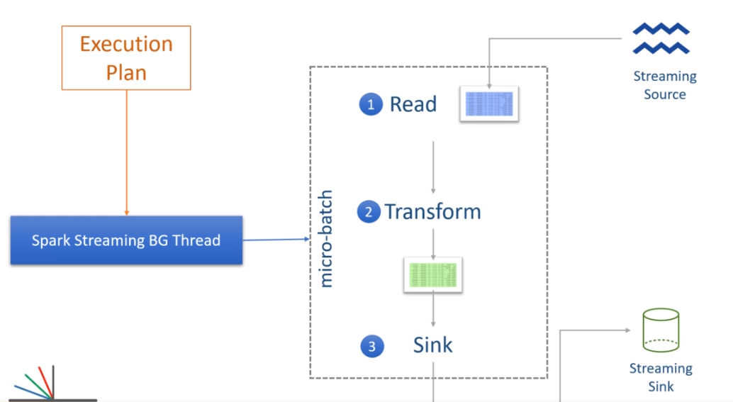

Read the data from the source and create an input Streaming DataFrame. Process the input DataFrame as per the defined logic to finally generate the output DataFrame. Write the output DataFrame to the given sink. That's your first micro-batch. It ends here. So, you should see a Spark Job completed. Now the background thread will again look for the new inputs from the given data source. If we do not have any new inputs yet, the background job will wait for data to arrive. As soon as you get some new inputs, the background thread will clean the input DataFrame and load it with the new data. And that will be your input data for the second micro-batch. The input data from the previous batch is already processed, and hence the background thread will discard it and load your input DataFrame with the newly arrived data. Make Sense? Now the background thread will trigger another Spark job to repeat the processing and writing operation. And this new job becomes your second micro-batch. The background process will wait for the second micro-batch to complete and trigger the third micro-batch if you have some more data to process. So the loop is created and managed by the background process, and it goes on forever. Make Sense?

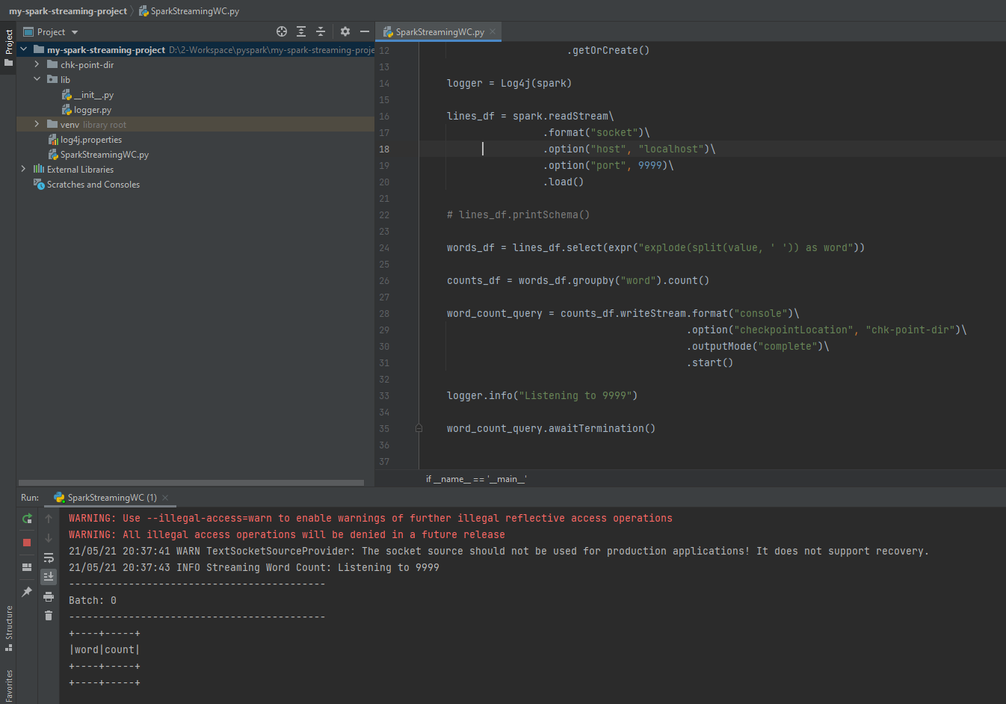

You can see some of these things happening on your Spark UI. Let me show you. I am starting my input data source socket. I will not be sending anything yet. Now, let me start the application. Then we go to the Spark UI. You will see one job which gets triggered and completes also. And this would be your first micro-batch. If you click the job, . you will see two stages

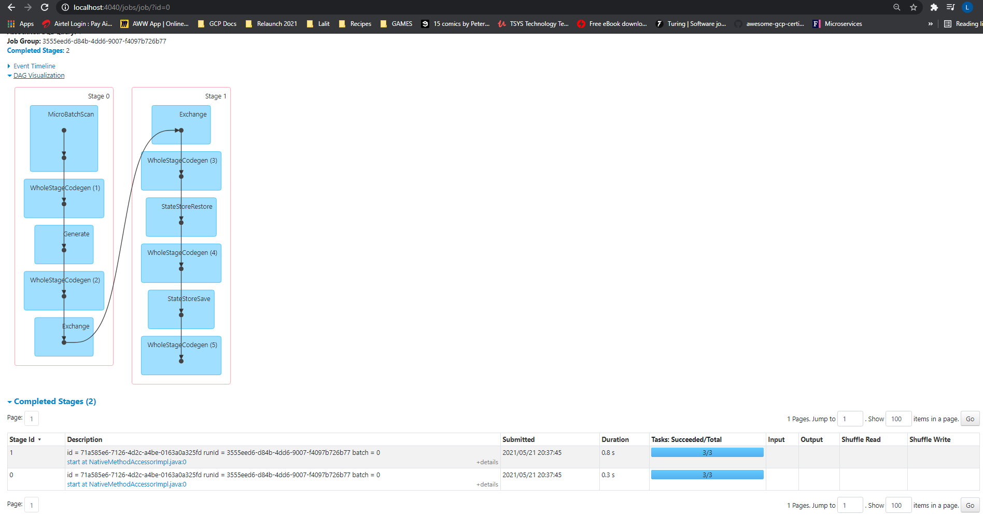

These two stages are obvious. The first stage is before the groupBy, and the second stage is for transformation after the groupBy. The groupBy operation triggers a shuffle, and you can see the exchange here. Right? Nothing else is happening. We are not seeing any new job because the background process is waiting for the new inputs.

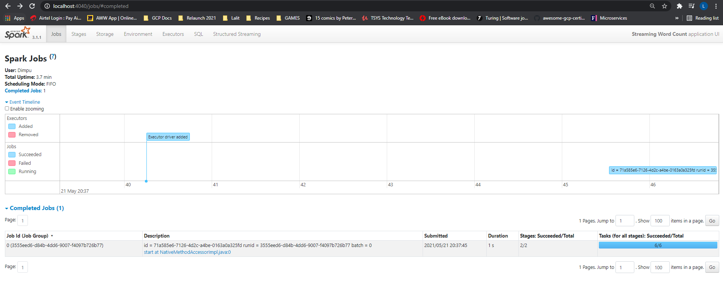

Let me send some text. Good. Batch 1 is triggered, and we can see the output here. Right?

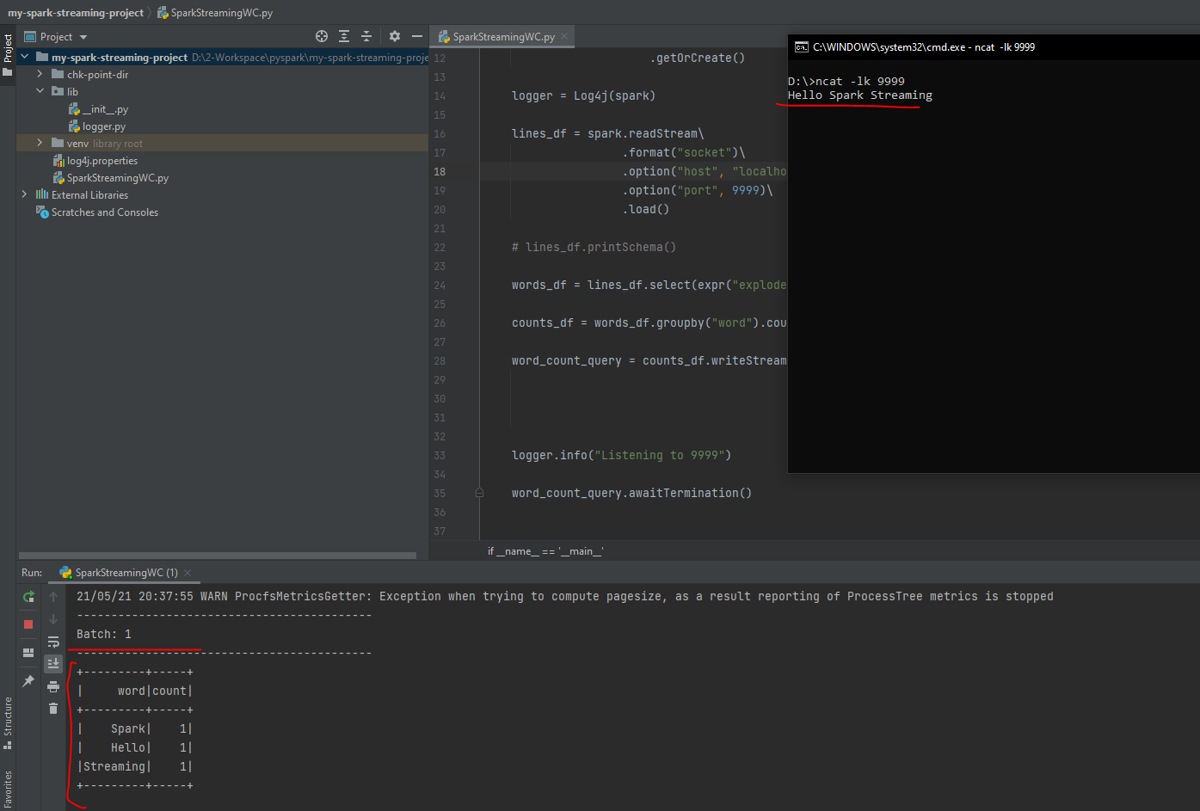

Let's go and check the Spark UI. Do you see one job? This new job was your next micro-batch.

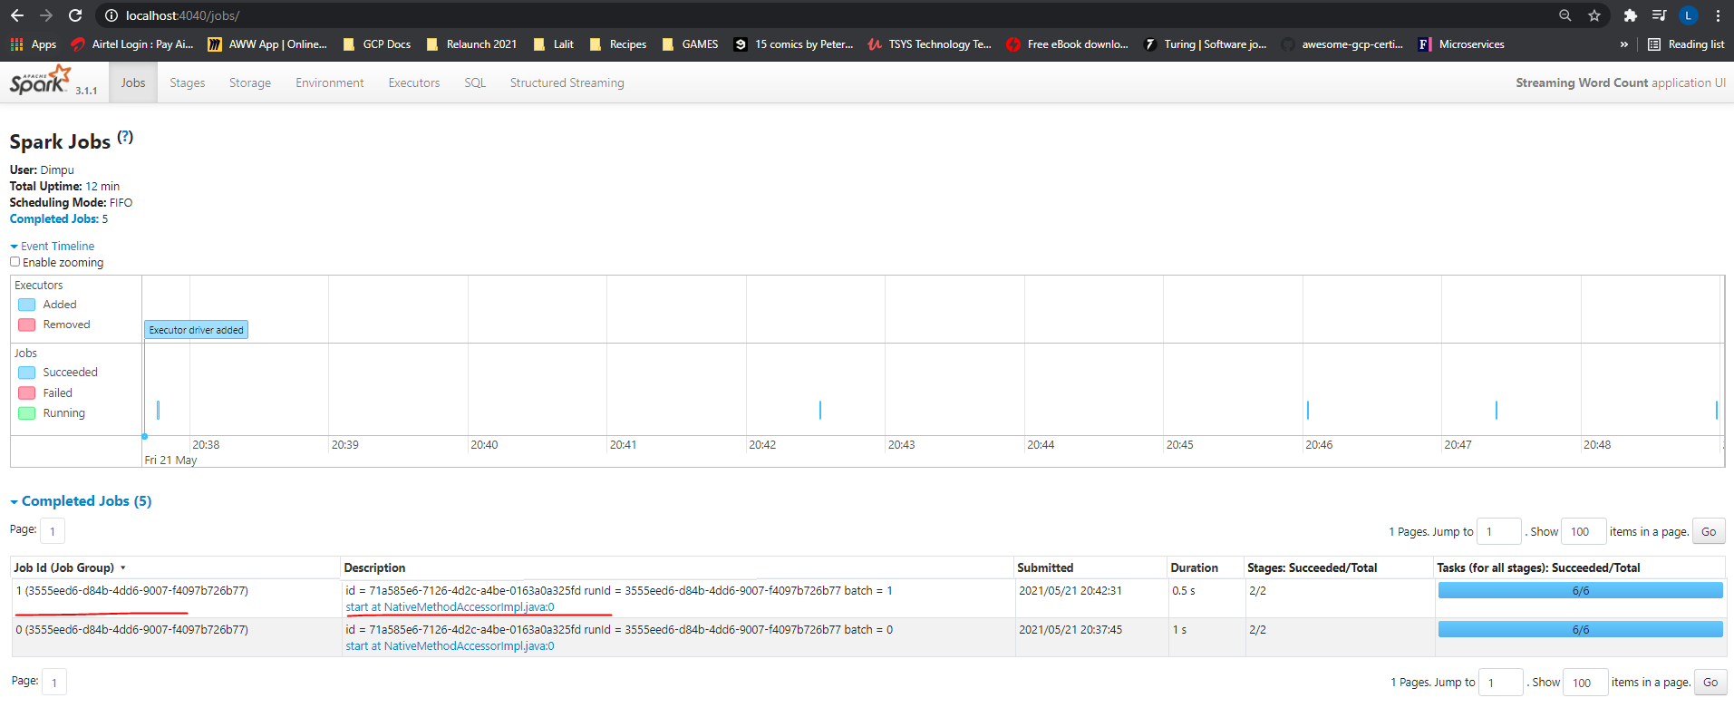

Send some more input, and you will see another micro-batch job. And this loop goes on forever. Great!

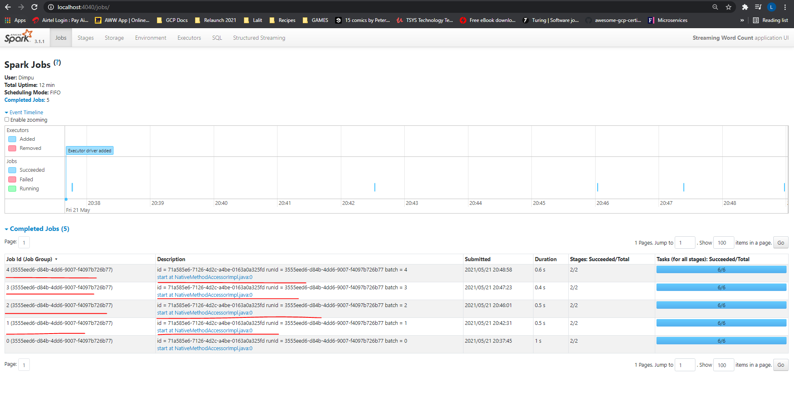

So now you understand how this micro-batch works. Right? However, I have a simple question. We saw that the micro-batch loop triggers as soon as we get some new data? The question is simple. How much data do we need to trigger the new micro-batch? Will it trigger for each record? Or is it based on time? Do we have some control here? Yes, we have. The DataStreamWriter allows you to define the trigger. As of Spark 3.0.0, we have four trigger configurations. The first option is no trigger configuration. This example does not define any trigger configuration, so we are using the default unspecified trigger configuration.

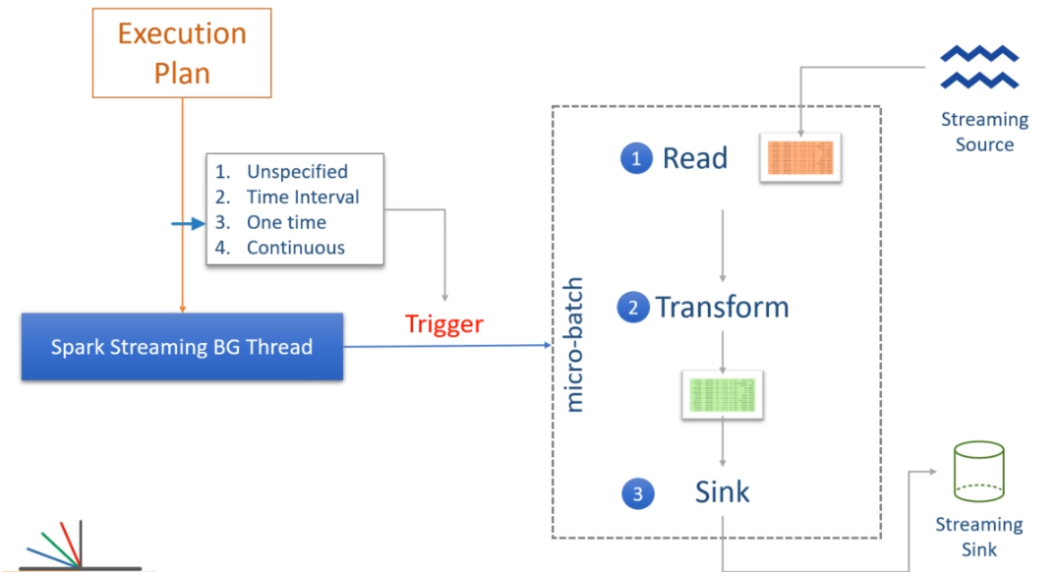

In this first case, the new micro-batch is triggered as soon as the current micro-batch finishes. However, the micro-batch will wait for the new input data. And we have seen this behavior. Right? The second option is to set some time limits for each micro-batch. For example, you can set the trigger interval to 5 minutes. In this case, the first trigger will start immediately. The second micro-batch will begin when the first trigger is complete. However, if the first trigger finishes in less than five minutes, the second micro-batch will wait for the remaining time and only trigger when 5 minutes are over from the start of the first micro-batch. If the first micro-batch takes more than five minutes to complete, then the second micro-batch will start immediately as soon as the first one ends because we already passed the trigger time. Make sense?

The time-based trigger gives you an option to collect some input data and process it together rather than processing each and every record individually. The third option is like a batch processing job. The one-time trigger will create one and only one micro-batch, and then the background process will stop. This option is useful in scenarios when you want to spin up a Spark cluster in the cloud, such as Amazon EMR, process everything available since the last period, and then shut down the cluster. So, in this case, you will be scheduling your job using a third party schedular, and the stream processing job acts as a batch job. However, you can still take advantage of other features such as restarting from the same point where you stopped and combining intermediate results.

The last option is a new feature in Apache Spark to achieve millisecond latencies. The micro-batch approach is good enough to create micro-batches that run as quickly as a few seconds. However, when you want to get things in less than a second, the micro-batch approach may not be suitable. Apache Spark is evolving with the continuous triggers to achieve millisecond latencies, but this feature is still marked as experimental. Great! So we also learned the trigger configuration. I will show you the mechanics of applying these triggers as we progress with the course. That's all for this video. Let me quickly summarize what we learned. Spark stream processing query runs as micro-batches. Each micro-batch starts with a new input data set and writes the outcome to the sink. The next batch again starts with a new data set, and this all goes in a loop. All of this is internally managed by a background thread. You can also configure the micro-batch trigger time by setting the trigger time interval.

**Working with Files and Directories**

We already created our first example, which reads a socket data stream and processes it in real-time. In this video, I will talk about Spark's built-in streaming sources and create one example to read streaming data from a file source. So, let's start. Apache Spark offers you four built-in streaming data sources. Socket source Rate source File source and the Kafka source We already used socket sources.

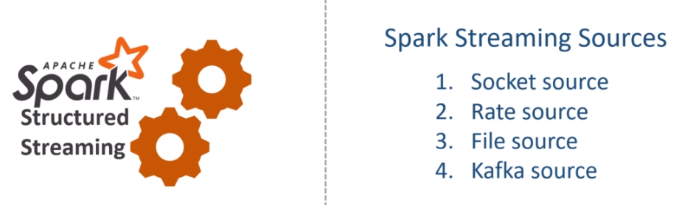

This source allows you to read text data from a socket connection. The socket source is not designed for production usage. So you should not be using it except for learning or some testing scenarios. The rate source is designed for testing and benchmarking your spark cluster. It is a dummy data source which generates a configurable number of key/value pair per second. I am not going to cover this data source in this course. However, if you want to use it, you can refer to the documentation. Using the Rate source is straightforward compared to other data sources. The file data source and the Kafka source are the most commonly used streaming data sources in real-life Spark Streaming projects. I will leave the Kafka source for the later section and cover the file data source in this video. So let's define a problem statement.

You are working for the XYZ Home Furniture and Kitchen utensils retailer. They have hundreds of retails stores across the country, and they also have an online presence. XYZ management decided to transform itself into a data-driven organization. As a first step towards that goal, they created a Data collection pipeline to collect all their invoices to a central data center. The data ingestion pipeline collects the invoices from the sales channel and dumps them into a distributed storage at regular intervals. Let's assume you have a directory in HDFS or S3.

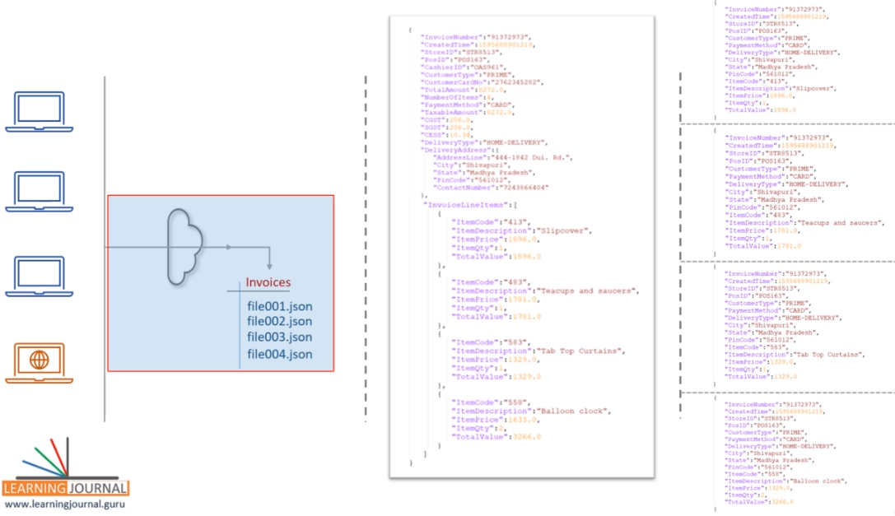

The ingestion pipeline collects data for a while and saves a bunch of records into a JSON file. So the input directory keeps getting new JSON files one after others. A single invoice record looks like this. So you have some simple fields such as InvoiceNumber, StoreID, and delivery type. We also have a complex column, such as a delivery address. We have an array of complex records for the invoice line items. You are then asked to create a Spark application that reads the input data files, flattens the invoice records, and writes it back to a different directory. The flattened record looks like this.

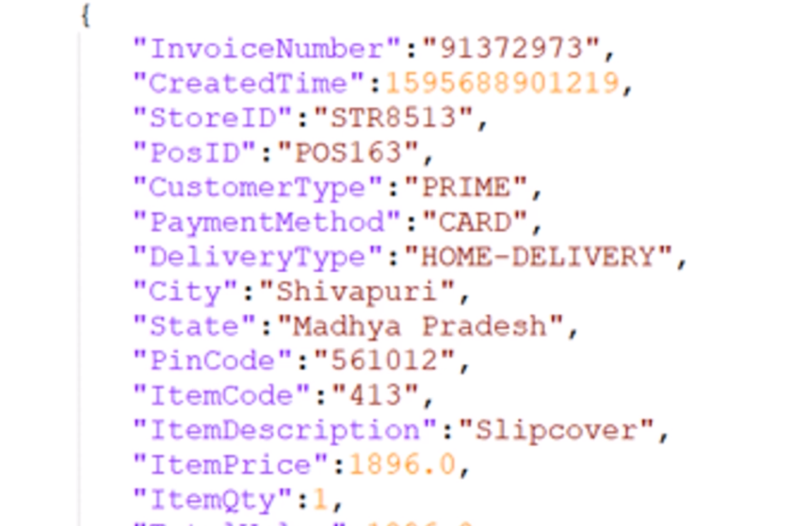

However, each invoice should generate one or more flattened records. For example, this given input should generate four output records because we have four line items in the input invoice. Make Sense? How will you go about this requirement? One approach is to write a simple Spark application that reads all the files in the input directory, flattens the invoice records, and writes it back to the output directory. However, you must schedule this application to run at regular intervals. Let's say your management wants to do it every five minutes.

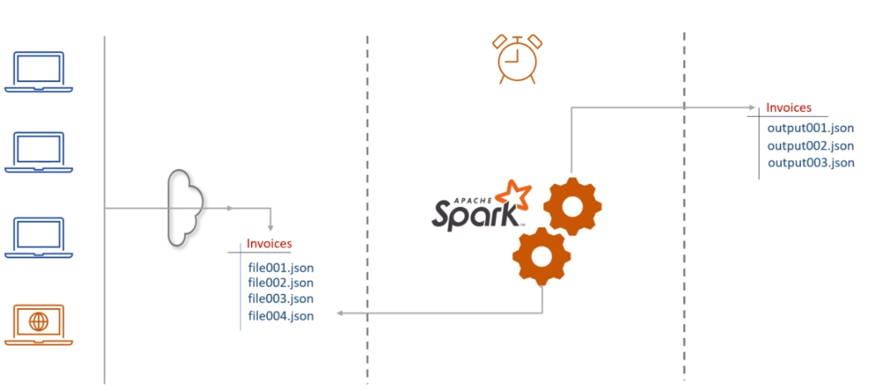

So you can simply schedule your simple Spark application to run every five minutes. However, you cannot read all the data files every time. Suppose you processed 3 files for the first execution. When you start your application again after five minutes, you should only read new files that you haven't processed in the previous execution. You may find different ways to handle this problem. A straightforward approach is to archive the files after processing it. You read three files for the first time, transformed it, and then moved those files to some other directory.

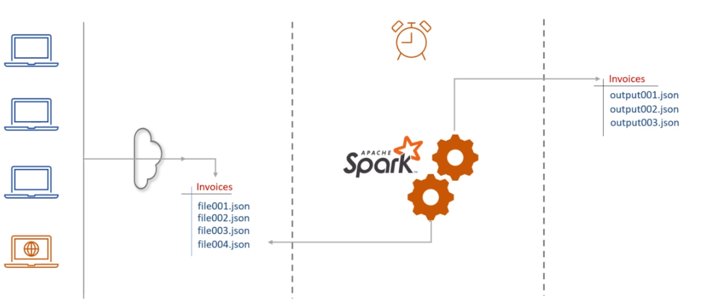

This way, you will not see those three files in the next execution. This approach looks simple, but it is not so easy to achieve. You have to write a lot of custom code. You will also have to handle the failure cases. What if your job completes writing some records but fails in between before you archive your files. You do not want to miss any records, and you also do not want to create duplicates. This requirement is popularly known as exactly-once-processing.

The point is straight. Handling failure scenarios and achieving exactly-once-processing is a complex requirement, and it needs a significant amount of time to code and test. We do not want to invest that much time and effort when Spark Structured Streaming is there to offer all of this. All we need to do is to create a stream processing application using the DataStreamReaderFileSource. Let's do it. Here is the initial project template. I already have a spark session, and now I am ready to read a data source. Let's code it. I am creating a raw DataFrame. So we start with the spark session, call the readStream() to get a DataStreamReader. Then we set the format. I want to read JSON data files, so the format is JSON. The next thing is to set some options. The only mandatory option is to set the path. I will be reading data from the input folder. Input is the directory name in the current directory. If you are reading from HDFS or the S3, you should provide the fully qualified path for the input directory. Finally, I will load the data.

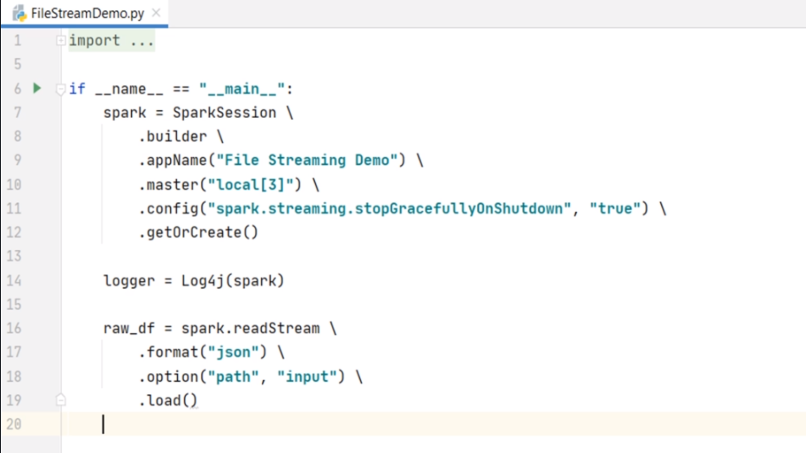

The load method will return a Streaming DataFrame. Reading a file stream is almost similar to reading a file. You will use the spark.read method to read a file and get a standard DataFrame. However, you will use the spark.readStream to read a streaming file and get a streaming DataFrame. Make sense? If your data is coming as CSV, you can set the format as CSV. You can even use the CSV options such as header, and dateFormat, etc. The point is straight. The readStream allows you to read any supported file format in the same way you read them to a standard DataFrame. Great! What is next? We want to process this DataFrame. But what is the schema of this DataFrame? You might be expecting Spark to infer the JSON schema. Right? However, by default, schema inference is disabled for the streaming sources. But you can enable it. Let me do it. I am setting spark.sql.streaming.schemaInference to true. This option will enable schema inference. Let's print the schema and see what do we get.

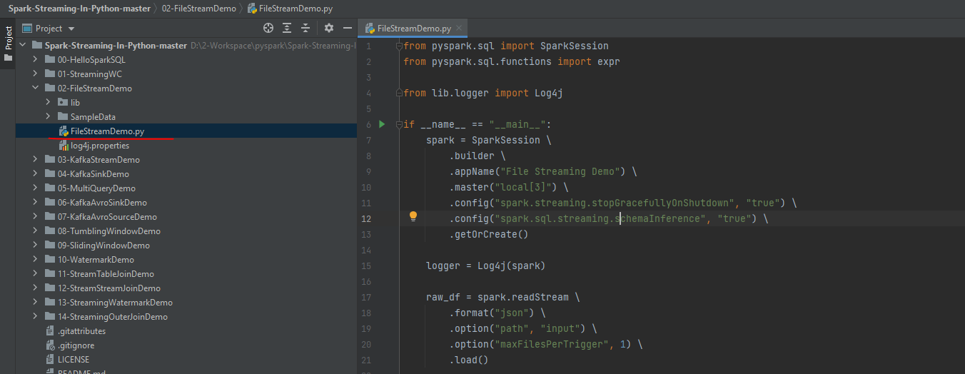

**FileStreamDemo.py**

from pyspark.sql import SparkSession

from pyspark.sql.functions import expr

from lib.logger import Log4j

if __name__ == "__main__":

spark = **SparkSession** \

.**builder** \

.**appName**("File Streaming Demo") \

.**master**("local[3]") \

.**config**("spark.streaming.stopGracefullyOnShutdown", "true") \

.**config**("spark.sql.streaming.schemaInference", "true") \

.**getOrCreate**()

logger = Log4j(spark)

raw_df = spark.readStream \

.**format**("**json**") \

.**option**("**path**", "input") \

.**option**("**maxFilesPerTrigger**", 1) \

.**load**()

Good. Looks like the schema inference worked.

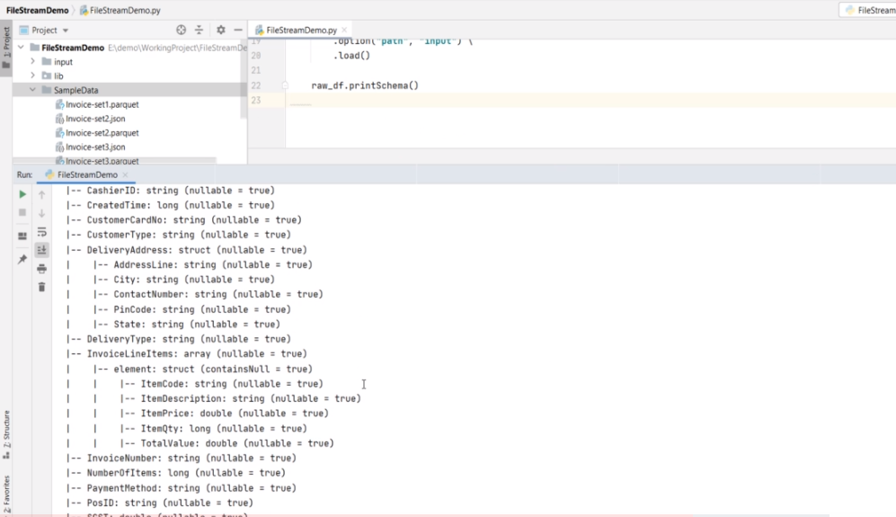

What is the next step? The rest is simple. We have an invoice such as this. And we want to produce this. Taking out these simple fields is a straightforward select expression. Right? Let me write it. We start with the raw DataFrame and use selectExpr(). What do I need? Invoice number, Created Time, Store ID, PosID, CustomerType, PaymentMethod, DeliveryType, DeliveryAddress.City, DeliveryAddress.State, and DeliveryAddress.PinCode. The rest of the fields are coming from the InvoiceLineItems array. We cannot take it until we explode it. So, let me explode the InvoiceLineItems.

from pyspark.sql import SparkSession

from pyspark.sql.functions import expr

from lib.logger import Log4j

if __name__ == "__main__":

spark = SparkSession \

.**builder** \

.**appName**("File Streaming Demo") \

.**master**("local[3]") \

.**config**("spark.streaming.**stopGracefullyOnShutdown**", "true") \

.**config**("spark.sql.streaming.**schemaInference**", "true") \

.**getOrCreate**()

logger = Log4j(spark)

**raw**_**df** = spark.**readStream** \

.**format**("**json**") \

.**option**("**path**", "./SampleData/*.json") \

.**option**("**maxFilesPerTrigger**", 1) \

.**load**()

**explode_df** = **raw_df**.**selectExpr**("InvoiceNumber", "CreatedTime", "StoreID", "PosID",

"CustomerType", "PaymentMethod", "DeliveryType",

"DeliveryAddress.City", "DeliveryAddress.State",

"DeliveryAddress.PinCode",

"**explode**(**InvoiceLineItems**) as **LineItem**")

So, this DataFrame is the exploded DataFrame. What is the schema now? Let me check. Good. We are almost there. Now all I need to do is to rename these columns. So we start with the exploded DataFrame and use the withCoulmn() to add simple columns.

**flattened**_**df** = **explode**_**df** \

.**withColumn**("ItemCode", expr("**LineItem**.ItemCode")) \

.**withColumn**("ItemDescription", expr("**LineItem**.ItemDescription")) \

.withColumn("ItemPrice", expr("LineItem.ItemPrice")) \

.withColumn("ItemQty", expr("LineItem.ItemQty")) \

.withColumn("TotalValue", expr("LineItem.TotalValue")) \

.**drop**("**LineItem**")

Finally, we drop the complex column. That's all.

We are done, and now we have a flattened DataFrame. Make Sense? What do you want to do next? Simple. Create a writer query and write the flattened DataFrame. Correct? What format do you want to write it? Let's do JSON. Where do you want to write it? Let's push it to the output directory. You should also set the checkpoint location. Right? One more mandatory setting is the output-mode. Let's use the append mode. I will talk about it in the next video. You can also set a name for your query. This name will show up in the Spark UI. Finally, start the query and wait for it to terminate. We learned about the triggers. Right? Do you want to set a trigger duration? Let me set a one minute trigger. Great! We are good to run it and see it in action. However, I am stopping here and take this further in the next video. I will also talk a little more about the internals of file-based streaming sources. Learn some additional options and also talk about the sink and the output mode. And finally, we will execute this example and see it in action.

from pyspark.sql import SparkSession

from pyspark.sql.functions import expr

from lib.logger import Log4j

if __name__ == "__main__":

spark = SparkSession \

.builder \

.appName("File Streaming Demo") \

.master("local[3]") \

.config("spark.streaming.stopGracefullyOnShutdown", "true") \

.config("spark.sql.streaming.schemaInference", "true") \

.getOrCreate()

logger = Log4j(spark)

raw_df = spark.readStream \

.format("json") \

.option("path", "./SampleData/*.json") \

.option("maxFilesPerTrigger", 1) \

.load()

explode_df = raw_df.selectExpr("InvoiceNumber", "CreatedTime", "StoreID", "PosID",

"CustomerType", "PaymentMethod", "DeliveryType",

"DeliveryAddress.City", "DeliveryAddress.State",

"DeliveryAddress.PinCode",

"explode(InvoiceLineItems) as LineItem")

flattened_df = explode_df \

.withColumn("ItemCode", expr("LineItem.ItemCode")) \

.withColumn("ItemDescription", expr("LineItem.ItemDescription")) \

.withColumn("ItemPrice", expr("LineItem.ItemPrice")) \

.withColumn("ItemQty", expr("LineItem.ItemQty")) \

.withColumn("TotalValue", expr("LineItem.TotalValue")) \

.drop("LineItem")

invoiceWriterQuery = flattened_df.writeStream \

.format("json") \

.queryName("Flattened Invoice Writer") \

.outputMode("append") \

.option("path", "output") \

.option("checkpointLocation", "chk-point-dir") \

.trigger(processingTime="1 minute") \

.start()

logger.info("Flattened Invoice Writer started")

invoiceWriterQuery.awaitTermination()

We created a stream processing application using a file source. In this video, I will explain the working of the same application and elaborate more on the sources and sinks. So let's start. Here is the example we created. How is it going to work? Let me explain. The program starts with reading a stream. The stream input is a directory. We call it a file input source, but it is a directory source. So, the readStream will look into the input directory and read all the available files. The file must be a JSON file. If you have other types of files in the directory, you may get an exception. So we should make sure that the input directory contains JSON data files and nothing else. The first micro-batch will read all the available files in the directory and load the data to this raw_df. Make Sense? The rest is straightforward.

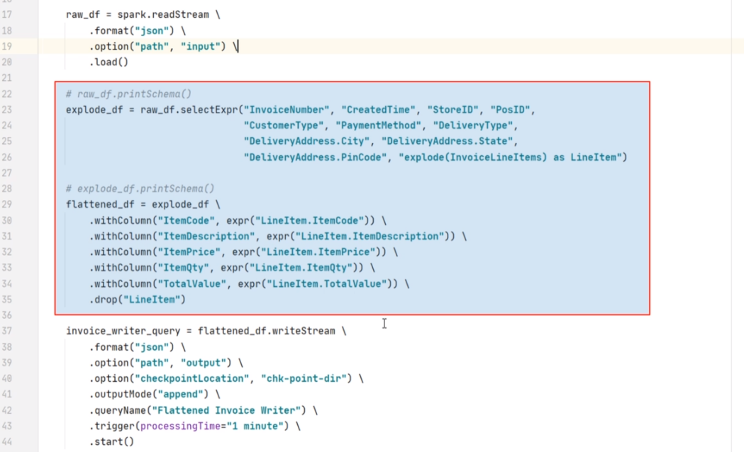

Spark will apply these transformations and finally create the flattened_df. Right? Finally, this flattened_df will be written to the output directory. Spark will also record the progress information to the checkpoint location. The checkpoint location holds information about the input directory and the files which you successfully processed in the first micro-batch. While the micro-batch job is running, the background thread keeps monitoring the progress of the micro-batch. Let's assume that all of this reading, processing, and writing finishes in 15 seconds. We defined the trigger time as one minute. So the background thread will wait for another 45 seconds. After that, the background thread will look into the input directory and check if we have received any new files. If not, the thread will wait and watch for new files to arrive. As soon as new files are created, the background thread will trigger the next micro-batch.

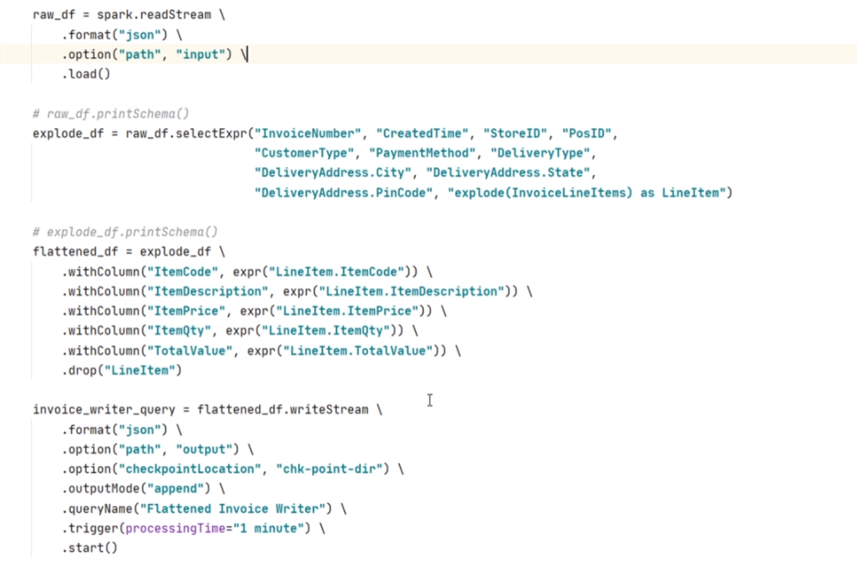

The next batch will read the new files and load them to your raw_df. The rest of the processing is the same. Your micro-batch will apply the transformations, write the output to the target directory, and commit the progress in the checkpoint directory. Once your micro-batch is over, the background thread will again take over the control and start planning for the next batch. And this goes on in an infinite loop. The streaming file source is much more flexible, and it allows you to configure the following interesting options. The maxFilesPerTrigger allows you to limit the number of files per micro-batch. Let me add it.

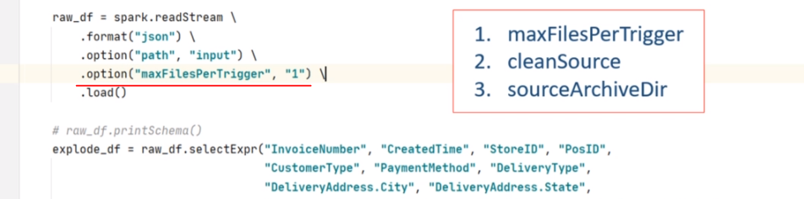

I am limiting it to one file per trigger. This option can be useful in some cases to achieve even workload for your micro-batches. The cleanSource and sourceArchiveDir options are often used together. This option allows you to archive the processed file automatically. The cleanSource takes two values. archive and delete If you are setting archive options and sourceArchiveDir, the Spark will move the processed files to a given archive location. The delete option will simply delete the processed files. You should also understand that moving or deleting will add some time to each micro-batch. On the other hand, a lot of processed files in a directory will also negatively impact your micro-batches. So, you must clean your input directory. If you are running longer batches, you can use the cleanSource option. However, if you are running shorter batches and cleanSource is not feasible in the micro-batch, you can create a separate cleaning job that might run daily. But make sure you are cleaning your input directory.

So now you understand the example and how it is going to work. Let's run it. I included three sample data files. I also have a parquet version of the same data. This example uses JSON files, but you can also try changing the example to work with the parquet files. You can copy one file in the input directory and run your application. Then you can copy the second and third files to see if the second batch is picking the new files. However, I am copying all of them at once. My example is going to pick one file per micro-batch because we configured the maxFilesPerTrigger option. Right? Let me run it.

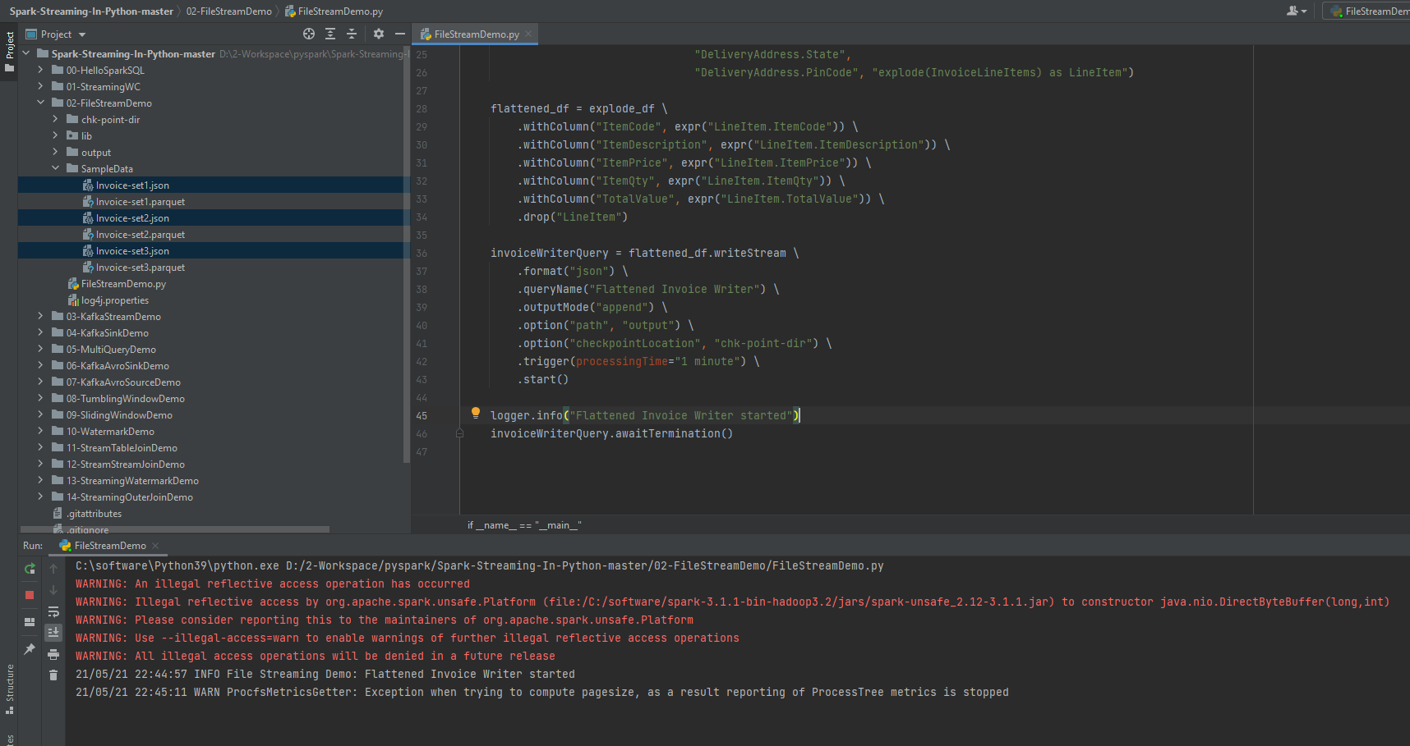

The program started. Let's go to the Spark UI and wait for three micro-batches to finish. Okay. So you can see this additional job. This job is created for inferring the schema. And these three are your micro-batches. You can see your query name here. Right? The first micro-batch start time is shown here.

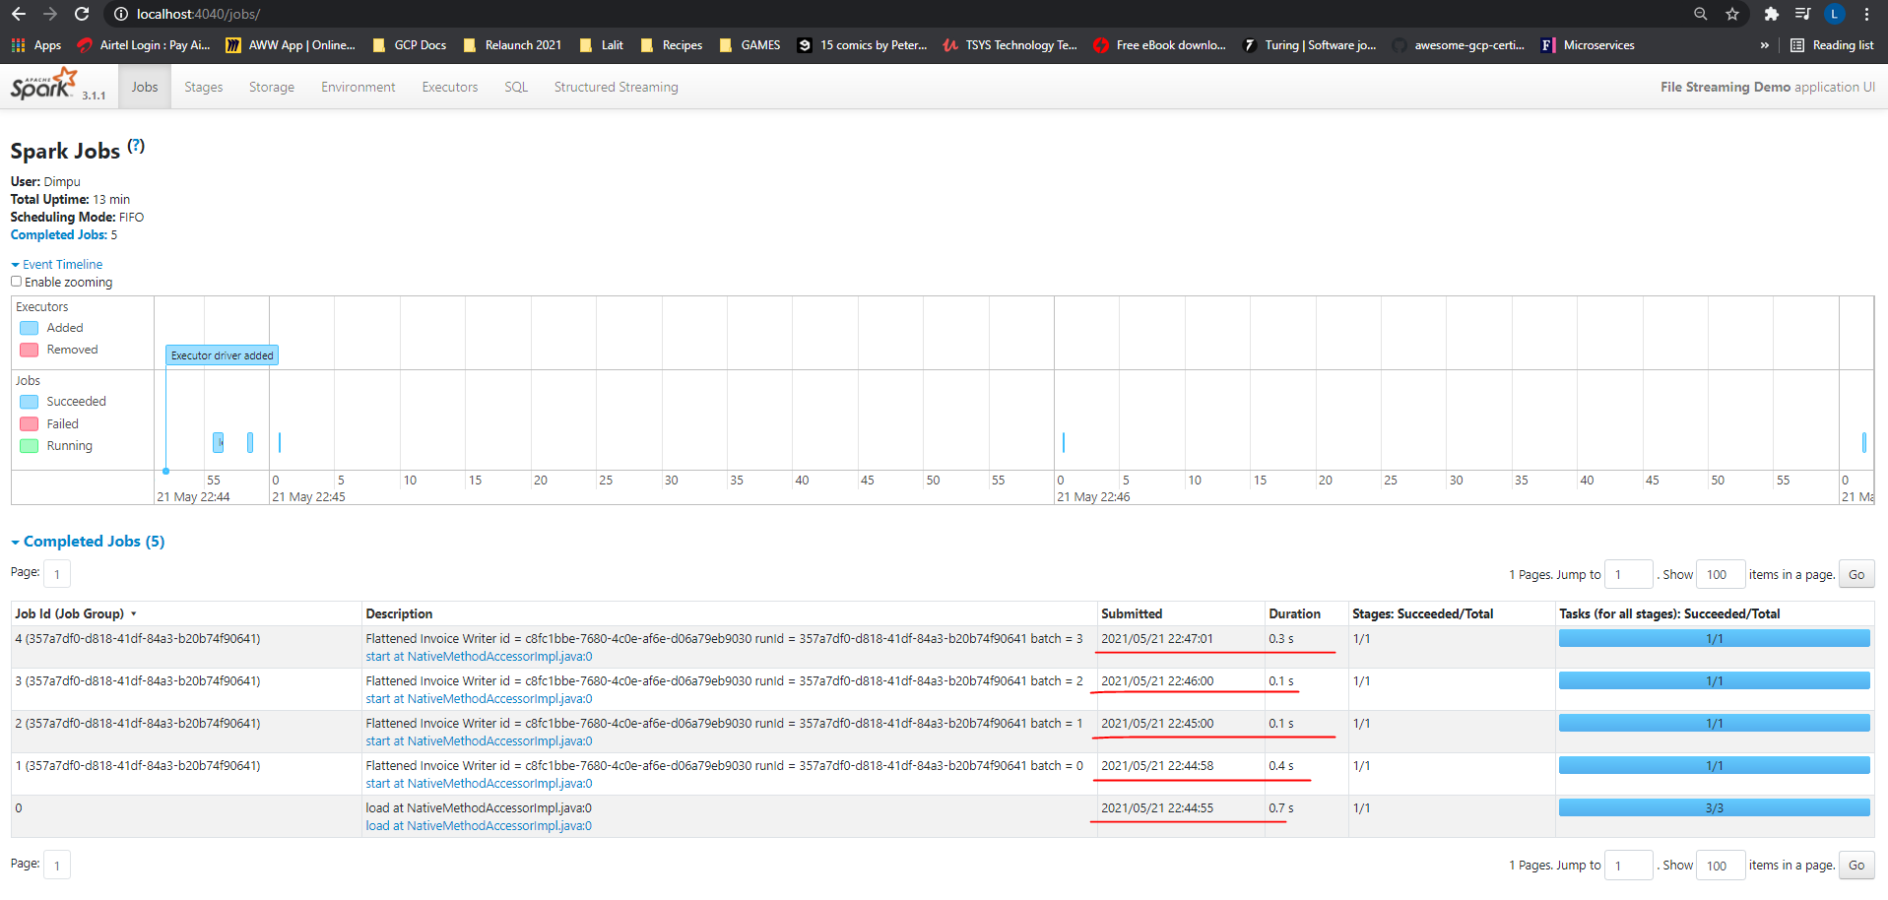

We had copied one of the files as the 4th file so we have 4 jobs here.

The second one started at this time. The difference between first and second micro-batch is less than one minute. But we set the trigger duration to one minute. Right? Then why is this started even before one minute? Well, let's look at the third batch. This one is exactly one minute from the second batch. Right? But why is it less than one minute for the first and second batch. This difference happens because Spark tries to align the trigger time to a roundoff time. So the first two triggers are where Spark will round off the trigger time and form third trigger onwards, you should see a consistent trigger time until your micro-batches are overrunning or they are waiting for new inputs. Great! Let's come back and check your output directory.

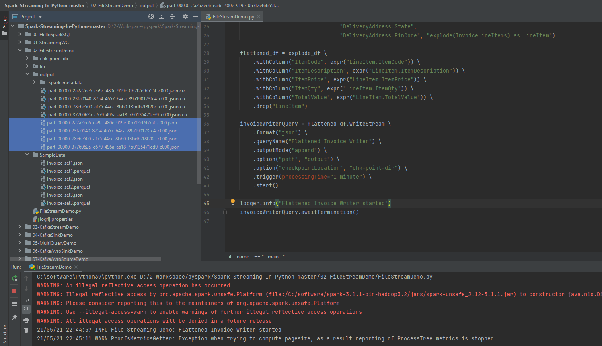

You can see the output files here. If you want, you can even look at the checkpoint directory. Check the sources directory. You will see one file for each micro-batch. The file name is the micro-batch id. Look inside the file, and it shows which file was processed in this micro-batch. I am showing it here, but we are not supposed to touch the checkpoint directory and its structure. The checkpoint is supercritical for fault tolerance. I will cover more about the checkpoint in the next video. So we are done with the current example. However, let me talk a little about the output-mode. DataStreamWriter allows you to specify three output modes. Append Update and Complete

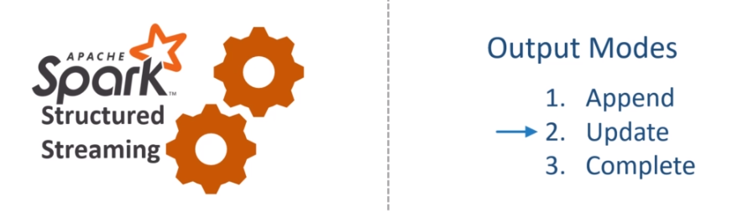

You can think of the append mode as insert only output. So you will be using this mode when you know that you are not going to update any previous output, and each batch will write new records only. The update mode is like the upsert operation. You will see only those records which are either new or the old value is updated. So you should be using this mode when you want to implement an upsert like operation. Finally, the complete-mode is like overwrite the complete result. So you always get the entire output. You should use this mode when you want to overwrite the previous results with the new results. That is what the output-mode means at a high level. However, you might find a lot of confusion around the output-modes. In some cases, certain modes are not supported, and Spark will throw an analysis exception. Let me show you some examples to make more sense of these modes. Here is the first example. In this example, we are counting words, and I am using a complete output mode. Let me run this example and show you what it means to use the complete-mode.

I am sending the first input - Hello Spark Streaming. What do you expect as output? We have three words, and each of those is appearing only once. Right? So I can expect an output like this. Now let me send another input. This time, I am sending Hello Spark Programing What do you expect in the output? The word Hello and Spark are now appearing again. So the count for these words should update as two. However, The count for the word Streaming is not changed, and it remains one. We got a new word programming, so it should also show up in the result. Right? So what do you expect in output? I can see two possibilities for output. The first one shows the complete result. It shows the updated values for the word Spark and Hello. It also shows the count for the word Streaming, which is not changed. And you can also see the new word Programing. Whereas, the second type of output is showing only the updated and the new values. It doesn't show the word count for the word Streaming. Both of these output makes sense. The first one is called complete mode output. The second one is called update mode output. So what do you expect from my example? I am using the complete-mode, so I am going to get the complete output. Here it is.

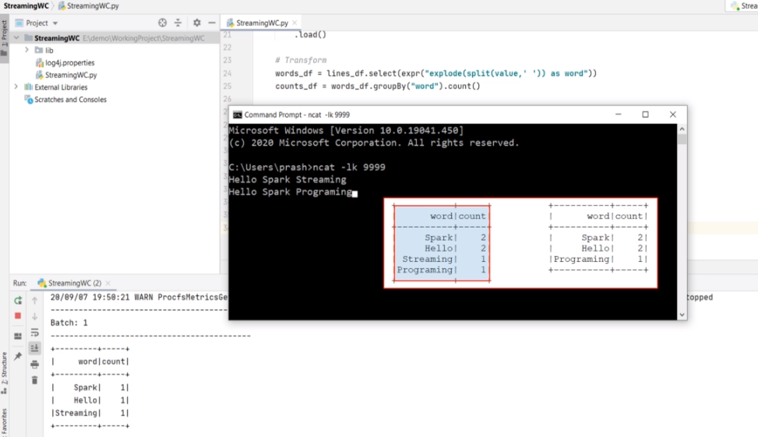

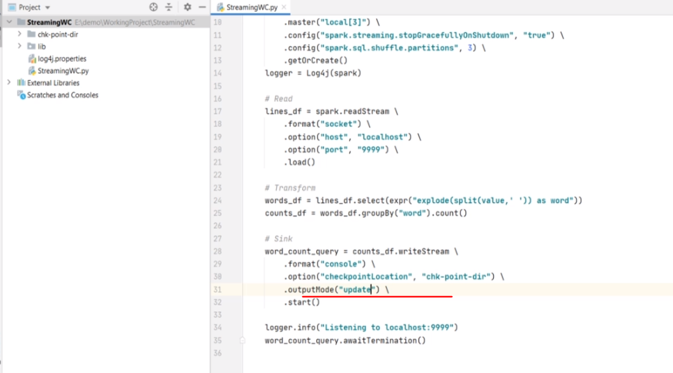

If you change the output mode to update and try the same two inputs, you will get the second type of output. Let me show you. It worked as expected. Right? So these modes allow you to decide the type of output that you want to see. You should be using the complete mode when you want to see and overwrite the full result. You will be using update mode when you want to see updated and new values only.

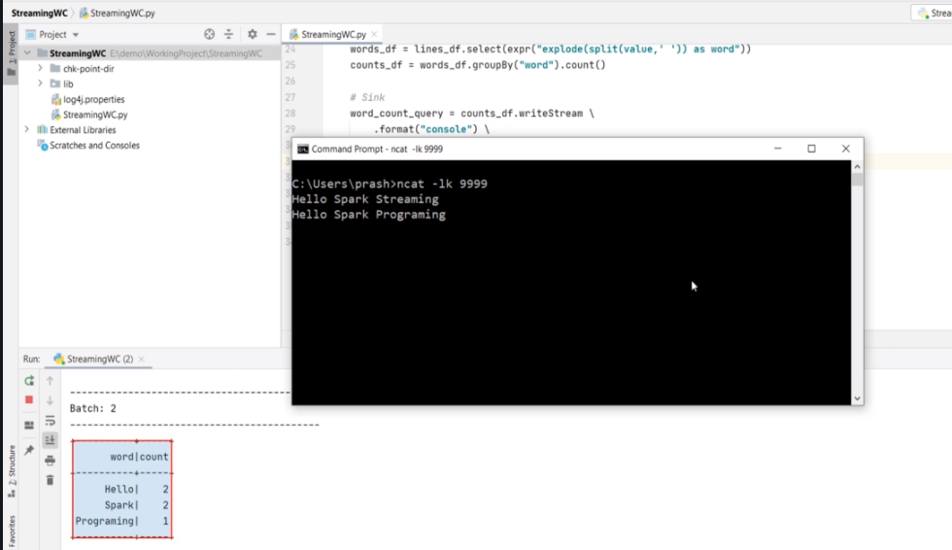

Now, what is the append mode? The append mode is to implement the insert only scenario. But the word-count example doesn't make any meaningful sense to insert only values. Let's try to understand it. If I try the append-mode, then I should expect an output like this for the first micro-batch. All three words are new, and so they should show up in the output. Now, if you send the second input, then you can expect the output like this. Why? Because Programming is the only new word. Spark, Hello, and Streaming were already there in the previous result, so they should not appear.

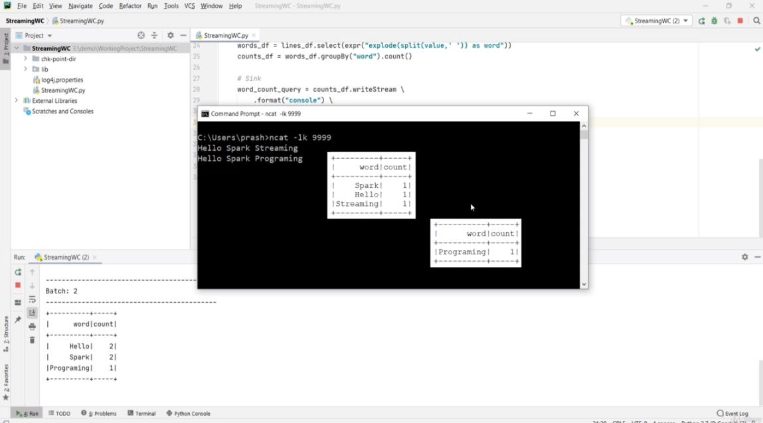

However, this kind of output is not at all meaningful. It doesn't make any sense for this example. Hence, the Append mode is not allowed here. Spark APIs are smart enough to detect such problems, and they throw you an exception. Let me try. I am changing it to append mode. Let me run it. What do you see? AnalysisException - Append output mode not supported when there are streaming aggregations. Why? Because aggregations such as count or sum might get updated in the future batches. Spark detects it and throws an error.

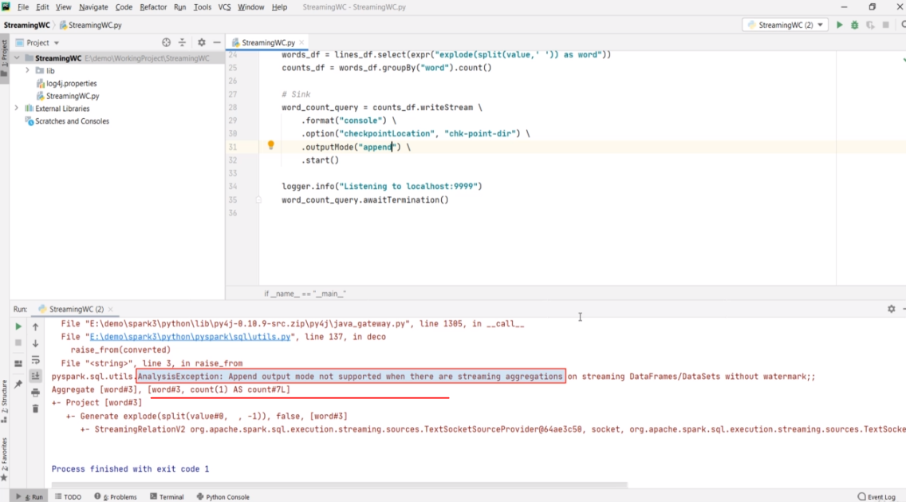

The point is straight. Understand the meaning and purpose of your Streaming code and use the output-mode accordingly. At a high level, remember this mapping as your guiding principle. Append mode is for insert only. Update mode is for updates and inserts. And the complete-mode is to overwrite the previous results. All three output-modes are not supported everywhere. Spark tries to catch your mistake and throws AnalysisException whenever possible. Make Sense?

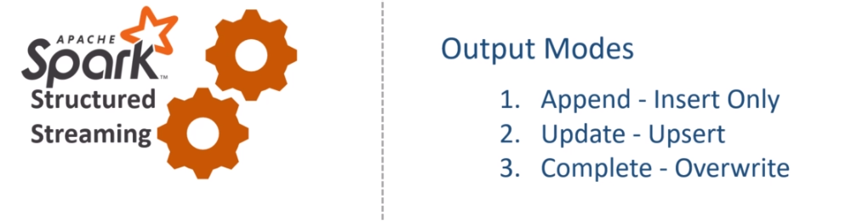

**Fault Tolerance and Restarts**

By now, you must have already got a sense of how Stream processing works in Apache Spark. You learned about the three-step process of creating Stream processing applications. I also talked about the built-in sources, sinks, schema inference, streaming query, triggers, output-mode, and checkpoint.

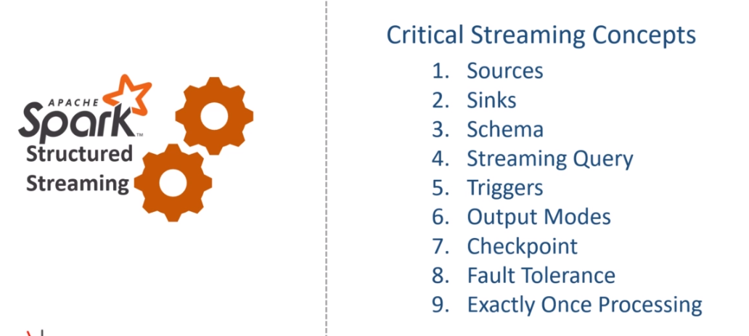

In this video, I am going to elaborate a little more on fault tolerance and exactly-once processing. So, let's start. A stream processing application in Apache Spark is expected to be running an infinite loop of micro-batches. So once a stream processing application is started, it should be running forever. Right? However, running an application forever is an impossible scenario. Even if it is a stream processing application, it will stop for one of the following reasons. Your application might stop due to a fault, such as an exception caused by malformed data or maybe for some other unknown reason. You cannot create a full-proof application that never fails or stops. Maintainance is another common reason for stoping your application. You might want to upgrade your application or upgrade the other software or the overall system where your application is running. The point is straight. Your application must be able to handle the stop and restart gracefully. What do we mean by gracefully?

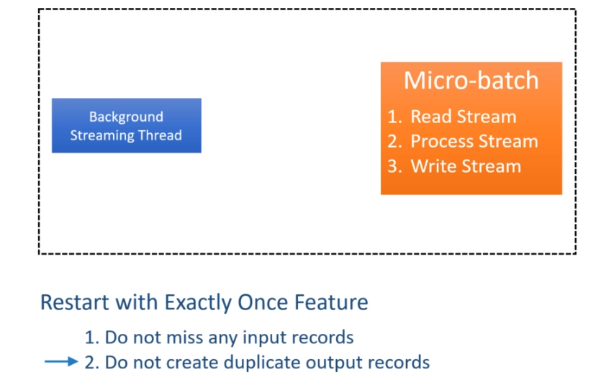

That simply means to maintain the exactly-once feature. Exactly-once means two things. Do not miss any input records. Do not create duplicate output records. Spark streaming API offers you enough support to achieve exactly-once. How? Let's try to understand it. Spark Structured Streaming maintains the state of the micro-batches in the checkpoint location. The checkpoint mainly contains two things. Read Position and State Information And these two things are maintained using checkpointing and write-ahead-log techniques that are used by databases to achieve durability and atomicity. The read position information represents the start and end of the data range, which is being processed by the current micro-batch. Once the micro-batch finishes, Spark also creates a commit to indicate that the data range is successfully processed.

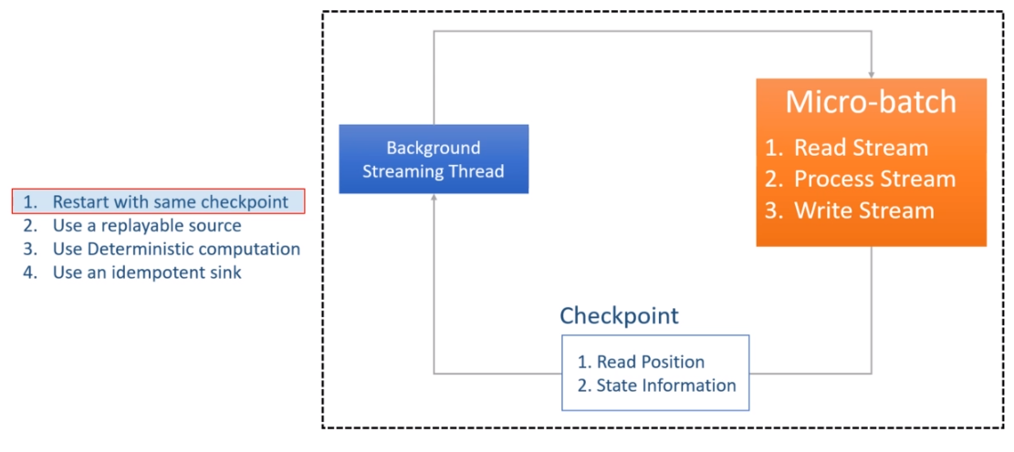

The state information is the intermediate data for the micro-batch, such as running-total of the word count. So the point is straight. Spark Structured streaming maintains all the necessary information to restart the unfinished micro-batch. However, the ability to restart the failed micro-batch does not guarantee exactly-once. You have the following requirements.

The first requirement is to restart your application with the same checkpoint location. And this makes sense also. Right? The checkpoint location contains all the necessary information to restart from the point it was stopped. If the checkpoint directory is deleted or the same query is started with a different checkpoint directory, it is like starting a new query from scratch.

The second requirement is to use a data source that allows us to re-read the incomplete micro-batch data. For example, the file data source and Kafka source allows you to read the old data once again from a given point. However, the socket data source does not allow you to reply to the socket read operation.

The third requirement is to make sure your application logic produces the same results when given the same input data. Suppose your application logic uses some date/time-dependent logic or uses some parameters that are going to change the output even if the input data is the same. In that case, a restart outcome is not deterministic.

Finally, your output sink should be able to identify the duplicates, ignore them, or update the older copy of the same record. Great! So you can stop your job, restart it and still achieve exactly-once as long as you are fulfilling these four requirements. One last thing. Let's assume your streaming job failed with an exception. You started investigating the problem, and you realized a bug in your code. You made some changes in your application code, and now you want to restart it again from the same point it was stopped. Is it possible? The answer is Yes and No.

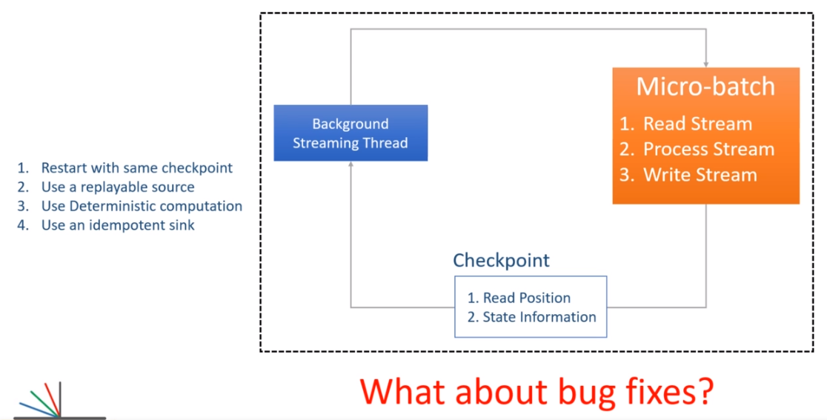

The answer is yes because Spark allows you to make some changes in your code and restart it again using the same checkpoint location as long as your changes do not cause a conflict with the checkpoint information. For example, you found that the error was caused by a malformed input record. So you decided to apply a filter condition to filter out the malformed records. Spark cannot detect such changes, and they will not even cause a conflict with the checkpoint information. So this change is allowed. However, Spark will throw an exception if your changes are detected. For example, if you change the groupBy() column name, the Spark will detect it and throw an exception. Now the next obvious question is this.

How Spark detects a change in code? Answer is simple. Spark maintains some information in the checkpoint location. For example, it keeps track of the source and sink. It also keeps track of the running aggregates. So if you are changing the groupBy column, the Spark will detect it by merely looking at the running aggregate of the previous batch. So, any change in the aggregate column is not allowed. However, you should not be getting into the details of what is allowed and what is not allowed. The simple guiding principle is understanding the impact of your code change and making a strategy of the restart. Restarting your application after a code change should go through impact analysis, assessment, and follow a restart strategy. Why? Because even if Spark does not throw an exception, your changes might still corrupt your data. So be careful with the code change in your production application.

### Spark Streaming with Kafka

**Streaming from Kafka Source**

So far, we made some excellent progress in learning Spark Streaming. We created a Spark Streaming application using the File Source. File Data sources are excellent in those scenarios where you collect data for some time, and then you write them to a file. I mean, creating files of 10, 20, or 50 records is not advisable. Right? Even if you look at the default block size of HDFS, it is 128 MB, and the S3 block size is 32 MB. The point is straight. File data sources will make sense when you collect some reasonable amount of data, and then you write it to a file. Collecting data and writing files might take a few minutes. Isn't it? So we often see the file data sources being used in a minute based micro-batches. If your use case can afford a few minutes of the trigger, then you can quickly implement your application using a file-based streaming source. However, a low latency stream processing requirements might not fit very well with the file-based sources.

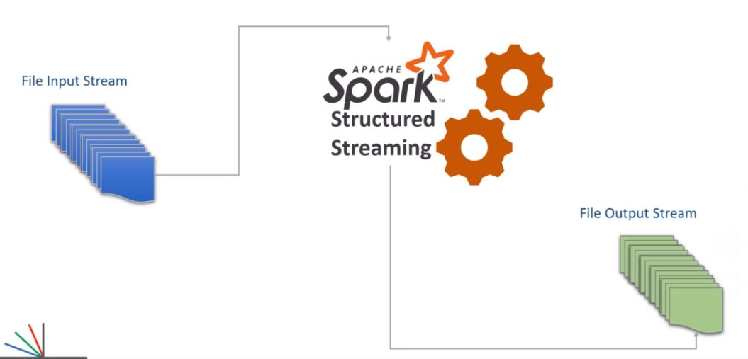

You might need to implement something that processes records more quickly and responds in seconds or less than a second. And there comes Apache Kafka.

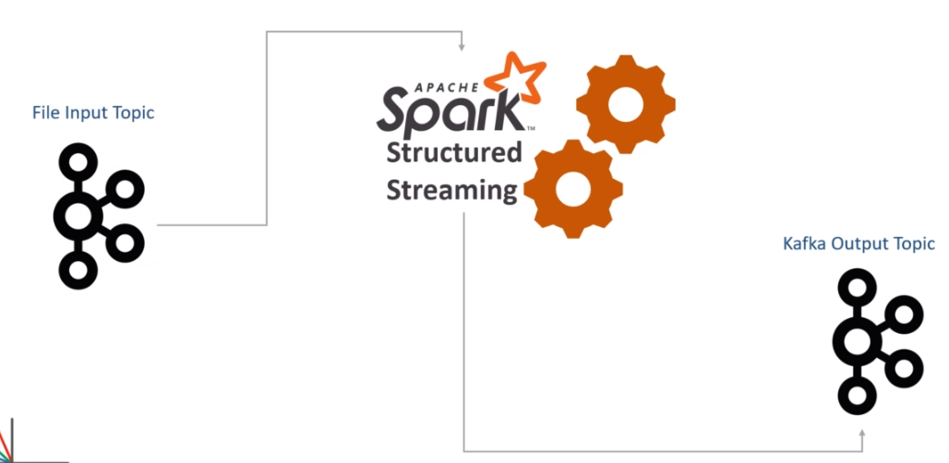

In this section, you will learn to work with Kafka as a streaming data source. Let's start. Do you remember the invoice flattening example? We are going to recreate the same example of flattening invoice items. However, this time, I am assuming that the records are coming to Apache Kafka. So, your invoices are continuously coming to Apache Kafka.

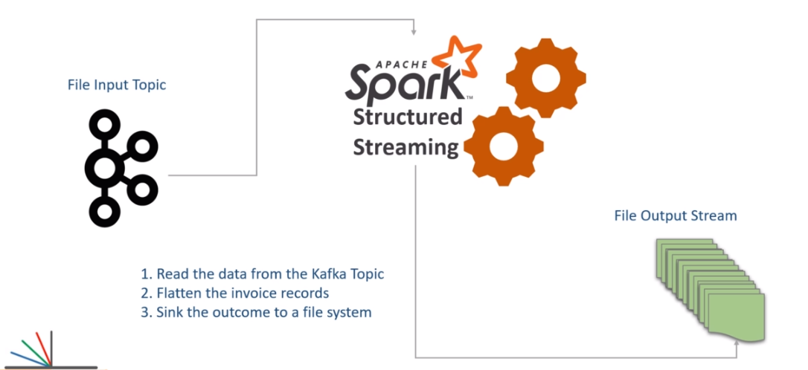

Now you are asked to create a Spark Structured Streaming application that does the following. Read the data from the Kafka Topic. Flatten the invoice records. And Sink the outcome to a file system. Let's do it. Here is my initial template application. I have a main entry point, and I also created a spark session. We are now ready to start coding the three steps. However, before we start, let me highlight a critical requirement. Spark SQL and Kafka integration is offered by a sperate package spark-sql-kafka. This package is available in the public maven repository. Let me show you.

<https://mvnrepository.com/artifact/org.apache.spark>

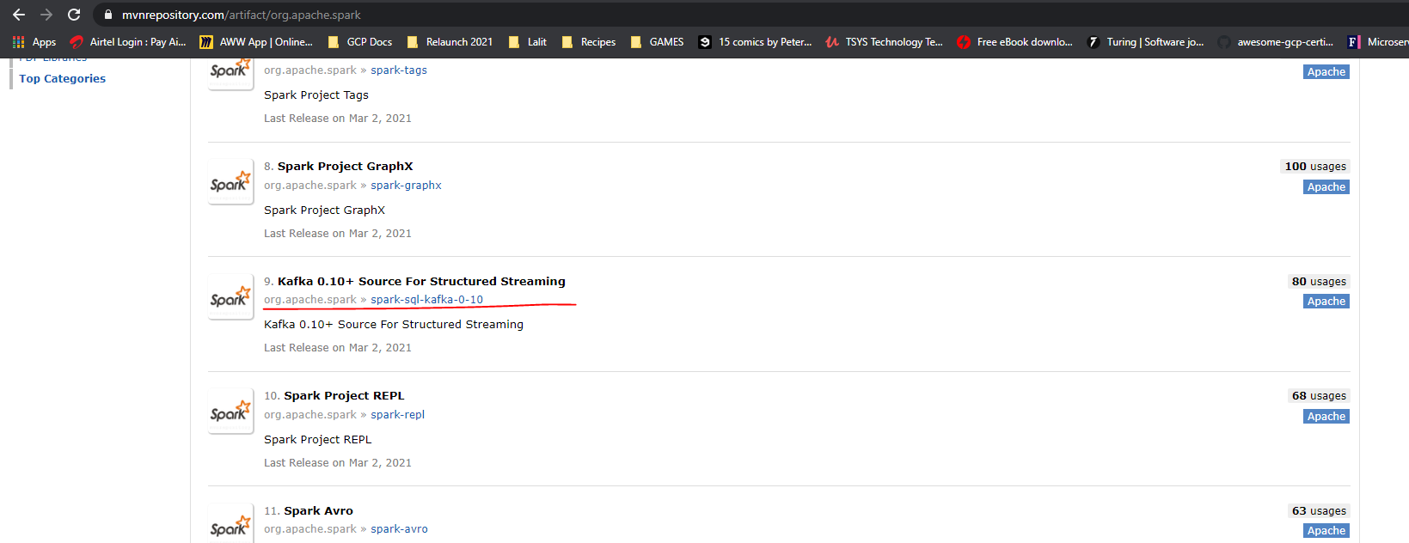

So, here is the base repository of Apache Spark. And here is the Kafka Source for Structured Streaming. This package supports Kafka 0.10 and above. The current version of Apache Kafka is 2.6. However, the Kafka API structure is the same since 0.10 onwards. So this package is good enough for us to use with any version of Apache Kafka above 0.10. If you scroll down, you will see one more package for Kafka Integration. However, this package is for the older DStream based APIs, which we do not recommend to use in your applications. Now let's come back to the structured streaming package for the Kafka integration. As on date, this package is available for the latest version of Spark 3.0.0. And this package is built using Scala 2.12. So, we should be using this one. Great! So how do we get this package to our spark environment? Simple. Include it in your spark-defaults.

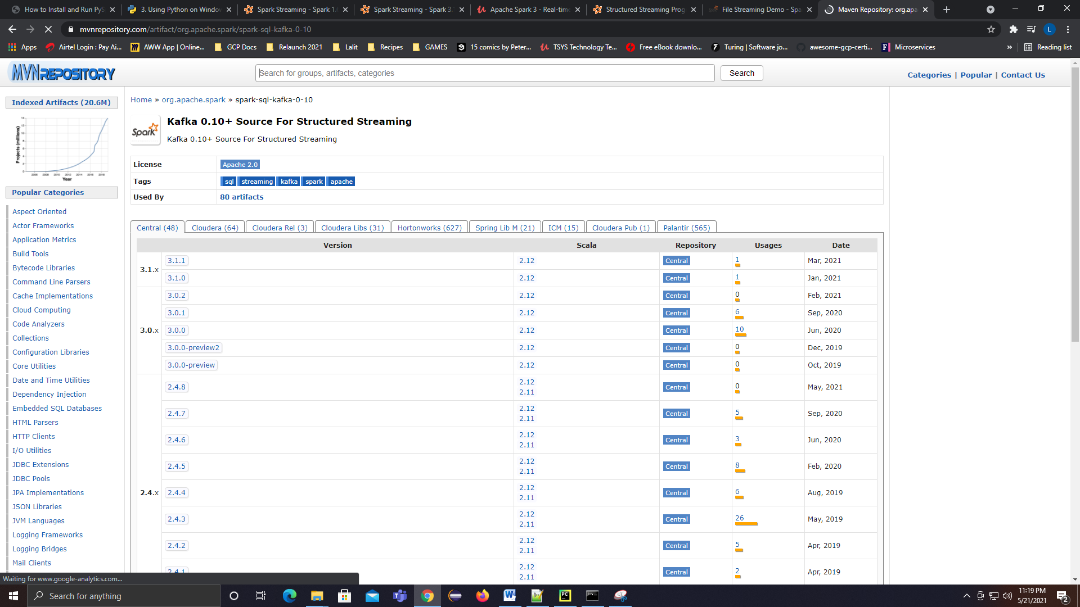

Let me show you. Here is my spark home. I will go to the conf directory and open my spark-defauls.conf. Here it is. I am setting spark.jars.packages configuration. And the value is the maven coordinates of the required package.

<!-- https://mvnrepository.com/artifact/org.apache.spark/spark-sql-kafka-0-10 -->

<dependency>

<groupId>org.apache.spark</groupId>

<artifactId>spark-sql-kafka-0-10_2.12</artifactId>

<version>3.1.1</version>

<scope>test</scope>

</dependency>

org.apache.spark**:**spark-sql-kafka-0-10_2.12**:**3.1.1

**spark-defaults.conf**

# Default system properties included when running spark-submit.

# This is useful for setting default environmental settings.

# Example:

# spark.master spark://master:7077

# spark.eventLog.enabled true

# spark.eventLog.dir hdfs://namenode:8021/directory

# spark.serializer org.apache.spark.serializer.KryoSerializer

# spark.driver.memory 5g

# spark.executor.extraJavaOptions -XX:+PrintGCDetails -Dkey=value -Dnumbers="one two three"

spark.driver.extraJavaOptions -Dlog4j.configuration=file:log4j.properties

spark.jars.packages org.apache.spark**:**spark-sql-kafka-0-10_2.12**:**3.1.1

We have three parts to the coordinates that are separated by a colon. The first part is the group id, the second one is the artifact id, and the last one is the spark version. Save this file and you are done. When we start our PySpark application, it will read this configuration and automatically download the required package and related dependencies from the Maven. Once downloaded, this package and other dependencies will be available to your application classpath. If you want, you can also set this configuration from your application. Here is an example.

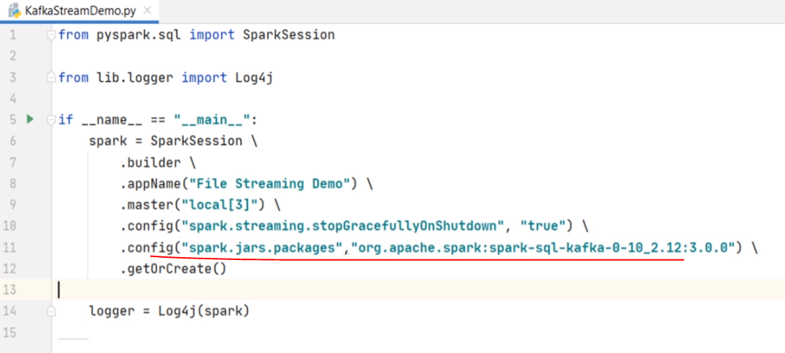

This setting will also give you the same effect. However, we do not recommend setting dependencies from inside your application code. It is always advised to keep such things outside the main application code. So, we recommend to keep it in the spark-defaults. Great! That's all. You are all set to integrate your Spark Streaming with Apache Kafka. Let's do it. We are going to create a DataFrame reading data from the Kafka source. Right?

We start with the spark session and call the readStream to get a DataStreamReader. Then we set the format. What is the format? Any guess? Yes, it is Kafka. However, reading from Kafka requires you to provide connection details. I hope you already learned Kafka. If not, check out my Kafka course for beginners. So, the first option is kafka.bootstrap.servers. You can give a comma-separated list of broker coordinates. But I am running a single node Kafka cluster, so I will be giving a single hostname and port. The Kafka source connector internally uses Kafka Consumer API. So, the next most crucial thing is to subscribe to a Kafka topic.

from pyspark.sql import SparkSession

from lib.logger import Log4j

if __name__ == "__main__":

spark = SparkSession \

.builder \

.appName("File Streaming Demo") \

.master("local[3]") \

.config("spark.streaming.stopGracefullyOnShutdown", "true") \

.getOrCreate()

logger = Log4j(spark)

kafka_df = spark.readStream \

.format("kafka") \

.option("kafka.bootstrap.servers", "localhost:9092") \

.option("subscribe", "invoices") \

.option("startingOffsets", "earliest") \

.load()

I want to read from the invoice topic, so I give the topic name as the invoice. What else? By default, the Kafka consumer reads from the latest offset. However, I want to change the starting offset as the earliest. This option makes sure we start reading from the beginning. However, you might be wondering with the following question? Will the second batch and third batch also read from the beginning? What if I stop the application and restart it again. Well, nothing to worry about. Spark maintains the current offset in the checkpoint. So, the starting offset is always overwritten from the checkpoint. The earliest will take effect only in case of the first run when your checkpoint is empty. Make Sense? Great! So we are done with the reading. What is next? The next step is to take this Kafka DataFrame and transform it as per the requirement. However, we have a catch here. Let me print the DataFrame schema and show you. So, the Kafka DataFrame always looks like this. You have a key and a value.

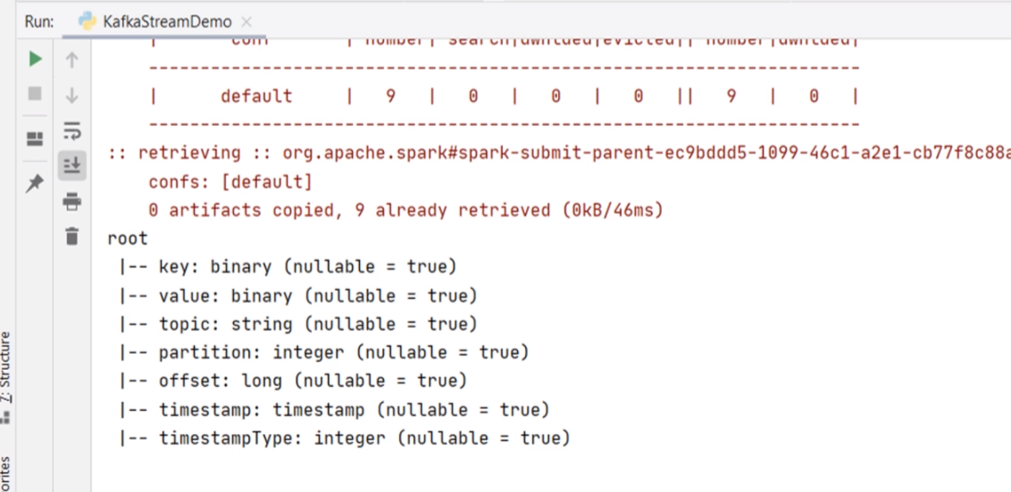

Then you have other fields like topic name, partition number, message offset, and timestamp. Most of the time, you are only concerned with the key and the value fields. Other fields are used by the Spark Streaming framework for creating the checkpoint. In this example, I expect a JSON invoice in the value field, and I do not care for the key. So, for me, it is the value field that I need to start with. However, I have a small problem. The value field is a binary type, and it is just a single field. Internally, it should contain a JSON data which looks something like this. This is one invoice. I can read it as a string by simply casting the value field to a string. Right? However, I cannot apply a DataFrame transform on this string unless I give it a proper schema. When I read the same invoice from a file, I could set the infer schema option, and the DataFrame that I got was a well structured DataFrame with a meaningful schema.

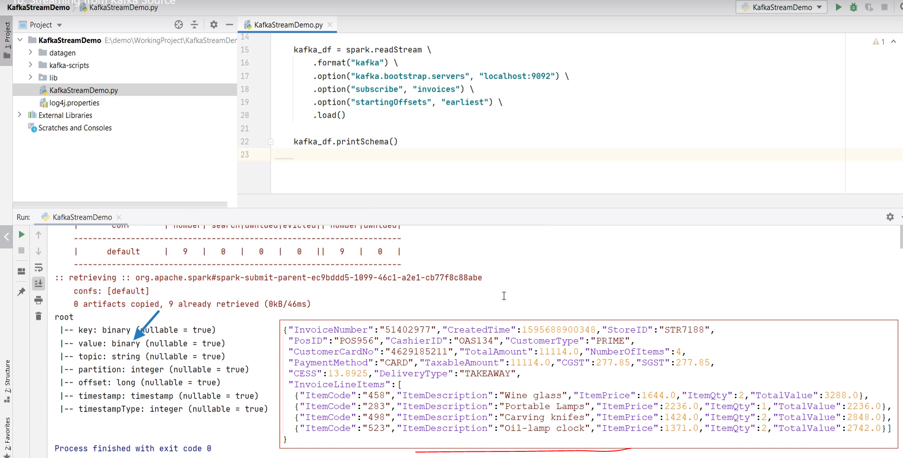

But in this Kafka DataFrame. I do not have a schema for my invoice. How do I fix it? Well, we can read the value field as a JSON string and assign a schema to it. I will show you in a minute. But before that, let me define a schema for the invoice. Here it is.

from pyspark.sql import SparkSession

from pyspark.sql.functions import from_json, col, expr

from pyspark.sql.types import StructType, StructField, StringType, LongType, DoubleType, IntegerType, ArrayType

from lib.logger import Log4j

if __name__ == "__main__":

spark = SparkSession \

.builder \

.appName("File Streaming Demo") \

.master("local[3]") \

.config("spark.streaming.stopGracefullyOnShutdown", "true") \

.getOrCreate()

logger = Log4j(spark)

schema = StructType([

StructField("InvoiceNumber", StringType()),

StructField("CreatedTime", LongType()),

StructField("StoreID", StringType()),

StructField("PosID", StringType()),

StructField("CashierID", StringType()),

StructField("CustomerType", StringType()),

StructField("CustomerCardNo", StringType()),

StructField("TotalAmount", DoubleType()),

StructField("NumberOfItems", IntegerType()),

StructField("PaymentMethod", StringType()),

StructField("CGST", DoubleType()),

StructField("SGST", DoubleType()),

StructField("CESS", DoubleType()),

StructField("DeliveryType", StringType()),

StructField("DeliveryAddress", StructType([

StructField("AddressLine", StringType()),

StructField("City", StringType()),

StructField("State", StringType()),

StructField("PinCode", StringType()),

StructField("ContactNumber", StringType())

])),

StructField("InvoiceLineItems", ArrayType(StructType([

StructField("ItemCode", StringType()),

StructField("ItemDescription", StringType()),

StructField("ItemPrice", DoubleType()),

StructField("ItemQty", IntegerType()),

StructField("TotalValue", DoubleType())

]))),

])

kafka_df = spark.readStream \

.format("kafka") \

.option("kafka.bootstrap.servers", "localhost:9092") \

.option("subscribe", "invoices") \

.option("startingOffsets", "earliest") \

.load()

I am using a StructType and StructField to model the invoice schema. I hope you already know this, and it does not require a separate explanation. After all, knowing Spark fundamentals is one of the prerequisites for this course. Right? Great! So now, we have a schema, and we want to assign this schema to the value field. Let's do it. I will create a new DataFrame starting from the Kafka DataFrame. I will use the select() method to take only one column. The value. Right? We are only concerned with the value filed. However, the value is binary. So, I should cast it to a string. I can safely cast it to string because I know the value contains a JSON string. Right? So now I should get a string. Assigning a schema to a JSON string is straightforward. Spark offers you a from_json() function to do it. So, let me apply the from_json() function to the value string. This function takes two arguments. The first argument is the JSON string, and the second argument is the schema. That's all. You will get a field that has a well-defined schema. Let's print the schema of this new DataFrame and see what do we get. So, my new DataFrame has got a single field. And the field itself has got a proper invoice schema. However, the field name is a little weird.

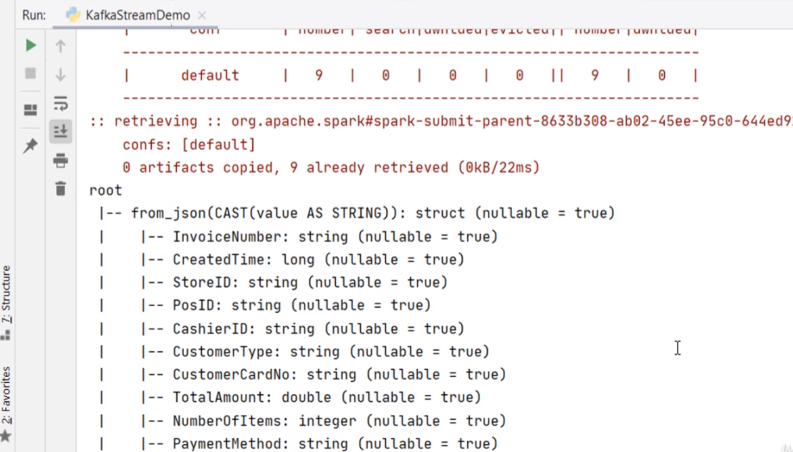

We can fix it. Right? Let's give an alias to the resulting column. Let me check it once again. Now it looks beautiful. Isn't it?

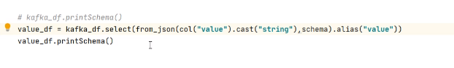

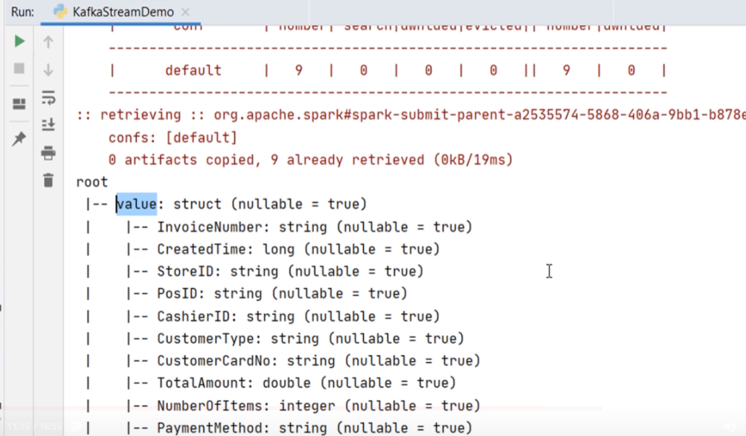

We came too far in fixing the Kafka record. Now I have a DataFrame of single column. The column itself is another DataFrame. So, it is like a DataFrame of DataFrame. The next step is to flatten it. Let's do it. I am going to create another exploded DataFrame. Then, I am going to select value-dot-invoice-number. Then the CreatedTime and so on. Finally, we explode() the InvoiceLineItems. The exploded DataFrame is the same as we created in the earlier example when we were reading data from the file. Right? The rest of the code is the same, as we have already written in the earlier example. I am flattening the exploded DataFrame, then I am creating and starting a stream query.

from pyspark.sql import SparkSession

from pyspark.sql.functions import from_json, col, expr

from pyspark.sql.types import StructType, StructField, StringType, LongType,

DoubleType, IntegerType, ArrayType

from lib.logger import Log4j

if __name__ == "__main__":

spark = SparkSession \

.builder \

.appName("File Streaming Demo") \

.master("local[3]") \

.config("spark.streaming.stopGracefullyOnShutdown", "true") \

.getOrCreate()

logger = Log4j(spark)

schema = StructType([

StructField("InvoiceNumber", StringType()),

StructField("CreatedTime", LongType()),

StructField("StoreID", StringType()),

StructField("PosID", StringType()),

StructField("CashierID", StringType()),

StructField("CustomerType", StringType()),

StructField("CustomerCardNo", StringType()),

StructField("TotalAmount", DoubleType()),

StructField("NumberOfItems", IntegerType()),

StructField("PaymentMethod", StringType()),

StructField("CGST", DoubleType()),

StructField("SGST", DoubleType()),

StructField("CESS", DoubleType()),

StructField("DeliveryType", StringType()),

StructField("DeliveryAddress", StructType([

StructField("AddressLine", StringType()),

StructField("City", StringType()),

StructField("State", StringType()),

StructField("PinCode", StringType()),

StructField("ContactNumber", StringType())

])),

StructField("InvoiceLineItems", ArrayType( StructType([

StructField("ItemCode", StringType()),

StructField("ItemDescription", StringType()),

StructField("ItemPrice", DoubleType()),

StructField("ItemQty", IntegerType()),

StructField("TotalValue", DoubleType())

]))),

])

kafka_df = spark.readStream \

.format("kafka") \

.option("kafka.bootstrap.servers", "localhost:9092") \

.option("subscribe", "invoices") \

.option("startingOffsets", "earliest") \

.load()

# kafka_df.printSchema()

value_df = kafka_df.select( from_json(col("value").cast("string"), schema)

.alias("value"))

explode_df = value_df.selectExpr("value.InvoiceNumber", "value.CreatedTime",

"value.StoreID",

"value.PosID", "value.CustomerType",

"value.PaymentMethod", "value.DeliveryType",

"value.DeliveryAddress.City",

"value.DeliveryAddress.State",

"value.DeliveryAddress.PinCode",

"**explode(**value.InvoiceLineItems**) as LineItem**")

flattened_df = explode_df \

.withColumn("ItemCode", expr("LineItem.ItemCode")) \

.withColumn("ItemDescription", expr("LineItem.ItemDescription")) \

.withColumn("ItemPrice", expr("LineItem.ItemPrice")) \

.withColumn("ItemQty", expr("LineItem.ItemQty")) \

.withColumn("TotalValue", expr("LineItem.TotalValue")) \

.drop("LineItem")

logger.info("Listening to Kafka")

invoice_writer_query.awaitTermination()

We are done. Do you want to run it? Let me show you. This example requires Kafka. So, I have these scripts to start the Kafka server. You can run these scripts from your IDE, or you can copy the script content and run it from the command window. So, we start zookeeper. Then we begin the broker. Then I create the topic. Now we need to start sending some invoices to the Kafka. Right? So, let me start a console producer. Good. Now you can take a sample invoice and send it here. Let me do it. Good. Let me start the application. What do you expect? It should create an output file. Right? Here it is. My invoice is flattened.

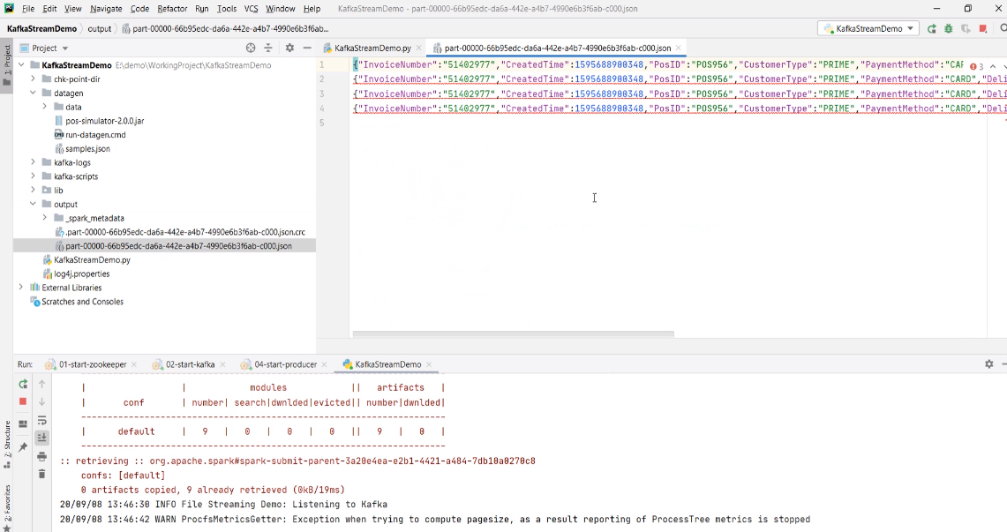

You want to send some more. Let me do it. Wait for a minute, and you can expect another file in the output directory. Looks like working. Right? Let's stop it. In fact, I want to stop everything and clean it up thoroughly.

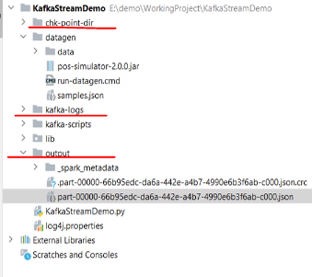

I am deleting the checkpoint, Kafka logs, and the output directory. I want to start over fresh. So, let's start the Kafka once again. But this time, I am not starting the producer. I got you something better. Let me start the Spark streaming application. It's running now. But it shouldn't be doing anything because we do not have invoices coming to the Kafka cluster. I got you a pos simulator jar.

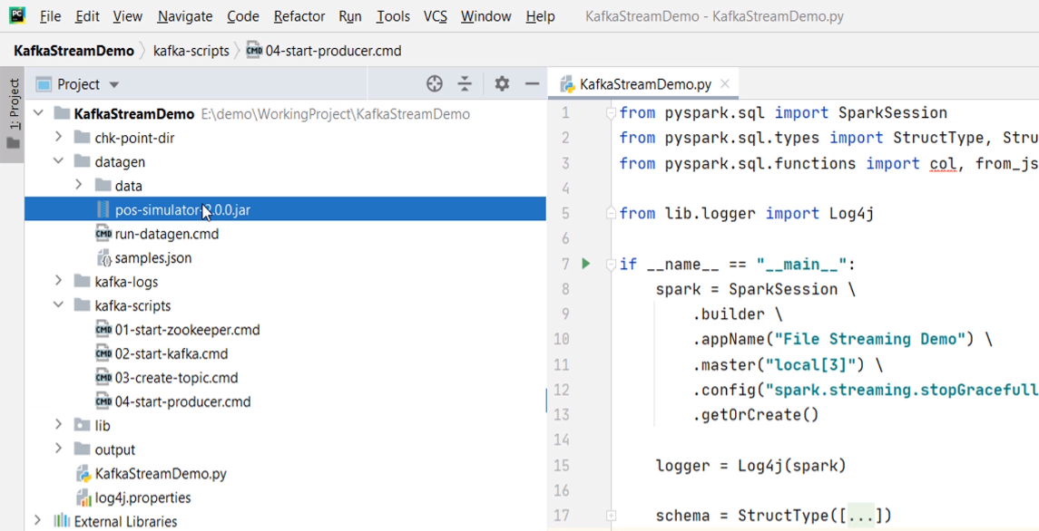

This is an example that I developed for my Kafka beginners course. This Jar can continuously generate realistic invoices and send it to the Kafka cluster. Here is a script to run the simulator application. It takes three arguments.

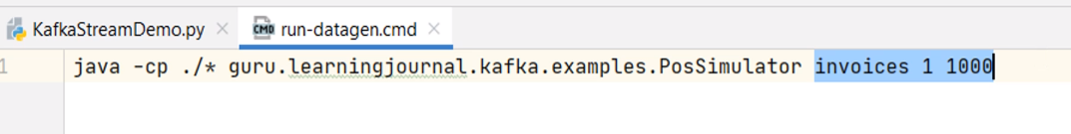

The first argument is the Topic name. The second one is the number of producer threads. I am using one thread, but you can give 2 or 3. The next argument is the pause in milliseconds between two invoices. So, this simulator is going to send one invoice and pause for one second. Then send the next invoice. You can increase the speed by reducing the pause time or increasing the thread count. Let me run it. Great! So we started sending one invoice every second. Now you can go to the Spark UI and check what is happening. We already got two batches. Right?

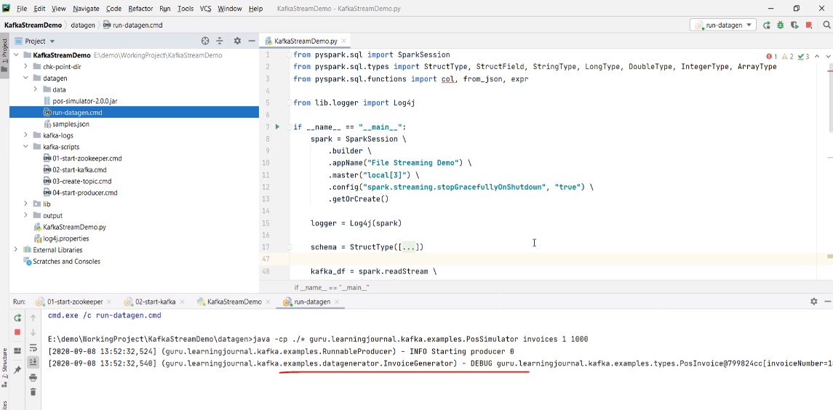

Let's wait for a few minutes. Now we have three batches. And this will keep going on. You can come back and check the output directory. We have a bunch of files now. Each file is an outcome of invoices received in one minute window. Right?

**Working with Kafka Sinks**

In the earlier video, we created an example to read data from a Kafka source. We applied some transformations and saved the outcome to a file sink. In this video, we will create a brand new example to read data from the Kafka cluster, perform some transformations, and write it back to the Kafka cluster. So, let's start. Let me define a simple problem statement. You are working for a retail organization. Your team has already built a data collection pipeline to bring all the invoices to a Kafka cluster. So, all your invoices are coming to the Kafka cluster. Now you are asked to create a Spark stream processing application to achieve the following. Read all the invoices from the Kafka Cluster. Extract necessary information from the Invoice record and create a notification record for the customer. The notification records look like this. It is s JSON record which shows only three fields. CustomerCardNo TotalAmount for the current invoice and the Loyalty Points that customer has earned on the current invoice.

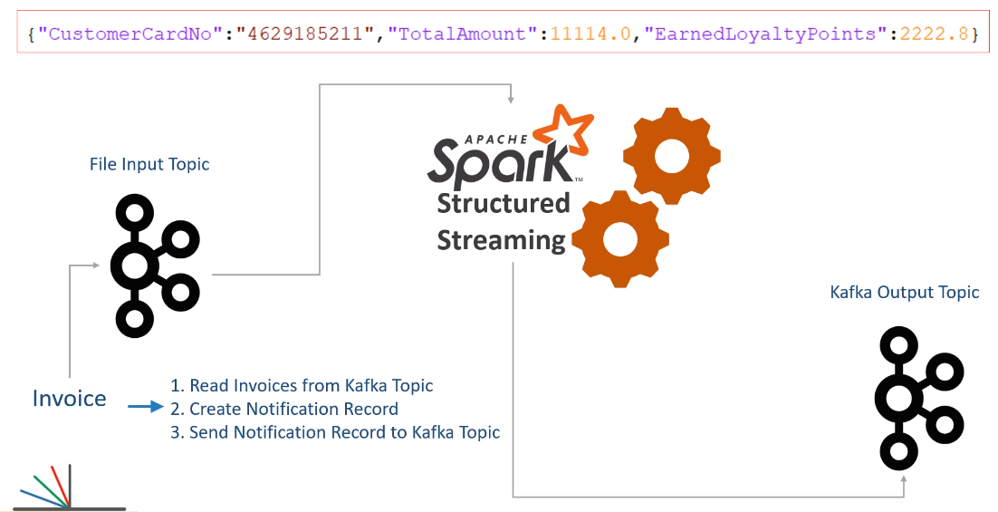

Finally, send the notification invoice to a Kafka topic. That's all. You are done. However, we have one more small requirement. Kafka topic receives data as a Key/Value pair. Right? So the requirement is to send the invoice number as a key, and the notification record goes as the value. Make Sense? A separate team will create a new application to read these notification records from the Kafka topic and send an SMS to the customer. How will you go about it? We already learned half of the things. You learned to read data from the Kafka topic, give it a schema, and transform the invoice record to the desired format. All that is simple because you already learned to do similar things. Right? Let me show you the rest of the things. Here is my example project. I have got you some sample invoices in this file to test your application. I also have these scripts to start the Kafka cluster, create input and output topics, run a producer and a consumer. And here is the starter application code. I already have some code to do the following things. Create a Spark session. Define the invoice schema. Read a stream from the Kafka topic. Finally, I am extracting the value field from the Kafka record, and converting it to a Dataframe with a proper schema.

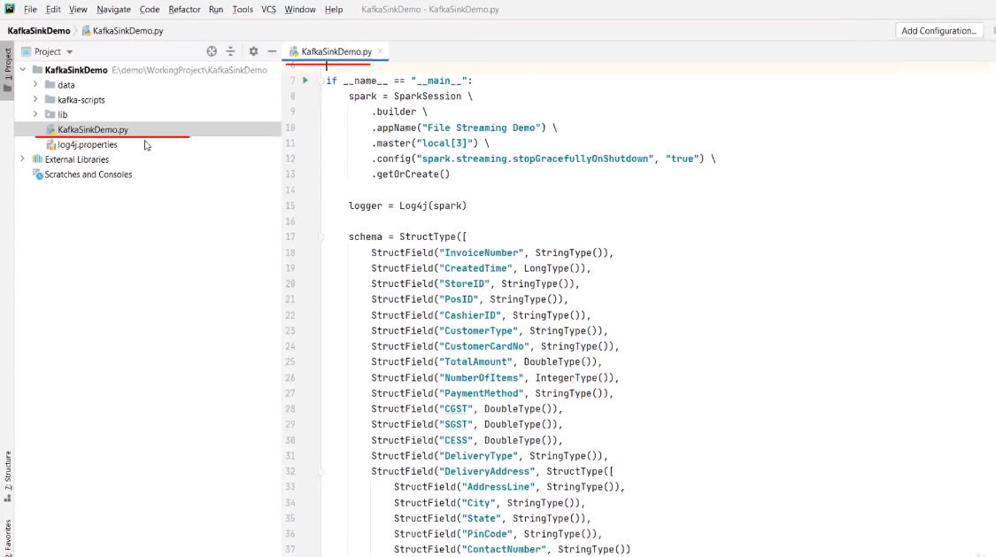

Up to this point, everything is the same as we learned in the earlier video. Right? Now, all we need to do is transform this value Dataframe to a notification Dataframe and send it to Kafka.

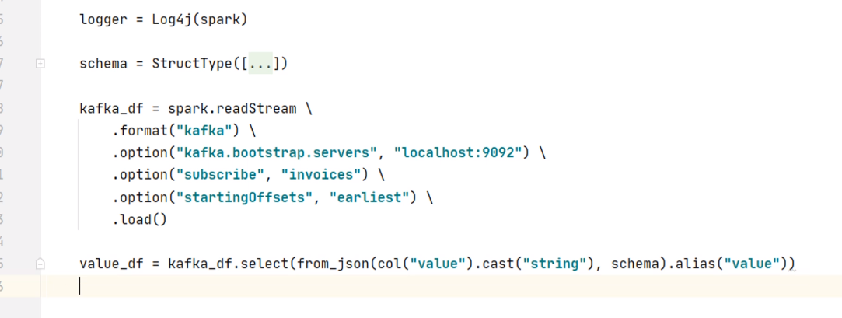

But before I proceed further, I want to see this value Dataframe. We can print the schema of this Dataframe as we did in the earlier video. However, I do not want to look at the schema only. I want to look at the values also. Let me try showing this Dataframe. Can I run it?

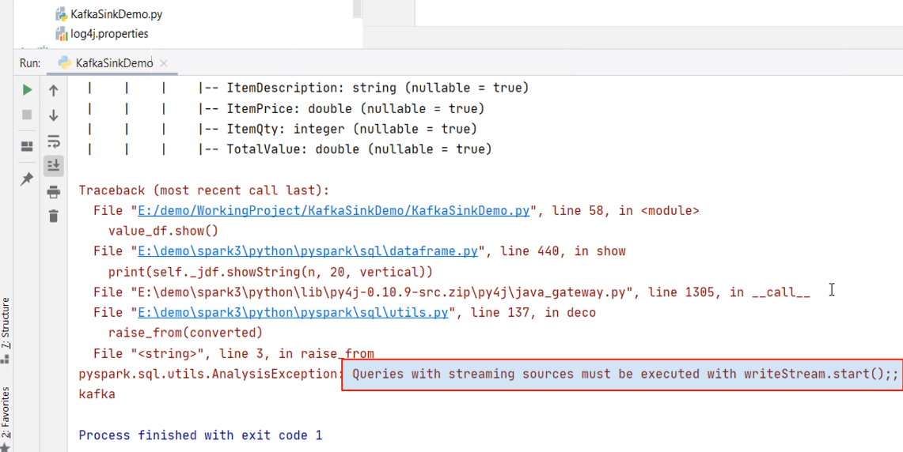

Oops! I got an AnalysisException - Queries with streaming sources must be executed with writeStream.start() So, you cannot show a streaming Dataframe. That's not a big problem. However, developing a series of transformations could be complicated, and you might want to take a step by step approach. I mean, apply some transformation and show your Dataframe to see if you are doing it correctly. Then you apply the next transformation and see the results once again. Right? I want to take that approach, and I am sure you will also need it. But how do we do it with a streaming Dataframe? It does not allow you to show your Dataframe. Here is the trick. Change the readStream to a plain read. The read method is a batch processing equivalent of the readStream. Now this kafka_df and all other subsequent Dataframes such as velue_df is no longer a streaming Dataframe. You are still reading data from the Kafka topic. But now it is not going to loop into micro-batches. You will read it once, do these transformations and stop. That's all. But as a side effect, you will be able to show() your dataframe and debug your application. Once you are done with your transformations, you can simply change it to readStream.

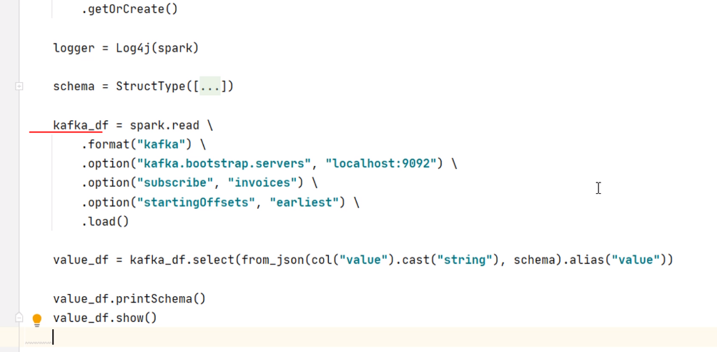

Everything else remains the same. Make sense? Great! So let me do one more transformation, and then I will check my Dataframe. So, I will start with the velue_df and apply the select() method. As per the requirement, I need only five fields. The first one is the value.InvoiceNumber. Then we have value.CustomerCardNo and TotalAmount. But we also need the Loyalty Points. The Loyalty points are 20% of the total amount. So, we can use the withColumn() to add a new field for the loyalty points. Make sense? You already learned all this in Spark fundamentals. Right? Now let me show this Dataframe. I want to make sure that I have done things correctly to this point.

from pyspark.sql import SparkSession

from pyspark.sql.functions import from_json, col, expr

from pyspark.sql.types import StructType, StructField, StringType, LongType, DoubleType, IntegerType, ArrayType

from lib.logger import Log4j

if __name__ == "__main__":

spark = SparkSession \

.builder \

.appName("File Streaming Demo") \

.master("local[3]") \

.config("spark.streaming.stopGracefullyOnShutdown", "true") \

.getOrCreate()

logger = Log4j(spark)

schema = StructType([

StructField("InvoiceNumber", StringType()),

StructField("CreatedTime", LongType()),

StructField("StoreID", StringType()),

StructField("PosID", StringType()),

StructField("CashierID", StringType()),

StructField("CustomerType", StringType()),

StructField("CustomerCardNo", StringType()),

StructField("TotalAmount", DoubleType()),

StructField("NumberOfItems", IntegerType()),

StructField("PaymentMethod", StringType()),

StructField("CGST", DoubleType()),

StructField("SGST", DoubleType()),

StructField("CESS", DoubleType()),

StructField("DeliveryType", StringType()),

StructField("DeliveryAddress", StructType([

StructField("AddressLine", StringType()),

StructField("City", StringType()),

StructField("State", StringType()),

StructField("PinCode", StringType()),

StructField("ContactNumber", StringType())

])),

StructField("InvoiceLineItems", ArrayType(StructType([

StructField("ItemCode", StringType()),

StructField("ItemDescription", StringType()),

StructField("ItemPrice", DoubleType()),

StructField("ItemQty", IntegerType()),

StructField("TotalValue", DoubleType())

]))),

])

kafka_df = spark.readStream \

.format("kafka") \

.option("kafka.bootstrap.servers", "localhost:9092") \

.option("subscribe", "invoices") \

.option("startingOffsets", "earliest") \

.load()

value_df = kafka_df.select(from_json(col("value").cast("string"), schema)

.alias("value"))

notification_df = value_df.select("value.InvoiceNumber", "value.CustomerCardNo",

"value.TotalAmount") \

.withColumn("EarnedLoyaltyPoints", expr("TotalAmount * 0.2"))

So, let me start the Kafka cluster, create a topic, start the producer, and send at least one record. Now I can run the application. Great! Looks like I am doing good. Isn't it? So now we have the notification record. All we need to do is to create a Kafka sink and send it. That should be simple. Let me change this read to the readStream. Now, I am ready to create a sink query and start it. Here is the writer query. Let me explain. We start with the notification Dataframe and use the writeStream. I am giving a name to the query. The format is Kafka, and I am also providing connection details and the topic name. The output behavior is insert-only, so I am applying the append mode. We also need to give the checkpoint location and finally start the query. This all looks similar to the file sink. Right? The only difference is in the format and these two options. Looks like we are done. However, there is a small gotcha. This query is not going to work. Why? Because the Kafka accepts a key/value pair. And my notification Dataframe is not a key/value pair. The notification dataframe has got four fields like this.

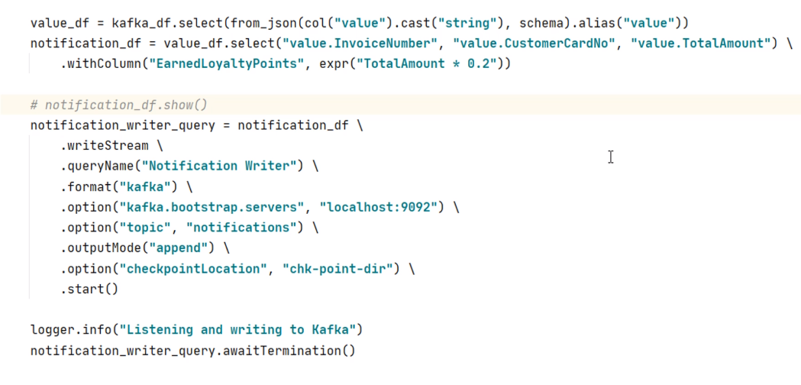

I showed you. Right? We cannot send it as it is, and even Spark will not allow you to send it to Kafka. So what can we do? We must transform the notification Dataframe to the following structure. So, if you want to send a Dataframe to Kafka, it must have two columns named as key and value. And you should also serialize your key and value to an appropriate format. We want to send the key as a string and the value as a JSON record. So we must transform the notification Dataframe to comply with the key/value schema.

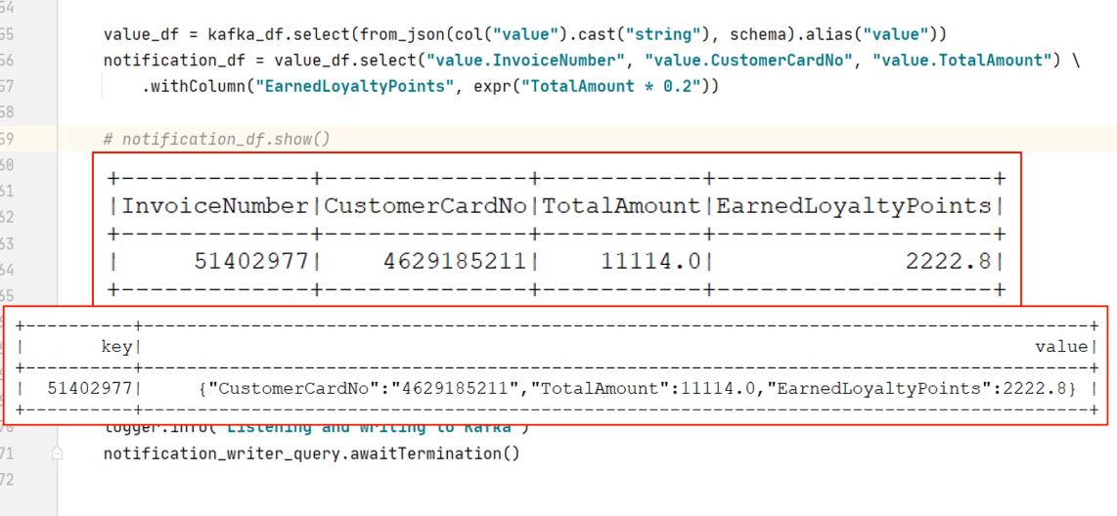

Let's do it. So I am going to create a Kafka target Dataframe. Start with the notification Dataframe and use the selectExpr() method. My first column should be InvoiceNumber renamed as key. The second column is a JSON record. Right? So you can use the to_json() function. Spark also gives you a named_struct() function. This function allows you to create a struct with the given field names and values. So, what do we want?

from pyspark.sql import SparkSession

from pyspark.sql.functions import from_json, col, expr

from pyspark.sql.types import StructType, StructField, StringType, LongType, DoubleType, IntegerType, ArrayType

from lib.logger import Log4j

if __name__ == "__main__":

spark = SparkSession \

.builder \

.appName("File Streaming Demo") \

.master("local[3]") \

.config("spark.streaming.stopGracefullyOnShutdown", "true") \

.getOrCreate()

logger = Log4j(spark)

schema = StructType([

StructField("InvoiceNumber", StringType()),

StructField("CreatedTime", LongType()),

StructField("StoreID", StringType()),

StructField("PosID", StringType()),

StructField("CashierID", StringType()),

StructField("CustomerType", StringType()),

StructField("CustomerCardNo", StringType()),

StructField("TotalAmount", DoubleType()),

StructField("NumberOfItems", IntegerType()),

StructField("PaymentMethod", StringType()),

StructField("CGST", DoubleType()),

StructField("SGST", DoubleType()),

StructField("CESS", DoubleType()),

StructField("DeliveryType", StringType()),

StructField("DeliveryAddress", StructType([

StructField("AddressLine", StringType()),

StructField("City", StringType()),

StructField("State", StringType()),

StructField("PinCode", StringType()),

StructField("ContactNumber", StringType())

])),

StructField("InvoiceLineItems", ArrayType(StructType([

StructField("ItemCode", StringType()),

StructField("ItemDescription", StringType()),

StructField("ItemPrice", DoubleType()),

StructField("ItemQty", IntegerType()),

StructField("TotalValue", DoubleType())

]))),

])

kafka_df = spark.readStream \

.format("kafka") \

.option("kafka.bootstrap.servers", "localhost:9092") \

.option("subscribe", "invoices") \

.option("startingOffsets", "earliest") \

.load()

value_df = kafka_df.select(from_json(col("value").cast("string"), schema).alias("value"))

notification_df = value_df.select("value.InvoiceNumber", "value.CustomerCardNo",

"value.TotalAmount") \

.withColumn("EarnedLoyaltyPoints", expr("TotalAmount * 0.2"))

# kafka_target_df = notification_df.selectExpr("InvoiceNumber as key",

# "to_json(struct(*)) as value")

kafka_target_df = notification_df.selectExpr("InvoiceNumber as key",

"""to_json(named_struct(

'CustomerCardNo', CustomerCardNo,

'TotalAmount', TotalAmount,

'EarnedLoyaltyPoints', TotalAmount * 0.2)) as value""")

logger.info("Listening and writing to Kafka")

notification_writer_query.awaitTermination()

The first field name should be CustomerCardNo, and the value comes from CustomerCardNo field. Similarly, the second field should be TotalAmount, and value also comes from the TotalAmount. The last name is the EarnedLoyaltyPoints, and the value is coming as 20% of the TotalAmount. Finally, we give an alias to this thing as value. That's all. Now, this Dataframe should look like this.

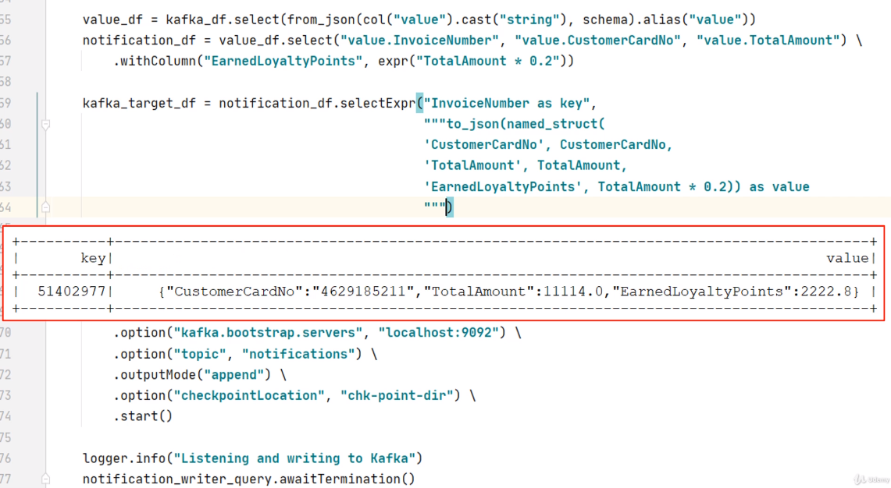

If you want, you can use the show() method and check it. Now we can change this Dataframe from notification to the KafkaTargetDF. Make Sense? That's all. We are done. Let me start the Kafka cluster.

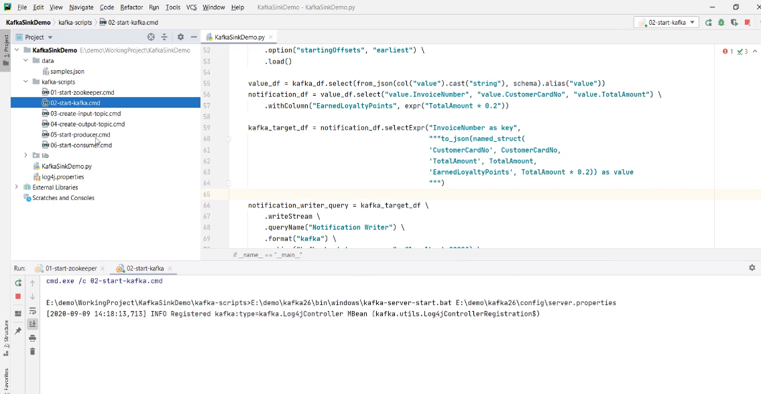

Start the producer and send at least one input. Now run the application. Looks like working. You can start the consumer and check the target topic. Send one more input, come back to the consumer, and you will see another notification record. Great! So we learned to create a Kafka sink. Right? The only point to remember is to make sure that you are transforming your target Dataframe to a key/value pair. And rest is the same as the file sink.

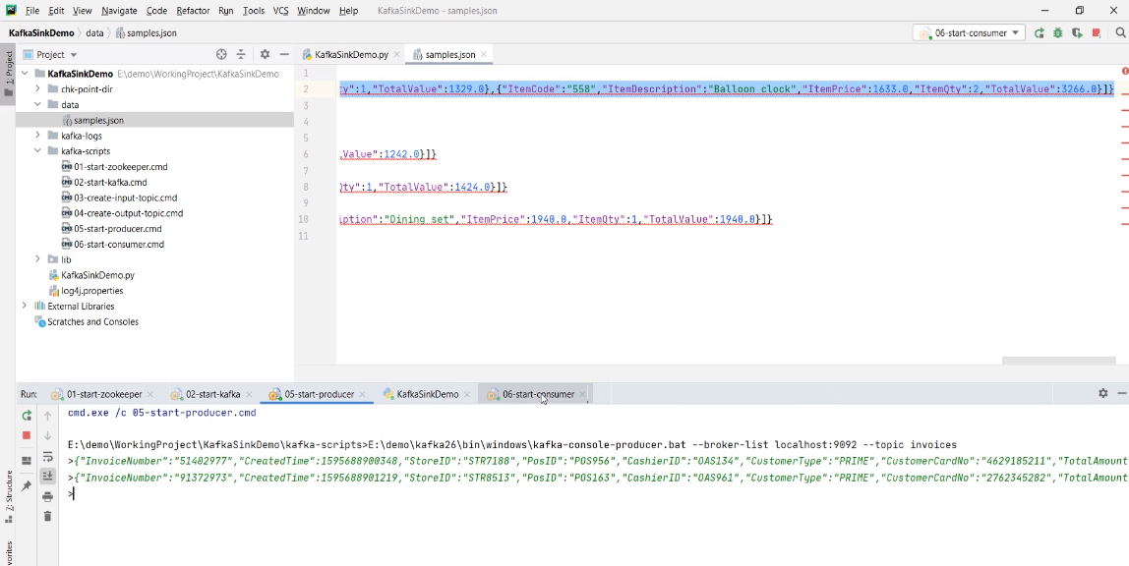

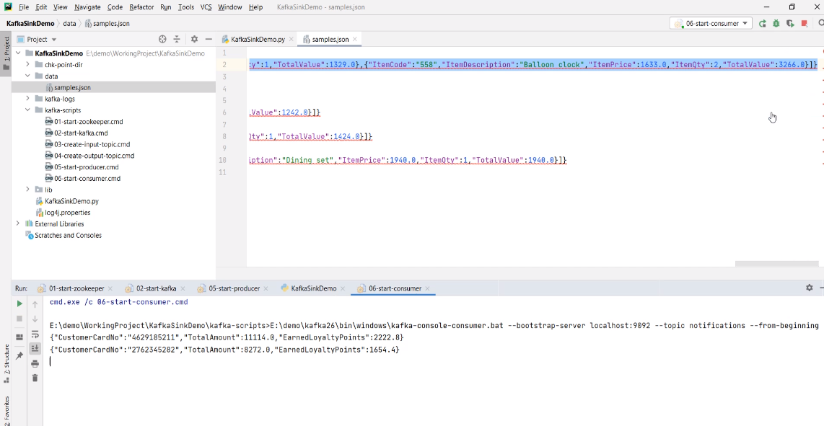

**Multi-query Streams Application**

We created two examples using Kafka as a source. In both examples, we were reading invoices from Kafka. However, we performed two different sets of processing. In the first example, we flattened the invoices and sent the output to a file sink. In the second example, we created a notification record and sent it to a Kafka topic.

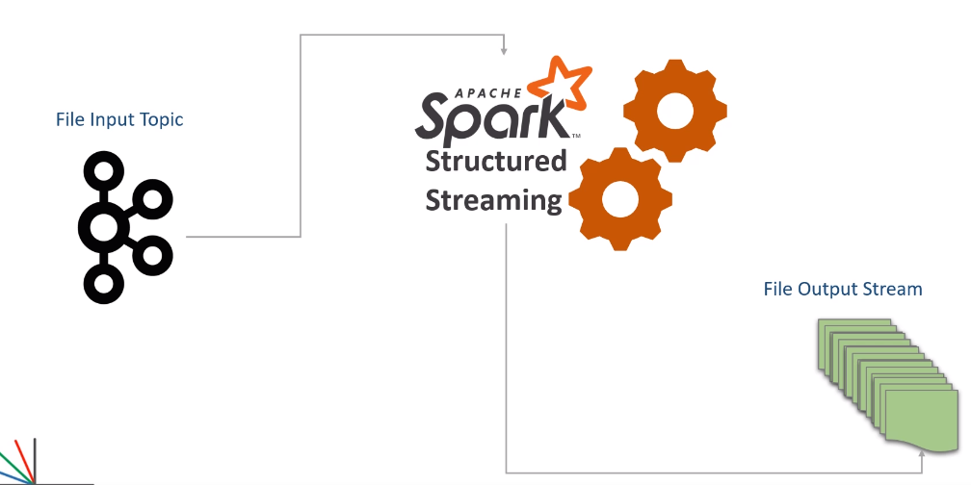

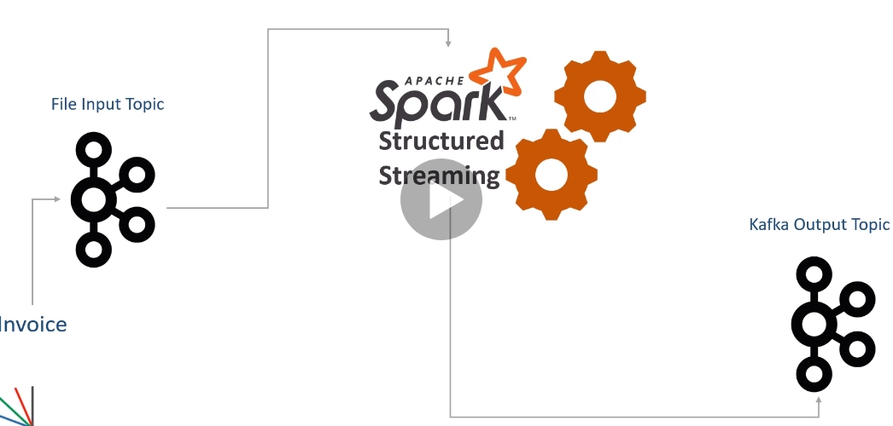

However, in both examples, we are reading the same invoice from the same Kafka source. Now the question is this. Do we really need two separate Spark applications? Can't we run two streaming queries in a single Spark application? We can do it. In fact, it makes a good sense to implement multiple queries in a single application if you need the same input for both the queries.

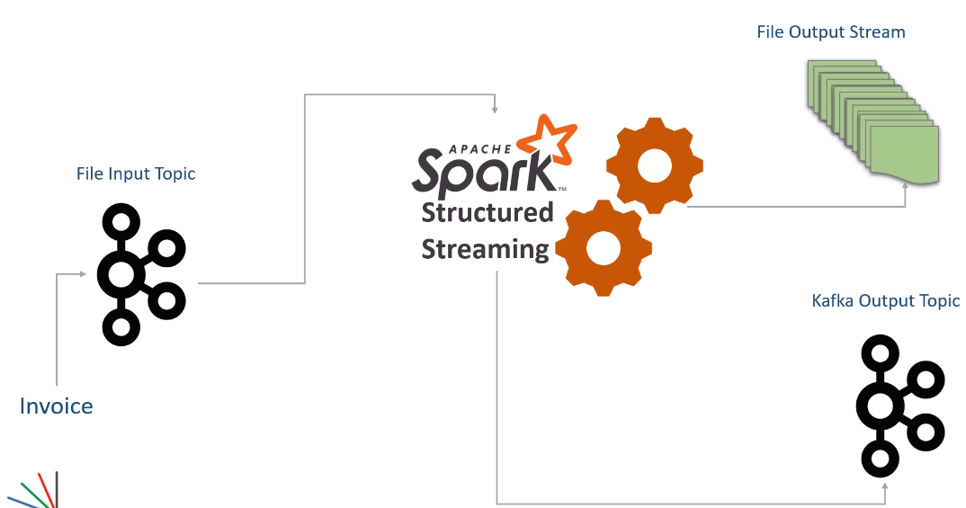

For example, flattening the Invoices and generating a notification can be done in a single application. Â And by doing that, we will be reading invoices from Kafka only once, which will save some time and resources. Right? Let's do it. Here is my new example project. I copied code from both the earlier examples and created this one. Let me explain. I am creating a Spark session. Then I am defining a schema for my invoice. The next step is to read the invoices from the Kafka topic. All this code is the same that we created in the previous example. The fourth step is to extract the value field, apply the schema, and create a DataFrame. Up to here, things are common for both the requirements. The next step is to implement one of the requirements. I am taking the notification requirement first. Implementing the notification requirement was a three-step process. The first step is to create a notification DataFrame. Then we transform it into key-value columns and get the KafkaTarget DataFrame. Finally, we create a Kafka sink query and start it. That's all. The first query is done. But we do not start waiting for this query to terminate. Instead, we start implementing the next requirement. Flattening requires a three-step process.

from pyspark.sql import SparkSession

from pyspark.sql.functions import from_json, col, expr

from pyspark.sql.types import StructType, StructField, StringType, LongType, DoubleType, IntegerType, ArrayType

from lib.logger import Log4j

if __name__ == "__main__":

spark = SparkSession \

.builder \

.appName("Multi Query Demo") \

.master("local[3]") \

.config("spark.streaming.stopGracefullyOnShutdown", "true") \

.getOrCreate()

logger = Log4j(spark)

schema = StructType([

StructField("InvoiceNumber", StringType()),

StructField("CreatedTime", LongType()),

StructField("StoreID", StringType()),

StructField("PosID", StringType()),

StructField("CashierID", StringType()),

StructField("CustomerType", StringType()),

StructField("CustomerCardNo", StringType()),

StructField("TotalAmount", DoubleType()),

StructField("NumberOfItems", IntegerType()),

StructField("PaymentMethod", StringType()),

StructField("CGST", DoubleType()),

StructField("SGST", DoubleType()),

StructField("CESS", DoubleType()),

StructField("DeliveryType", StringType()),

StructField("DeliveryAddress", StructType([

StructField("AddressLine", StringType()),

StructField("City", StringType()),

StructField("State", StringType()),

StructField("PinCode", StringType()),

StructField("ContactNumber", StringType())

])),

StructField("InvoiceLineItems", ArrayType(StructType([

StructField("ItemCode", StringType()),

StructField("ItemDescription", StringType()),

StructField("ItemPrice", DoubleType()),

StructField("ItemQty", IntegerType()),

StructField("TotalValue", DoubleType())

]))),

])

kafka_df = spark.readStream \

.format("kafka") \

.option("kafka.bootstrap.servers", "localhost:9092") \

.option("subscribe", "invoices") \

.option("startingOffsets", "earliest") \

.load()

value_df = kafka_df.select(from_json(col("value").cast("string"), schema)

.alias("value"))

notification_df = value_df.select("value.InvoiceNumber", "value.CustomerCardNo", \

"value.TotalAmount") \

.withColumn("EarnedLoyaltyPoints", expr("TotalAmount * 0.2"))

kafka_target_df = notification_df.selectExpr("InvoiceNumber as key", \

"to_json(struct(*)) as value")

notification_writer_query = kafka_target_df \

.writeStream \

.queryName("Notification Writer") \

.format("kafka") \

.option("kafka.bootstrap.servers", "localhost:9092") \

.option("topic", "notifications") \

.outputMode("append") \

.option("checkpointLocation", "chk-point-dir/notify") \

.start()

explode_df = value_df.selectExpr( "value.InvoiceNumber", "value.CreatedTime",

"value.StoreID",

"value.PosID", "value.CustomerType",

"value.PaymentMethod", "value.DeliveryType",

"value.DeliveryAddress.City",

"value.DeliveryAddress.State",

"value.DeliveryAddress.PinCode",

"explode(value.InvoiceLineItems) as LineItem")

flattened_df = explode_df \

.withColumn("ItemCode", expr("LineItem.ItemCode")) \

.withColumn("ItemDescription", expr("LineItem.ItemDescription")) \

.withColumn("ItemPrice", expr("LineItem.ItemPrice")) \

.withColumn("ItemQty", expr("LineItem.ItemQty")) \

.withColumn("TotalValue", expr("LineItem.TotalValue")) \

.drop("LineItem")

invoice_writer_query = flattened_df.writeStream \

.format("json") \

.queryName("Flattened Invoice Writer") \

.outputMode("append") \

.option("path", "output") \

.option("checkpointLocation", "chk-point-dir/flatten") \

.start()

logger.info("Waiting for Queries")

spark.streams.awaitAnyTermination()

The first step is to explode the value DataFrame and get the exploded columns. Remember, we are reusing the value DataFrame here. Right? The second step is to create the flattened records. Finally, we create the second query for a file sink and start it. Now both the queries should run in parallel as long as you have enough resources to do it. However, you must wait for the driver thread for the background process to complete. Right? But a multi-query application should not wait for a single query. Waiting for one of the queries will halt the other queries. Spark gives you another option. You can use the spark session.streams object and wait for any of the queries to terminate. Both the queries are going to run forever. And one of those will terminate in only two possible scenarios. The first possibility is an error condition when one of the queries fails to raise an exception. The second scenario is to manually stop the application for maintenance. In both cases, your application will stop, and both the queries will also stop. There is one more supercritical point to remember here. Each query should have a unique checkpoint location. I am not sure if you noticed it here. The notification query is using this checkpoint, and the flattening query is using another different checkpoint.

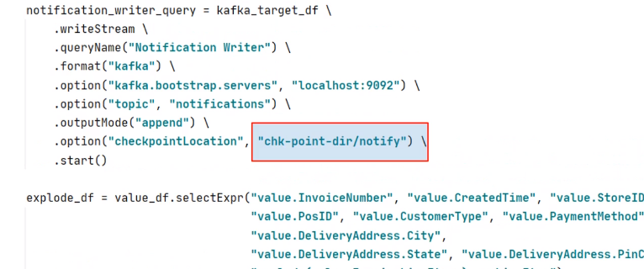

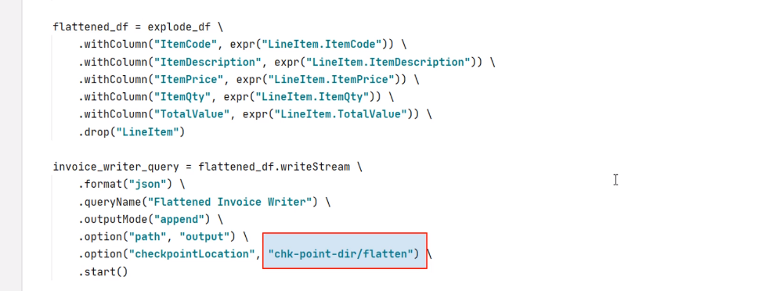

Two queries cannot and should not be using the same checkpoint. They are running from the same application, or you have two different applications. Every query is identified by a unique ID in the Spark cluster based on the checkpoint location. So, your checkpoint location must be unique for every query in the spark cluster.

**Kafka Serialization and Deserialization for Spark**

We learned to interact with Kafka as a source and also as a sink. Now you should be confident to read a stream from Kafka, transform it in real-time, and finally sink your output to Apache Kafka. Kafka works on a key/value pair. So when you read data from kafka, you will get a record with the following schema. Similarly, when you want to send the record to Kafka, you should create a Dataframe of a similar type.

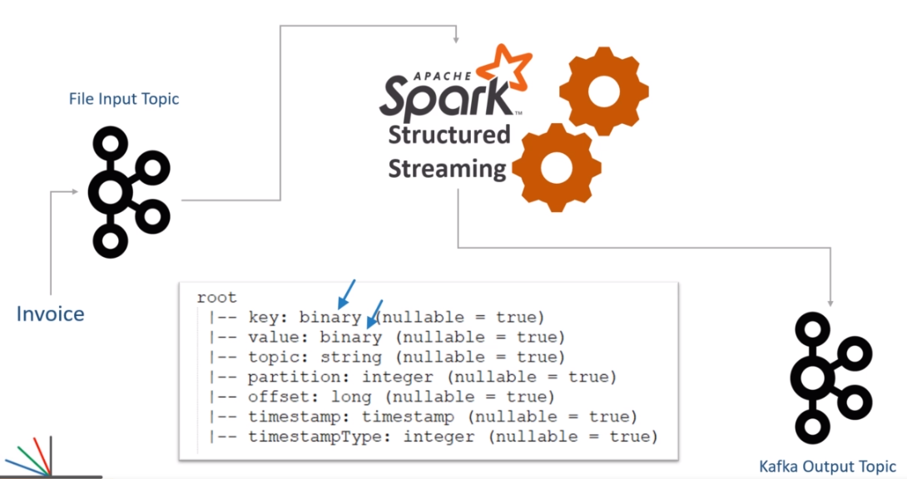

But everything except key and value is optional. In fact, we do not specify anything else except key and value in most of the cases. The rest of the fields are automatically filled by the Spark Kafka sink API, and that's perfectly fine. I am showing this schema here to help you realize the key and value fields' data type. The key, as well as the value column in Kafka record, is of binary type. So, when you are reading Kafka records, you must know the actual type of your key and value. If you know the types, you can easily deserialize them. Let me explain this. We have three common and popular types to use in Apache Kafka. String/CSV JSON and AVRO We already used examples of JSON.

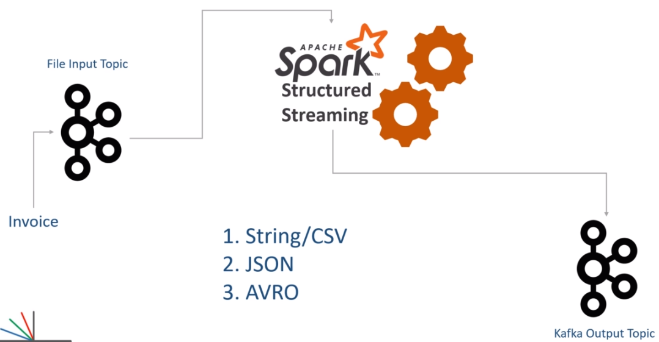

Let me show you once again. In this example, the value field comes as binary. But we know that the actual type is a JSON string. The JSON is also a string. Right? So we cast the value field to a String. Now I have a string. However, this string is not enough for us. We know it is a JSON, so we want to deserialize the JSON also. Spark gives you the from_json() function for doing this. What if it was a CSV instead of a JSON? Possible? Yes, it is possible.

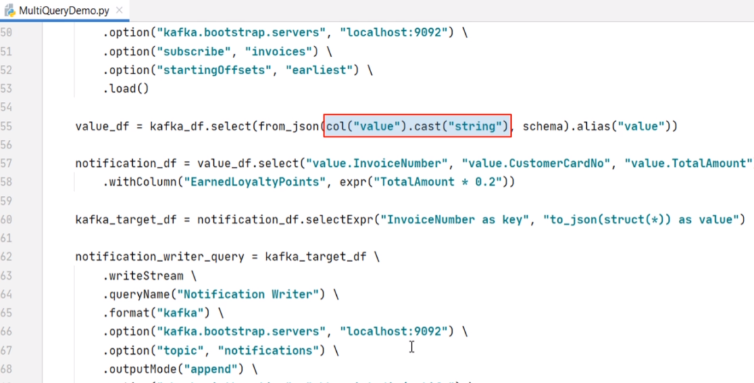

You might get a CSV string in the Value field. Right? Nothing to worry! Spark gives you a from_csv() function to deserialize a CSV. The from_csv() method works, in the same way, we used the from_json(). The from_csv() function also takes two arguments. The first argument is the value, and the second one is the schema. But what if it was an AVRO record? AVRO is also a standard message format with Kafka. The main idea is the same. Spark offers a from_avro() function also. However, using from_avro() requires some more details. So, I will create one example to show you the mechanics of using AVRO records from Apache Kafka. Great! So all this discussion on deserializing your Kafka records was on the reading side. I mean, when you read data from Kafka, you will use one of the following methods to deserialize your key/value. If your key/value is a plain string, you can cast it to a string that should be enough. If you received a JSON or CSV, you should cast it as a string and use from_json() or the from_csv() function.

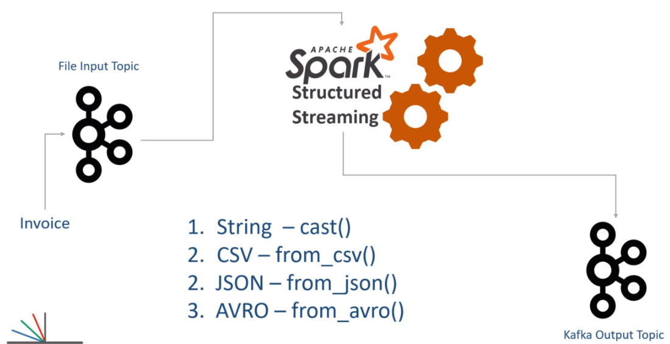

But if you received an AVRO record, you should be using from_avro() function. Casing an Avro to a string is incorrect. You should not be doing it. However, we also have a writing side of Kafka interaction. How do you write your Dataframe to Kafka in CSV, JSON, and AVRO formats? We already implemented writing a JSON record to Kafka. Right? Let me show you once again. Here it is.

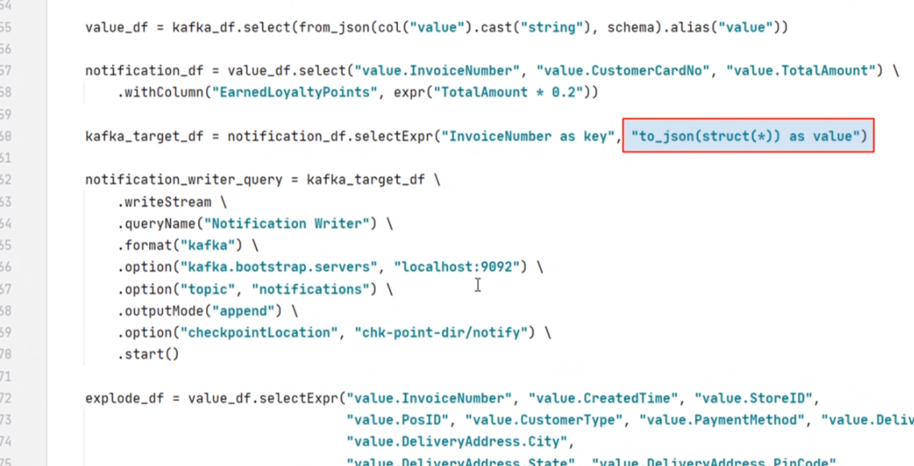

So you can use to_json() function to create a JSON value from your Dataframe. The to_json() function alone is not enough. We often need another function such as struct() or named_struct(). The struct(), and the named_struct() are used to create a Dataframe structure. The outcome is again used by the to_json for generating a JSON string. The struct() method takes a list of selected columns. Whereas, the named_struct() allows you to rename the selected columns. We have already done all this, and I hope you learned to serialize your Dataframe to JSON and send the JSON values to Kafka. Right? What if you want to send your Dataframe as CSV value. Nothing to worry. You also have a to_csv() function. The to_csv() works in the same way we used the to_json() function. No other difference at all. What about AVRO? You have a to_avro() function for doing that. I will show you an example of Avro. But I am skipping examples for CSV because they work the same way as JSON. Great! We learned some theory about serializing and deserializing Kafka records. We already learned to work with JSON. In the next two videos, I will create examples for writing an AVRO record to Kafka, and then we will be reading the same Avro record from Kafka.

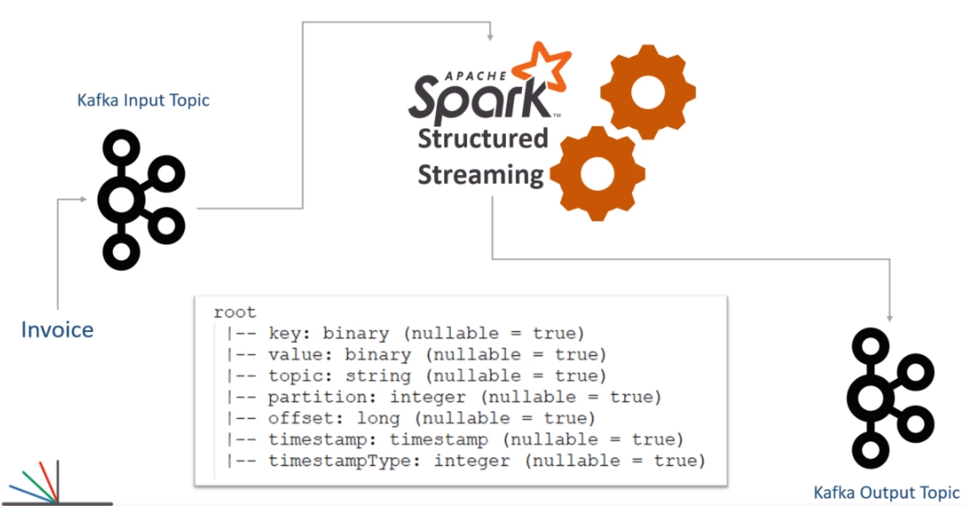

**Creating Kafka AVRO Sinks**

In the previous video, I talked about different types of message formats in Apache Kafka. We already learned to work with JSON input and output. In this video, I am going to create an example for producing AVRO output to Kafka topic. So let's start. I want to keep it short and straightforward. So I took the same invoice flattening example and created this new project. Most part of the code is exactly the same as we created earlier. Let me quickly walk you through. I am creating a spark session and also defining the invoice schema. Then we are reading data from the Kafka source. The input data is still coming in JSON format. So I am casting it to a string, using from_json() function, and applying the schema to get a DataFrame. Then we explode it, and finally, I am flattening it. Now we need to prepare a Kafka target dataframe.

from pyspark.sql import SparkSession

from pyspark.sql.avro.functions import to_avro

from pyspark.sql.functions import from_json, col, expr, struct

from pyspark.sql.types import ArrayType, StructType, StructField, StringType, LongType, DoubleType, IntegerType

from lib.logger import Log4j

if __name__ == "__main__":

spark = SparkSession \

.builder \

.appName("Multi Query Demo") \

.master("local[3]") \

.config("spark.streaming.stopGracefullyOnShutdown", "true") \

.getOrCreate()

logger = Log4j(spark)

schema = StructType([

StructField("InvoiceNumber", StringType()),

StructField("CreatedTime", LongType()),

StructField("StoreID", StringType()),

StructField("PosID", StringType()),

StructField("CashierID", StringType()),

StructField("CustomerType", StringType()),

StructField("CustomerCardNo", StringType()),

StructField("TotalAmount", DoubleType()),

StructField("NumberOfItems", IntegerType()),

StructField("PaymentMethod", StringType()),

StructField("CGST", DoubleType()),

StructField("SGST", DoubleType()),

StructField("CESS", DoubleType()),

StructField("DeliveryType", StringType()),

StructField("DeliveryAddress", StructType([

StructField("AddressLine", StringType()),

StructField("City", StringType()),

StructField("State", StringType()),

StructField("PinCode", StringType()),

StructField("ContactNumber", StringType())

])),

StructField("InvoiceLineItems", ArrayType(StructType([

StructField("ItemCode", StringType()),

StructField("ItemDescription", StringType()),

StructField("ItemPrice", DoubleType()),

StructField("ItemQty", IntegerType()),

StructField("TotalValue", DoubleType())

]))),

])

kafka_df = spark.readStream \

.format("kafka") \

.option("kafka.bootstrap.servers", "localhost:9092") \

.option("subscribe", "invoices") \

.option("startingOffsets", "earliest") \

.load()

value_df = kafka_df.select(from_json(col("value").cast("string"), schema).alias("value"))

explode_df = value_df.selectExpr("value.InvoiceNumber", "value.CreatedTime", "value.StoreID",

"value.PosID", "value.CustomerType", "value.CustomerCardNo",

"value.DeliveryType",

"value.DeliveryAddress.City",

"value.DeliveryAddress.State", "value.DeliveryAddress.PinCode",

"explode(value.InvoiceLineItems) as LineItem")

flattened_df = explode_df \

.withColumn("ItemCode", expr("LineItem.ItemCode")) \

.withColumn("ItemDescription", expr("LineItem.ItemDescription")) \

.withColumn("ItemPrice", expr("LineItem.ItemPrice")) \

.withColumn("ItemQty", expr("LineItem.ItemQty")) \

.withColumn("TotalValue", expr("LineItem.TotalValue")) \

.drop("LineItem")

kafka_target_df = flattened_df.select(expr("InvoiceNumber as key"),

to_avro(struct("*")).alias("value"))

invoice_writer_query = kafka_target_df \

.writeStream \

.queryName("Flattened Invoice Writer") \

.format("kafka") \

.option("kafka.bootstrap.servers", "localhost:9092") \

.option("topic", "invoice-items") \

.outputMode("append") \

.option("checkpointLocation", "chk-point-dir") \

.start()

logger.info("Start Writer Query")

invoice_writer_query.awaitTermination()

The Kafka target dataframe should have two columns - key and value. Creating a key is straightforward. I am selecting the invoice number and give an alias. That's all. Creating an AVRO column is also straightforward. All you do is use the to_avro() function. The to_avro() function expects a struct of desired columns. So, you can use the struct() function. I need all the columns, so I am using a star. If you needed some specific columns, you could use the comma-separated names of the column like this.

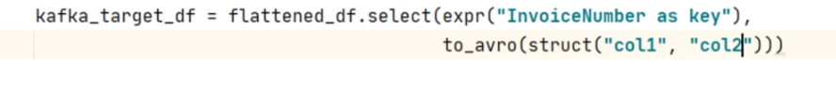

However, I already prepared the DataFrame as per my requirement. So I can select all the columns. Make Sense? The rest of the code is the same. We create a Kafka writer query, set the format, and supply necessary options. That's all. However, we have a small problem. The to_avro() function requires an additional package named spark-avro.

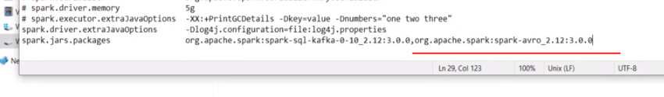

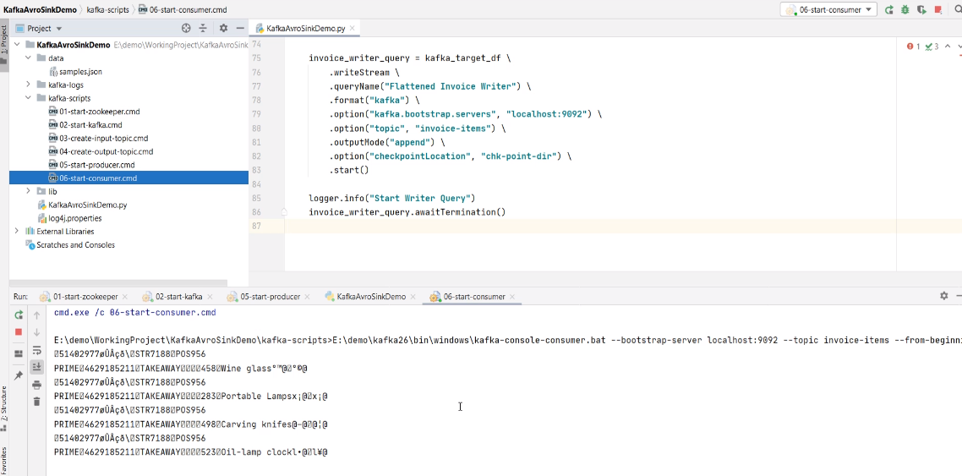

So, we also need to include the spark-avro package to our dependency list. How to do it? You already know it. Right? Add this dependency in your build.sbt file. Let me show you. Here it is. That's all. You are done. Now let me run it once and show you some output. Start the zookeeper and Kafka server. Create input and output topics. Start the producer and send at least one input. Now you can run your application. Start the consumer to see if you are getting the output. Great! Looks like we are getting some data. But Avro is a binary format. So you may not make any sense of this output.

**Working with Kafka AVRO Source**

In the previous video, we created an example that sends flattened invoices to Apache Kafka. However, these flattened invoices are coming as AVRO serialized data. In this video, I want to create a new example that reads those AVRO formatted Kafka records and does some meaningful things. So, let's start. Let me quickly define the problem statement. In another example, we tried to compute the customer's earned rewards and send a notification message. The notification message looked like this. However, we have a small problem with this notification. This message shows the purchase amount and loyalty points for the current invoice only. However, you have a new requirement to notify the customer with the totals. I mean, the total purchases and the total rewards which the customer has accumulated. So basically, we want to produce a notification record to a Kafka topic that looks like this. Let's do it. Here is my brand new example project. I am creating a Spark session and also reading data from the Kafka topic. Up to this point, you already learned everything. The kafkaSourceDF is the raw Dataframe which comes with key and value columns. Right? Now I need to extract the value and create a usable dataframe. Let's do it. We will start with the kafkaSourceDF and use the select() method. I will select the value column. Right? However, this column is coming in Avro format. But that's not a problem. I can use the from_avro() function. The from_avro() function takes the value and schema. Then I can give it an alias. That's what we dis with the JSON format messages. Right? The same applies to the Avro messages also. However, we have a small gotcha here. When we extracted JSON or CSV messages, we used spark Dataframe schema. Remember? Let me show you the earlier example. Here it is. We created a schema using the Spark syntax and used it to deserialize a JSON string. Right? However, you cannot use a Dataframe schema to deserialize an Avro record. The schema here is an Avro format schema string. Let me show you. Here it is. I created this Avro schema and kept it in a separate file. This schema is defined using the Avro Schema definition language. Things are simple, but you need some additional knowledge to understand and create a schema definition when dealing with Avro records. Now I can load the schema string from the file and apply it here. Let me do it. That's all. This code will load the Avro schema definition from the file, and I can apply it here. That's all. Rest all is just a Spark Dataframe transformation. Let me paste the code. So I am filtering for PRIME customers. Then I will groupBy the CustomerCardNo, and take a sum for the sale value and rewards points. Now the rewardsDF is ready to go. But I want to send it to Kafka, so I am again transforming it to a key/value Dataframe. You already learned all this. Finally, I am sending it to Kafka. That's all. Do you want to run it? We cannot run this example alone. This KafkaAvroSourceDemo example is the second part of the KafkaAvroSinkDemo example. The KafkaAvroSinkDemo creates the AVRO records in a Kafka topic. Then the KafkaAvroSourceDemo reads the same topic and produces the Notification record. So, you should run the SinkDemo first and then run the SourceDemo. I leave it on you to try running it yourself. Great! So we learned to read Avro records from Kafka. The process is exactly the same as you would read a JSON record. However, we have two new things to take care of. You should include a spark-avro package to your application dependency. When you want to deserialize the Avro message, you will need Avro schema string. The JSON records can be deserialized using Spark Schema, but the Avro records would need the Avro schema.

<https://tsys.udemy.com/course/spark-streaming-using-python/learn/lecture/21955630#content>

## Multi Node Spark Cluster

<https://medium.com/ymedialabs-innovation/apache-spark-on-a-multi-node-cluster-b75967c8cb2b>

<https://github.com/ashishtam/apache-spark-multi-node-installation/blob/master/index.md>

## Deploying to Spark Cluster

## RDDs

### Introduction to RDDs

RDD stands for Resilient Distributed Data sets. The RDD API was actually released in 2011, so this basically means that RDDs were the primary user facing API since the inception of Spark. By the way, API actually stands for Application Programmers Interface, and it's basically a set of libraries that are made available to extend the functionality or perhaps the capability of a particular programming language. Now, depending on the context, we may refer to an RDD as a distributed dataset or perhaps just an API. So what is an RDD exactly?

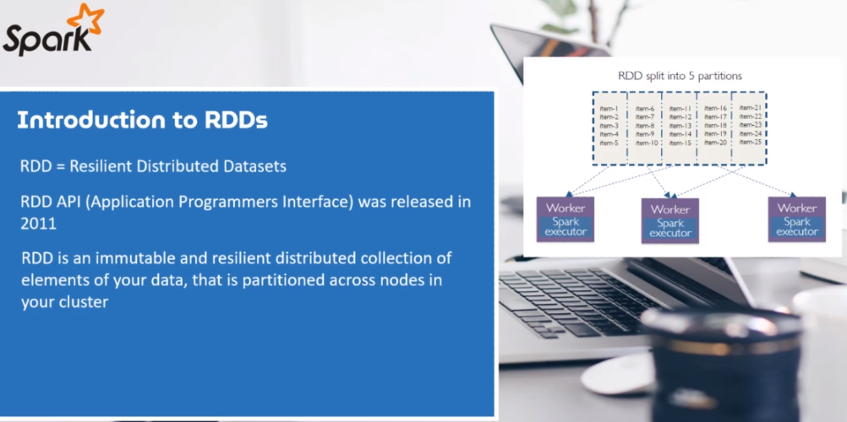

At the core, and it is an immutable and resilient distributed collection of elements of your data. The data is also partitioned across nodes in your cluster. By immutable, we also mean that the RDD has been defined with an allocation of data and the operations on the RDD does not change its shape whatsoever. The operations are typically referred to as transformation's and actions. And you shall soon see that they always result in a new RDD, instead, they typically store the results of an operation. So therefore, once the RDD has been created, the RDD can be operated in parallel. So those transformations and actions execute in parallel, which now brings us to why RDDs have to be resilient. Well, data is also stored in a partitioned manner, which means data is not stored in the same place and therefore authorities have to be fault tolerant. Fault tolerance, just means that they can recover from failures and are guaranteed not to lose shape and hence the word resilient.

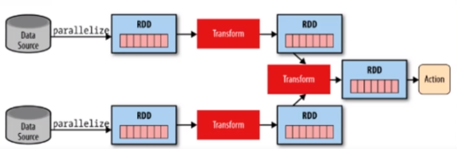

As probably you would have established, RDDs are referred to as low level API, which are not easy to use and to learn as compared to high level structured API such as Spark data frames and data sets. So why do we need to learn RDDs? Well, let's look at a few reasons. Well, the first reason is that. You want low level transformation and actions to control your data sets. The other reason is perhaps your data is unstructured, such as meta streams or streams of text, which cannot be handled by structured APIs such as data frames and data sets.

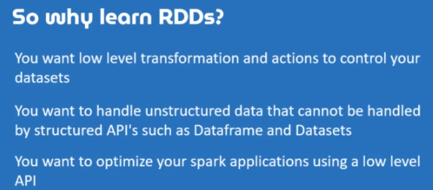

However, perhaps another important reason is to help you understand how Spark actually works, and especially if you need to establish what's happening behind the scenes when using the high level APIs, which are data frames and data sets. So knowledge on RDDs can help a lot when optimizing your Spark applications. Since Spark 2, and perhaps more especially Spark 3, RDDs have been relegated to second class citizens ever since the inception of data frames and data sets. However, they are not going anywhere, and especially for reasons that we have just tabulated. So let's look RDDs, but however, we will focus only on the basics and work through a number of examples together just to get a feel of RDDs. And right at the end, you will be required to do a challenge on your own where you will be required to perform RDD transformation and actions all on your own.

### Data Preparation

In the last section, we had a brief look at how we can manipulate data frames and for this particular lesson, we will look to manipulate RDDs pretty much the same way, but using core RDD functionality. We will kick things off by looking at transformation's, by the way, the difference between data frames and RDDs is that when it comes to RDD, you manipulate raw Java objects as compared to Spark types, which are mainly just data frames.

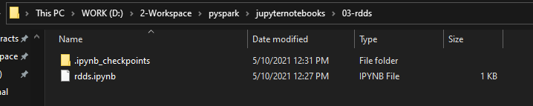

|  |  |
| --- | --- |
|  | On that note, let's create a new notebook. But first, let's open your command line terminal and create a new directory. And I just happen to have mine open. Navigate to the folder created. Start a Jupyter Notebook.  I am going to import from pyspark sql and import the spark session class. Now, to do that, I am just going to type from pysql import SparkSession, what I want to do next is to have a variable that will hold the spark session and I'm just simply going to call it just a spark.  from pyspark.sql import SparkSession  spark = (SparkSession  .builder  .appName(“TestingRDDs”))  .getOrCreate()) |

Run this with shift, enter.

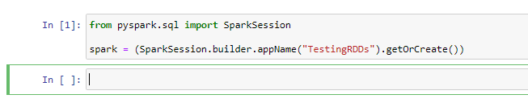

Now, let's talk about transformations before we continue any further, RDD transformations are lazy operations. Now, we've seen this before in our last section, and this means that none of the transformations get executed before you call and action. Let's work with a few examples and let's start by creating an RDD that will hold a collection of words. But before we dive into transformations, let's prepare the data that we are going to use. So let's start by creating a list that will store the list of words. So words_list is assigned to well, I'm going to now insert a sentence. So "Spark Makes life a lot easier and puts me into good spirits. Spark is too awesome".

Just like that and not what I want to do next is to split the words into a list, to do that, I am going to split by a space just like that shift enter.

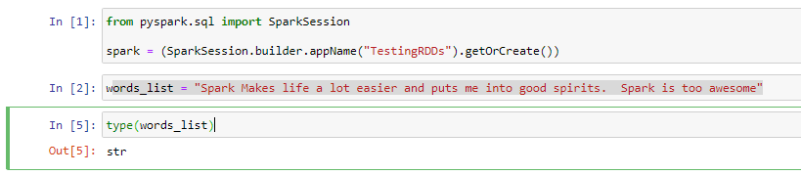

To make this a list lets do this instead

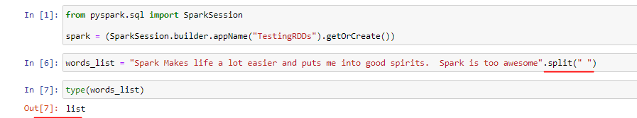

Now what we need to do next is to start creating a words are basically and RDD that will store the words list. Now, to do that, words_rdd OK. And I'm going to call Spark. And the context this time around. And I need to parallelize my armed support, the allies, and I'm going to pass in would list just like that and to confirm this shift and to run.

from pyspark.sql import SparkSession

spark = (SparkSession.builder.appName("TestingRDDs").getOrCreate())

words_rdd = spark.sparkContext.parallelize(words_list)

type(words_list)

*Output is list*

words_rdd = spark.sparkContext.parallelize(words_list)

type(words_rdd)

*Output is pyspark.rdd.RDD*

Now, let's print the contents of the RDD. In order to retrieve the print of values of an RDD first, you need to collect the data into a list and then loop through the results and print the content. Now, to do that, I am going to create another variable that will store the list. So it will be words_data? words_rdd, and call on the action, call it just like that shift, enter and to print the result. So for word in words_data. Print would just like that shift enter and indeed we get a printout of what our RDD contains.

words_data = words_rdd.collect()

for word in words_data:

print(word)

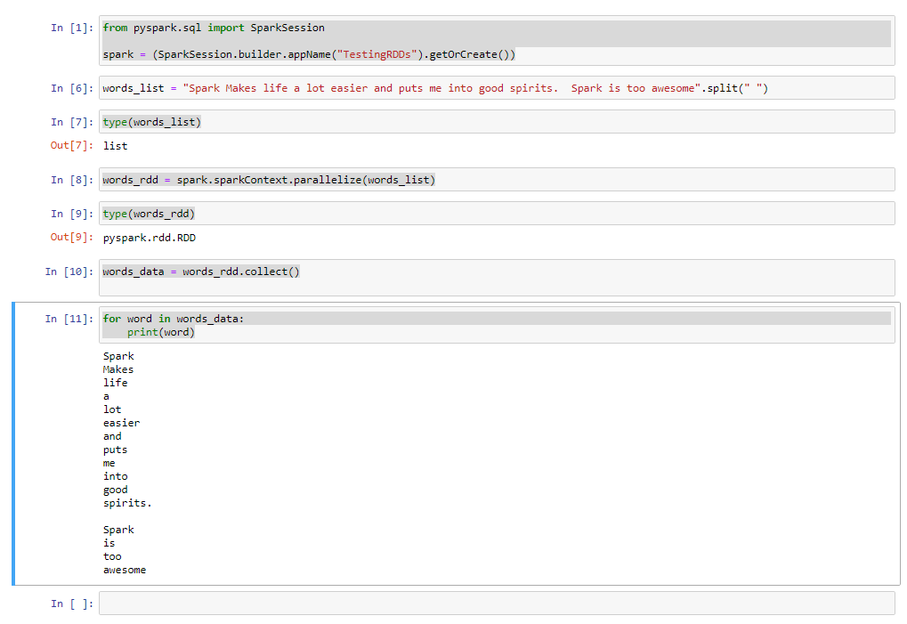

### Distinct and Filter Transformation

Now that we have prepared the data, I think it's time to play around with RDD transformations. Oh, by the way, remember to save your notebook as Testing RDDs. Spark has a number of transformations and we are going to have a look at the basic ones, starting with the distinct and filter transformation. The distinct transformation allows us to remove duplicates from our RDD. And based on our word list, we have the word Spock repeated at least twice. Let's see if we can remove the duplicate record. Now, what we need to do first is to counter the current records to do that, I am going to call on my RTD again, so words_rdd and I'm going to call the count. And we get an output of just 16 records.

print("There are ", words_rdd.count(), "words!")

*OUT: There are 17 words!*

Note that we are using the RDD here and not the list

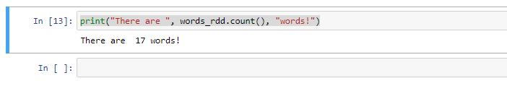

Let's now call the distinct function and see if we can get a count without the duplicated record. Now, to do that, I am going to call on my RDD again. So words_rdd.distinct() function. And I am also going to pull in count as well to count the number of records. And as you can see, we now have just 15 records, minus of the one recorded that was duplicated, which is Spark, but did we remove the records from the RDD? Let's check it out. To confirm this, we can start printing out the records ourselves.

print("Total of distinct words are ", words_rdd.distinct().count() )

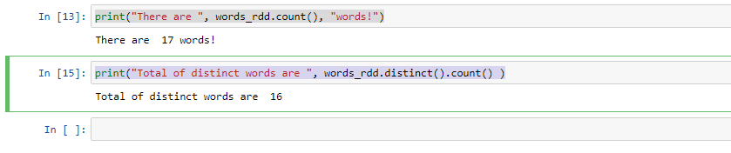

So what I want to do first is to collect the data from the RDD into a list. Now to do that I am simply going to reuse words_data. So for word in words_data print word. Shift enter to run. And it appears that the duplicated recorder, which is a spark, by the way, was not removed at all. In the last section, I have indicated that transformations always result in a new or and does not physically manipulate the current RDD, making RDDs immutable. So we should have done the following then basically just assign the result into a new RTD. Now, to do that, simply just create a new variable that will hold the resulting RDD. So words_unique on the RDD. And let's start printing the content of the RDD, so this time around, what I'm going to do is to use my for statement again, so for word in words_unique_rdd.collect. OK, press enter.

for word in words_data:

print(word)

*Spark*

*Makes*

*life*

*a*

*lot*

*easier*

*and*

*puts*

*me*

*into*

*good*

*spirits.*

*Spark*

*is*

*too*

*awesome*

words_unique_rdd = words_rdd.distinct()

And now check whether there are any duplicates in the new RDD created which is words_unique_rdd

Note that we are not iterating a list here but instead getting data from a RDD so we are required to call the collect() transformation that would return a list to us and then iterate on that

for word in words_unique_rdd.collect():

print(word)

*Makes*

*good*

*life*

*a*

*lot*

*puts*

*Spark*

*easier*

*too*

*and*

*spirits.*

*into*

*is*

*awesome*

*me*

And as you can see, we no longer have the duplicated record, which is Spark from our RDD. Now, let's have a look at the filter transformation before we end this lesson, let's say that we wanted to filter our RDD and have only words that begin with the letter S. Let's create a function that will help us determine whether each word begins with an S or not. So let's create the function.

def wordStartsWith(word, letter):

return word.startswith(letter)

Note: lowercase w in startswith

Perfect, now that we have a nice little function, let's use the filter transformation to cut words that starts with an S. So let us call on the RDD so words_rdd and use the filter transformation. So .filter(). OK, and now it's time to use our anonymous lambda function to test whether the word begins with an S or not. And if two, I want to keep the records. If not, I want to discard the records. So Lambda. OK, and then word and let me call on the function, so wordStartsWith. OK, and I need to pass in word and the letter to search, and now I want to collect this into a list for a quick print. Shift, enter to run. And let's see what happens.

words_rdd.filter(lambda word: wordStartsWith(word, "S")).collect()

['Spark', 'Spark']

And indeed, we were able to use the filter method to ensure that we only stole the words that starts with the letter S.. Please note that when filtering records, you're most likely to use anonymous functions which are referred to as LAMBDA if you don't know what they are. Please make a Google your best friend and learn a thing or two about Python Lamda. In our example, the words already contains what can be considered as a list of words. So when using the filter transformation, Spark travels through the entire data set and evaluates each word and for each word, that will become inputs for each lambda available. In our case, the lambda variable is just word. And then straight after the semicolon, you can write any expression that can operate on the word variable. As for the expression we have chosen to call a function that will return true or false, depending on whether a match has been found or not. And if true, that word will be collected into a python list, as you can see from our output.

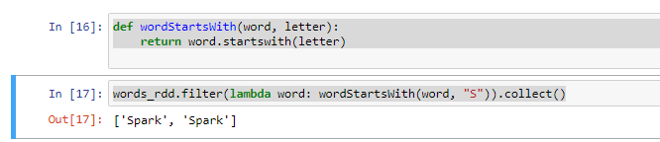

### SortByKey

Well, this is the last lesson on our basic transformations and we are going to have a look at sorting using sortByKey. Well, let's create a data set and start using the sortByKey transformation. We will need a list that is made up of tuples that contain country and some made up ranking, what you need to know is that the sortByKey transformation requires a key value pair. And this is why we are going to use a list of tuples. So let's create the list of tuples. Now, I want a countries list variable, and to do that, I am going to create a countries list variable so countries_list like that and I want to open and close a square brackets to start creating my list of tuples. Now, I am going to start with the first one and it will be India. With a ranking of 91 and the second one will be, let's say USA. With a ranking of of four and let's do one more tuple and let's do Greece with a ranking of 13. Perfect.

countries_list = [("India", 91), ("USA", 4), ("Greece", 13)]

Now, what I want to do next is to create a countrys rdd that will hold the list of countries. So to do that, it will be countries_rdd and spark.sparkContext. And I wanted to start creating the RDD by using the parallelize method. OK, so let's create a list of from a sorted RDD and we are going to demonstrate the use of these sort by key transformation.

countries_list = [("India", 91), ("USA", 4), ("Greece", 13)]

countries_rdd = spark.sparkContext.parallelize(countries_list)

So let's create the list and let us create a variable called sorted_country_list is assigned to countries_rdd.sortByKey().collect().

sorted_countries_list = countries_rdd.sortByKey().collect()

for country in sorted_countries_list:

print(country)

*Output*

*('Greece', 13)*

*('India', 91)*

*('USA', 4)*

Now, as you can see, we have managed to sort the list by country name, but what if we want to sort of the list of by the ranking in descending order? Well, as mentioned before, the tuple is effectively a key value pair. The key in this instance is country and the value is the ranking. So I guess it's pretty clear that we need to switch things up and then call on the sortByKey transformation to sort using the ranking number instead. So let's get down to business.

So what I want to do is to just reuse the sorted countries list available again, and I wanted to use the map transformation to transform our countries RDD. OK to do that. I am just going to do countries_rdd.map. OK, as you know, each value of the country's RDD contains a tuple, now to use LAMDA, the c will represent each tuple, but I wanted to switch things up, so what I need to get in return is the switched RTD. And to do that. A tuple once more, and for the first element, I am going to supply it with the value of position one from our tuple and the second one will come from position zero from our tuple. And what I want to do now is sortByKey.

sorted_countries_list = countries_rdd.map( lambda c: (c[1], c[0]) ).sortByKey().collect()

for country in sorted_countries_list:

print(country)

*Output*

*(4, 'USA')*

*(13, 'Greece')*

*(91, 'India')*

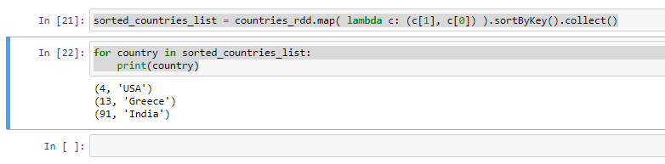

And since I want the printed values in descending order, I am going to supply a false and once more to a .collect like that shift enter to run. And now I am going to copy and paste cell number twenty four to start printing the values again and shift enter.

sorted_countries_list = countries_rdd.map( lambda c: (c[1], c[0]) )

.sortByKey(False)

.collect()

for country in sorted_countries_list:

print(country)

*Output*

*(91, 'India')*

*(13, 'Greece')*

*(4, 'USA')*

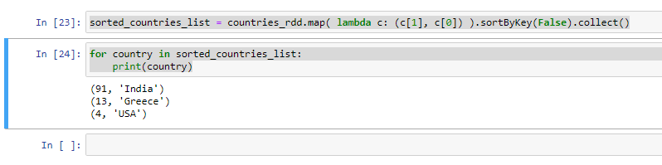

And now we have managed to sort using the ranking number and also in descending order.

### RDD Actions

In the last section, we have created a sales data frame and we also have ascertained that the only way a transformation can produce a result is when we specify an action. You have already been introduced to a number of actions already which are collect, count and take. So we are going to focus on actions that we haven't looked at yet, starting with the produce action. The reduce action is used to reduce and well, I read by reduce, we mean to aggregate values into just one value as a result. Well, given a set of numbers, you can reduce the set of numbers to just one value if you happen to sum up the numbers. So let's work on our next example, and we will start by creating a numbers list and to create the list, I am simply just going to create a variable called name list, and I will assign it with a list of numbers, which will be one, five, two, three and four, just like that shift enter to run.

num_list = [1,5,2,3,4]

Now let's use the reduce function to aggregate the values by summing up of the list. Now let's create a variable that will hold the result. So result is assigned to spark. That Spock context thought parallelize. And let's insert name list now, what we need to do next is to call the reduce action so that reduce. And to sum up the values, we are going to call on our famous lamda function, so lamba the X Y because we will need two arguments, so X plus Y to do the summing up of the values. Now, what I want to do next is to start a printing of the results of print result, shift enter and let's see what we get. And as you can see, the reduced function has created an accumulation off of the list, giving us exactly one output of a value of 15.

from pyspark.sql import SparkSession

spark = (SparkSession.builder.appName("Actions in RDDs").getOrCreate())

num_list = [1,5,2,3,4]

result = spark.sparkContext.parallelize(num_list).reduce(lambda x, y: x + y)

print(result)

*Out: 15*

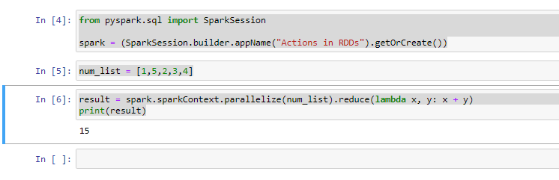

If you are unsure about what's going on here about the LAMBDA function. Well, let's dissect it by creating a function that does the summation of of values. Now, to do that, let's create a function called a sumList. It will accept two arguments. So X and Y just like that. And what I want to do is to start printing the values of X and Y as they come into the function. So print X and Y and what I want to do is to return X plus Y. Just like that now let me shift into the function and what I want to do is to copy and paste cell twenty eight. OK. And instead, I wanted to call the sumList function right here. And I will pass on the values of X and Y, so shift enter and let's see what happens. Now, the LAMBDA function takes in two values, the first one will be the first element, which is one assigned to X and the second element will be assigned to Y. However, as the reduced function traverses through the list, the X value will store the accumulation and the Y value will store the next element.

def sumList(x, y):

print(x, y)

return x + y

result = spark.sparkContext.parallelize(num_list).reduce(lambda x,y: sumList(x, y))

*Output:*

*1 5*

*6 2*

*8 3*

*11 4*

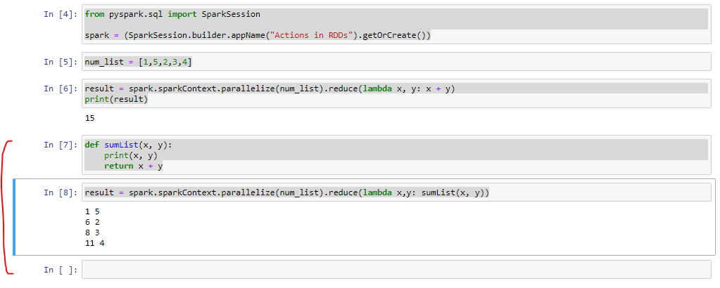

So let's work on one more example. We can use the reduced function to find the longest word in a set of words. Now we can start by defining a function called wordLengthReducer. I need two arguments, OK, because I need to supply at least two words, so left word and right. Now, what I want to do is to start testing whether the left word is greater than the right word. I am going to return the largest length, which is left word if left word is longer and right word if right word is longer. Now shift enter to run the function.

def wordLengthReducer(leftWord, rightWord):

if len(leftWord) > len(rightWord):

return leftWord

return rightWord

str_list = ["lalit", "sasha", "yamini"]

words_rdd = spark.sparkContext.parallelize(str_list)

words_rdd.reduce(wordLengthReducer)

*Output: 'yamini'*

Not what I want to do next is to just call words are did that reduce? And I'm going to just pass in the function word length. Reducer, just like that shift, enter and let's see what happens. And once again, the left word comes from the first element and the right word comes from the, well, second element. Please feel free to dissect what's going on here like we did before. And basically, the largest word in our list is 'yamini'.

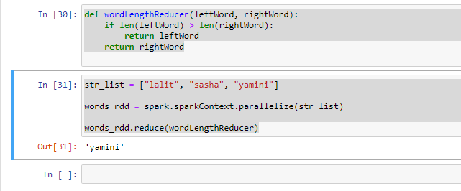

Now, let's see if we can get the first element from the words RDD, and to do that, I simply just going to do a word_rdd, that first, just like that shift enter to run and we get "lalit", which is correct.

str_list = ["lalit", "sasha", "yamini"]

words_rdd = spark.sparkContext.parallelize(str_list)

words_rdd.reduce(wordLengthReducer)

words_rdd.first()

*Output: "lalit"*

Let's now get the min and maximum value from a list of values. Now all we can do for this example is just copy and paste.

num_list = [1,5,2,3,4]

result = spark.sparkContext.parallelize(num_list)

result.min()

*Output: 1*

result.max()

*Output: 5*

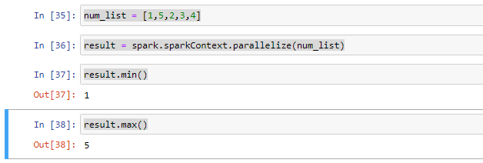

**Another way of doing this**

myrdd = spark.sparkContext.parallelize(range(1, 99))

myrdd.min()

*Output: 1*

myrdd.max()

*Output: 98*

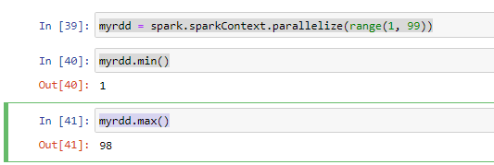

### Challenge - Convert Fahreinheit to Centigrade

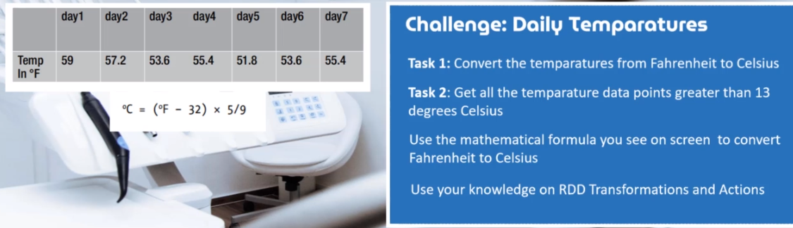

**Approach 1:**

from pyspark.sql import SparkSession

spark = (SparkSession.builder.appName("Temperature Conversion").getOrCreate())

fah_arr = [59, 57.2, 53.6, 55.4, 51.8, 53.6, 55.4]

fah_rdd = spark.sparkContext.parallelize(fah_arr)

cent_rdd = fah_rdd.map(lambda x: (x - 32) * 5 / 9 )

cent_list = cent_rdd.collect()

for i in cent_list:

print(i)

*Output:*

*15.0*

*14.000000000000002*

*12.0*

*13.0*

*10.999999999999998*

*12.0*

*13.0*

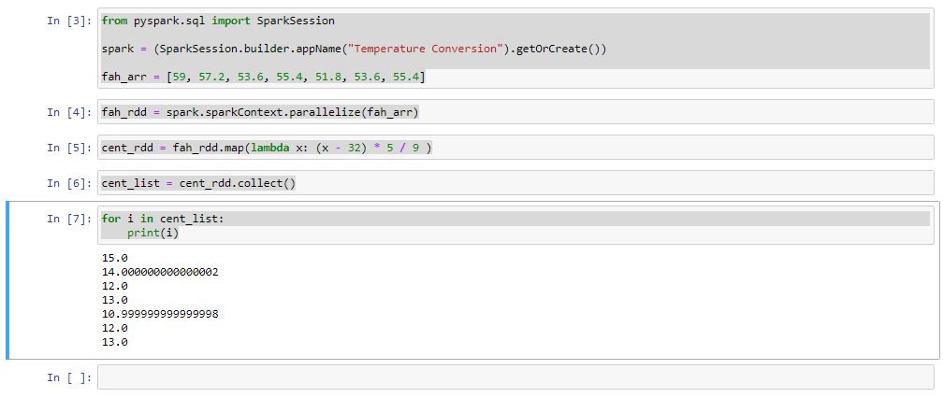

**Approach 2:**

from pyspark.sql import SparkSession

spark = (SparkSession.builder.appName("Temperature Conversion").getOrCreate())

fah_arr = [59, 57.2, 53.6, 55.4, 51.8, 53.6, 55.4]

fah_rdd = spark.sparkContext.parallelize(fah_arr)

fah_rdd.collect()

*Output: [59, 57.2, 53.6, 55.4, 51.8, 53.6, 55.4]*

def fahrenheitToCentigrade(temperature):

centigrade = (temperature - 32) * 5 / 9

return centigrade

cent_rdd = fah_rdd.map( lambda x: fahrenheitToCentigrade(x))

cent_rdd.collect()

*Output: [15.0, 14.000000000000002, 12.0, 13.0, 10.999999999999998, 12.0, 13.0]*

cent_rdd.filter(lambda x: x > 13).collect()

*Output: [15.0, 14.000000000000002]*

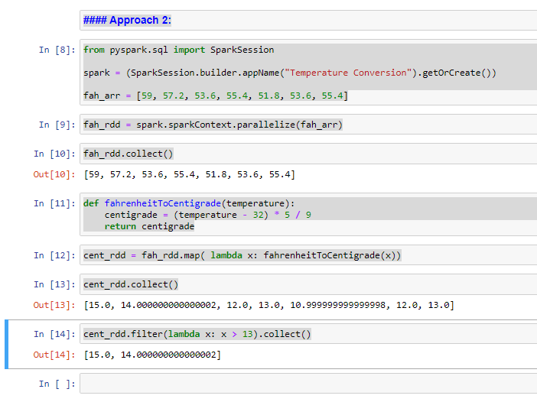

### Challenge 2 – XYZ Research

**Use Case**

We are going to work on a little project together that will help us to really drill the idea of using our leads and drive it home once and for all. So let's discuss the challenge that we need to solve together. Imagine a company called XYZ research that conducts research on many diversified topics and each research project comes with a research id. Each research topic may come to a conclusion in just about one year, or it may even take more than one year, but not more than three years. If we have a look at the data provided, it provides the indication of research projects conducted in a year

So in 2001, there were at least seven research projects, 2002 and 2005, they had about five projects, respectively.

|  |  |
| --- | --- |
|  | Now, we will need to answer the following question for your challenge. The first one would be how many research projects were initiated in the three years, and the second task is how many projects were completed in the first year. And the last question is how many projects were completed in the first two years? Feel free to try this yourself, but I do urge you to follow along with me, because I wanted to introduce to you at least two more transformations which are union and subtract to tackle this problem together. OK, please make sure that you download the attached data file, so let's dive into the next lecture to get our hands dirty, does is it for me and I shall catch you on the next one. |

**Data**

data2001List = ['RIN1', 'RIN2', 'RIN3', 'RIN4', 'RIN5', 'RIN6', 'RIN7']

data2002List = ['RIN3', 'RIN4', 'RIN7', 'RIN8', 'RIN9']

data2003List = ['RIN4', 'RIN8', 'RIN10', 'RIN11', 'RIN12']

**XYZ Research**

RDD API - XYZ - Research

Imagine working as a Data Scientist for a company called XYZ Research that performs research on many diversified topics, and each research project comes with a Research ID.

Each Research can be completed within a year and beyond.

Take a look at the data below;

data2001List = ['RIN1', 'RIN2', 'RIN3', 'RIN4', 'RIN5', 'RIN6', 'RIN7']

data2002List = ['RIN3', 'RIN4', 'RIN7', 'RIN8', 'RIN9']

data2003List = ['RIN4', 'RIN8', 'RIN10', 'RIN11', 'RIN12']

The above-mentioned data indicates the number of projects that have been completed over a period of 3 years.

In 2001, there were at least 7 research projects [RIN1 - 7] that were initiated, RIN8 and RIN9 were initiated in 2002, while RIN10, RIN11, and RIN12 were initiated in 2003.

RIN3 also appears in 2002, meaning that the research project has actually spanned over 2 years, RIN4, on the other hand, appears in 2001, 2002, and 2003 which means that the research project spanned over 3 years.

XYZ Research Requires you to examine the data and find answers to the following questions;

1. How many research projects were initiated in the three years?

2. How many projects were completed in the first year?

3. How many projects were completed in the first two years?

Solution

We have three lists that hold the research data, we can now create RDDs based on the data set for each year.

from pyspark.sql import SparkSession

spark = (SparkSession.builder.appName("Actions in RDDs").getOrCreate())

data2001List = ['RIN1', 'RIN2', 'RIN3', 'RIN4', 'RIN5', 'RIN6', 'RIN7']

data2002List = ['RIN3', 'RIN4', 'RIN7', 'RIN8', 'RIN9']

data2003List = ['RIN4', 'RIN8', 'RIN10', 'RIN11', 'RIN12']

data2001Rdd = spark.sparkContext.parallelize(data2001List)

data2002Rdd = spark.sparkContext.parallelize(data2002List)

data2003Rdd = spark.sparkContext.parallelize(data2003List)

For the first question

**1. How many research projects were initiated in the three years?**

unionOfAllRdds = data2001Rdd.union(data2002Rdd).union(data2003Rdd)

unionOfAllRdds.count()

*Output: 17*

unionOfAllRdds.collect()

*Output: ['RIN1',*

*'RIN2',*

*'RIN3',*

*'RIN4',*

*'RIN5',*

*'RIN6',*

*'RIN7',*

*'RIN3',*

*'RIN4',*

*'RIN7',*

*'RIN8',*

*'RIN9',*

*'RIN4',*

*'RIN8',*

*'RIN10',*

*'RIN11',*

*'RIN12']*

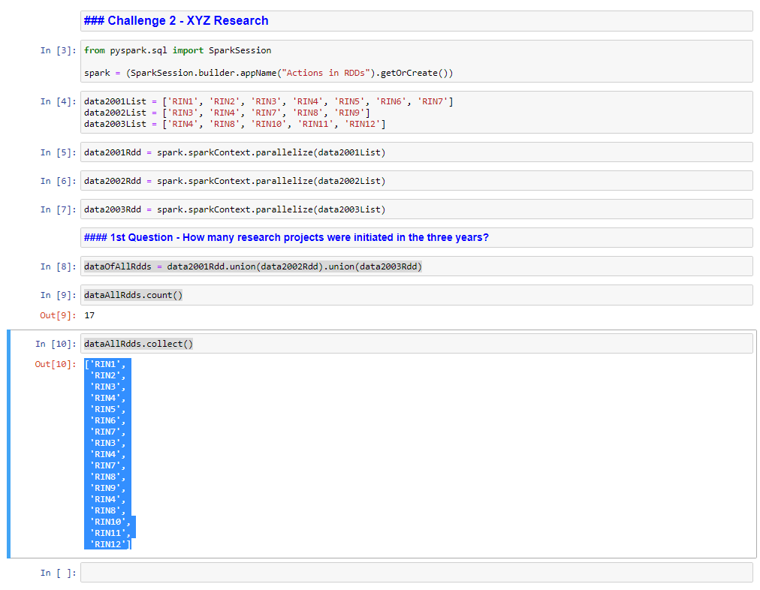

OK, looking at the results that we see on the screen, we obviously have duplicated research IDs, so how about we make our data set unique? To do that, I'm just going to go back to my. So again, and I'm just going to add a distinct. And shift enter to run again.

unionOfAllRdds = data2001Rdd.union(data2002Rdd).union(data2003Rdd).distinct()

unionOfAllRdds.collect()

*Output: ['RIN4',*

*'RIN10',*

*'RIN2',*

*'RIN5',*

*'RIN11',*

*'RIN6',*

*'RIN1',*

*'RIN9',*

*'RIN12',*

*'RIN3',*

*'RIN8',*

*'RIN7']*

unionOfAllRdds.count()

*Output: 12*

OK, now all that is left to do is a count, and we should reveal the answer and I will simply just copy and paste all research again and simply just do a dot count just like that shift enter to run. And there you have it, we have found the answer to the first question, which is 12 research projects that were conducted in the first three years.

**2. How many projects were completed in the first year?**

firstYearCompletionRdd = data2001Rdd.subtract(data2002Rdd)

firstYearCompletionRdd.count()

*Output: 7*

**3. How many projects were completed in the first two years?**

data2002Rdd.union(data2003Rdd).count()

*Output: 10*

Let's imagine that we have two sets of data, which is set A and also set B. So when we subtract A, set B from set A, that will give us all the elements that are members of Set A, but not set B. Using this example, the 2001 data is our set A and the two 2002 data is our set B. Now let's subtract set B from set A. Now I am going to need an authority that will store the results of 2001 minus 2002 data, which will represent the projects that have been completed in year 1. Now, to do that, I will create a new RDD, so first year completion RDD. And I'm going to subtract our set B, which is 2002 data.

firstYearCompletionRdd = data2001Rdd.subtract(data2002Rdd)

firstYearCompletionRdd.count()

*Output: 4*

firstYearCompletionRdd.collect()

*Output: ['RIN6', 'RIN2', 'RIN5', 'RIN1']*

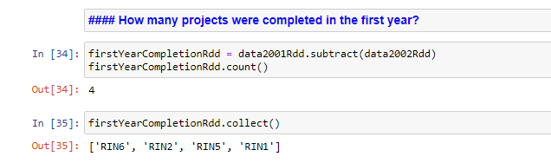

So let's answer the third and final question, which is how many projects that were completed in the first two years? It appears that we will have to use the union transformation again to solve this question. A union of our RDDs will give us all the projects that were started in the first two years. We can then subtract projects that were still running and also have started in the third year. We will then return all the projects that were completed in the first two years.

data2002Rdd.union(data2003Rdd).count()

*Output: 10*

data2001Rdd.union(data2002Rdd).subtract(data2003Rdd).distinct().collect()

*Output: ['RIN2', 'RIN5', 'RIN6', 'RIN1', 'RIN9', 'RIN3', 'RIN7']*

And I'm going to do a collect right over here just like that, to get our answers or shift, enter and let's see what we get. And just like that, we have a list of projects that were completed in the first two years. All right. Just as easy as you like, we have completed our challenge and it's time for you to work on the third one on your own.

## Spark SQL and DataBricks

### Introduction to Databricks

So we are going to discuss the idea behind databricks. In the last couple of years it has become something of a buzzword in the world of data science and engineering. If you spend your time and pay attention to tech news, you probably would have heard or seen data in action.



Databricks market themselves heavily across the web of they hold a regular live events on streaming platforms such as YouTube and Facebook. The idea behind is live events is to attract data scientists and data engineers in order to showcase the capabilities of Databricks. So try finding them on YouTube and Facebook and make sure to subscribe to keep yourself updated, perhaps let's discuss the idea behind databricks and why it has become so popular. Well, the first reason is that database is a managed Spark platform. So what is a managed Spark platform? To set up Spark in a traditional way, you would have to acquire the knowledge to set up and install the Cluster yourself. And this often requires knowledge about computer networking and operating systems when setting up multiple computer servers to work together. Perhaps the most popular open source of the utility to manage large scale data processing is on a Hadoop cluster. So in addition to knowledge about computer networking and operating systems, you require knowledge on how to set up and configure Hadoop to work with Spark and furthermore, you will need to install Spark yourself and configure it to work in the most optimal manner. To get started with data, you can easily set it up with a few clicks on buttons and everything happens for you automatically behind the scenes, and just like that, you have a cluster ready, which then puts more focus on your data challenges instead of digging through configuration files. The other good reason why datapoints has become so popular is cloud optimize, and therefore it can scale up and down as and when needed.

Let's say you have regular sales data processing jobs and it takes only two seconds to complete the jobs. And on Black Friday, where we expect astronomical sales and all of a sudden we need more processing power databricks can easily scale up more to handle the load and scale back down when there is no longer a need. The scale and capabilities of darabrick allows companies to have the power when they need it and also at no cost when they don't. So this pay as you call model is a big benefit for most companies as they won't find themselves maintaining worker nodes they do not need, as it often comes with a huge cost. The other good reason why Databricks is popular amongst data scientists is a user interface which is minimal and very easy to use.

In fact, if you have used Jupiter notebook before, you'll find yourself very much at home with databricks and it works pretty much the same way as Jupiter notebook. The data interface is pretty much built for collaboration, so you and your colleagues can work on the same notebook no matter where you are around the world. Databricks comes packaged with many tools that can allow you to connect to desktop analytics tools such as Microsoft Power BI, and also Tableau, and furthermore, you can use the built in job scheduler to schedule the execution of jobs at a specific moment for your data engineering use cases. So let's meet again in the next lesson to get started with data breaks.

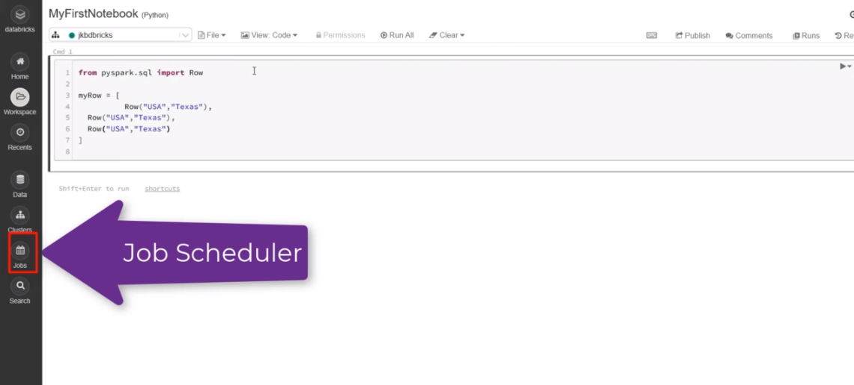

### Spark SQL

Let's discuss SQL and Spark SQL as well. So what does SQL actually stands for? It stands for structured query language. The idea behind a phrase structure simply means that there needs to be a data structure that actually exists. And query implies you can interact with a data structure. In the world of relational databases such as MySQL, Oracle and SQL Server, the structure suggests that you have to find a database and a database has a number of tables that stores data such as customer movies, bank transactions and so on.

So what can we do with SQL? First and foremost, SQL is a language that lets you communicate with the database and you can do the following, you can create databases and tables, you can also execute queries, against database tables to generate analytics. You can retrieve data from database tables and insert records into database tables. SQL can also assist you in updating and deleting records from database tables. But these are some of the features that SQL provides, and obviously you can do more, and I am therefore pleased to inform you that Spark also supports SQL. In fact, the SQL features that I have just listed, you can also do it with Spark SQL.

SQL is a standard, and most technologies that claim to support SQL must ensure that they are at least ANSI or ISO compliant and must support the following basic commands which are select, update, delete, insert and where and once more, Spark SQL will also support the list commands and also many more. And we are going to go through most of the commands throughout the rest of the course. If we take a closer look, we can't immediately make a determination that Spark SQL is a spark module that is closely related to dataframe API, since you can to a large extent use the same SQL commands and collectively they are known as structured APIs.

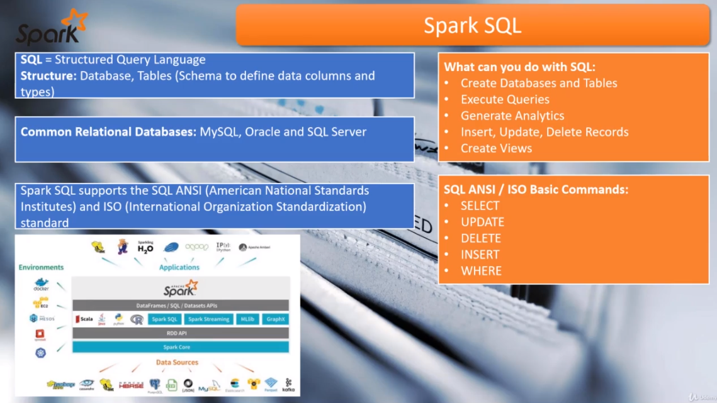

And furthermore, the engine behind a dataframe and dataset APIs is actually Spark SQL. So are the standalone Spark as your module will simply interpret the SQL that you write and this Sparl core SQL engine or convert the code into Java bytecode that can be executed over a cluster. So the advantage of Spark SQL is that you can actually use the same knowledge that you have acquired when working with relational databases and it will look very familiar to you. And as always, the best way to learn something is through practice over and over again. So let's meet again in the next lesson and go over the platform of choice to practice Spark SQL. And this time around it will be the cloud platform databricks.

### Register on Databricks

Database offers a version of its software for absolutely free, and databricks calls it community edition. So why don't we register a new community edition account with data? I would like you to visit the URL that you see on screen and it will take you straight to the database login page. And if you don't already have an account, please it the sign up link.

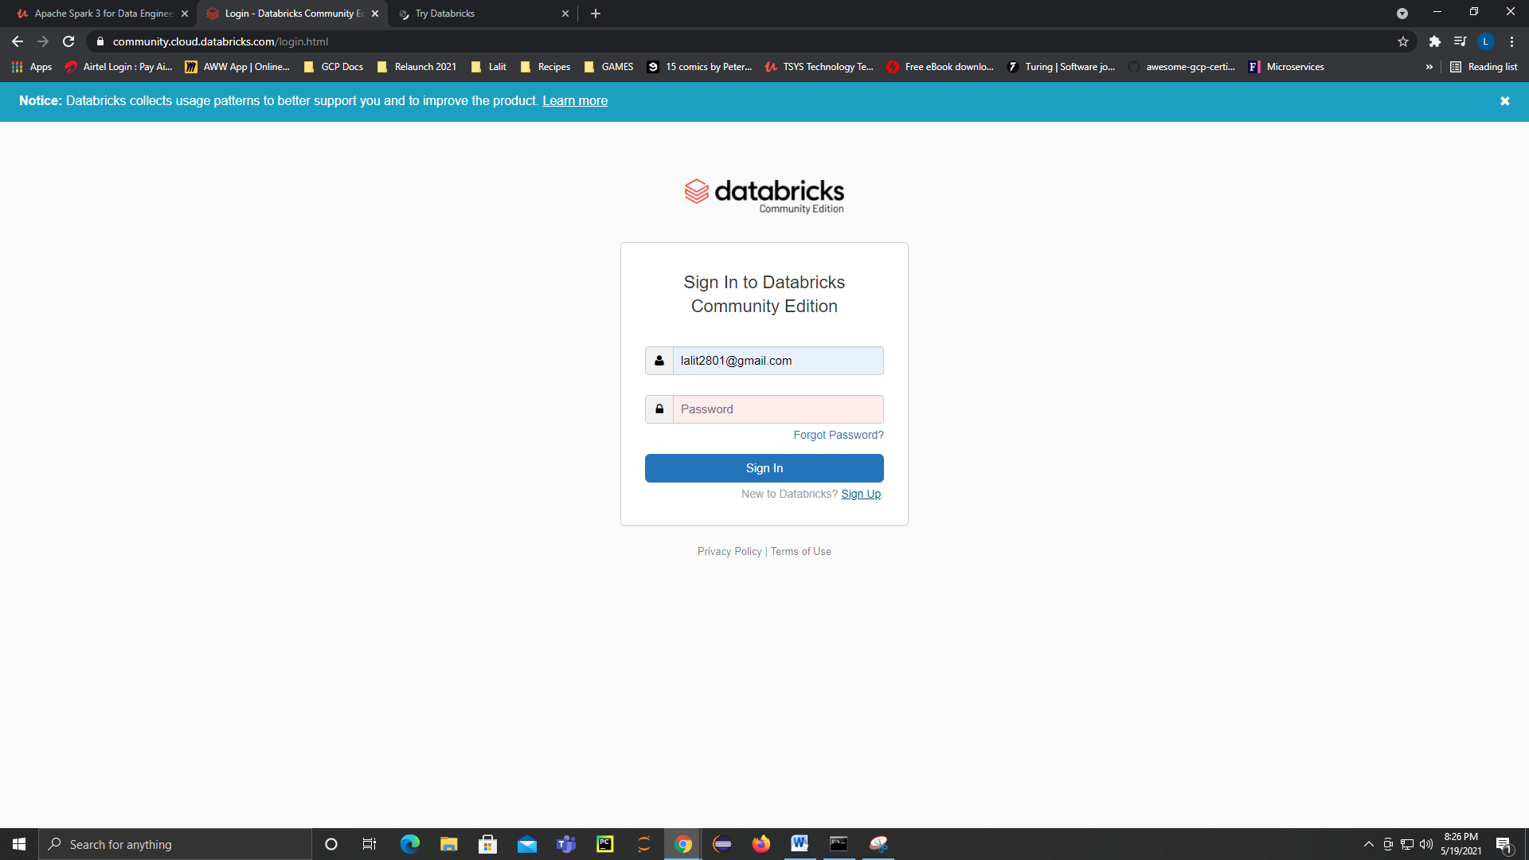

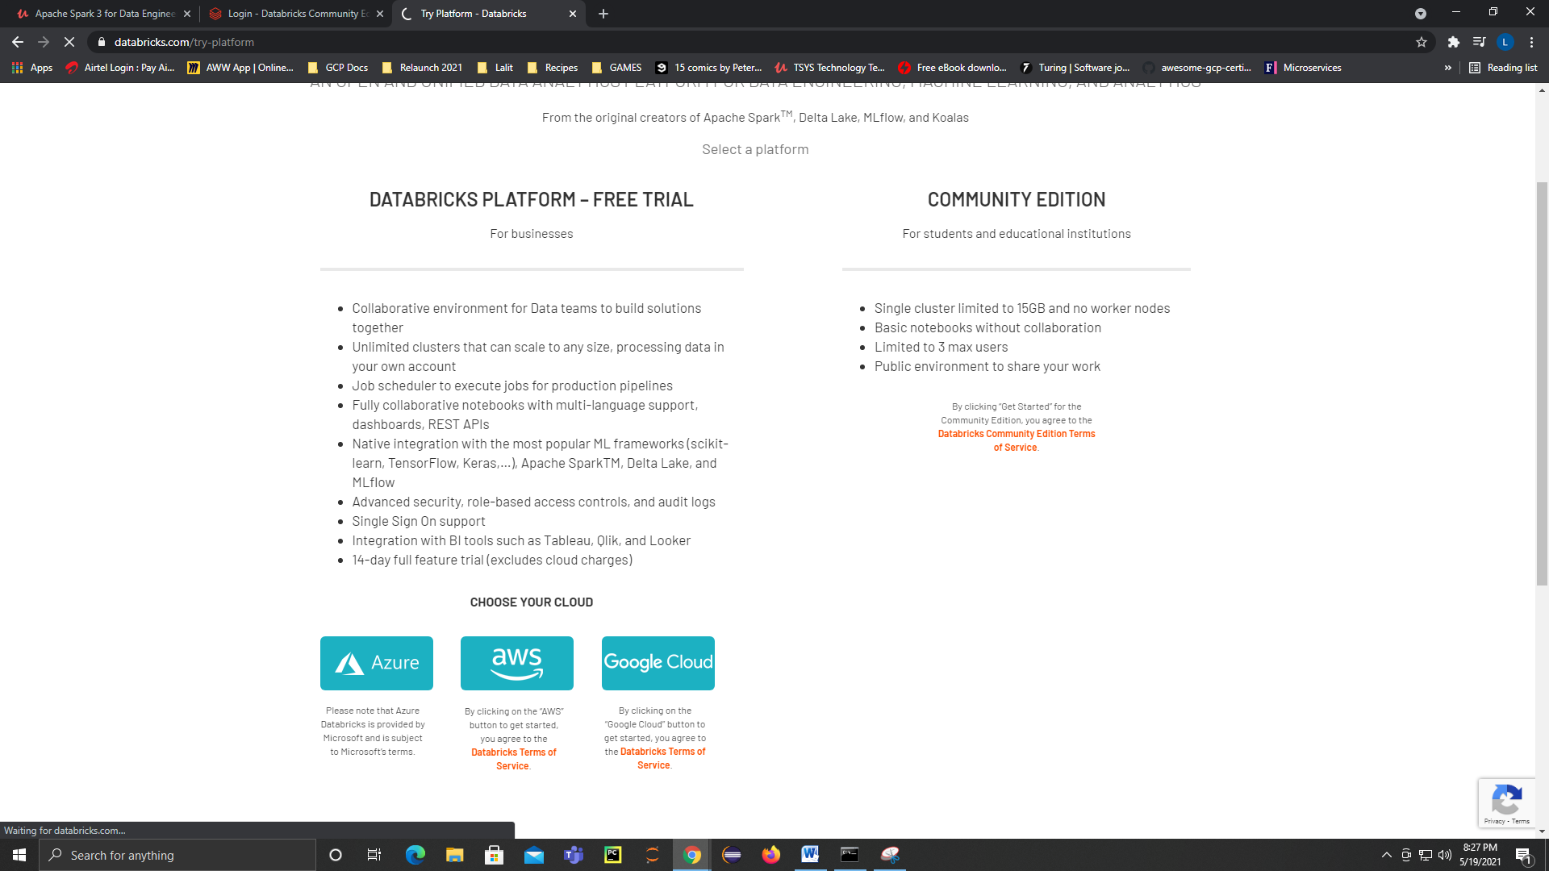

Mail registered: [lalit2801@gmail.com](mailto:lalit2801@gmail.com), D@t@kin$123

Now, I do already have an account, but I am going to sign up anyways, so I am just glad you decided to sign up. An option to choose a commercial addition of data as a free trial? Well, we can choose the community edition. The coming lessons are actually focused on the community additions and therefore we will choose the community additions. So let me hit that get started button on the community, edition. And just as the message says, it's time to check your email and confirm the registration. So go right ahead and validate your email address. Once you have completed the email confirmation, we can return back to the sign up page just like that. And I am just simply going to enter my credentials, which I already have, and I am just going to select sign in. And here we find ourselves in the front landing page off of the data platform. Now, we are not going to do anything just yet, but definitely we are going to do a lot on this platform in the coming lessons.

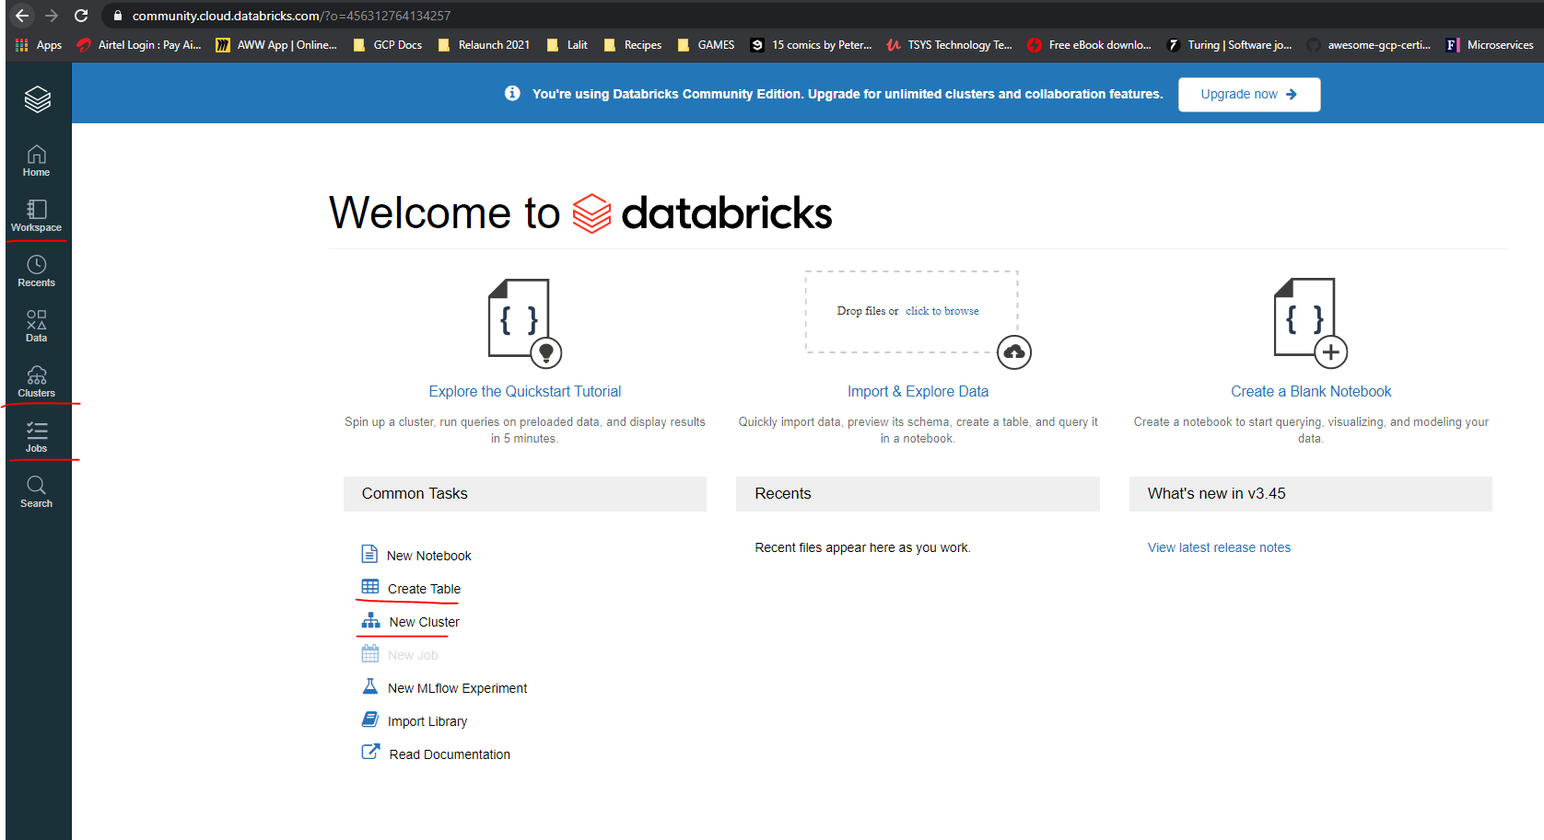

### Create DataBricks Cluster

|  |  |
| --- | --- |
|  | Perhaps the best way to learn any type of tool is to actually do something with it. How about we start by creating a cluster? So let me select cluster menu. Now, let's talk about the cluster just a little bit. If you're going to write and execute any form of Spark code databricks can only do the processing through a cluster consisting of a number of nodes. However, this is a community version and databricks will only offer you just one node. Which basically means it's just one virtual machine, just like your PC or laptop. You will get access to at least one Spark driver and roughly around fifteen point three gigabytes of memory, with, just two CPU cores? Don't worry about a DBUs ( Databrick Processing Units ) or perhaps data exposes units at this point, this will only become relevant once you choose the paid version of data through a cloud provider of choice, which can either be Amazon Web Services or Microsoft, as usual. In a nutshell, data that uses DBUs to charge your data processing on a per hour basis and also the number of resources you need. But this one note cluster may seem a little small, but honestly, it's enough to get you started with data breaks. |

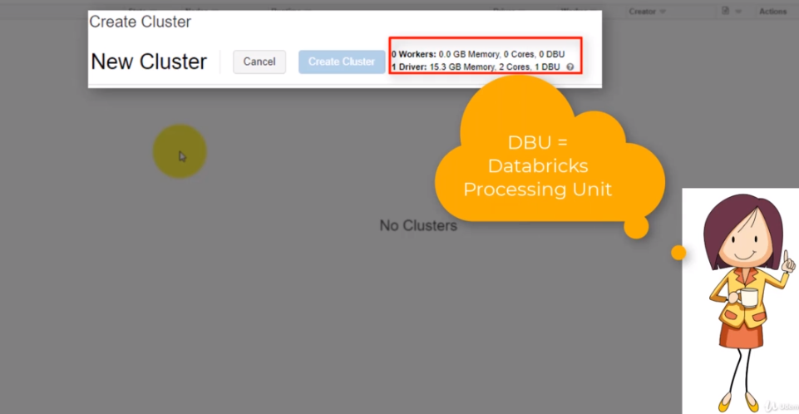

So let's create a cluster, and to do that, I am going to select the eight cluster button and within the cluster name, I'm just going to type my awesome cluster. In fact, you can give the cluster just about anything that you like, and I am going to live on the time version as it is. Now, the right time version actually supports Python three, and this is exactly what we need to write our Python code.

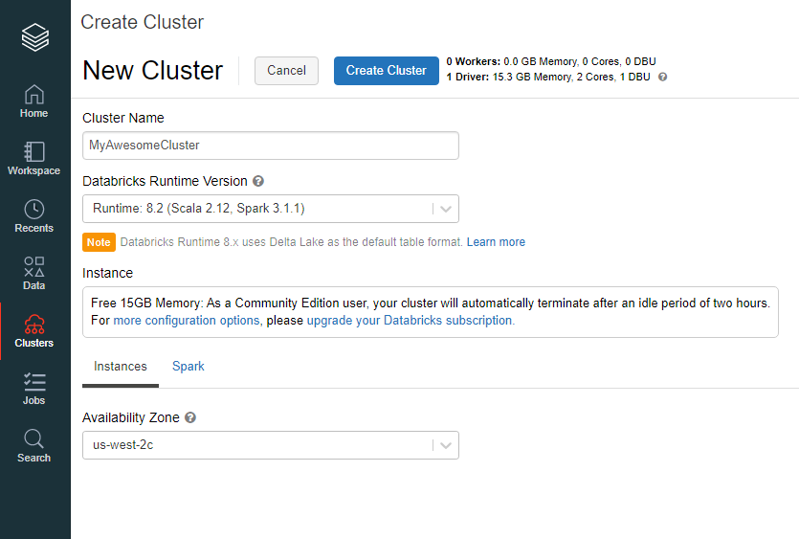

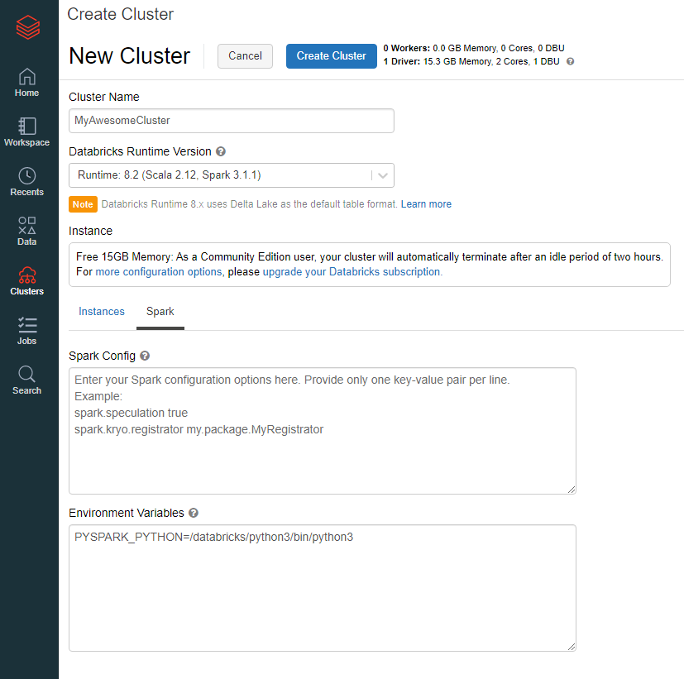

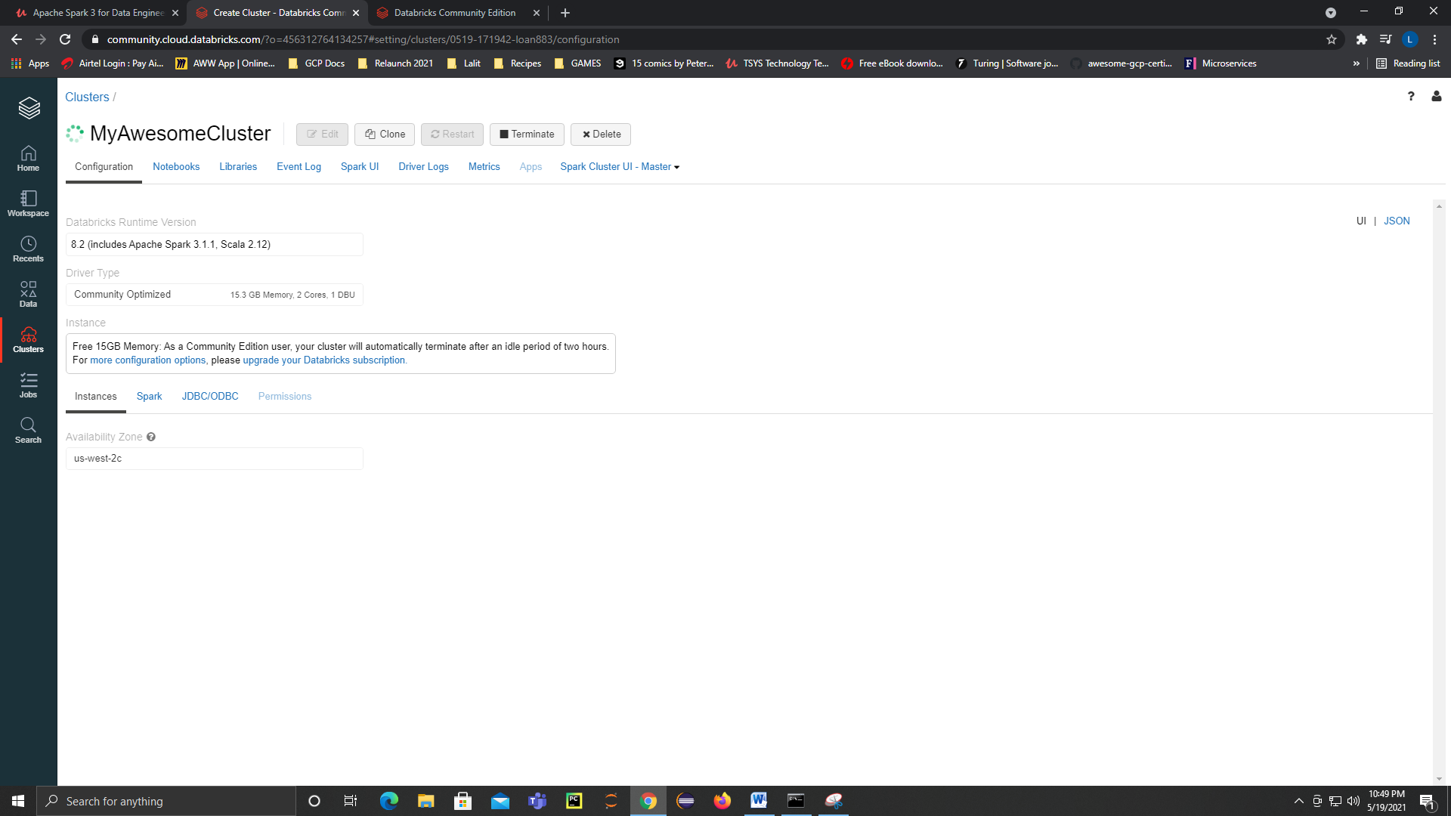

|  |  |
| --- | --- |
|  | Now, I would like you to take notice of the instance details. What this actually means is that your Cluster will only be available as long as you keep using it. If you happen to leave it idle for 12 hours or more, your cluster will potentially be terminated. The good news is if you have created databases and tables, your data will not disappear and you could always revert to your saved notebooks and execute your sportcoat on a new cluster.  Now, the last step is to actually select the availability zone, and what you need to understand is that data is a shared platform and this is why you cluster will get terminated upon non usage to free up resources. By default the databrick clusters are actually managed by Microsoft Azure, and you will need to select the availability zone where your cluster will be managed. OK. So I am going to leave the default selection as it is and just hit the eight Kluster button just like that, now creating the cluster can take a few seconds to a few minutes. So how about we engage in the next lesson to continue our lessons on data optics? |

### Creating our first 2 Databrick Notebooks

It's time to create at least two new notebooks and we can create a new notebook in two ways, the first being from the home page and the other from the workspace side menu. So let's start with the easiest way by navigating to the help menu and to navigate to the whole menu. We are going to select the logo and definitely not the whole button. And on the common task, we can select a new notebook. And we can name our new notebook sales.

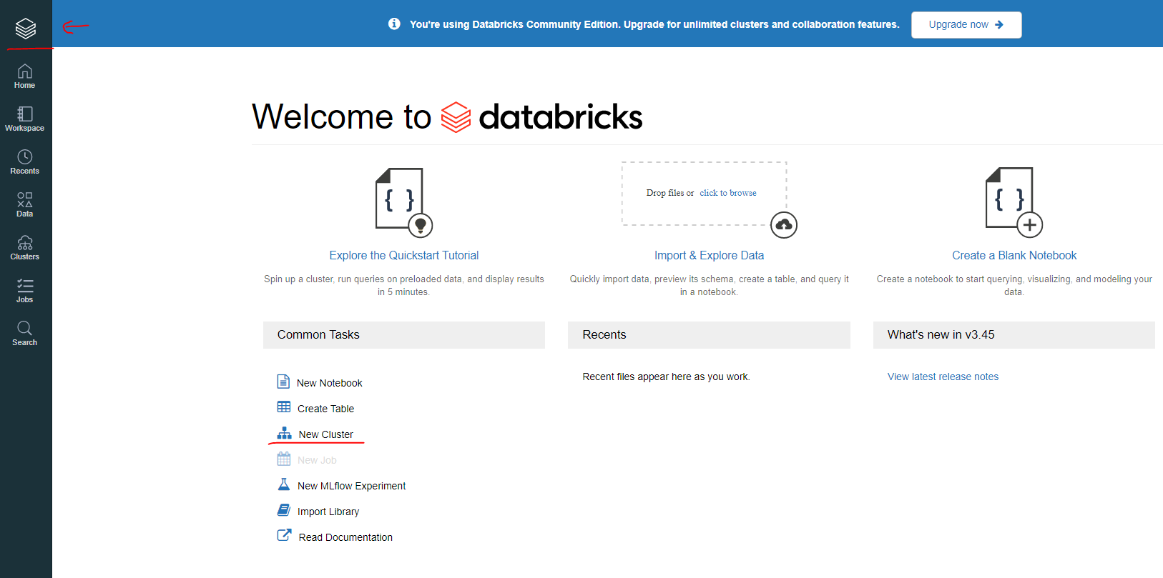

Databricks, just like, and I am going to create. Now that we have our notebook opened, it's time to see where the notebook is actually stored. We can do that by selecting the workspace menu. And if I do that. And a workspace is pretty much your storage area where you can find your notebooks listed on the right hand side, and if we navigate to the user list, which is on your left hand side, and here you are presented with three options.

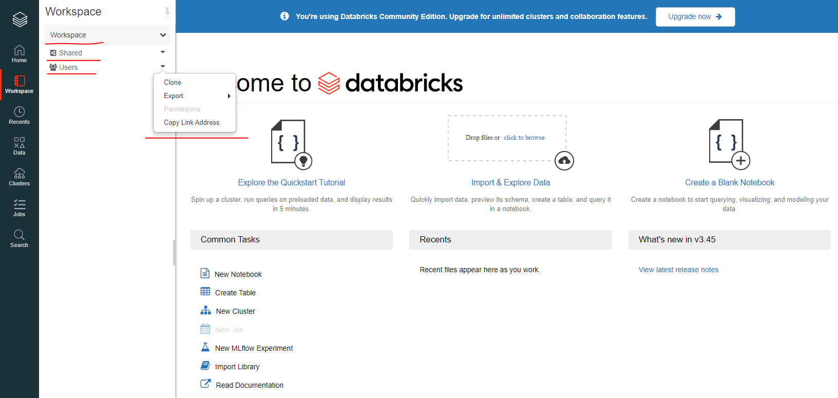

The first one is to clone your workspace in order to create a duplicate of your workspace. The other is to export your workspace as a data cloud archive in case if you want to create a backup of your notebooks and you can also create an e-mail backup if you want to, and this won't really work since you're on a free version of data. Now, let's let's users right here. And here you are going to find at least two folders, a shared folder and uses folder. These folders will become relevant if you're working in a collaborative manner, if you're working on a shared notebook, then you'll probably create and store them in the shared area.

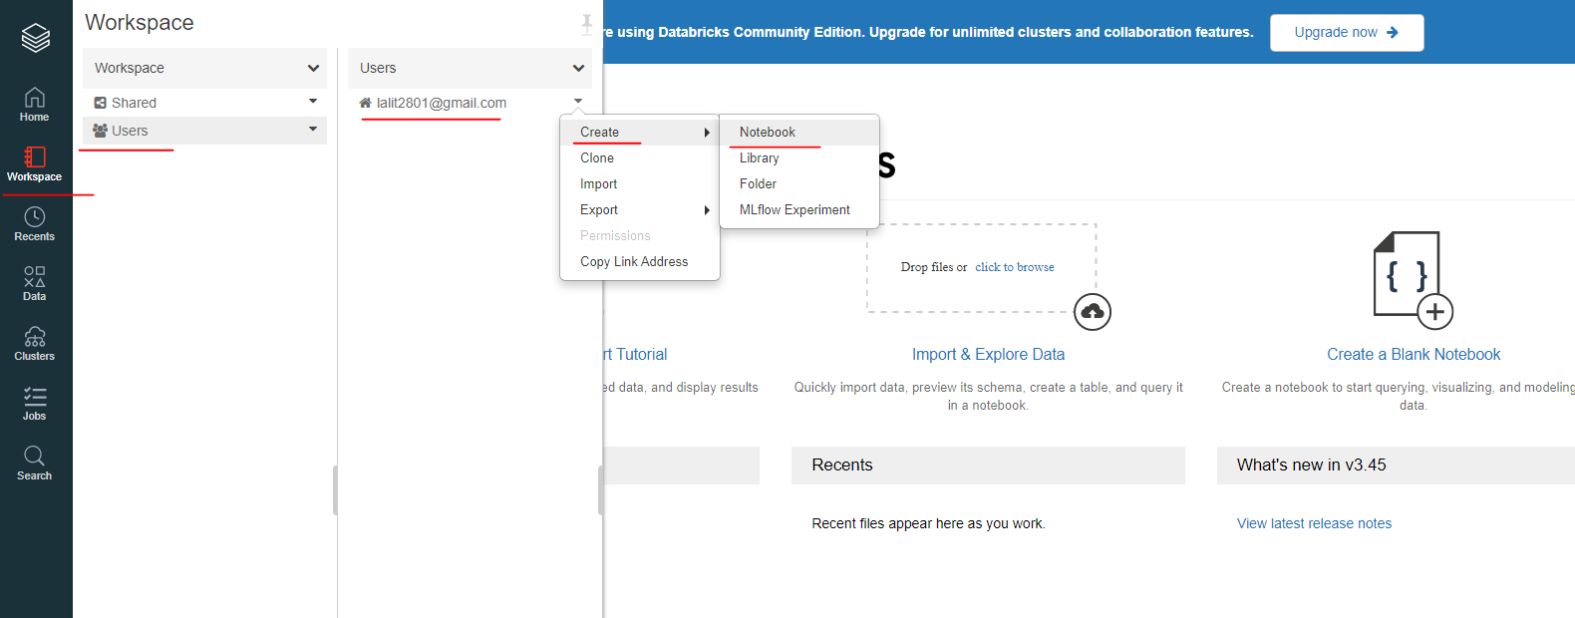

So let's create a new notebook and I am going to navigate back to the right hand side. And I am going to select my username once more, navigate back to my right hand side click the arrow select notebook just like that, and I am going to call it sales queries. OK, and this time around, the default language will be as SQL just like that and select create.

All right, we are going to use the SQL notebook at a later stage of the course, what we can do now is to return back to Dataprep. So I am going to select the workspace again and I will select sales dataprep. What we want to do now is to read our sales data file. And so we are going to import the libraries that we are going to need to create a special session and also a schema. So let's do exactly that.

So from pyspark.sql import SparkSession. So from pyspark.sql.types import StructType, StructField and StringType. Now to run this, I want to attach my cluster, which is MyAwesomeCluster, and to run, it will be shift enter just like on Jupiter, note book. Now, what I want to do next is to create a special session. So Spark is assigned to Spark Session.builder.appName and I am going to call it SalesDataPrep, and now I need to getOrCreate my session and to run the second Shift enter just like that. And this is enough for one lesson, so let's get back together in the next listen to upload our first dataset and this is it for me and I'll catch you on the next one.

### Creating CSV Files into Dataframe

What we need to do next is to load the sales CSV files from our previous project and then also create a schema we can select file and then upload data. So from our upload data window, we can enter the path where we want to store the data. So I want to store under salesdata/raw just like that. So I am going to load my sales data files from my previous project and I will just simply just drag them into this Files Pane.

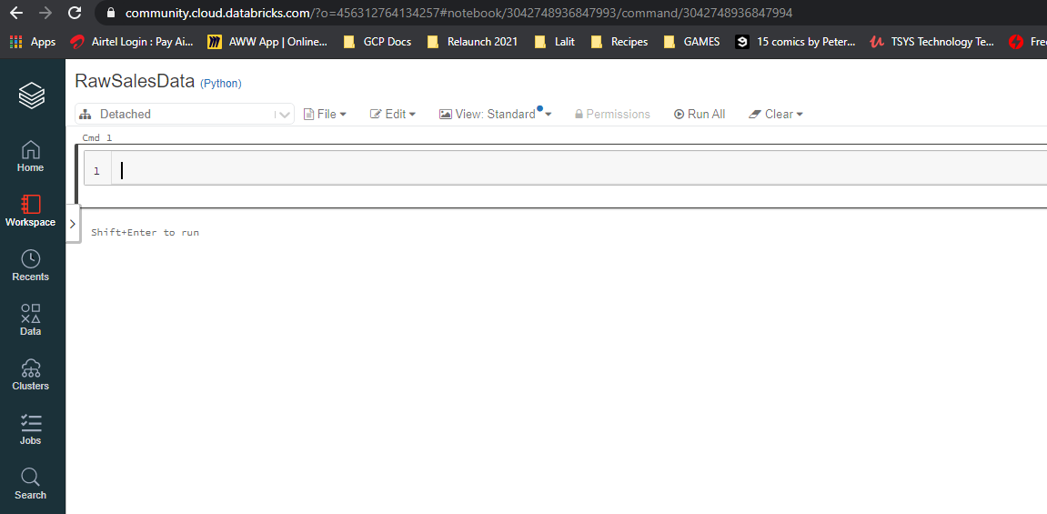

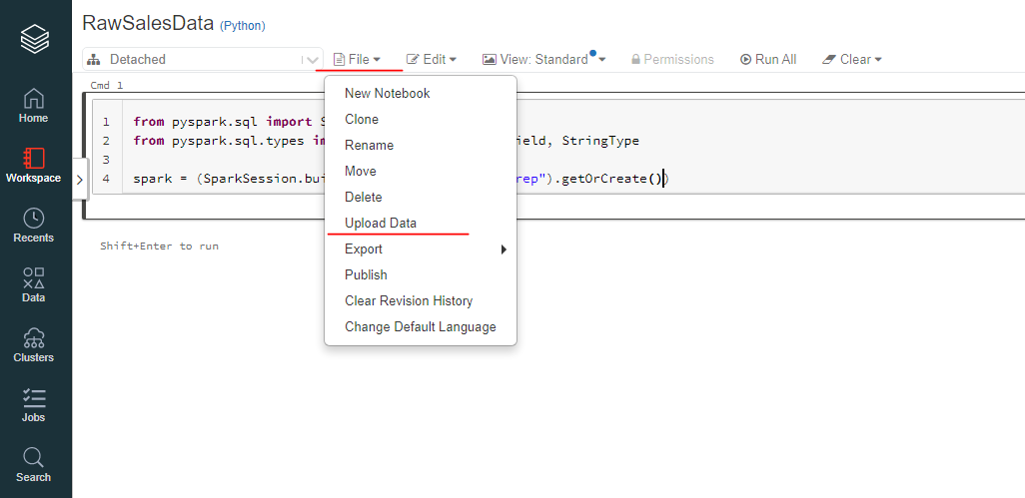

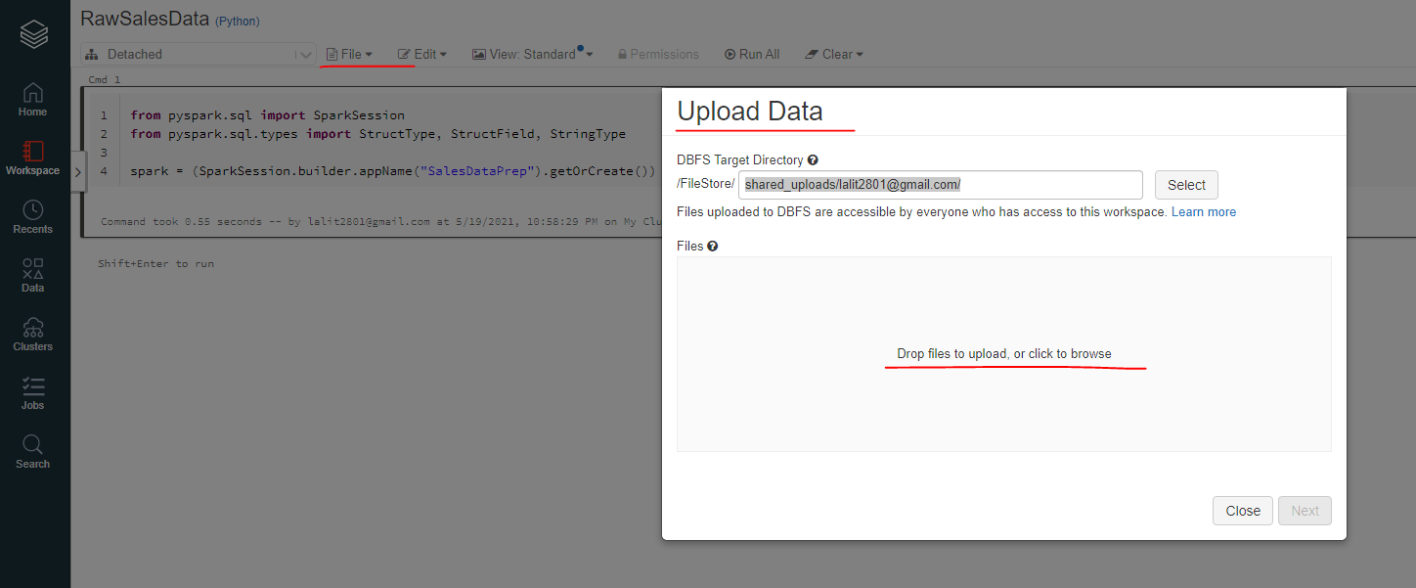

The question is what does DBFS actually stands for DBF is the Databricks Distributed File System and its functionality is very similar to the more common HDFC, which is known as the Hadoop distributed file system. As I have mentioned before, a distributed file system allows you to store data in a distributed manner, which means a data file can be split multiple times, such as our public example, and can be stored across multiple nodes within a cluster. However, the clients that you use, such as this one, will make the data appear as if it's stored within one folder. OK, we can now select the next button since we have completed uploading our file just like that.

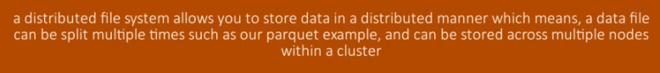

On pressing shift and enter key, we can run the instructions

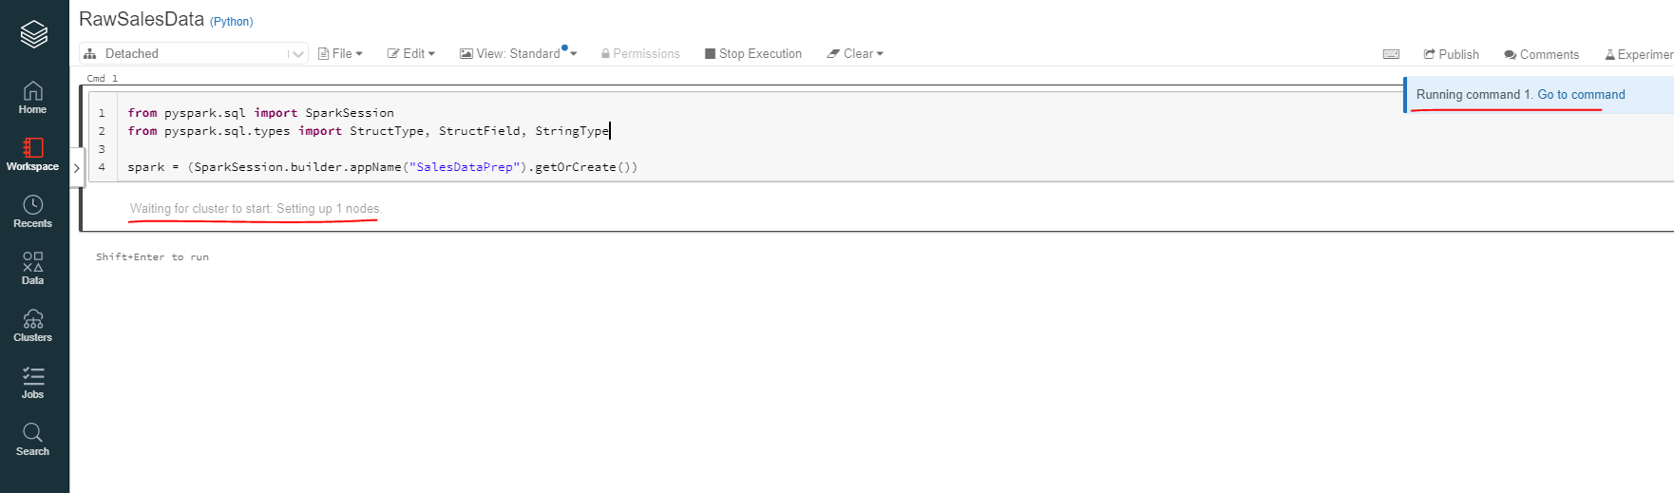

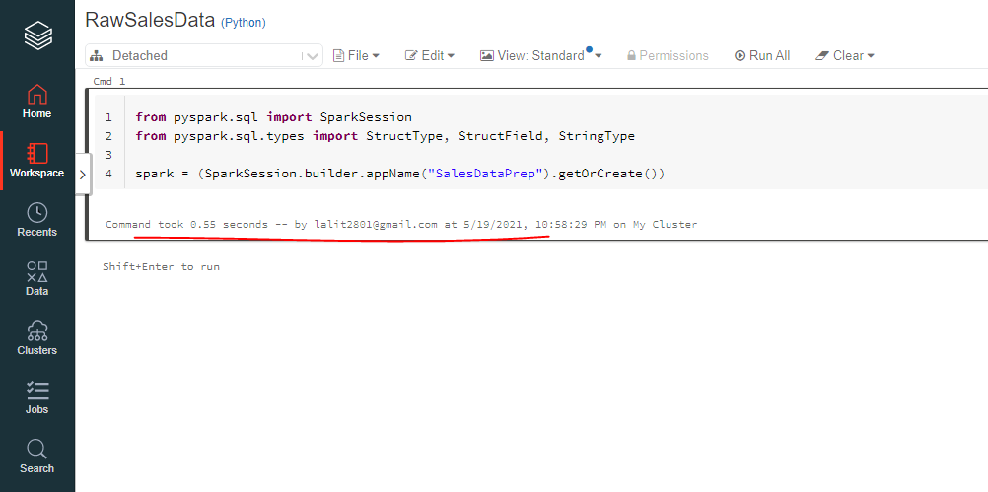

Uploaded the sales data to this folder

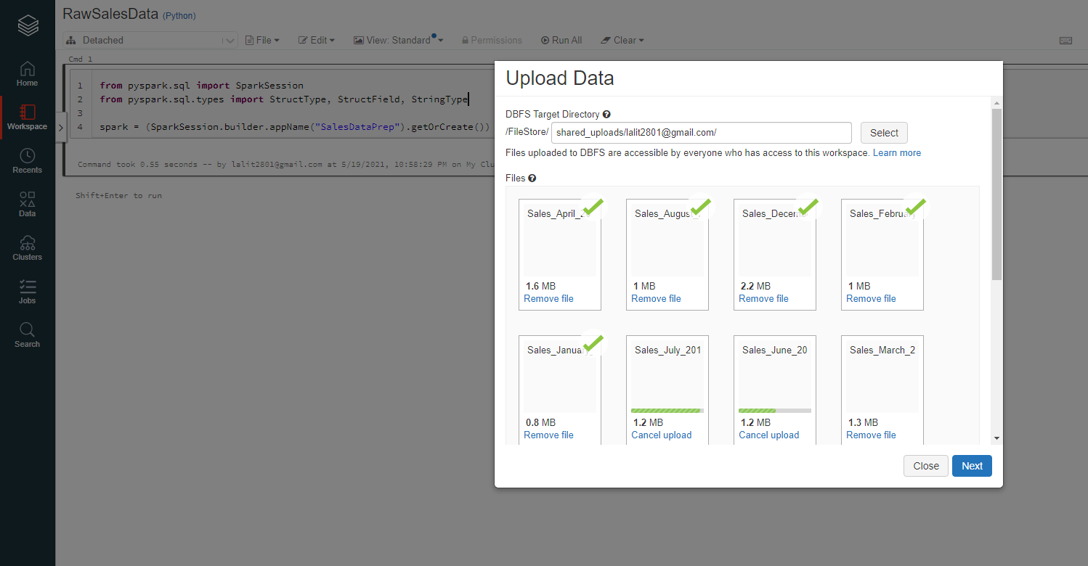

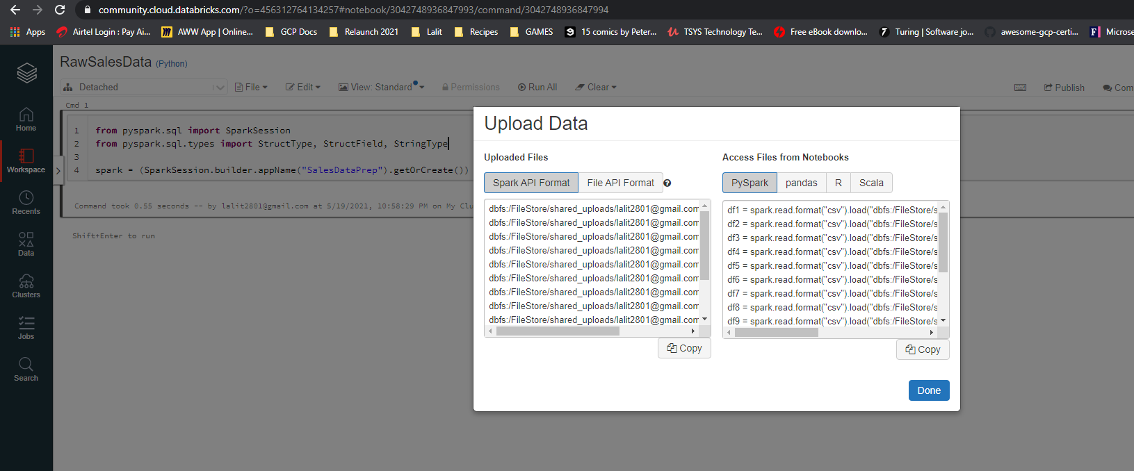

Now, the purpose of this window is designed to help you help code that you can paste onto your notebook. The code in the listed formats and languages is meant to load the data onto your Spock data frame.

dbfs:/FileStore/shared_uploads/lalit2801@gmail.com/Sales_August_2019.csv

dbfs:/FileStore/shared_uploads/lalit2801@gmail.com/Sales_April_2019.csv

dbfs:/FileStore/shared_uploads/lalit2801@gmail.com/Sales_February_2019.csv

dbfs:/FileStore/shared_uploads/lalit2801@gmail.com/Sales_December_2019.csv

dbfs:/FileStore/shared_uploads/lalit2801@gmail.com/Sales_January_2019.csv

dbfs:/FileStore/shared_uploads/lalit2801@gmail.com/Sales_July_2019.csv

dbfs:/FileStore/shared_uploads/lalit2801@gmail.com/Sales_June_2019.csv

dbfs:/FileStore/shared_uploads/lalit2801@gmail.com/Sales_March_2019.csv

dbfs:/FileStore/shared_uploads/lalit2801@gmail.com/Sales_May_2019.csv

dbfs:/FileStore/shared_uploads/lalit2801@gmail.com/Sales_November_2019.csv

dbfs:/FileStore/shared_uploads/lalit2801@gmail.com/Sales_October_2019.csv

dbfs:/FileStore/shared_uploads/lalit2801@gmail.com/Sales_September_2019.csv

dbfs:/FileStore/shared_uploads/lalit2801@gmail.com/Line_blue_background.ai

df1 = spark.read.format("csv").load("dbfs:/FileStore/shared_uploads/lalit2801@gmail.com/Sales_August_2019.csv")

df2 = spark.read.format("csv").load("dbfs:/FileStore/shared_uploads/lalit2801@gmail.com/Sales_April_2019.csv")

df3 = spark.read.format("csv").load("dbfs:/FileStore/shared_uploads/lalit2801@gmail.com/Sales_February_2019.csv")

df4 = spark.read.format("csv").load("dbfs:/FileStore/shared_uploads/lalit2801@gmail.com/Sales_December_2019.csv")

df5 = spark.read.format("csv").load("dbfs:/FileStore/shared_uploads/lalit2801@gmail.com/Sales_January_2019.csv")

df6 = spark.read.format("csv").load("dbfs:/FileStore/shared_uploads/lalit2801@gmail.com/Sales_July_2019.csv")

df7 = spark.read.format("csv").load("dbfs:/FileStore/shared_uploads/lalit2801@gmail.com/Sales_June_2019.csv")

df8 = spark.read.format("csv").load("dbfs:/FileStore/shared_uploads/lalit2801@gmail.com/Sales_March_2019.csv")

df9 = spark.read.format("csv").load("dbfs:/FileStore/shared_uploads/lalit2801@gmail.com/Sales_May_2019.csv")

df10 = spark.read.format("csv").load("dbfs:/FileStore/shared_uploads/lalit2801@gmail.com/Sales_November_2019.csv")

df11 = spark.read.format("csv").load("dbfs:/FileStore/shared_uploads/lalit2801@gmail.com/Sales_October_2019.csv")

df12 = spark.read.format("csv").load("dbfs:/FileStore/shared_uploads/lalit2801@gmail.com/Sales_September_2019.csv")

# Additional files uploaded

# dbfs:/FileStore/shared_uploads/lalit2801@gmail.com/Line_blue_background.ai

However, it would make sense if we were loading just one file. And unfortunately, we have a requirement to load the entire directory of files and this code would not help us in that particular requirement. We can just simply just select done just like that. Now, I would like you to take notice of the top down list just on the sales dataprep heading, which is this one. It can give you a list of clusters that you can select in the event that the cluster has been detached from your notebook.

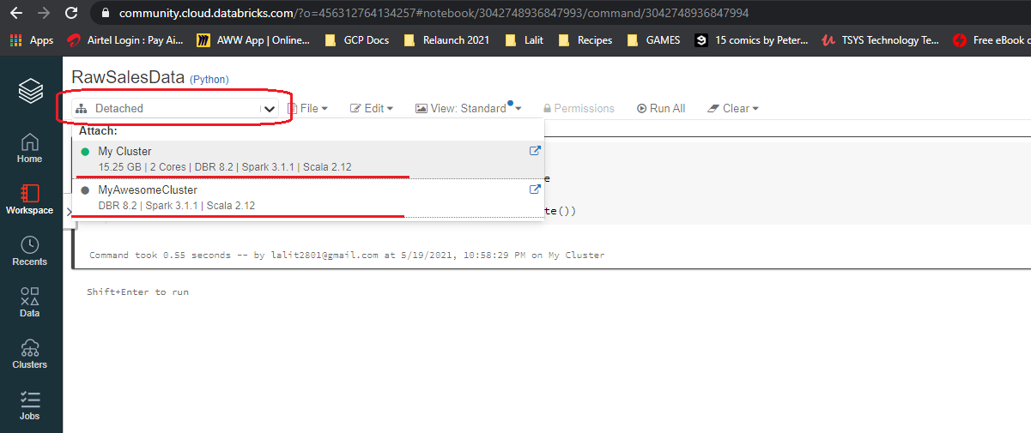

It could be that your cluster is idle and the instance was shut down or your cluster was terminated. If your cluster was terminated, then you would have to create a new one, then come back to this notebook and attach this new one. Luckily, my cluster is still running, so I am going to select my awesome cluster. Now let's create a heading and it will be an H2 Heading. Now to create a heading on the databricks notebook. We can insert a %md ## "Read CSV Files into Dataframe" just like that and to confirm -- into.

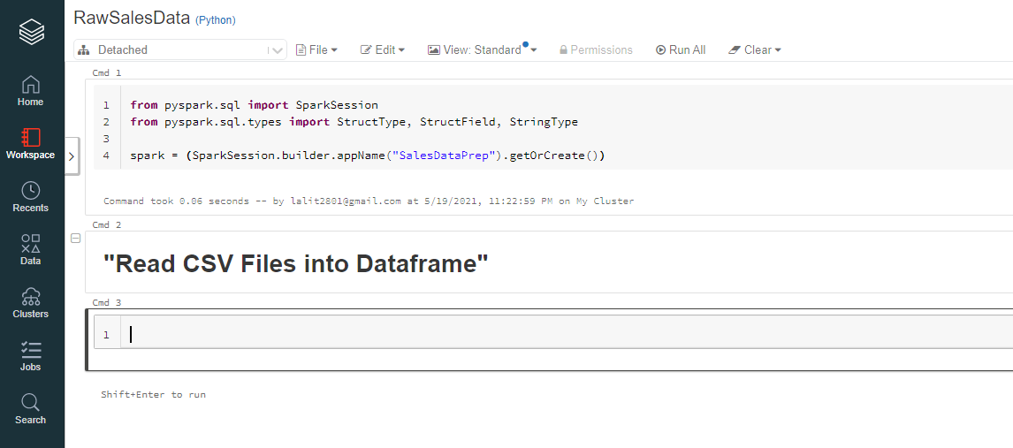

Working on the data notebook is pretty much keyboard driven and there is quite a number of keyboard shortcuts that you can use to interact with the notebook. To get the list of shortcuts, we can select, well, short cuts right here.

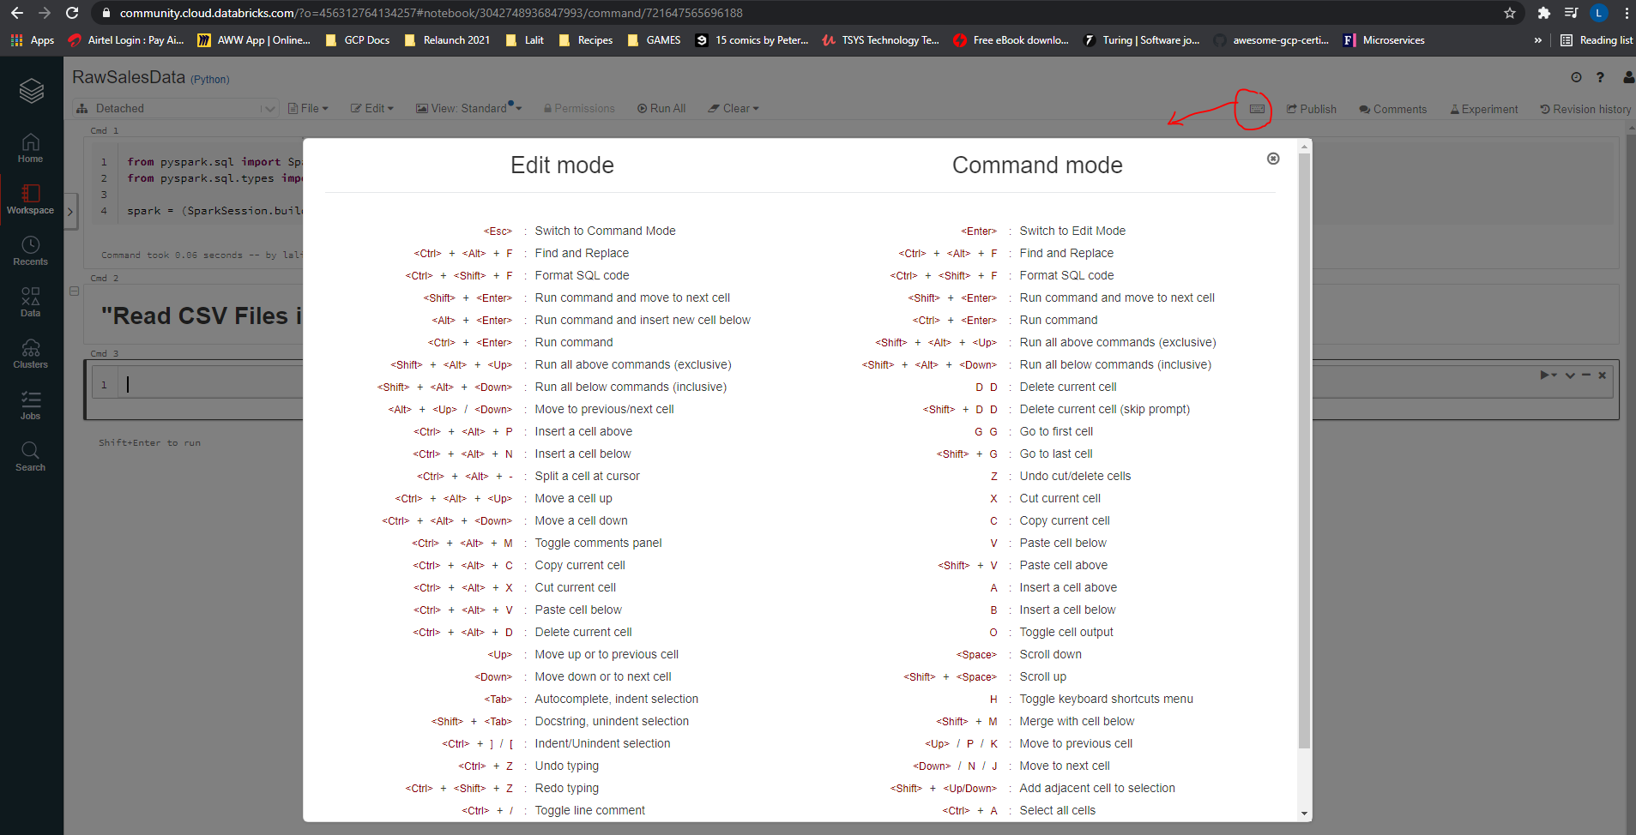

Here you will find a complete list of keyboard shortcuts in at least two modes of the edit and command mode. So in edit mode, which means while editing cell, you can simply use control plus Alt plus P to insert a cell above or even N to insert a cell below. I guess you get the picture. So let's close the window.

Let's now create this schema and also load our data now to create our schema. We are going to assign a variable called schema, which will hold our schema basically, and we are going to need a structure type.

schema = StructType([

StructField("OrderId", StringType(), True),

StructField("Product", StringType(), True),

StructField("Quantity Ordered", StringType(), True),

StructField("Price Each", StringType(), True),

StructField("Order Date", StringType(), True),

StructField("Purchase Address", StringType(), True)

])

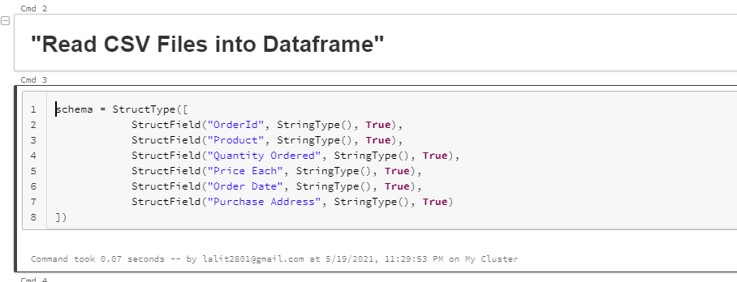

OK, now that we have ran our code, what I want to do next is to actually start loading our data into our data frame. Now, I am going to create a variable called sales_data_path, which will hold the path to our Data, so it will be the data file system, so dbfs:/Filestore/salesdata. Now let's create our sales raw data frame is assigned to, well, spark.read.format and it will be CSV, just like we did before. Now let's enter our options and we need to tell Spark that our files contain headings. So the first option will be Header Assigned to True. And it will be option again, actually, it will be schema because we need to tell schema that we have a schema and schema assigned with our schema variable just like that.

Now let's load the data so that load(sales_d_fpath). Let me fix this, it should be sales_data_fpath now shift enter to run. Shift enter to run. OK, let's now show the first 10 days records record.

sales_data_fpath = [/FileStore/shared_uploads/lalit2801@gmail.com/](mailto:/FileStore/shared_uploads/lalit2801@gmail.com/)

sales_raw_df = (spark.read.format("CSV")

.option("header", True)

.schema(schema)

.load(sales_data_fpath)

)

sales_raw_df.printSchema()

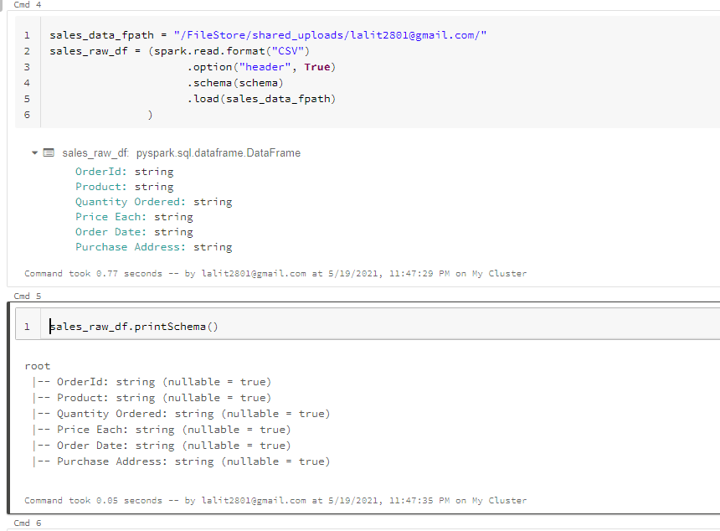

So that's good. If we want to, we can also print the schema so sales_raw_df dot printSchema and enter just like that

We took the path to our data from here.

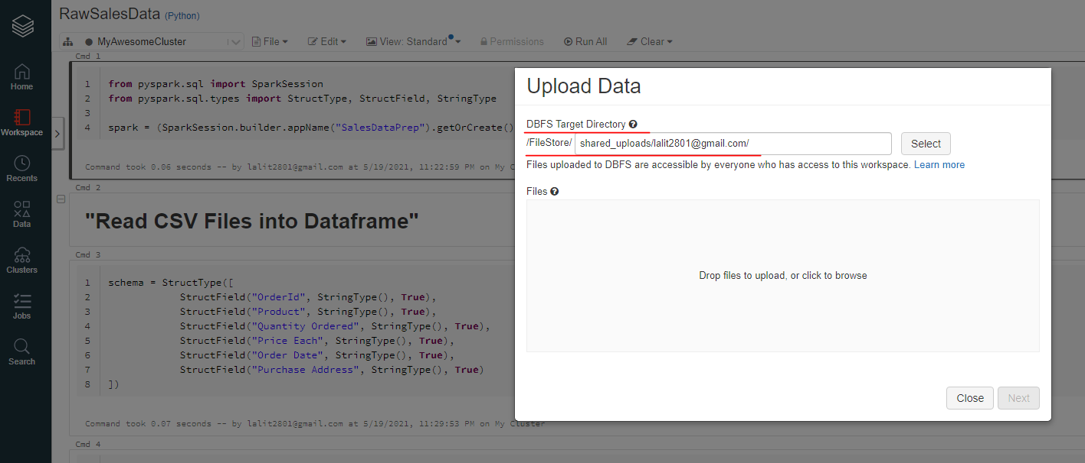

### Creating a Database and a Table

It's time to create a database and also a very first table that will store the raw sales data. And to do that, I am simply going to call my spark sessions of Spark and to use SQL, I am going to call the SQL function just like that open brackets and to create the database. I am going to issue the statement create database if not exists and I am going to call the database sales on the sales_db just like that and to run shift enter.

spark.sql("CREATE DATABASE IF NOT EXISTS sales_db")

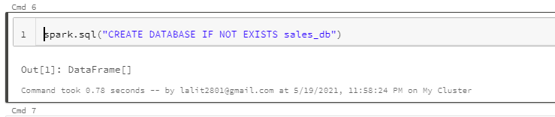

Now, what I want to do next is to ensure that we use our database and to do that, I am going to issue again the following statement. If I don't use this particular code to use sales DB, what will happen is that if I create any tables, it will create them within the default DB and I don't want to do that.

spark.sql("USE sales_db")

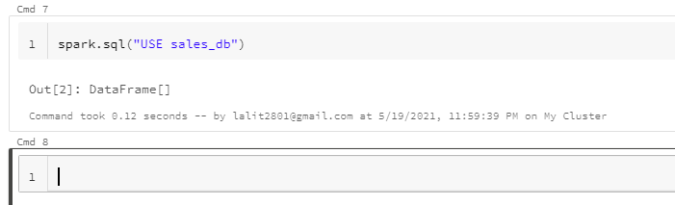

I want to ensure that all the tables that I create are created within sales_db. So let's create our table so

Now, what I want to do next is to ensure that. I have at least triple quotes. Just like that. Simply because now I want to move to the following subsequent lines, and therefore I need triple. Now let's create our first field so order ID STRING and so on. OK, now to run this -- into to create the table. All right, it looks like I have gotten to put in open brackets a. And I need to close my brackets right over there now, shift enter to run again to create the table and this should be fine.

spark.sql("""CREATE TABLE IF NOT EXISTS sales_raw (

OrderID STRING,

Product STRING,

QuantityOrdered STRING,

PriceEach STRING,

OrderDate STRING,

PurchaseAddress STRING

) """)

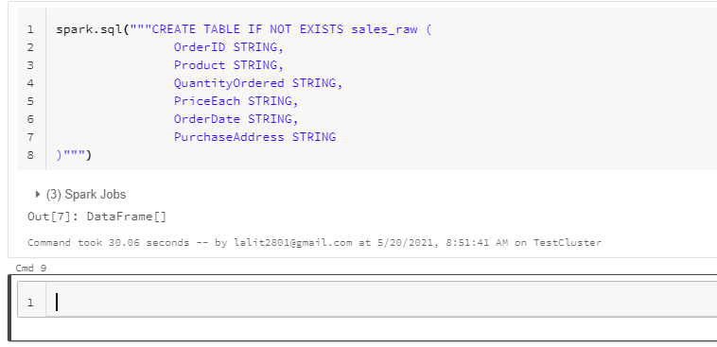

Now, notice the syntax of creating a database and also the table as well. These statements are referred to as the data definition language or perhaps DDL else in short. So basically DDLs are SQL commands that can be used to define a schema and a database schema is made up of databases and tables, you can view a database as a container that holds one or more tables. So you just need to create the table just once. If you want to check out the information about the syntax that was used here, you can visit the documentation from better databricks as displayed on screen. You can actually create the database table without using the if not exist. And what will happen is that if the database or table does actually exist, the statement is going to fail. Now, let's turn it to the table syntax as well, and let's choose the second one.

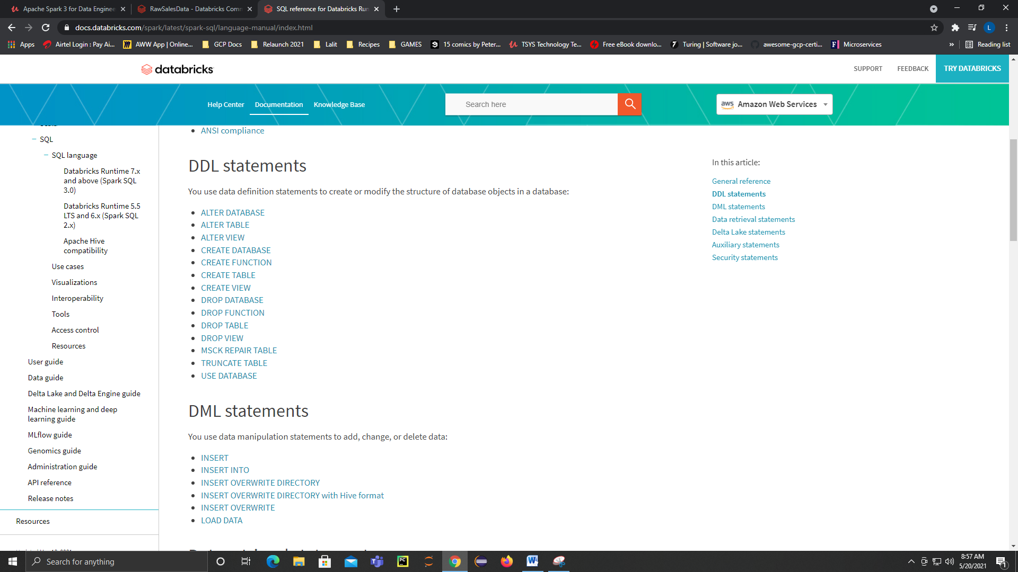

OK. I would like you to go through the documentation on databricks and learn the syntax and parameters that you can apply on your table statement. Now, our own create table segment has omitted some syntax and parameters. We could have used the USING clause to sign it storage file type, such as a parquet or csv and many more. The ommission will then use a default format known as Delta, which is a databricks specific file format. The Delta file format is optimized for ACID database transactions, which guarantee the integrity of the data during processing, and this is an advantage over a traditional file types, which doesn't offer the same.

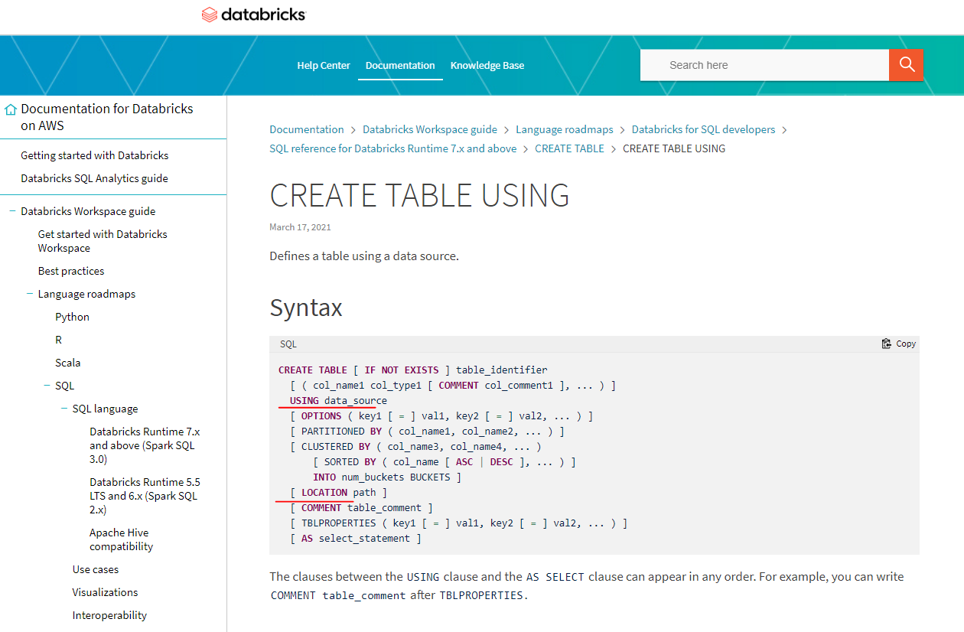

We have also ommitted partition by we don't need to partition our table just yet, and we will do that within our final sales table. We have also ommitted the location, which means you can choose with data files are actually located. So I could have supplied the directory files store sales role as a string and added some more properties to tell Spark that this is a CSV file with headings which will require the usage of options or TBL properties. We will explore this at a later stage of the cause, but for now the table will be created at an internal default location and therefore this will make the table a managed table.

A Managed table just means when you drop off the table using the drop table syntax, the data will also be deleted together with the meta data. If you happen to supply the location, the table will be classified as a managed table, so if you drop the table, you will no longer be able to transact on the table, but at least your data at the provided location will not be deleted. So using unmanaged tables are actually the safer option.

### Inserting Records Into a Table

Now that we have our table created as a Managed table, we can now look forward to writing the data from our sales raw data frame into our sales table. So let's start by creating a new heading Dataframe data to Sales Raw Table. What we want to achieve is to use spark sql to read the data from our sales raw data frame. In other words, I want to use Pure SQL to query the data. Let's see what happens if we try to query the sales raw data frame using Spark as well. Now to try this, I am just going to do a spark.sql select all from sales_raw_df and to show the first 10 results.

spark.sql("select * from sales_raw_df").show(10)

As you can see, we seem to have an error that reads table of you not found.

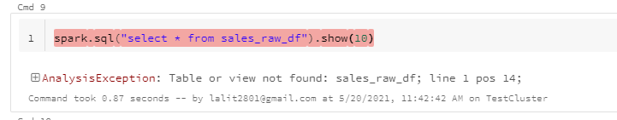

What this actually means that the data frame is not compatible with just pure SQL, in fact, you can only use a data frame API and use the sql like syntax that we've seen before. To fix this, we will need to convert the dataframe into a table to make it compatible with Spark SQL. So let's convert the dataframe to a temporary table instead. So let me take this piece of code now. Now what I want to do is to create a temporary table. So sales_raw_df.createOrReplace Temp view just like that, and we are going to call the temporary table tmp_sales_raw. Now, let's try running the SQL statement again, so now what I'm going to do is to copy this line of code. OK, and I don't want to truncate the results, so shift and to run and let's see what happens. And as you can see, we were able to query the table using Spark.

spark.sql("select * from sales_raw_df").show(10)

sales_raw_df.createOrReplaceTempView("tmp_sales_raw")

spark.sql("select * from tmp_sales_raw").show(10, False)

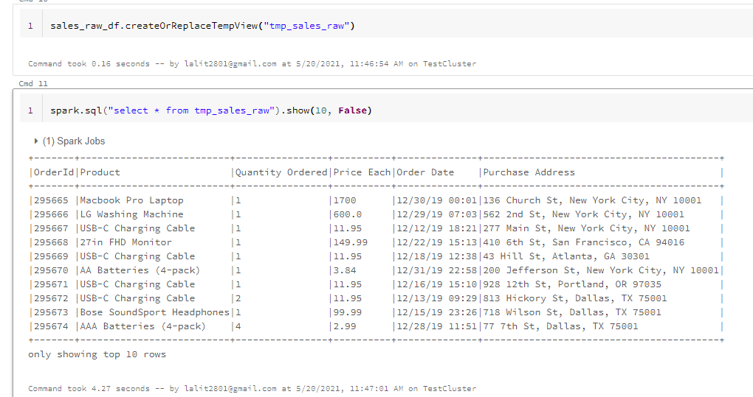

Statements that are used to achieve data from the database are known as the data query language.

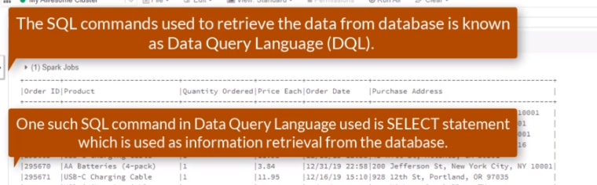

So DQL statements are basically silent statements, so what are temporary tables, temporary tables are only available within the current session? Temporary tables are automatically dropped at the end of the current session. So in other words, use temporary tables to assist in your data processing and you can use managed and unmanaged tables to store data permanently.

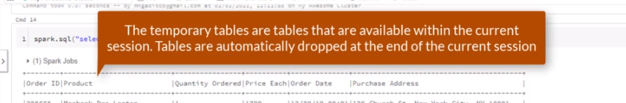

Now that we have a temporary table in place, it's time to insert the records into our sales_raw managed table. But first, we need to check if both tables are compatible with each other. We can do that by describing both tables and to two that we can do spark.sql("describe temp_sales_raw").show().

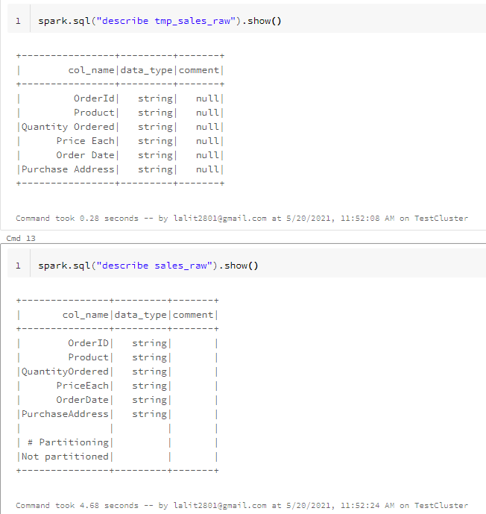

A you can see, the describe command actually prints out table schema information for each table, we can immediately see that all the tables are actually compatible with each other because we have matching data columns and also matching data types. So let's insert data and to do that, I am going to do a spark.sql now, triple quotes again, because we need a multiline statement. And I am going to do an insert override and sales_db.sales_raw table. And I need to do a select statement

spark.sql("""INSERT OVERWRITE sales_db.sales_raw

SELECT `OrderID`, `Product`, `Quantity Ordered`, `Price Each`,

`Order Date`, `Purchase Address`

FROM tmp_sales_raw

""")

We have to use the backticks as the column names contain spaces. I want to repeat this a number of times. So for the product, quantity ordered, price each, order date and purchase address. Now what I want to do is to get to the product. And now the quantity ordered and also the price each and the order date and lastly the purchase address. OK, now it needs to come from some table, so from temp_sales_raw.

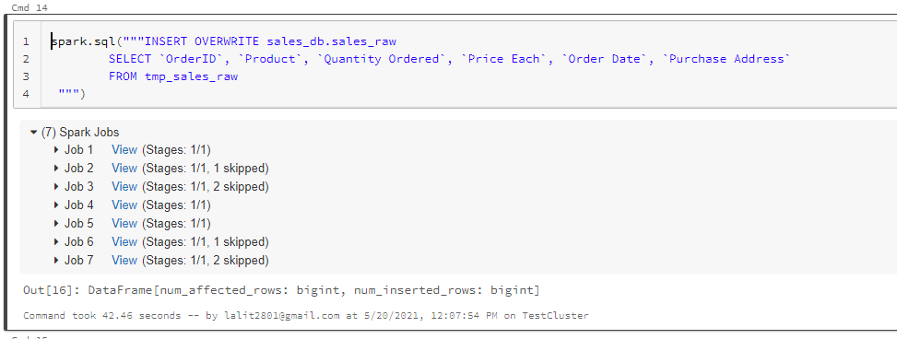

All right, so it looks like the inside has finished, so lets see

spark.sql("SELECT * from sales_db.sales_raw").show(10)

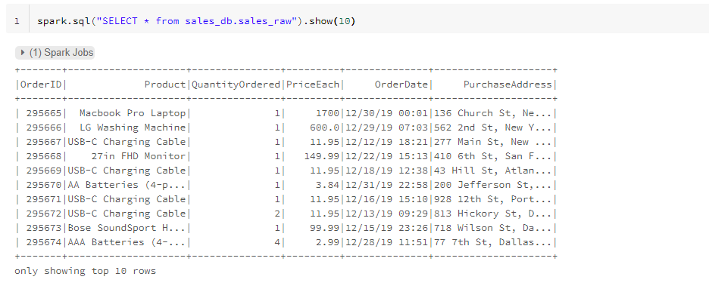

And as you can see, we have successfully inserted records into our sales_raw table. To get the inserts to work, we have used a combination of a DML statement and EQL. Damul stands for data manipulation language, which also includes update and the delete statement. The overall command just basically indicates that I want to delete the existing data.

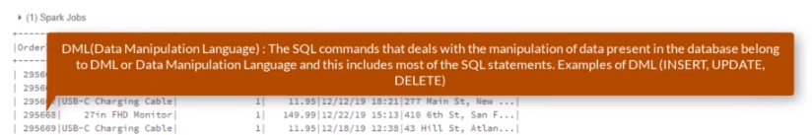

So let me just move that up to the override command and basically just to refresh the table whether the latest and newest data. We are going to come across a variety of insert statements throughout the course.

### Exposing Bad Records

Our data does in fact contain bad data, and it's our duty to ensure that the data that we have is in the highest level of quality by ensuring that we remove that data. Let's start by exposing the bad data. This time around, we are going to use just pure SQL, which is driven by spark, of course. So let's open our sales queries, not put in a new tab that we created a few lessons ago. And to do that, I am going to select workspace and then move over to sales queries on the upside down arrow and also select open a new tab just like that.

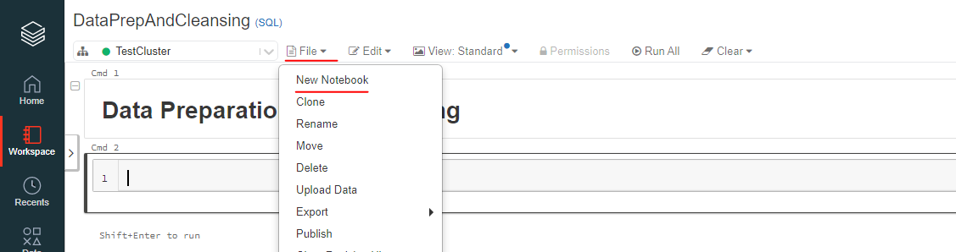

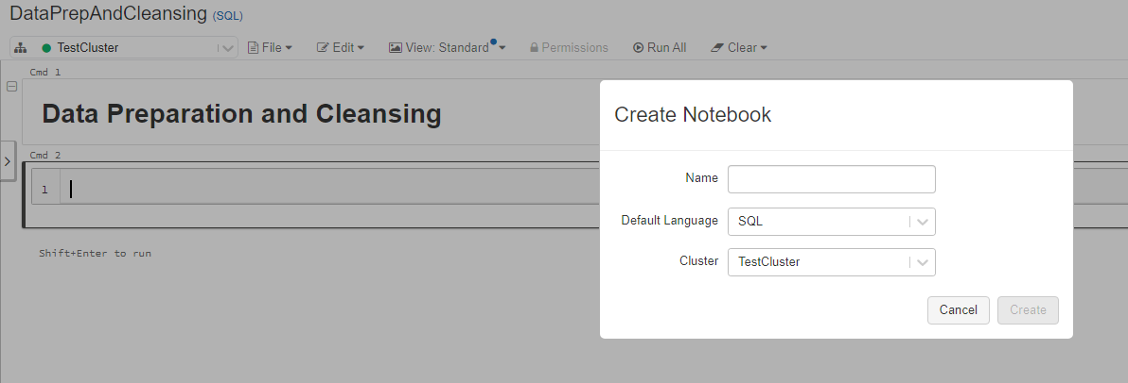

Now that we have our pure sql notebook open, let's indicate to spark that we want to use sales_db, which is our database in question. And to do that I am simply just going to use sales_db and shift enter. Now we can actually create a new heading, so to create a new heading it is #md and ## heading "Data preparation and Cleansing". Let's not once again use the statement to retrieve the first ten records just to confirm that indeed we are using the right database and table and to do that, I have simply just going to

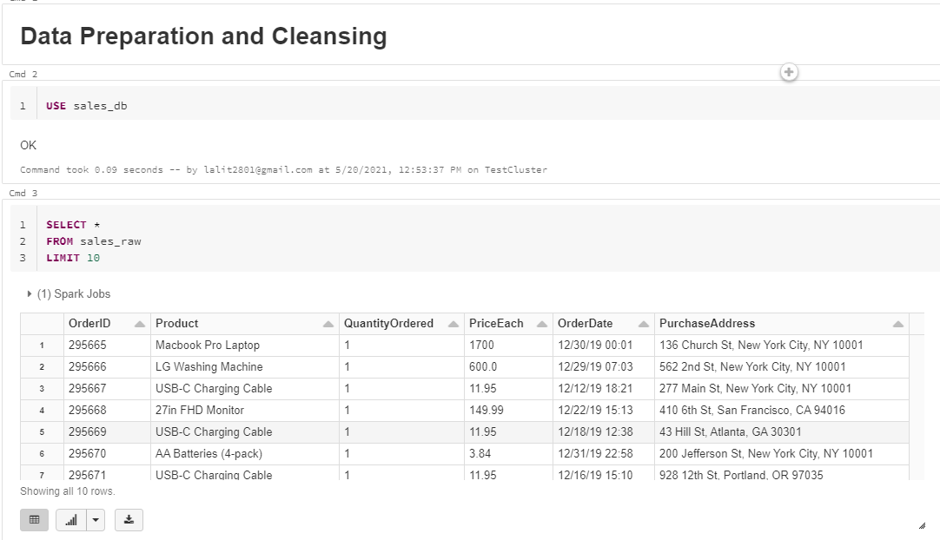

USE sales_db

SELECT *

FROM sales_raw

LIMIT 10

And this confirms that we are not querying from our default database because sales_raw is non-existent there. Now notice this statement and more specifically, the pattern of using the select and from commands. So it will always be the case that if you are retrieving records from the database table, the first statement will always be the select command. And then you can indicate the number of data columns that you are interested in. And in our case, we are selecting every available data column by using the * symbol. The SELECT command will always be followed by a FROM command that indicates which database table or perhaps tables that we are selecting the data from. Now, it's unusual to refer the displayed statement as a DQL statement we normally just call it the SELECT statement. Let's now expose the bad data and let's start with the records. And to do that, I am going to start with a heading.

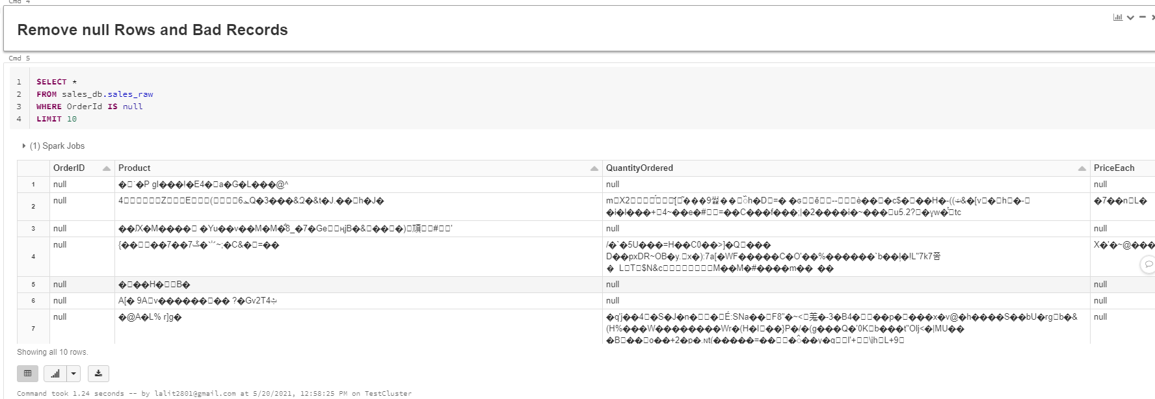

SELECT *

FROM sales_db.sales_raw

WHERE OrderId IS null

LIMIT 10

OK, so let's expose the records of So Select. Home from sales underscore DEPI sales underscore role. We that the order it is now and let's limit. The records to just rows, so shift into two one and it looks like we have a number of records that we need to remove. Now, notice the next statement once again. It now contains an optional clause, which is nothing but a way to filter the records.

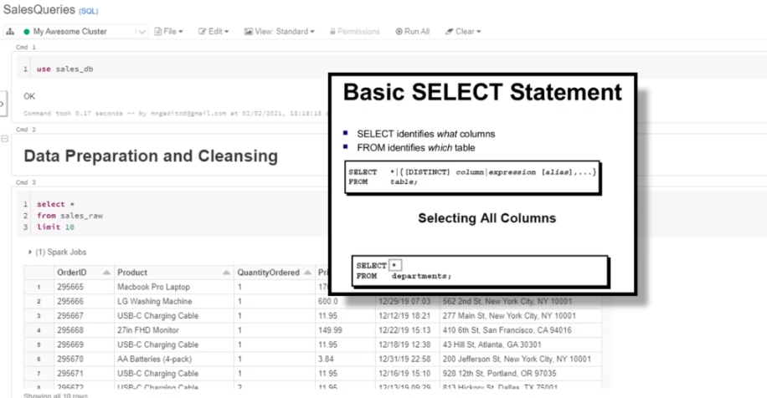

What we also did differently is to indicate the therapist together with the table that we are selecting from this is useful and is actually good practice, and especially if you are working with data from different databases. No records onto the only problem, however, we also have a problem of rules where they are actually junk records. So let's expose these records. And to do that, I am simply just going to copy this entire statement. And paste it within this new cell. And this time around, it will be.

SELECT *

FROM sales_db.sales_raw

WHERE OrderId = "Order ID"

LIMIT 10

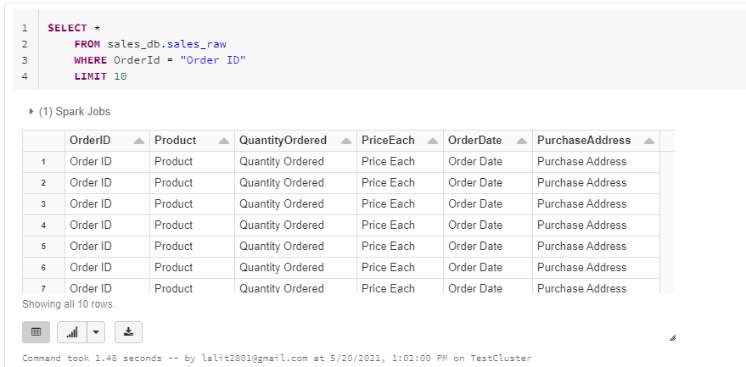

As you can see, these records point to problematic and we need to find a way to remove them using Spok as well, so let's get that together in the next list and figure out how we can actually remove these records.

### Removing Bad Records

We had a look at how we can expose bad records using as SQL. So how about we figure out exactly on how we can actually produce a query without the bad records? We can start by constructing a query that excludes the null records and also the bad records. We can do that by SELECT ALL FROM sales_db.sales_raw where Order ID is not equal to "Order ID" and "Order ID", is not null. And shift enter to run.

SELECT *

FROM sales_db.sales_raw

where OrderID != "Order ID"

and OrderID is not null

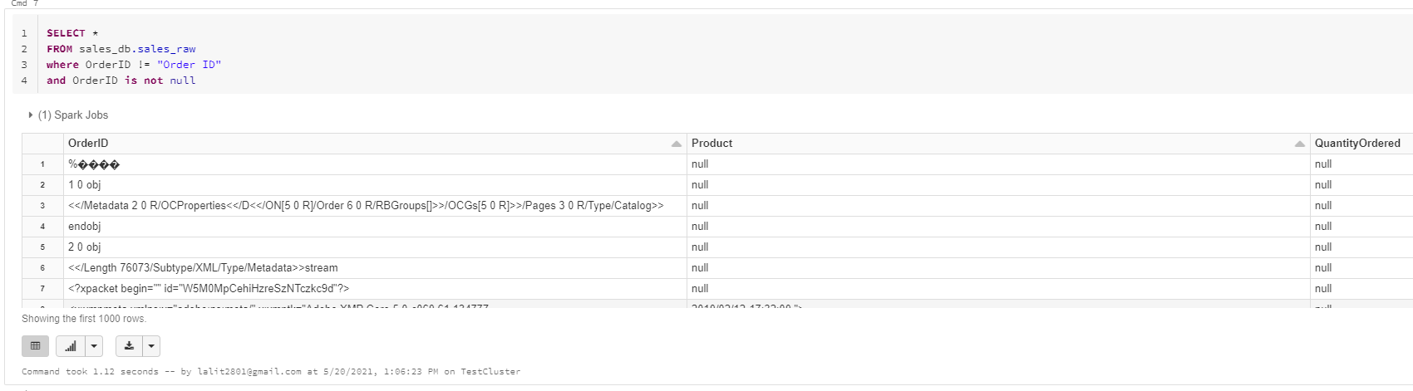

As you can see, the query return the first one thousand rows that exclude the bad records. So what are the ways we can confirm our SQL statement is working as it should, we could create a temporary table that holds the number of records based on our current query output and test if the temporary table, if it contains the records from the current query output and they after seek to confirm if the records have disappeared.

OK, so now what I am going to do is to copy this statement, OK, and use of the with clause to create the template on a table. So with tmp_sales_raw as and I am going to paste my SQL statement right here just like that and then SELECT ALL from tmp_sales_raw and let's limit it to 10. So shift enter to get the results. And there you have it, we can confirm that the temporary table contained the records from the above query. Now, let's confirm that the temporary table does not contain the bad records.

WITH tmp_sales_raw as (

SELECT *

FROM sales_db.sales_raw

where OrderID != "Order ID"

and OrderID is not null

)

SELECT * FROM tmp_sales_raw LIMIT 10

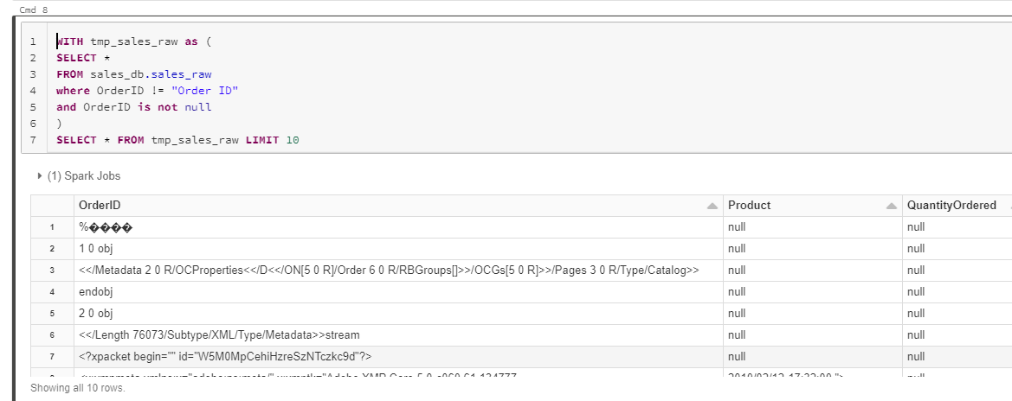

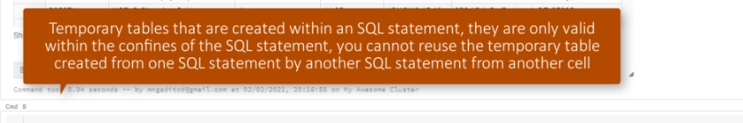

What we can do is to copy this whole entire statement and paste it right here and what I want to do is to filter the records, so where Order ID is null or Order ID = Order ID.

WITH tmp_sales_raw as (

SELECT *

FROM sales_db.sales_raw

WHERE OrderID = "Order ID"

AND OrderID IS null

)

SELECT * FROM tmp_sales_raw LIMIT 10

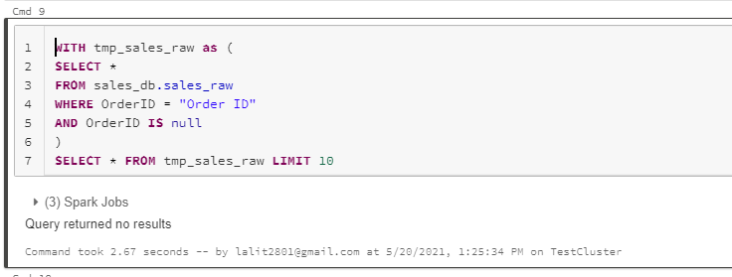

And shift enter and see what actually happens. Cool. And since the status reflects that they are no returned results. We can safely confirm that our initial query to filter out, but records actually works as intended. One thing to note about temporary tables that are created within an SQL statement, they are only valid within the confines of the SQL statement. You cannot reuse the temporary table created from one SQL statement by another SQL from another cell. The advantage of writing SQL statements is that you can solve almost all the required transformations within one SQL statement. We have a requirement to extract the state and city from the data, and we can do that within one SQL statement while filtering out the bad records.

### Extract the City and State

What we want to do next is to extract the city and state from the purchase address. Let's start by examining our previous query results and focus only on the purchase orders, so if I scroll a little bit up right here, let me make this a little bit bigger. Cool, what we can tell by observing each row is that each purchase address string has addressed elements separated by commas.

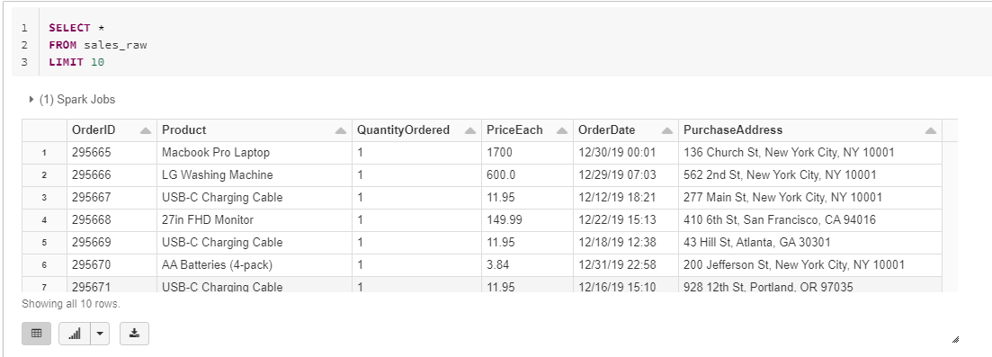

We need to get the city from the second element and also the state from the third element. And just like our data frame API example, we will need a split function that will create a list that is based on these three elements. So let's find the split function. We can visit the url that you see on screen, then we can search for the split function and to search for the split function.

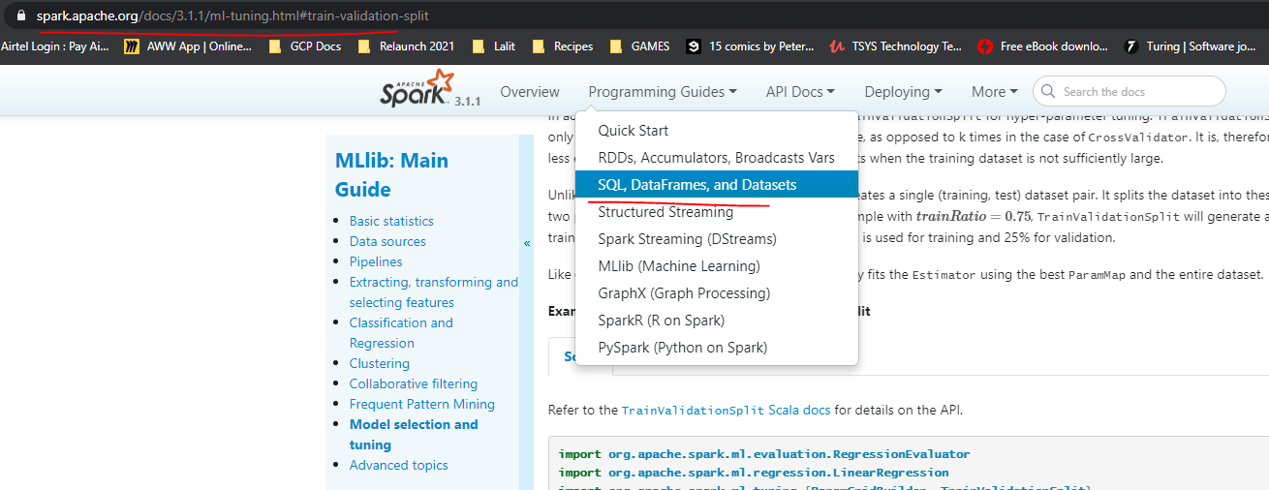

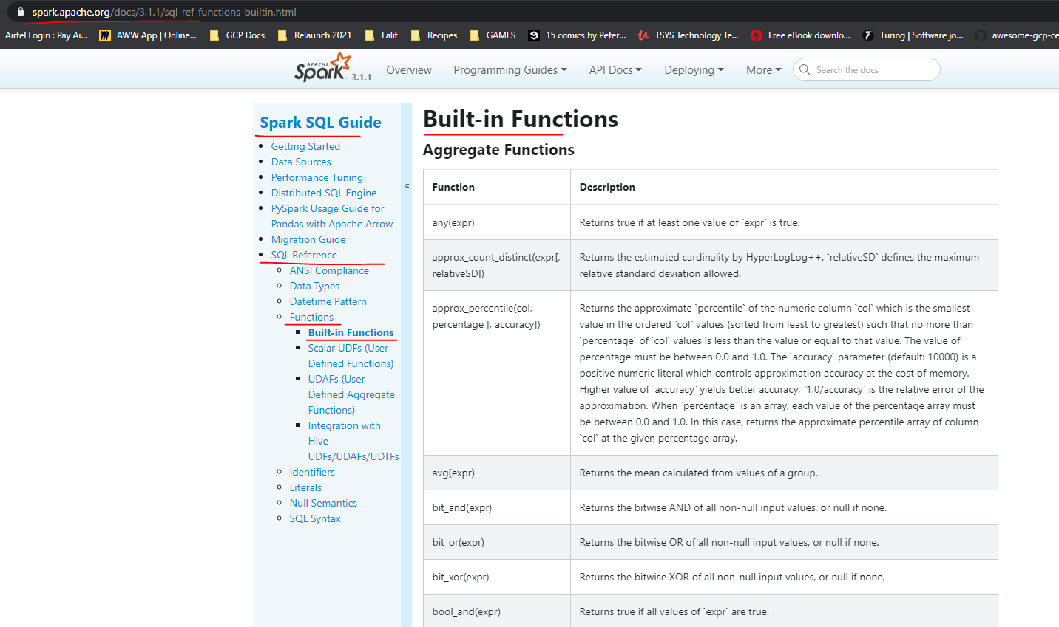

For now lets use this url instead

<https://spark.apache.org/docs/3.1.1/api/sql/>

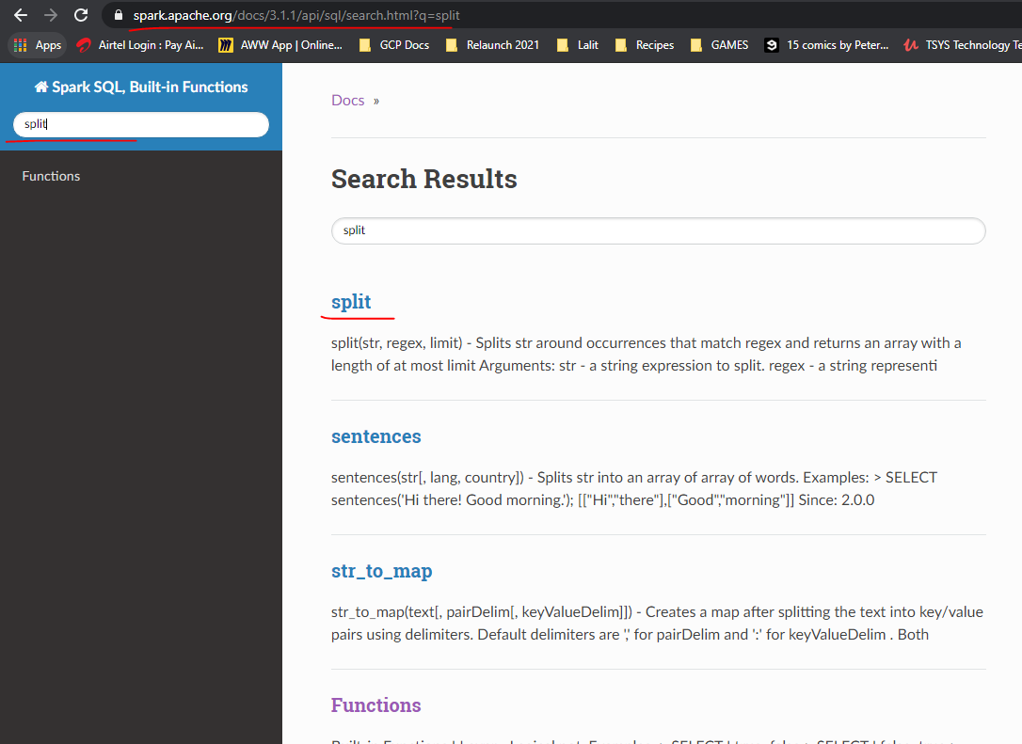

I am going to navigate to this search box text box and I will simply just type it, split and press enter. And now I am going to select the function from the search results. The key thing to understand here is that these are spark sql specific built in functions. The idea behind the phrase built in is that you don't have to import to them like we did when using the data frame API, and I would like to stress that you cannot use sql built in functions with the data frame API. Now, looking at the example that you can see on screen, we can tell that we can use this function by supplying it with a string of value and then split the string into a list by providing a delimiter as a second parameter. So let's get cracking with the split function. Now, I am going to navigate back to sales queries. And what I am going to do is to just write a query using the split function, so select. And, of course, to purchase. And I need to supply the delimiter. And as a city, OK, just for now, so from sales on the school roll, we orderID is not equal to well. OrderID. And OrderId is not null. And let's limit this to the first ten records.

SELECT split(PurchaseAddress, ",")[1] AS City

FROM sales_raw

LIMIT 10

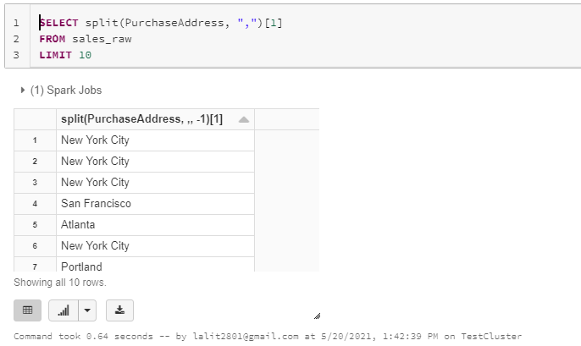

Now for the state which appears as the 3rd element in the Purchase address

SELECT split(PurchaseAddress, ",")[1] AS City,

split(PurchaseAddress, ",")[2] AS State

FROM sales_raw

LIMIT 10

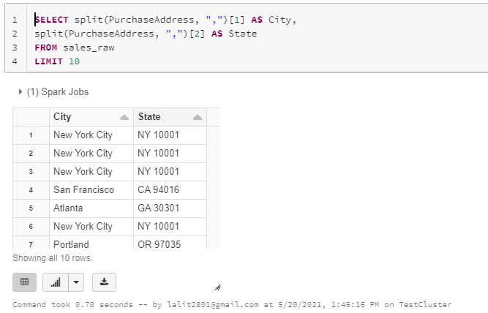

The substring function takes in and input string as the first parameter. And then we need to specify the characters that we need to extract from the string. And we can do that by providing the second parameter to indicate the position of the first character. Now, you may be tempted to thinking that the third parameter, which is the end position that perhaps we need to apply to. Well, that won't work.

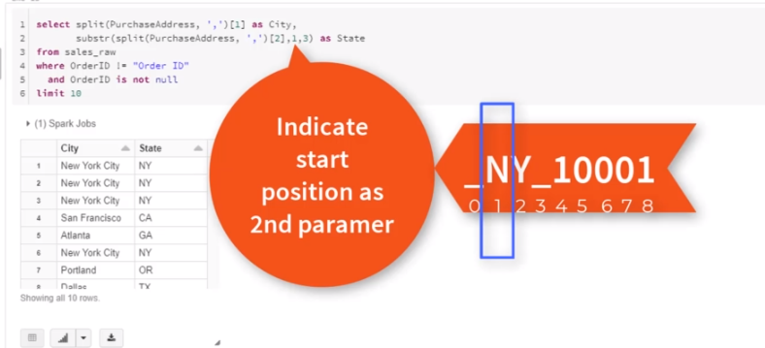

The end position has a starting index of the first character in a string as a one time instead of a zero, so therefore we have to supply a three instead of two as the and position. OK, you can actually read more about the substring function from the documentation and have a look at some more examples.

SELECT split(PurchaseAddress, ",")[1] AS City,

substring(split(PurchaseAddress, ",")[2], 1, 3) AS State

FROM sales_raw

LIMIT 10

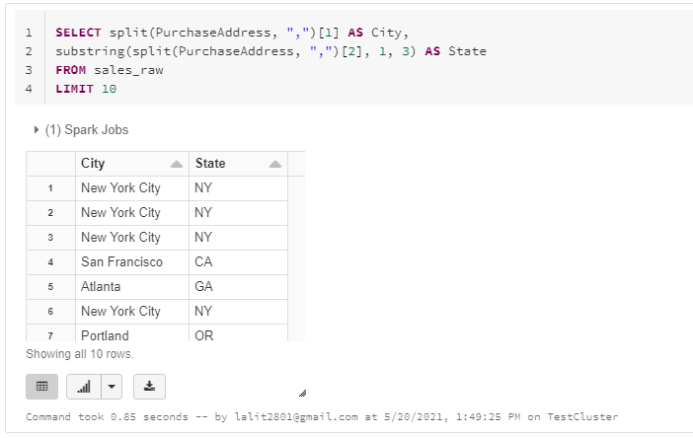

### Inserting Records to Final Sales Table

Now that we have worked out how to filter back data and also extract the city and state, how about we compile one final statement that contains all the required transformations? We will use the SQL statement to insert records into the final sales table. We need to also address a couple of requirements that we need to take into account first. The first requirement is that we need to ensure that the order date is represented in the right format. We also need to extract the money from the order date as our second requirement.

SELECT cast(OrderId as int) as OrderId,

Product, QuantityOrdered, PriceEach,

to_timestamp(OrderDate, 'MM/dd/yy HH:mm') as OrderDate, PurchaseAddress,

split(PurchaseAddress, ",")[1] AS City,

substring(split(PurchaseAddress, ",")[2], 1, 3) AS State

year(to_timestamp(OrderDate, 'MM/dd/yy HH:mm') ) as ReportYear,

month(to_timestamp(OrderDate, 'MM/dd/yy HH:mm') ) as Month,

FROM sales_raw

WHERE OrderID != "Order ID"

and OrderID is not null

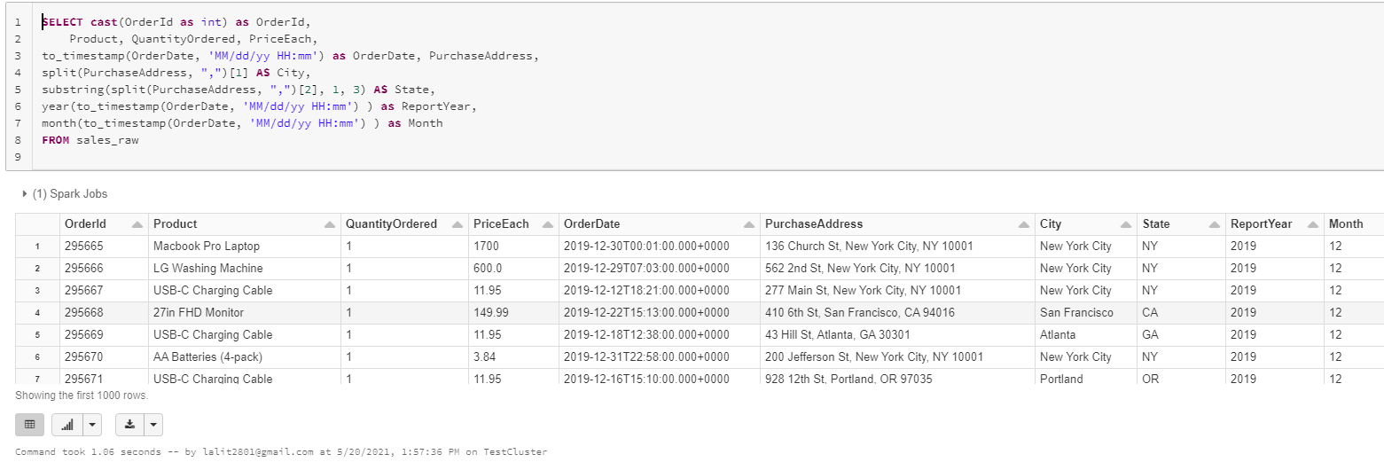

Lets convert this SQL statement into a Dataframe now.

Go back to the other Notebook ( non sql one )

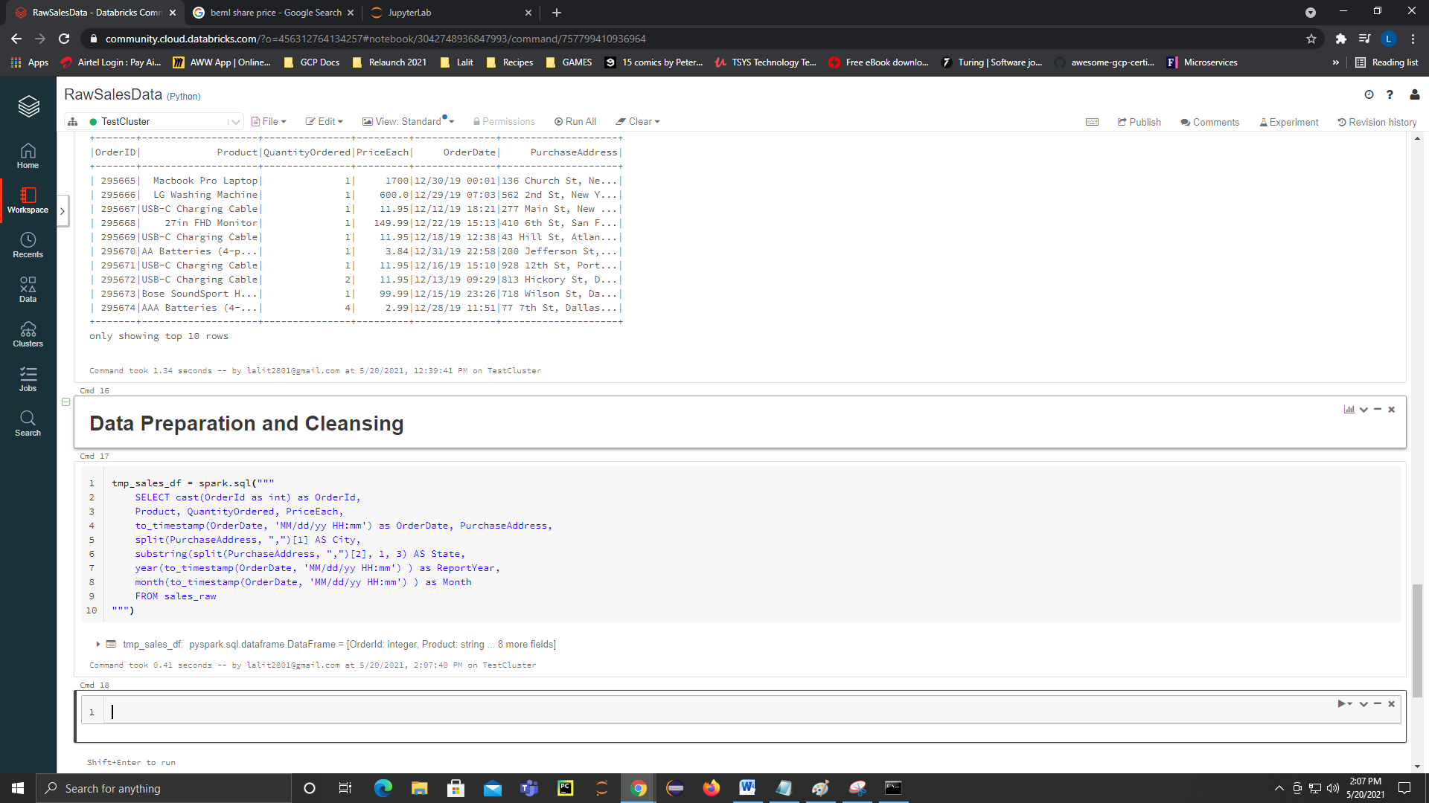

tmp_sales_df = spark.sql("""

SELECT cast(OrderId as int) as OrderId,

Product, QuantityOrdered, PriceEach,

to_timestamp(OrderDate, 'MM/dd/yy HH:mm') as OrderDate, PurchaseAddress,

split(PurchaseAddress, ",")[1] AS City,

substring(split(PurchaseAddress, ",")[2], 1, 3) AS State,

year(to_timestamp(OrderDate, 'MM/dd/yy HH:mm') ) as ReportYear,

month(to_timestamp(OrderDate, 'MM/dd/yy HH:mm') ) as Month

FROM sales_raw

""")

But before we do that, lets create a temporary table based on our dataframe and so we can apply tmp_sales_df createOrReplaceTempView

tmp_sales_df.createOrReplaceTempView("tmp_sales")

spark.sql("describe tmp_sales").show()

+---------------+---------+-------+

| col_name|data_type|comment|

+---------------+---------+-------+

| OrderId| int| null|

| Product| string| null|

|QuantityOrdered| string| null|

| PriceEach| string| null|

| OrderDate|timestamp| null|

|PurchaseAddress| string| null|

| City| string| null|

| State| string| null|

| ReportYear| int| null|

| Month| int| null|

+---------------+---------+-------+

Command took 0.11 seconds -- by lalit2801@gmail.com at 5/20/2021, 2:09:13 PM on TestCluster

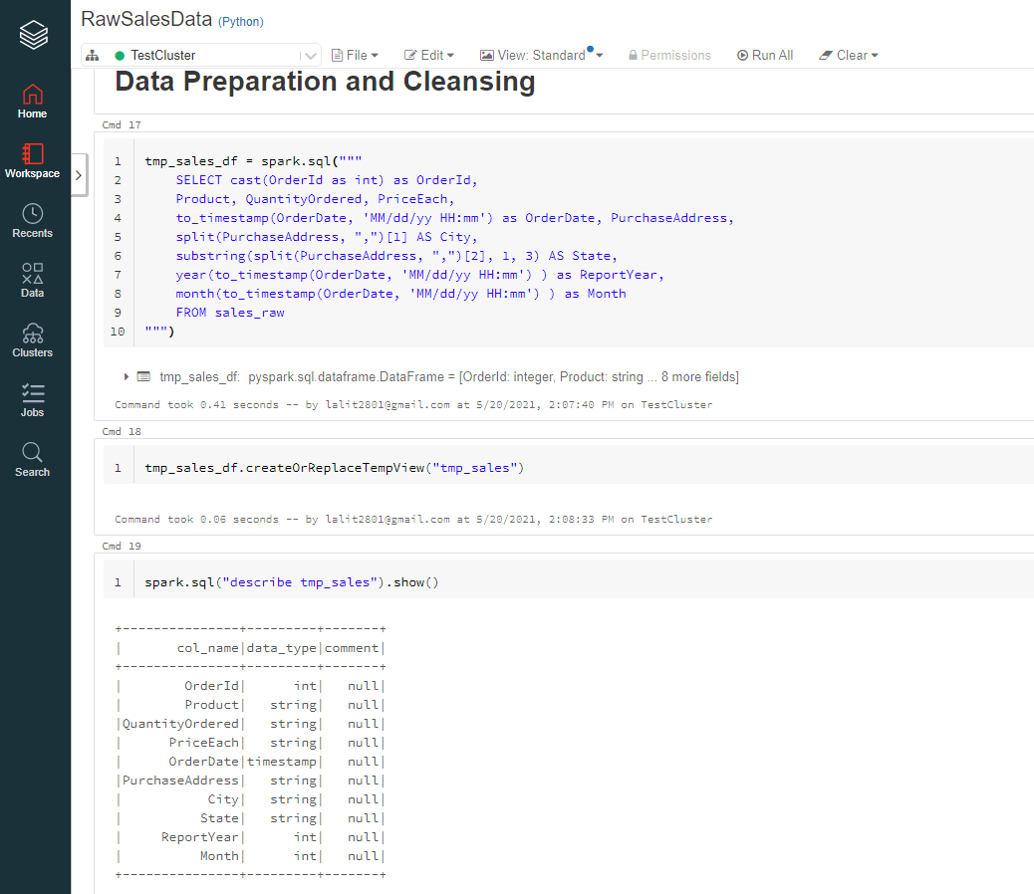

Lets create the table now

spark.sql("""

CREATE TABLE IF NOT EXISTS sales(

OrderId INT,

Product STRING,

Quantity INT,

OrderDate TIMESTAMP,

StoreAddress STRING,

State STRING,

ReportYear INT,

Month INT

)

""")

We want to tell spark that we want this table to be as Parquet. Also specified partition and a option for compression to snappy.

spark.sql("""CREATE TABLE sales(

OrderId INT,

Product STRING,

Quantity INT,

PriceEach INT,

OrderDate TIMESTAMP,

StoreAddress STRING,

City STRING,

State STRING,

ReportYear INT,

Month INT )

USING PARQUET

PARTITIONED BY (ReportYear, Month)

OPTIONS('compression' = 'snappy')

LOCATION 'dbfs:/Filestore/salesdata/published'""")

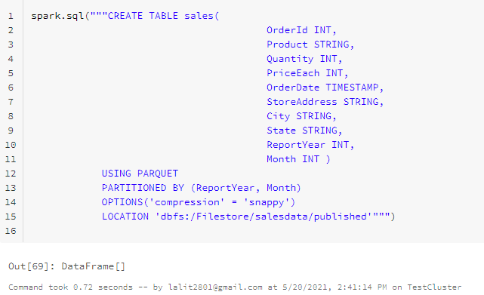

spark.sql("""

INSERT INTO sales

SELECT

OrderId,

Product,

cast(QuantityOrdered as int),

cast(PriceEach as float),

OrderDate,

PurchaseAddress,

City,

State,

ReportYear,

Month

FROM tmp_sales

""")

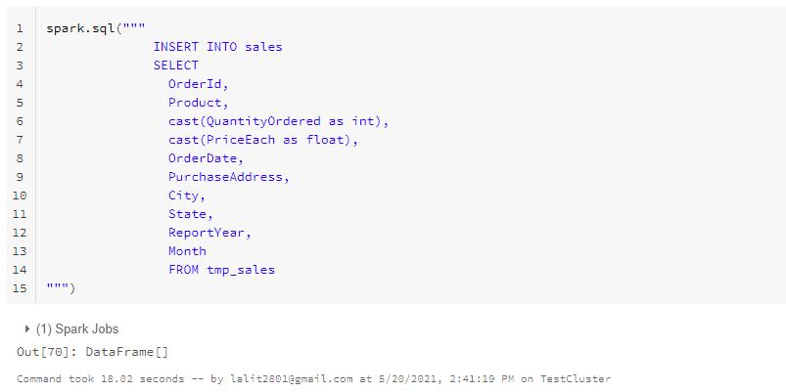

Switch to the SQL Notebook we had created and lets execute the following query now to see the data

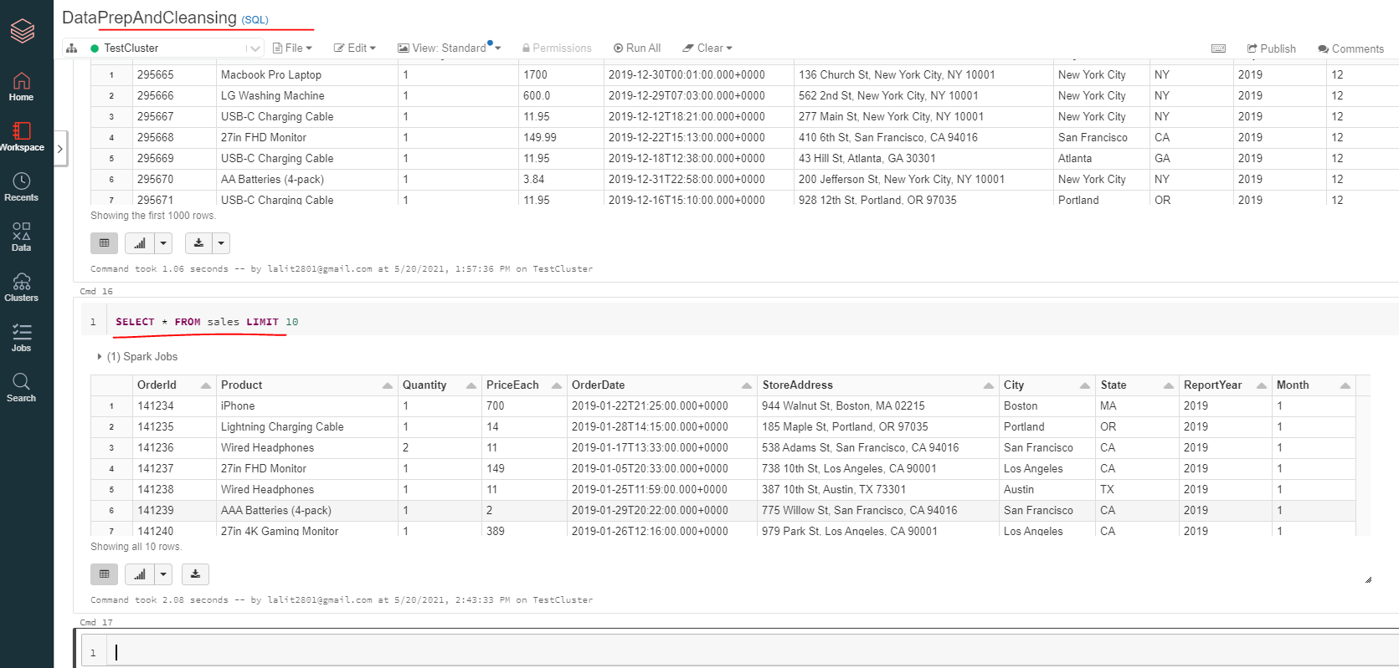

### Best Month for Sales

Check the database and the tables

use sales_db

show tables

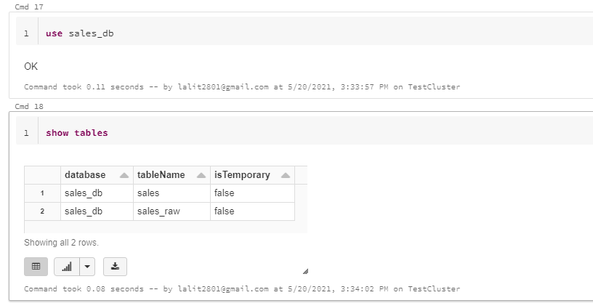

Let's confirm the structure of the sales table, so describe Sales.

describe sales

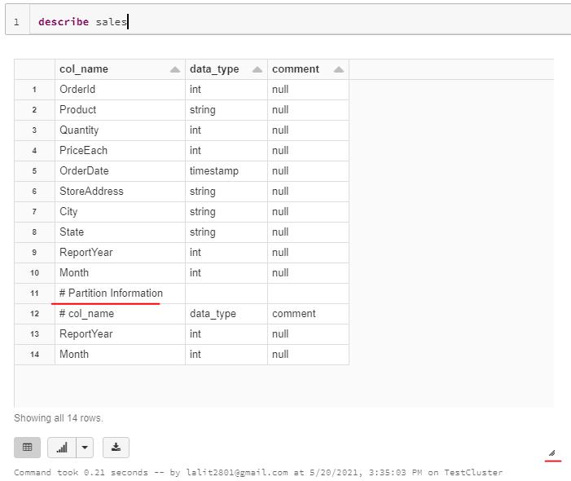

The right side marking is where you can drag the cell to see full information

We can also see the partition information once we drag and expand to see the full information here.

It is common practice to check the structure of the tables before using them in order to guarantee expected behavior.

Now we need to find what was the best month for the sales

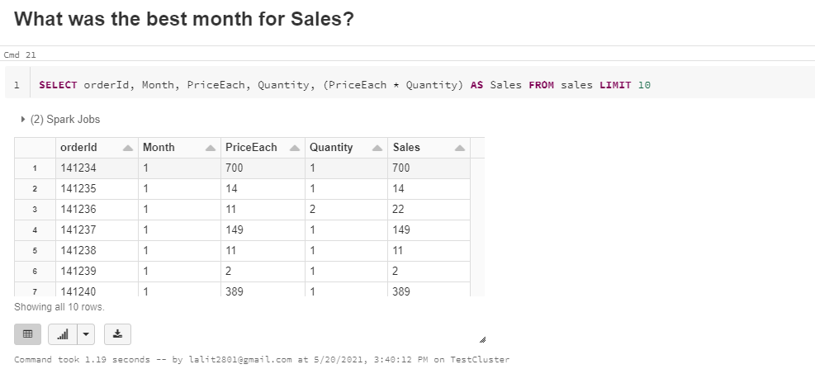



SELECT Month, round(sum((PriceEach * Quantity)), 2)

AS TotalSales

FROM sales

GROUP BY Month

ORDER BY TotalSales DESC

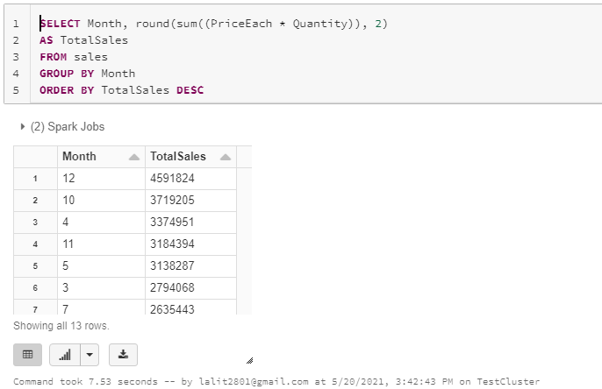

The top sales month is 12 i.e. December

Lets get the monthwise sales

Same query but ordered by month this time

SELECT Month, round(sum((PriceEach * Quantity)), 2)

AS TotalSales

FROM sales

GROUP BY Month

ORDER BY Month DESC

Now to get the visualization, select the graph button and click on the bar chart

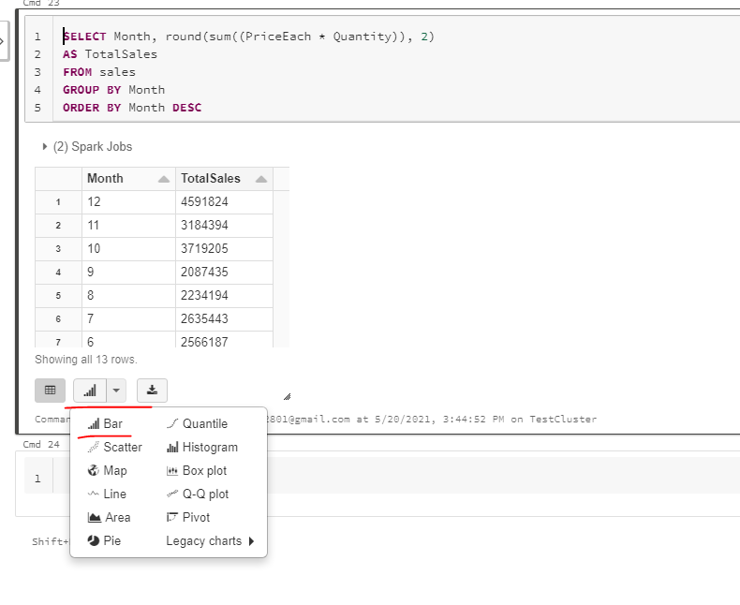

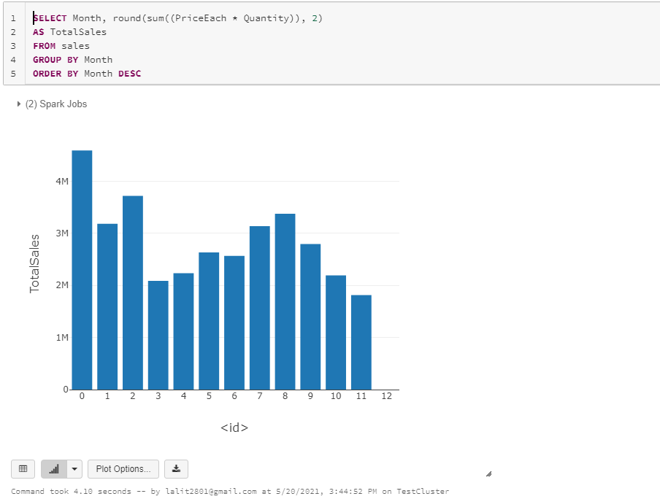

To customize the graph click on Plot Options and customize

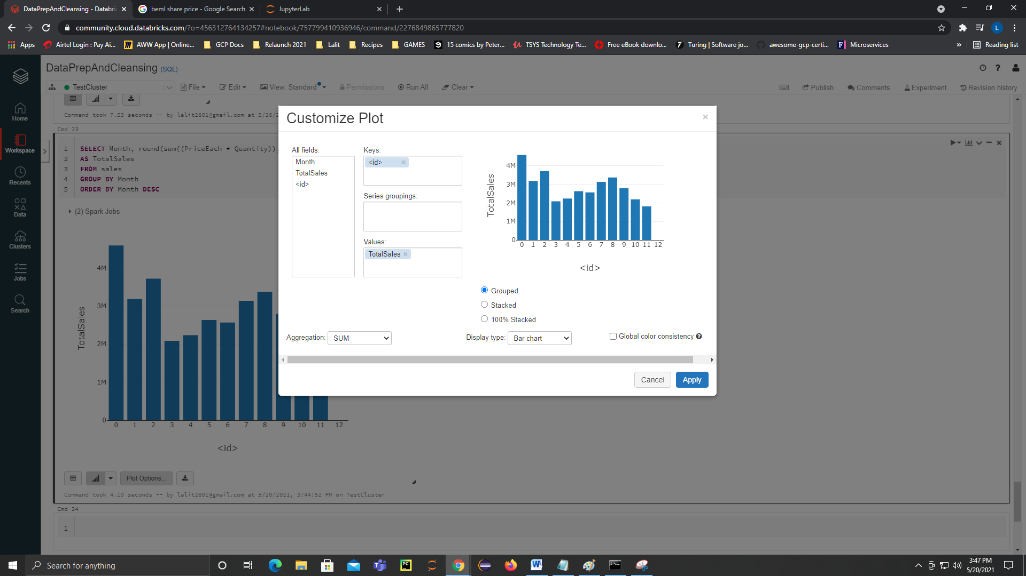

Example we are changing the x axis from <id> to Month as the key

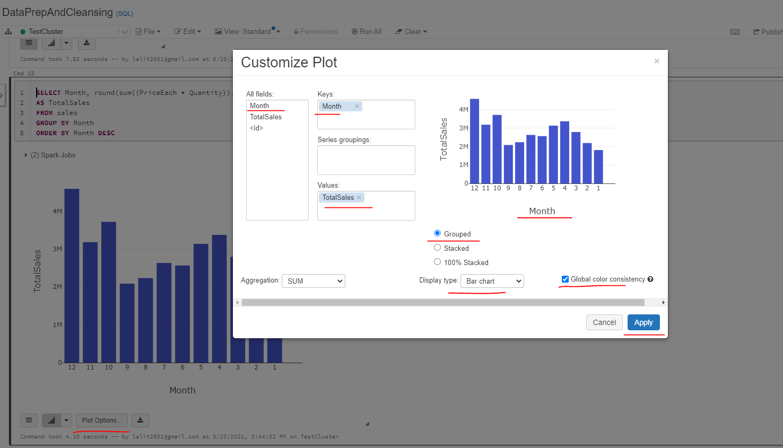

### City that Sold Most Products

So this is pretty much an easy one. What we need to do here is to group the data by city and then calculate the sum of all product quantities for each city.

SELECT city, sum(quantity) AS TotalProducts

FROM Sales

GROUP BY city

ORDER BY TotalProducts DESC

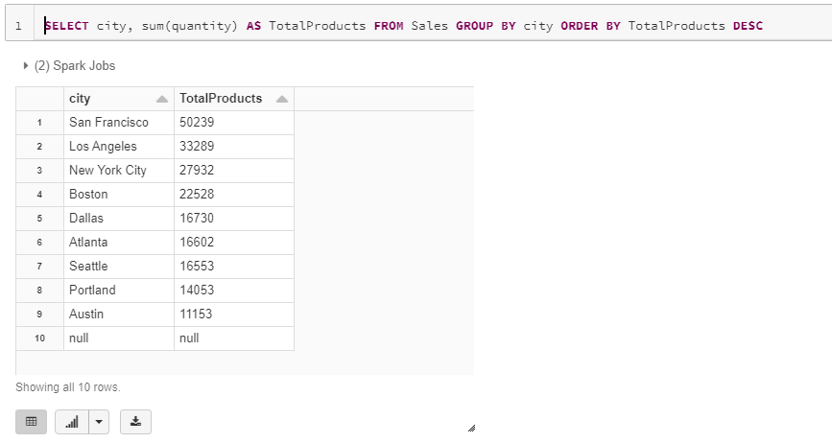

On enabling Graph we see

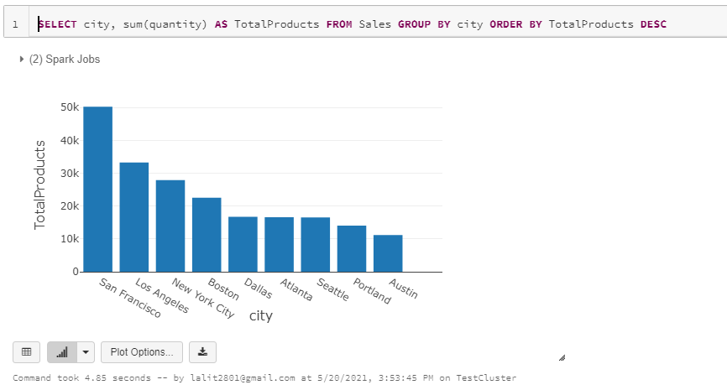

Made some changes to the graph now, dropped the key as city and brought city into the Series groupings

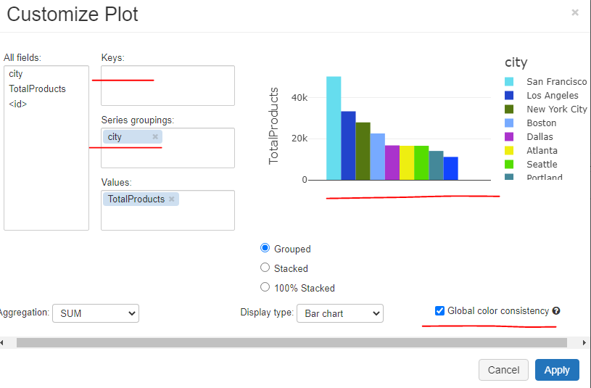

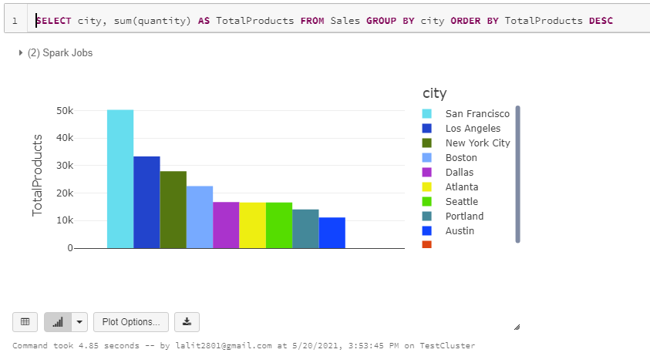

And by looking at the results, San Francisco still has the most sold products.

### Right Time to Advertise

What we need to do here is to capture the purchasing hour of each unique order ID. So let's see how we can get the hour for each voter ID. And to do that, I would simply select distinct OrderID to get the unique set of Order IDs. Now, what I want to do is to get the hour using the sql function. And it needs to come from the sales table

Pending from <https://www.udemy.com/course/introduction-to-python-for-big-data-engineering-with-pyspark/learn/lecture/24790116#content>

Just 3 videos pending